**Question 1**

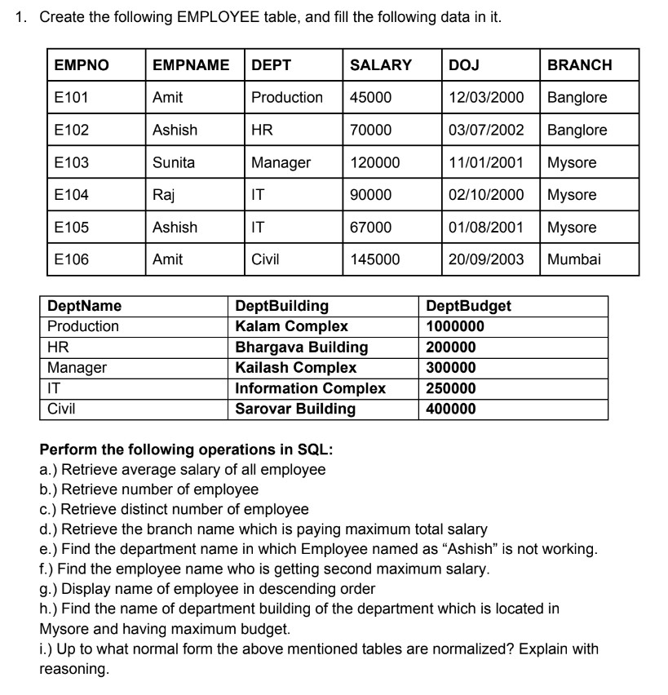

**SQL Queries and Output**

* Creating Database
  + create database labAssign;
* Switching to ‘labAssign’ Database
  + use labAssign;
* Creating the tables ‘DEPARTMENT’ and ‘EMPLOYEE’
  + create table DEPARTMENT ( DeptName varchar(20) unique not null, DeptBuilding varchar(50), DeptBudget int, primary key (DeptName) );
  + create table EMPLOYEE ( EMPNO varchar(10) unique not null, EMPNAME varchar(25), DEPT varchar(20), SALARY int, DOJ date, BRANCH varchar(30), primary key (EMPNO), foreign key (DEPT) references DEPARTMENT(DeptName) on update cascade on delete cascade);
* Inserting the data in the tables ‘DEPARTMENT’ and ‘EMPLOYEE’
  + insert into DEPARTMENT values ('Production', 'Kalam Complex', 1000000), ('HR', 'Bhargava Building', 200000), ('Manager', 'Kailash Complex', 300000), ('IT', 'Information Complex', 250000), ('Civil', 'Sarovar Building', 400000);
  + insert into EMPLOYEE values ('E101', 'Amit', 'Production', 45000, '2000-03-12', 'Banglore'), ('E102', 'Ashish', 'HR', 70000, '2002-07-03', 'Banglore'), ('E103', 'Sunita', 'Manager', 120000, '2001-01-11', 'Mysore'),('E104', 'Raj', 'IT', 90000, '2000-10-02', 'Mysore'),('E105', 'Ashish', 'IT', 67000, '2001-08-01', 'Mysore'),('E106', 'Amit', 'Civil', 145000, '2003-09-20', 'Mumbai');

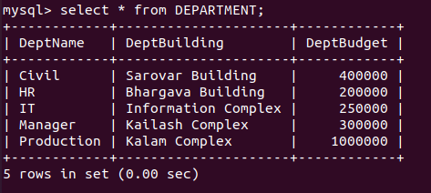

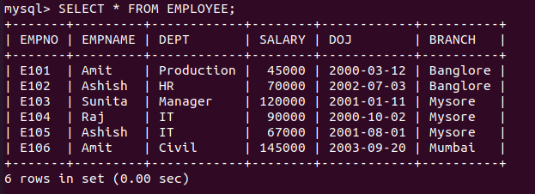

* Perform the following operations in SQL

1. Retrieve average salary of all employee

**SQL Query:** select avg(SALARY) as AverageSalary from EMPLOYEE;

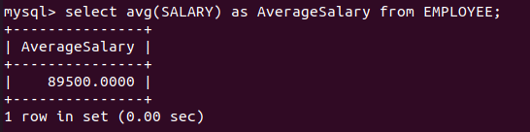**OUTPUT:**

1. Retrieve number of employee

**SQL Query:** select count(EMPNO) as NumberOfEmployees from EMPLOYEE;

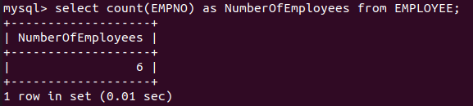**OUTPUT:**

1. Retrieve distinct number of employee

**SQL Query:** select count(distinct(EMPNO)) as DistinctNumOfEmployees from EMPLOYEE;

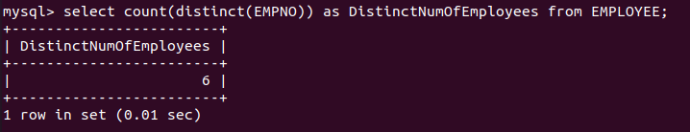**Output:**

1. Retrieve the branch name which is paying maximum total salary

**SQL Query:** select BRANCH as maxTotalSalaryBranch from EMPLOYEE where SALARY in (select max(SALARY) from EMPLOYEE);

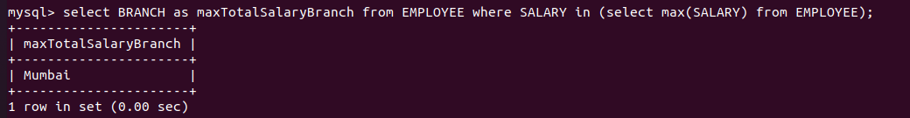**Output:**

1. Find the department name in which Employee named as “Ashish” is not working.

**SQL Query:** select DEPT from EMPLOYEE where not DEPT in (select DEPT from EMPLOYEE where EMPNAME = 'Ashish');

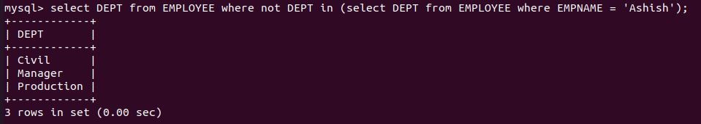**Output:**

1. Find the employee name who is getting second maximum salary.

**SQL Query:** select max(SALARY) from EMPLOYEE where SALARY not in (select max(SALARY) from EMPLOYEE);

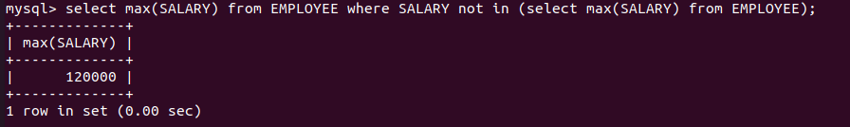**Output:**

1. Display name of employee in descending order

**SQL Query:** select EMPNAME from EMPLOYEE order by EMPNAME DESC;

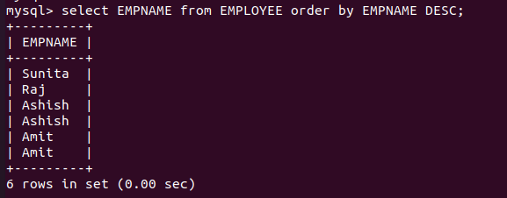**Output:**

h.) Find the name of department building of the department which is located in

Mysore and having maximum budget.

**SQL Query:** select DeptBuilding from DEPARTMENT where DeptBudget in (select max(DeptBudget) from DEPARTMENT where DeptName in (select DEPT from EMPLOYEE where BRANCH = 'Mysore'));

**Output:**



i.) Up to what normal form the above mentioned tables are normalized? Explain with reasoning.

The tables are normalized till BCNF. The explanation for the same is given below.

In the table EMPLOYEE, the following set of functional dependencies hold.

$$EMPNO→EMPNAME$$

$$EMPNO→DEPT$$

$$EMPNO→SALARY$$

$$EMPNO→DOJ$$

$$EMPNO→BRANCH$$

Since, none of the attributes are multivalued, hence table is in 1NF.

The only candidate of the EMPLOYEE table is $\{EMPNO\}$, hence all other attributes are non-prime and they only depend on the $\{EMPNO\}$. Hence, there are no partial dependencies. Hence, the table is in 2NF.

As there are no transitive dependencies, the table is in 3NF.

As there is a candidate key on the left side of each dependency, the table is in BCNF.

In the table DEPARTMENT, the following set of functional dependencies hold.

$$DeptName→DeptBuilding$$

$$DeptName→DeptBudget$$

Since, none of the attributes are multivalued, hence table is in 1NF.

The only candidate of the DEPARTMENT table is $\{DeptName\}$, hence all other attributes are non-prime and they only depend on the $\{DeptName\}$. Hence, there are no partial dependencies. Hence, the table is in 2NF.

As there are no transitive dependencies, the table is in 3NF.

As there is a candidate key on the left side of each dependency, the table is in BCNF.

**Question 2**



**SQL Queries and Output**

* Adding column ‘RAISE’ in ‘EMPLOYEE’ table
  + alter table EMPLOYEE add RAISE int;
* Adding values to ‘RAISE’ column
  + update EMPLOYEE set RAISE = 1.1 * SALARY;

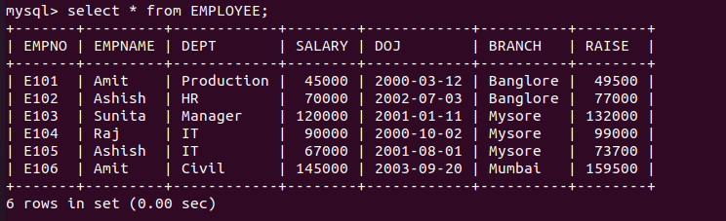

**Question 3**

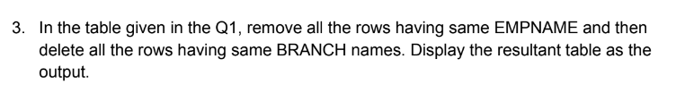

**SQL Queries and Output**



* Removing all the rows having same EMPNAME

**SQL Query:**