MA202 ASSIGNMENT 8

NAME:

ARCHIT AGRAWAL

ROLL NO. :

202051213

SECTION:

2

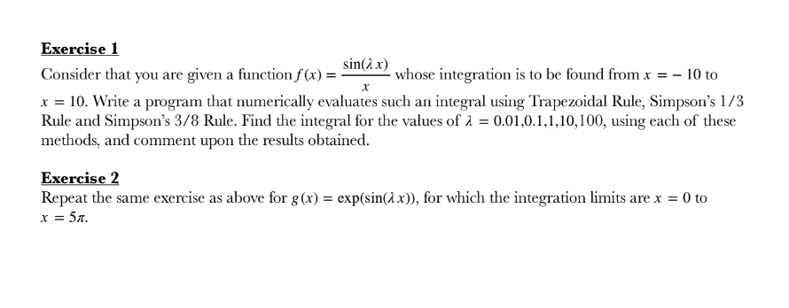

**Exercise 1**

***Code***

The values of ain is changed repeatedly.

Lower=-10 ;

upper =10 ;

n= 100;

%Trapezoidal Rule, Simpson’s One third Rule and Simpson’s Three Eighth Rule by multiple application

h = (upper-lower)/n;

xVec = lower :h:upper;

xVec(n+1) = upper +h;

xVec(n+2) = xVec(n+1)+h;

xVec(n+3) = xVec(n+2)+h ;

fVec = myFunInt(xVec);

%applying correction for sinx/x = 1 as x tends to 0

fVec(51) =1;

interval_trap = zeros(n,1);

interval_onethird = zeros(n,1);

interval_threeeigth = zeros(n,1);

for i = 1:n

interval_trap(i)=(h/2)*(fVec(i)+fVec(i+1));

interval_onethird(i)=(h/3)*(fVec(i)+4*fVec(i+1)+fVec(i+2));

interval_threeeigth(i)=(3*h/8)*(fVec(i)+3*fVec(i+1)+3*fVec(i+2)+fVec(i+3));

end

fprintf(‘The integration is ‘)

I_trap1 = sum(interval_trap)

I_onethird = sum(interval_onethird)

I_threeeight = sum(interval_threeeigth)

function fval = myFunInt(x)

a = [0.01,0.1,1,10,100];

ain= 0.01

%ain= 0.1

%ain= 01

%ain= 10

%ain= 100

fval = sin(ain*x)./x;

end

***Output***

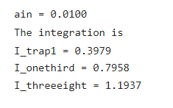

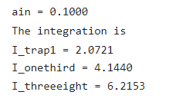

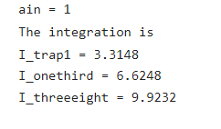

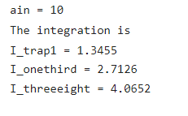

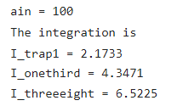

**Exercise 2**

***Code***

The values of ain is changed repeatedly.

lower = 0;

upper =5*pi;

n= 100;

%Trapezoidal Rule, Simpson's One third Rule and Simpson's Three Eighth Rule by multiple application

h = (upper-lower)/n;

xVec = lower :h:upper;

xVec(n+1) = upper +h;

xVec(n+2) = xVec(n+1)+h;

xVec(n+3) = xVec(n+2)+h;

fVec = myFunInt(xVec);

%applying correction for sinx/x = 1 as x tends to 0

interval_trap = zeros(n,1);

interval_onethird = zeros(n,1);

interval_threeeigth = zeros(n,1);

for i = 1:n

interval_trap(i)=(h/2)*(fVec(i)+fVec(i+1));

interval_onethird(i)=(h/3)*(fVec(i)+4*fVec(i+1)+fVec(i+2));

interval_threeeigth(i)=(3*h/8)*(fVec(i)+3*fVec(i+1)+3*fVec(i+2)+fVec(i+3));

end

fprintf('The integration is ')

I_trap1 = sum(interval_trap)

I_onethird = sum(interval_onethird)

I_threeeight = sum(interval_threeeigth)

function fval = myFunInt(x)

a = [0.01,0.1,1,10,100];

ain= 0.01

%ain= 0.1

%ain= 01

%ain= 10

%ain= 100

fval = exp(sin(ain*x));

end

***Output***

