MA202 ASSIGNMENT 9

NAME:

ARCHIT AGRAWAL

ROLL NO. :

202051213

SECTION:

2

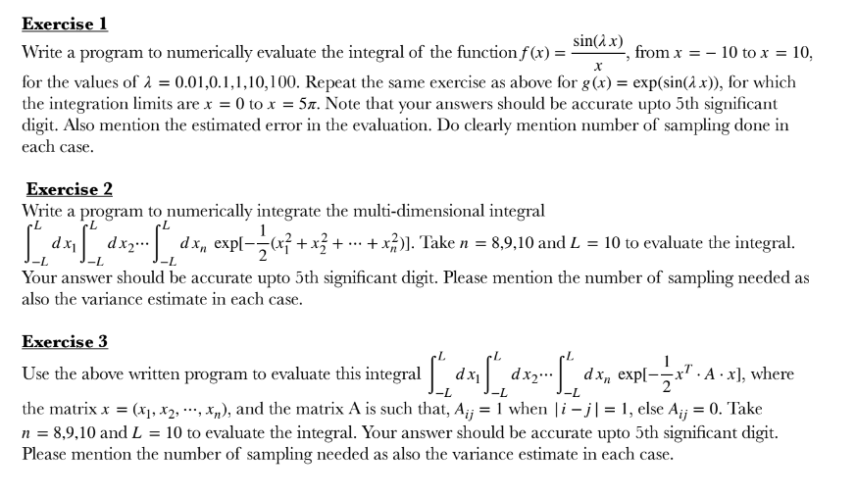

**Exercise 1(a)**

***Code***

The values of c is changed repeatedly.

%%Monte Carlo Height implementation

%lower Limit

a = -10;

%upper limit

b = 10;

%total tries

N = 1000;

%c values

c = 0.01

%c = 0.1

%c = 1

%c = 10

%c = 100

%defining the function

f = @(x) sin(c*x)./(x);

for i = 1: N

x_val(i) = rand(1)*(b-a)+a;

y_val(i) = (b-a)*f(x_val(i));

end

mean = sum(y_val)/N

MATLAB_method = integral(f,a,b)

error = MATLAB_method - mean

***Output***

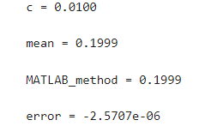

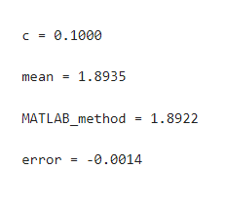

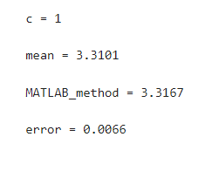

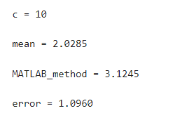

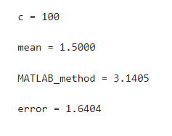

**Exercise 1(b)**

***Code***

%%Monte Carlo Height implementation

%lower Limit

a = 0;

%upper limit

b = 5*pi;

%total tries

N = 1000;

%c values

%c = 0.01

%c = 0.1

%c = 1

%c = 10

%c = 100

%defining the function

f = @(x) exp(sin(c*x));

for i = 1: N

x_val(i) = rand(1)*(b-a)+a;

y_val(i) = (b-a)*f(x_val(i));

end

mean = sum(y_val)/N

MATLAB_method = integral(f,a,b)

error = MATLAB_method - mean

***Output***

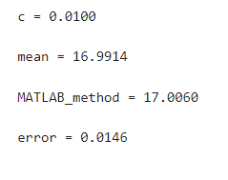

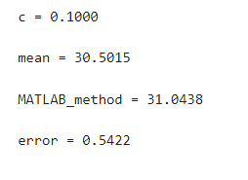

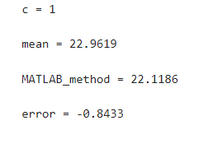

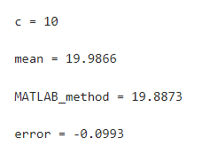

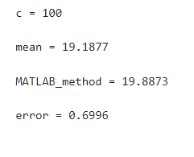

**Exercise 2**

***Code***

%%Monte Carlo Height implementation

%lower Limit of x1

ax1 = -10;

%upper limit of x1

bx1 = 10;

%lower Limit of x2

ax2 = -10;

%upper limit of x2

bx2 = 10;

%lower Limit of x3

ax3 = -10;

%upper limit of x3

bx3 = 10;

%lower Limit of x4

ax4 = -10;

%upper limit of x4

bx4 = 10;

%lower Limit of x5

ax5 = -10;

%upper limit of x5

bx5 = 10;

%lower Limit of x6

ax6 = -10;

%upper limit of x6

bx6 = 10;

%lower Limit of x7

ax7 = -10;

%upper limit of x7

bx7 = 10;

%lower Limit of x8

ax8 = -10;

%upper limit of x8

bx8 = 10;

%lower Limit of x9

ax9 = -10;

%upper limit of x9

bx9 = 10;

%lower Limit of x9

ax10 = -10;

%upper limit of x9

bx10 = 10;

%total tries

N = 1000;

%defining the function

f = @(x1,x2,x3,x4,x5,x6,x7,x8,x9,x10) exp(-0.5*(x1.^2 + x2.^2+x3.^2+x4.^2 +x5.^2 +x6.^2 +x7.^2 +x8.^2+x9.^2+x10.^2));

for i = 1: N

x1_val(i) = rand(1)*(bx1-ax1)+ax1;

x2_val(i) = rand(1)*(bx2-ax2)+ax2;

x3_val(i) = rand(1)*(bx3-ax3)+ax3;

x4_val(i) = rand(1)*(bx4-ax4)+ax4;

x5_val(i) = rand(1)*(bx5-ax5)+ax5;

x6_val(i) = rand(1)*(bx6-ax6)+ax6;

x7_val(i) = rand(1)*(bx7-ax7)+ax7;

x8_val(i) = rand(1)*(bx8-ax8)+ax8;

x9_val(i) = rand(1)*(bx9-ax9)+ax9;

x10_val(i) = rand(1)*(bx10-ax10)+ax10;

plane(i)= f(x1_val(i),x2_val(i),x3_val(i),x4_val(i),x5_val(i),x6_val(i),x7_val(i),x8_val(i),x9_val(i),x10_val(i));

end

mean = (20^10)*sum(plane)/N;

mean

***Output***

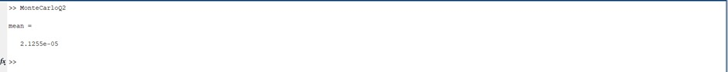

**Exercise 3**

***Code***

clc;

clear all;

lower_limit = -10;

upper_limit = 10;

% For n = 8

for i = 1:8

for j = 1:8

if abs(i-j) == 1

A(i,j) = 1;

else

A(i,j) = 0;

end

end

end

sum = 0;

for i = 1 : 10000

x(:,i) = lower_limit + (upper_limit - lower_limit)*rand(1,8);

sum = sum + exp((-0.5*transpose(x(:,i))*A*x(:,i)));

end

sum = sum/10000;

sum = sum*(upper_limit - lower_limit).^8

clc;

clear all;

lower_limit = -10;

upper_limit = 10;

% For n = 9

for i = 1:9

for j = 1:9

if abs(i-j) == 1

A(i,j) = 1;

else

A(i,j) = 0;

end

end

end

sum = 1;

for i = 1 : 10000

x(:,i) = lower_limit + (upper_limit - lower_limit)*rand(1,9);

sum = sum + exp((-0.5*transpose(x(:,i))*A*x(:,i)));

end

sum = sum/10000;

sum = sum+(upper_limit - lower_limit).^9

clc;

clear all;

lower_limit = -10;

upper_limit = 10;

% For n = 10

for i = 1:10

for j = 1:10

if abs(i-j) == 1

A(i,j) = 1;

else

A(i,j) = 0;

end

end

end

sum = 0;

for i = 1 : 10000

x(:,i) = lower_limit + (upper_limit - lower_limit)*rand(1,10);

sum = sum + exp((-0.5*transpose(x(:,i))*A*x(:,i)));

end

sum = sum/10000;

sum = sum*(upper_limit - lower_limit).^10

***Output***

