CS266 ASSIGNMENT 2

NAME:

ARCHIT AGRAWAL

ROLL NO. :

202051213

SECTION:

2

***Based on shell script***

1. 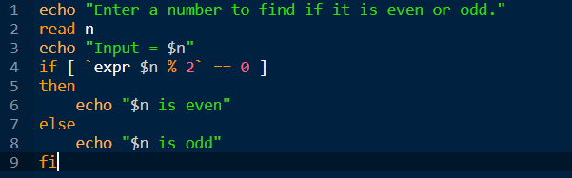Write a shell script to find whether an input integer is even or odd.

Output

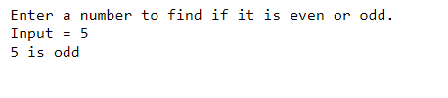

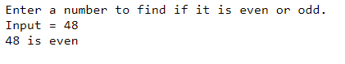

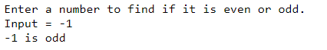

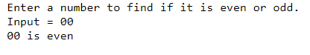

1. 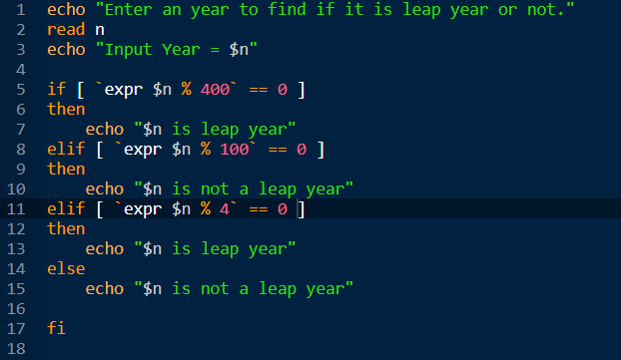Write a shell script to find whether an input year is leap year or not.

Output

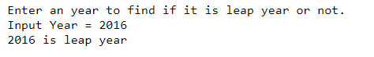

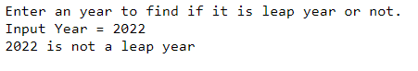

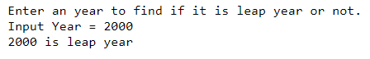

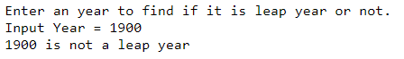

1. Write a shell script to find out the length of an input string.

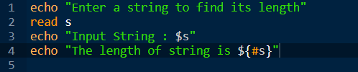

Output

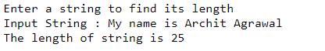

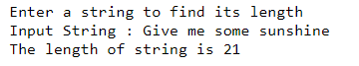

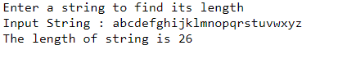





1. Write a shell script to concatenate two strings input by the user.

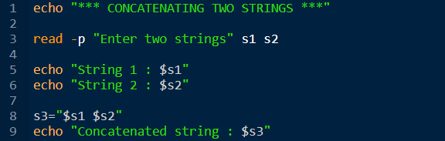

Output

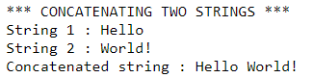

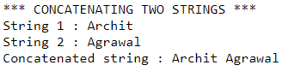

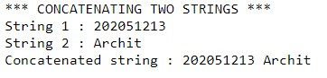

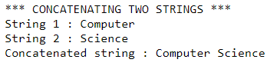

1. 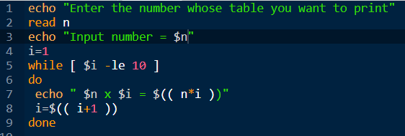Write a shell script to print multiplication table of a number which is given by user.

Output

