CS266 ASSIGNMENT 3

NAME:

ARCHIT AGRAWAL

ROLL NO. :

202051213

SECTION:

2

1. ***Write a C program to create the process using fork() and display the parent and child process ID using getpid() and getppid() system calls, respectively.***

***Code***

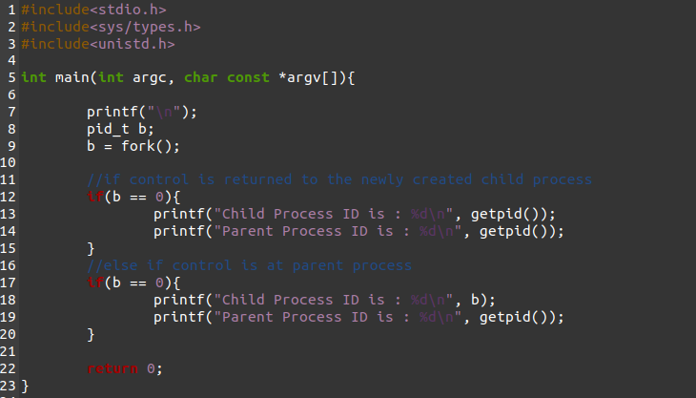

***Terminal***

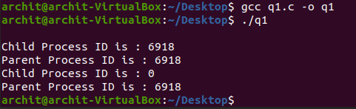

1. ***Write a C program to demonstrate the execl() system call for***

***(a) display the content of directory (command: ls)***

***(b) display the process tree (command: pstree).***

***Code (a)***

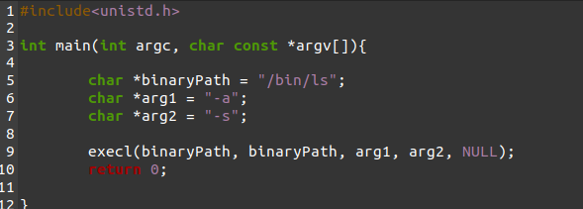

***Terminal(a)***

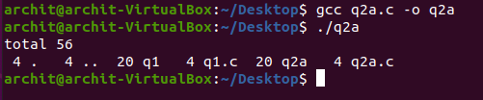

***Code (b)***

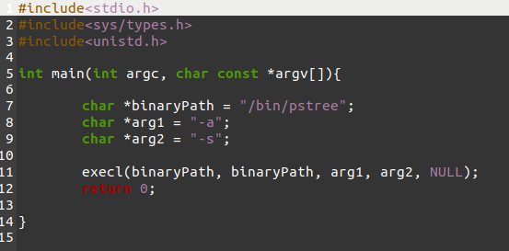

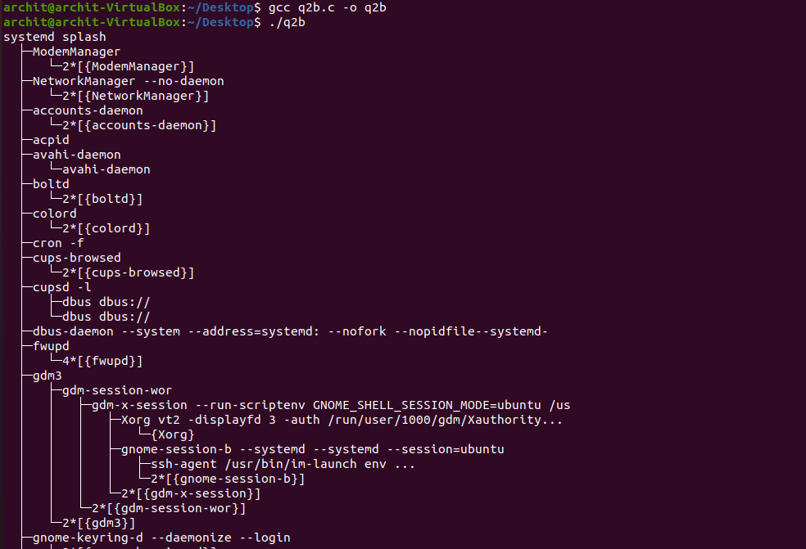***Terminal(b)***

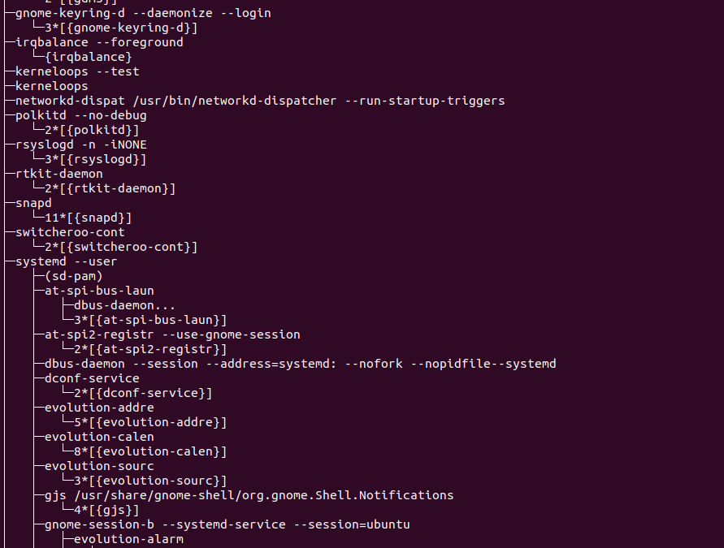

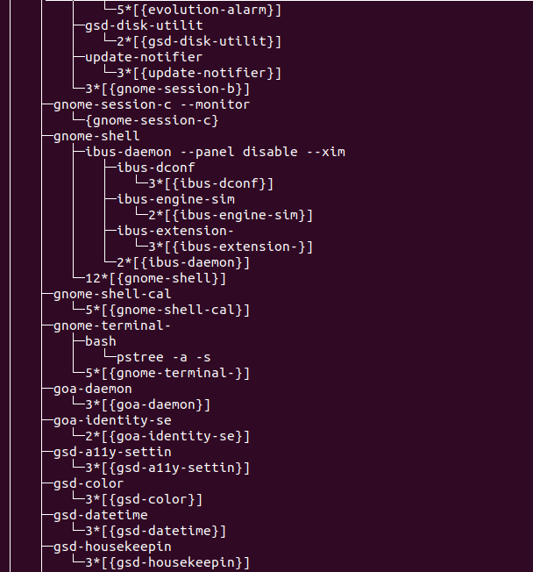

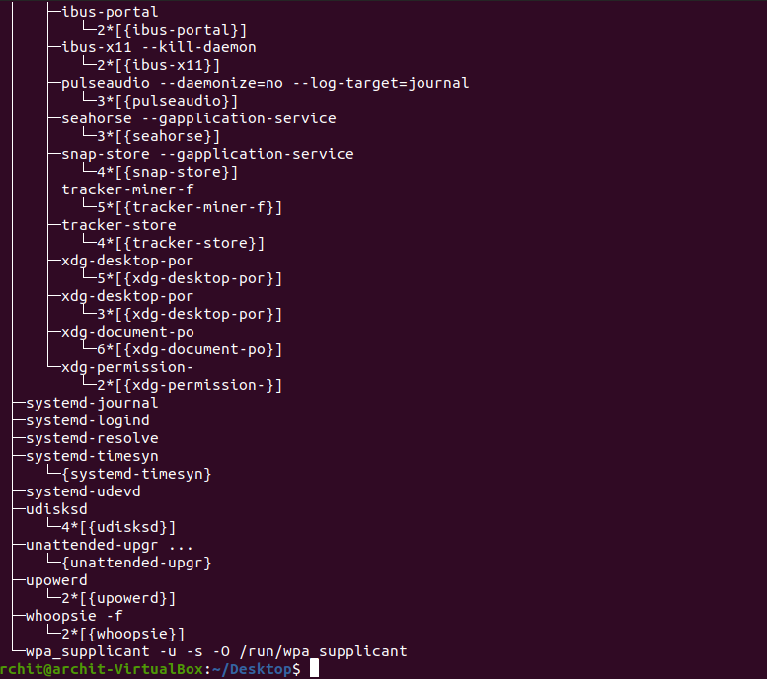

1. ***Write a C program to demonstrate wait and sleep system calls return the pid of the child that terminated.***

***Code***

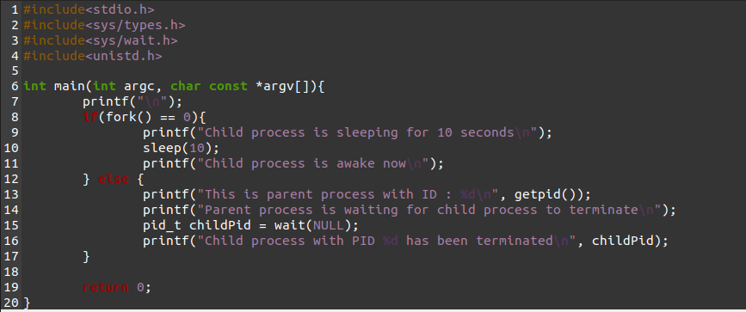

***Terminal***

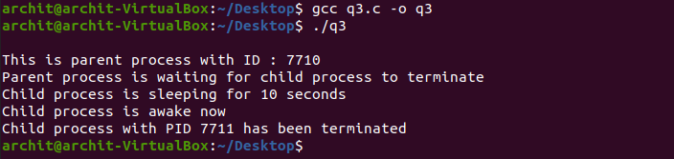

1. ***Write a C program to create the multiple processes using fork() and display the process IDs and their parent process IDs in hierarchy.***

***Code***

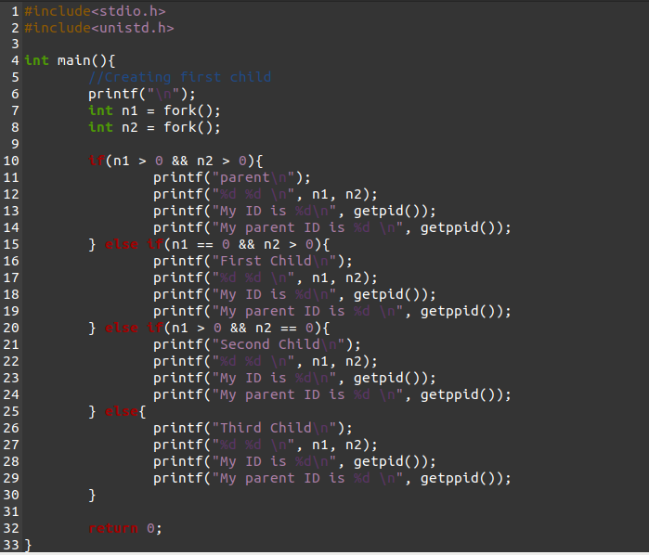

***Terminal***

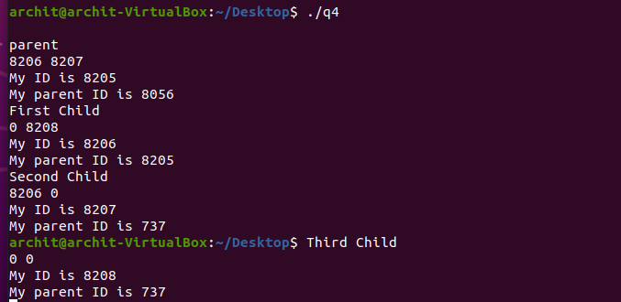

1. ***Write C program to display the directory content using readdir system call.***

***Code***

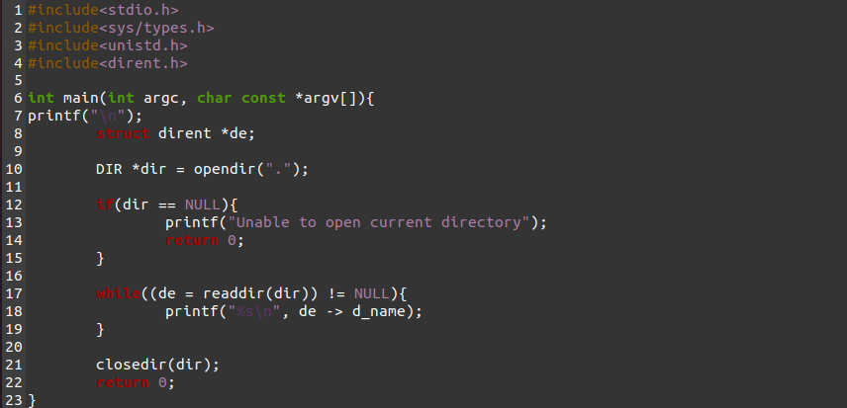

***Terminal***

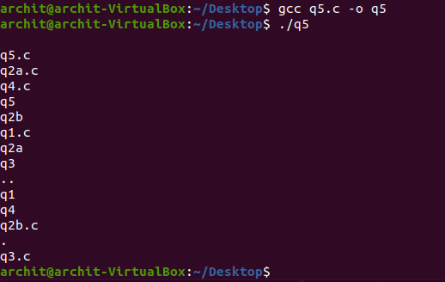

1. ***Write a c program to interrupt and terminate the current process using signal handlers. (use SIGINT i.e., Ctrl-C to interrupt and Ctrl-\to kill the process)***

***Code***

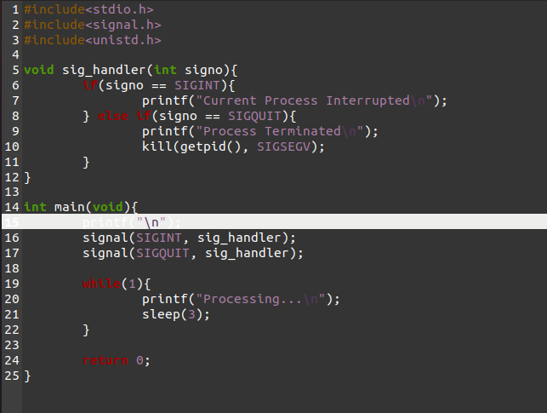

***Terminal***

