CS266 LAB 11

NAME:

ARCHIT AGRAWAL

ROLL NO. :

202051213

SECTION:

2

***Question***

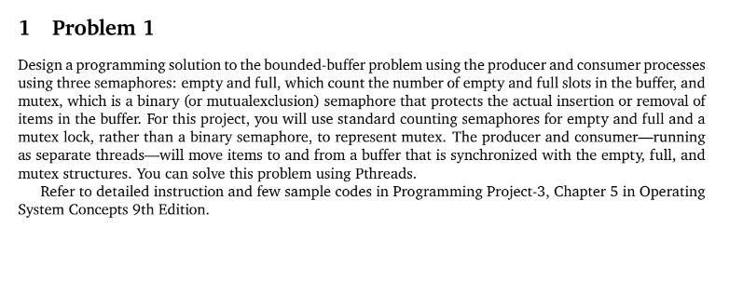

***Code***

#include <pthread.h>

#include <semaphore.h>

#include <stdlib.h>

#include <stdio.h>

#define MaxItems 5 // Maximum items a producer can produce or a consumer can consume

#define BufferSize 5 // Size of the buffer

/*

This program provides a possible solution for producer-consumer problem using mutex and semaphore.

*/

sem_t empty;

sem_t full;

int in = 0;

int out = 0;

int buffer[BufferSize];

pthread_mutex_t mutex;

void *producer(void *pno){

    int item;

    for(int i = 0; i < MaxItems; i++) {

        item = rand(); // Produce an random item

        sem_wait(&empty);

        pthread_mutex_lock(&mutex);

        buffer[in] = item;

        printf("Producer %d: Insert Item %d at %d\n", *((int *)pno),buffer[in],in);

        in = (in+1)%BufferSize;

        pthread_mutex_unlock(&mutex);

        sem_post(&full);

    }

}

void *consumer(void *cno){

    for(int i = 0; i < MaxItems; i++) {

        sem_wait(&full);

        pthread_mutex_lock(&mutex);

        int item = buffer[out];

        printf("Consumer %d: Remove Item %d from %d\n",*((int *)cno),item, out);

        out = (out+1)%BufferSize;

        pthread_mutex_unlock(&mutex);

        sem_post(&empty);

    }

}

int main(){

    int n;

    printf("Enter n (number of producers and consumers) : ");

    scanf("%d", &n);

    pthread_t pro[n],con[n];

    pthread_mutex_init(&mutex, NULL);

    sem_init(&empty,0,BufferSize);

    sem_init(&full,0,0);

    int a[n];

    for(int i = 0; i < n; i++){

        a[i] = i + 1;

    }

    for(int i = 0; i < n; i++) {

        pthread_create(&pro[i], NULL, (void *)producer, (void *)&a[i]);

    }

    for(int i = 0; i < n; i++) {

        pthread_create(&con[i], NULL, (void *)consumer, (void *)&a[i]);

    }

    for(int i = 0; i < n; i++) {

        pthread_join(pro[i], NULL);

    }

    for(int i = 0; i < n; i++) {

        pthread_join(con[i], NULL);

    }

    pthread_mutex_destroy(&mutex);

    sem_destroy(&empty);

    sem_destroy(&full);

    return 0;

}

***Output 1***

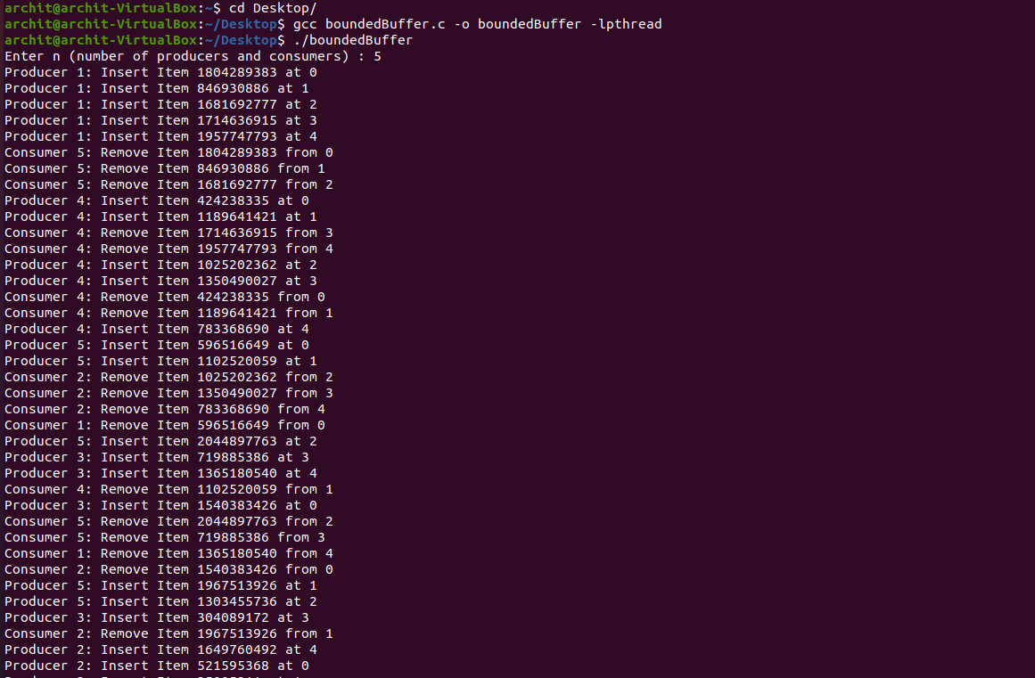

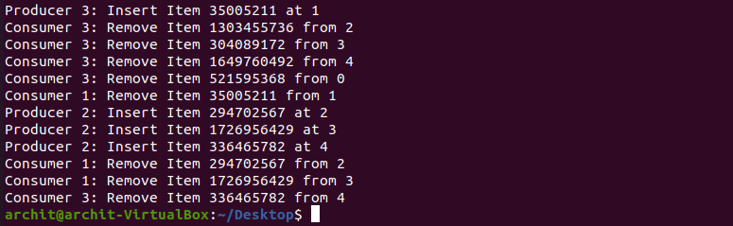

***Output 2***

