CS361

Laboratory 1

NAME:

ARCHIT AGRAWAL

ROLL NO. :

202051213

SECTION:

2B

1. **Write the differences between switch and hub?**

**Hub** is a networking device which is used to transmit the signal to each port (except one port) to respond from which the signal was received.

**Switch** is a network device which is used to enable the connection establishment and connection termination on the basis of need.

|  |  |
| --- | --- |
| ***Hub*** | ***Switch*** |
| Hub is operated on the Physical layer of the OSI model. | The switch is operated on the Data link layer of OSI Model. |
| Hub is a broadcast type transmission. | While switch is a Unicast, multicast and broadcast type transmission. |
| Hub cannot be used as a repeater. | The switch can be used as a repeater. |
| Hub is a half-duplex transmission mode. | Switch is a full duplex transmission mode. |

1. **Create a small network using a switch and show that the message transferred from one end device to other is successful.**

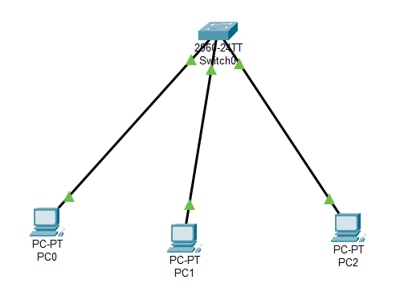

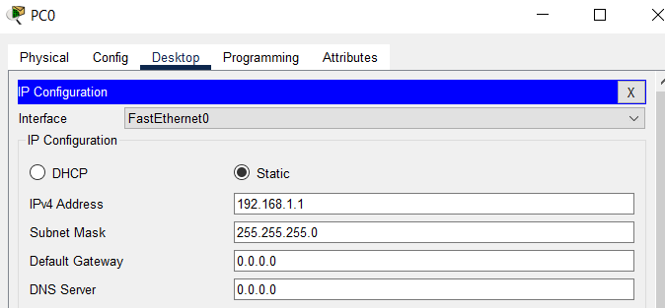

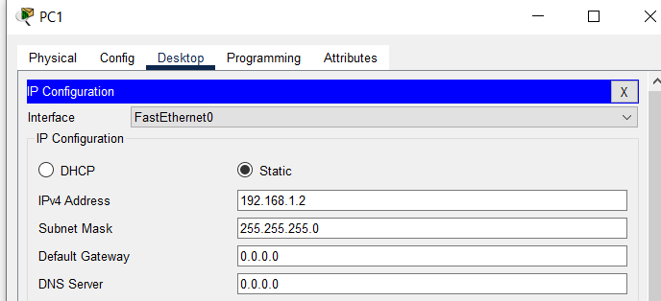

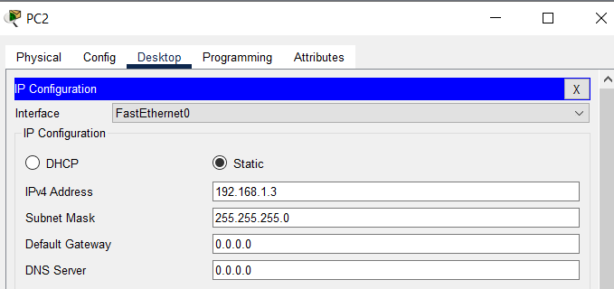

Switch can unicast, multicast and broadcast messages as it stores a MAC address table.

Using Simulation sending a message from PC0 to PC2.

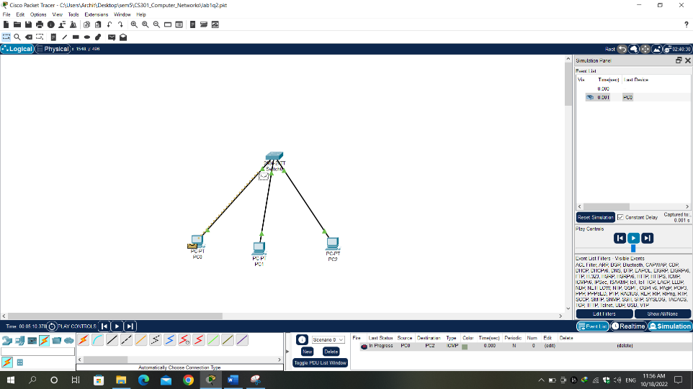

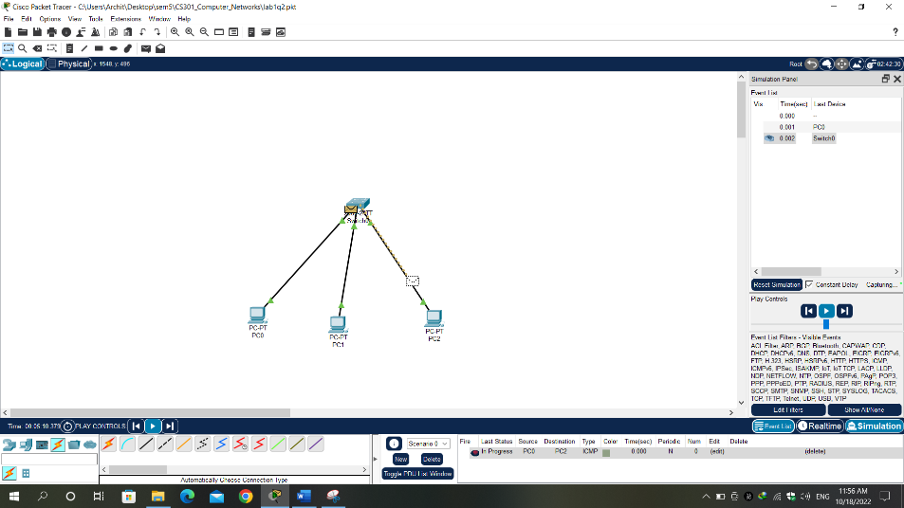

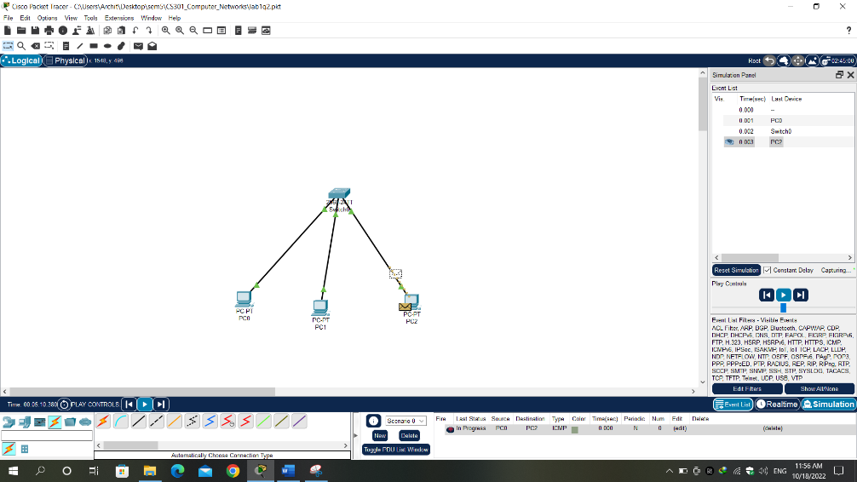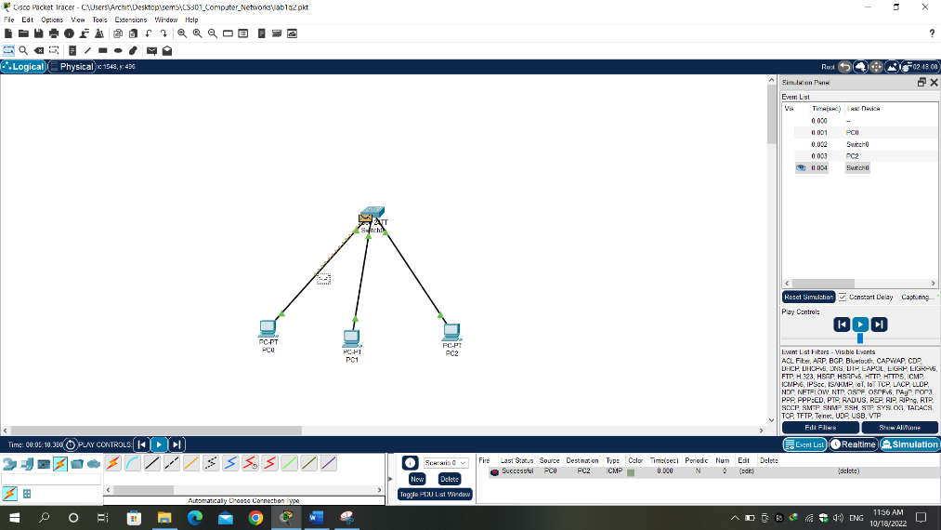

1. **Create a small network using a hub and show that the message transferred from one end device to other is successful**.

IP configuration is same as Q2.

Hubs broadcast each message.

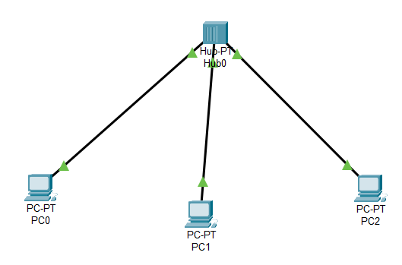

Using Simulation sending a message from PC0 to PC2.

