CS361

Laboratory 10

NAME:

ARCHIT AGRAWAL

ROLL NO. :

202051213

SECTION:

2B

1. **Create 3 different networks/site:**

* **Site 1 contain router, multiplayer switch & 4 switches. Each switch connects to minimum 4 PCs and One DNS server.**
* **Site 2 contains router, multilayer switch and connect 2 servers DNS and HTTP server.**
* **Site 3 contains router and a multilayer switch, two switches and each switch contain two PCs and one DNS servers.**
* **Finally connect 3 network sites each other.**

The network sites are shown below:

* Site 1

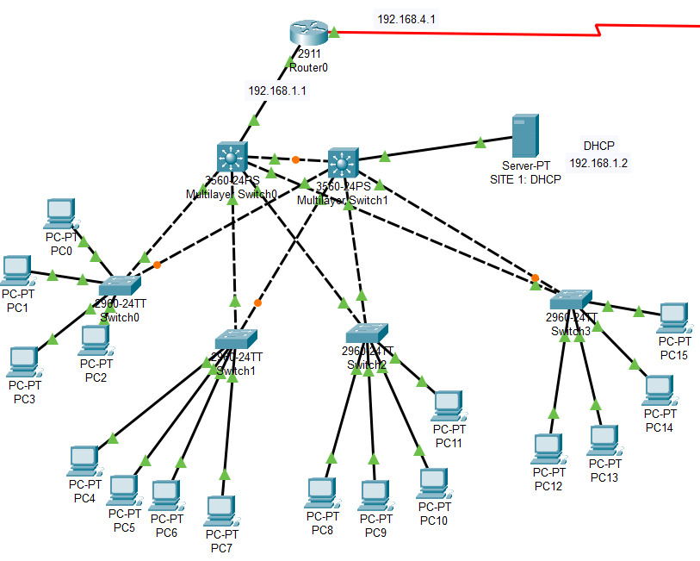

* Site 2

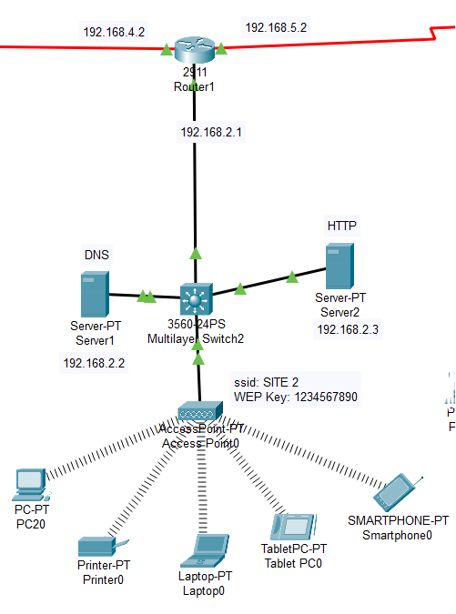

* Site 3

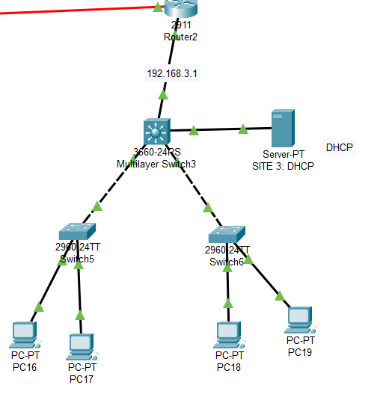

* The connection of the three sites.

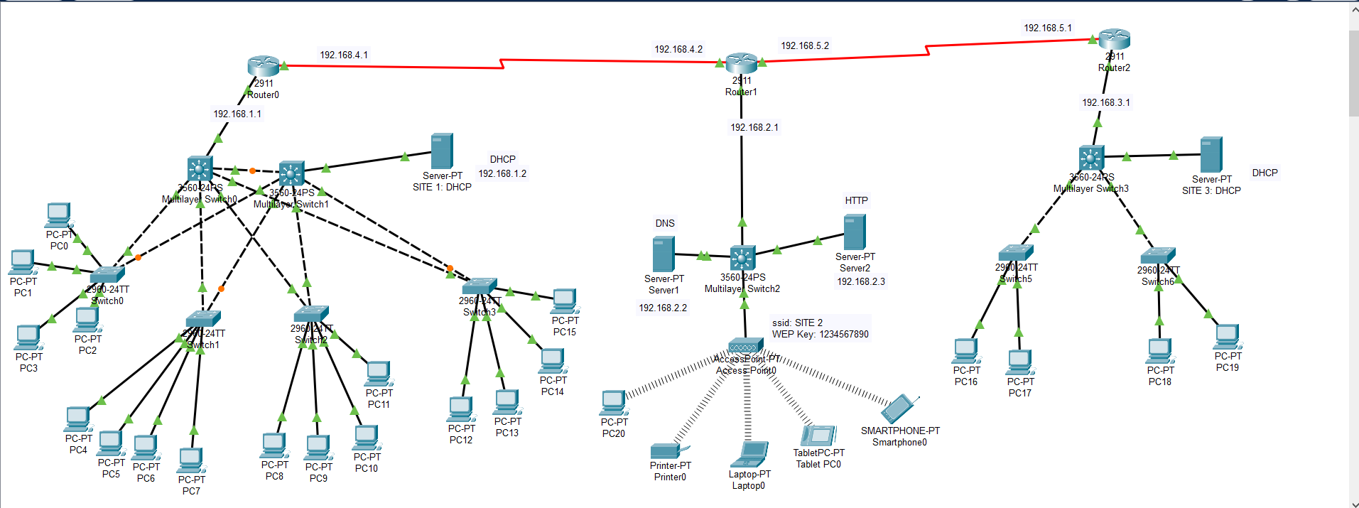

The configuration of the network is not shown as it was done in all previous labs and this lab is just a compilation of all the previous labs.

***RESULTS***

* Sending messages from SITE 1 to SITE 2.

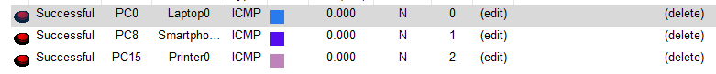

Check device labels to ensure the devices are in different sites.

* Sending messages from SITE 1 to SITE 3.



* Sending messages from SITE 2 to SITE 3.



* Opening website in SITE 1 to ensure HTTP and DNS Servers are working.

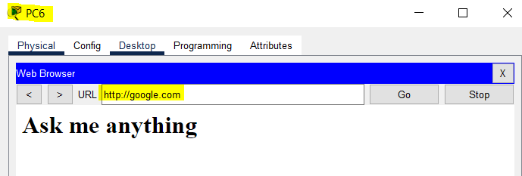

* Opening website in SITE 2 to ensure HTTP and DNS Servers are working.

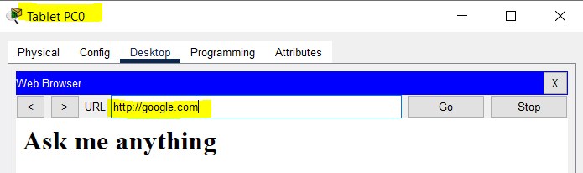

* Opening website in SITE 3 to ensure HTTP and DNS Servers are working.

