CS361

Laboratory 2

NAME:

ARCHIT AGRAWAL

ROLL NO. :

202051213

SECTION:

2B

1. **What is a router and how it functions?**

A router is a device that connects two or more packet-switched networks or subnetworks. It serves two primary functions: managing traffic between these networks by forwarding data packets to their intended IP addresses, and allowing multiple devices to use the same Internet connection.

**Working**: In order to direct packets effectively, a router uses an internal routing table — a list of paths to various network destinations. The router reads a packet's header to determine where it is going, then consults the routing table to figure out the most efficient path to that destination. It then forwards the packet to the next network in the path.

1. **Create a small network using a switch and show that the message transferred from one end device to other is successful.**

***Steps in creating the network:***

1. Create two LAN’s with different IPv4 address formats.

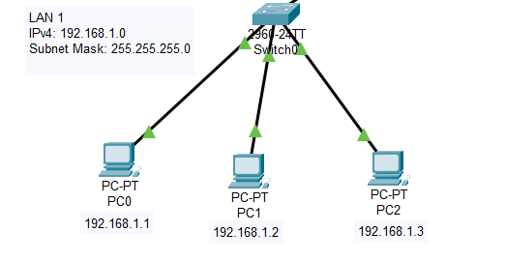

. 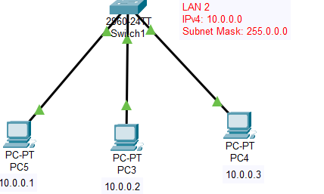

As you can see, LAN1 uses IPv4 addresses of 192.168.1.0 format where the subnet mask is 255.255.255.0, while the LAN2 uses IPv4 addresses of 10.0.0.0 format where the subnet mask is 255.0.0.0.

Check if messages are transferred within LAN or not. Select a PC, go to its command prompt and ping another IPv4 of same LAN.

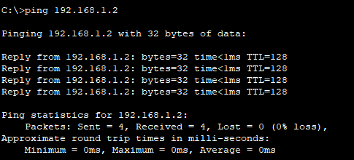

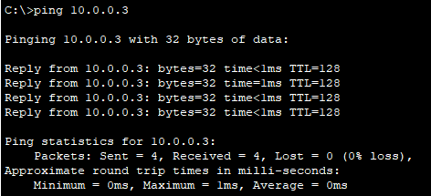

This indicates that LAN are setup successfully (using switches).

1. Select a router and turn it on, then connect the switches of both the LAN’s to the router and provide the router with the interfaces to connect the two LAN’s.

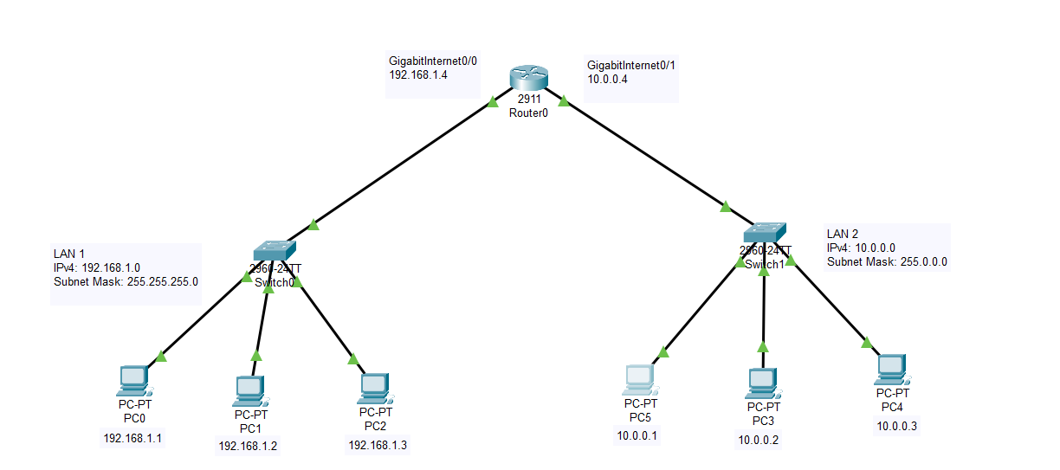

1. Now, since router has 192.168.1.4 interface on LAN1 side and 10.0.0.4 interface on LAN2 side, set the default gateway of each PC in LAN1 to 192.168.1.4 and to 10.0.0.4 for each PC in LAN2.

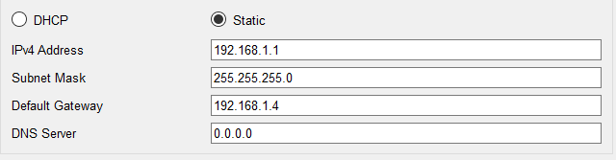

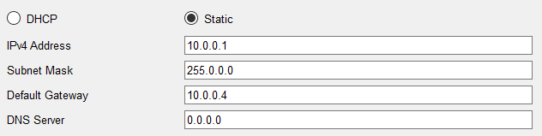

1. Now, select a source and a destination across LAN’s.

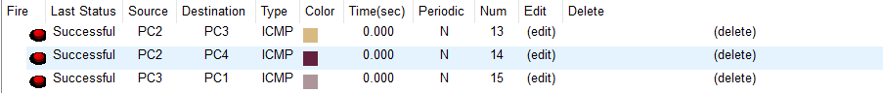



The successful status indicates that the message transfer was successful.

1. We can trace the packets movement using simulation.
2. Message from source reaches switch0.

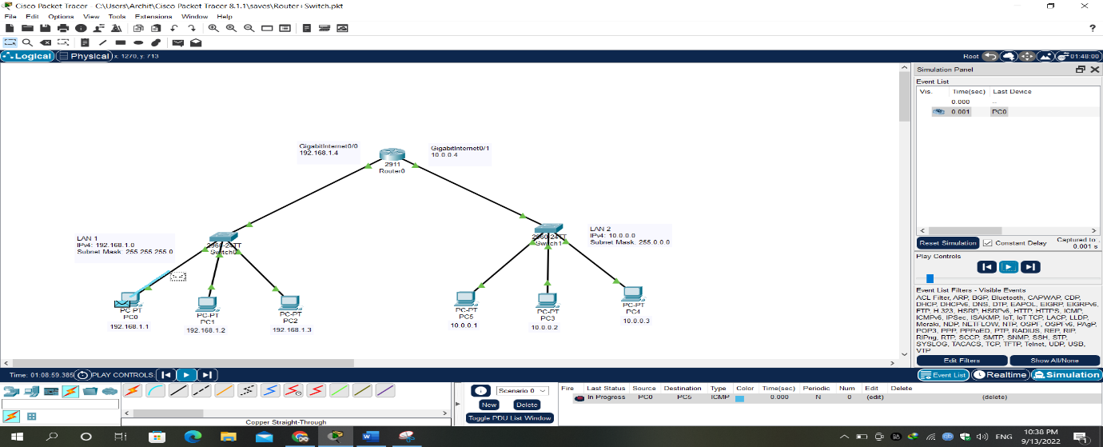

1. Message from switch reaches router. Since, the IPv4 address of destination does not matches with the IPv4 format of LAN, switch transmits the message to router.

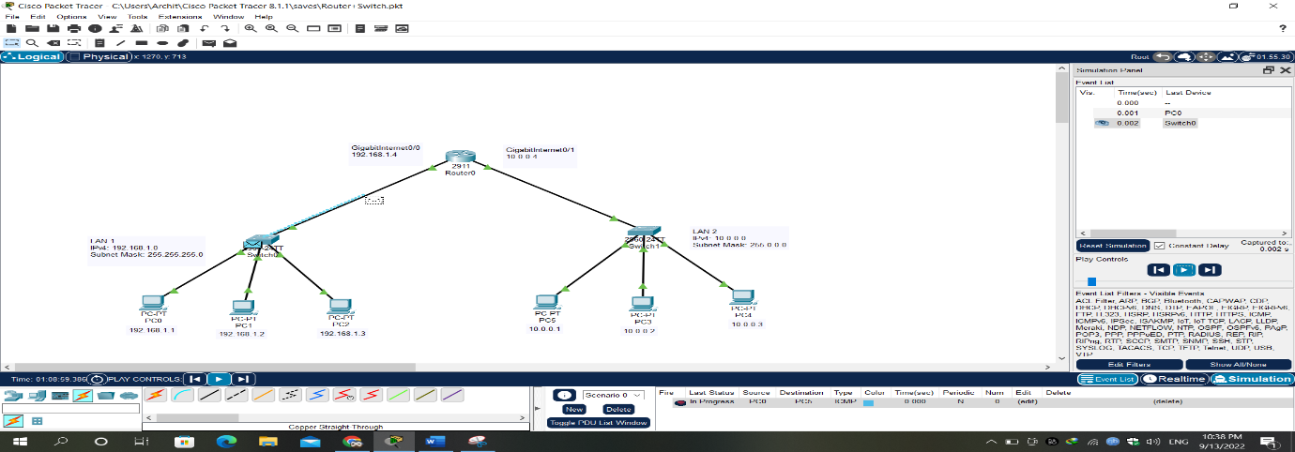

1. Router transmits the message to switch of other LAN.

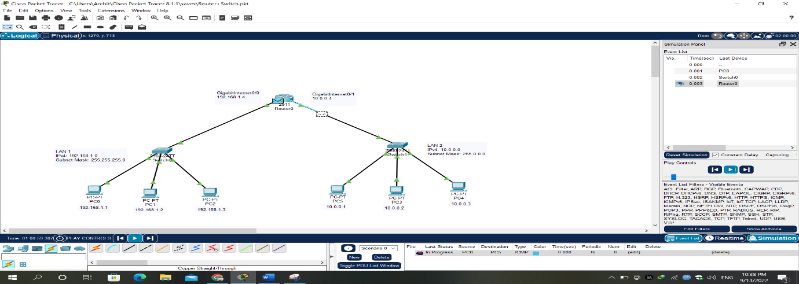

1. Switch1 unicasts the message to the destination PC.

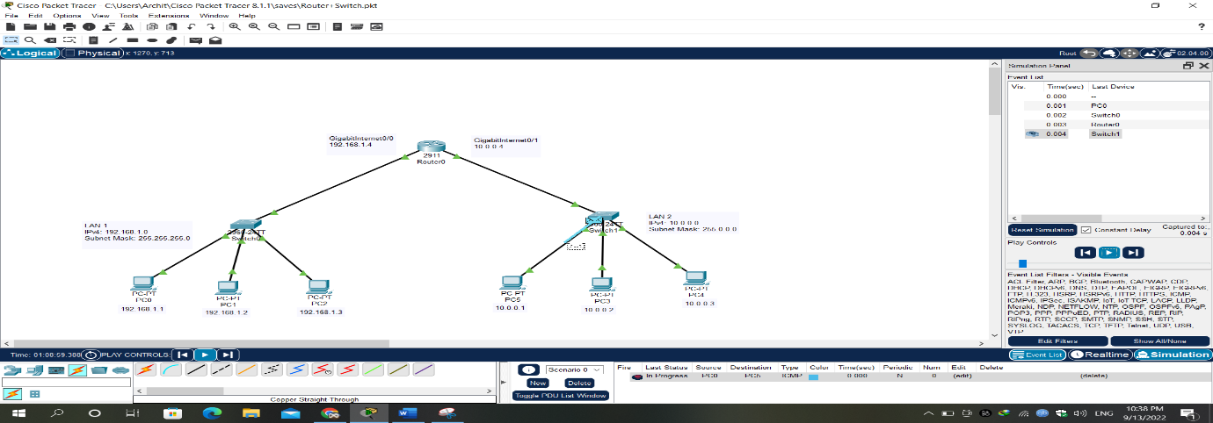

1. Destination PC generates a response and transmit it to switch.

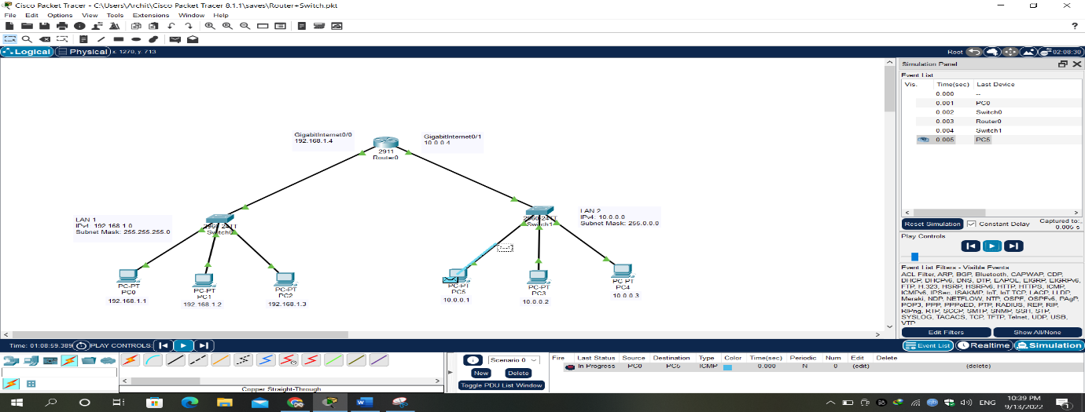

1. Since, switch does not find the destination address of response in the LAN2, it transmits the message to router.

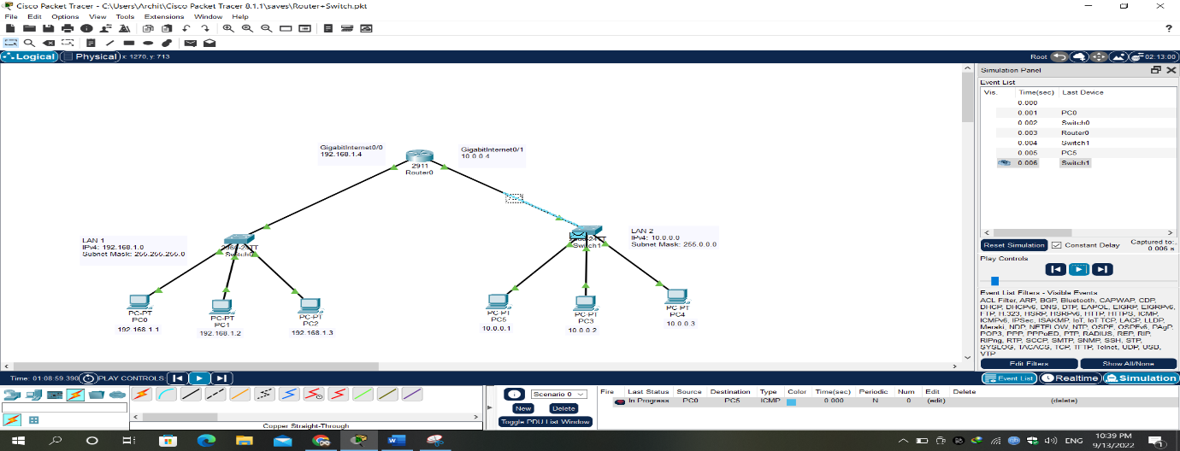

1. The router transmits the message to switch of LAN1.

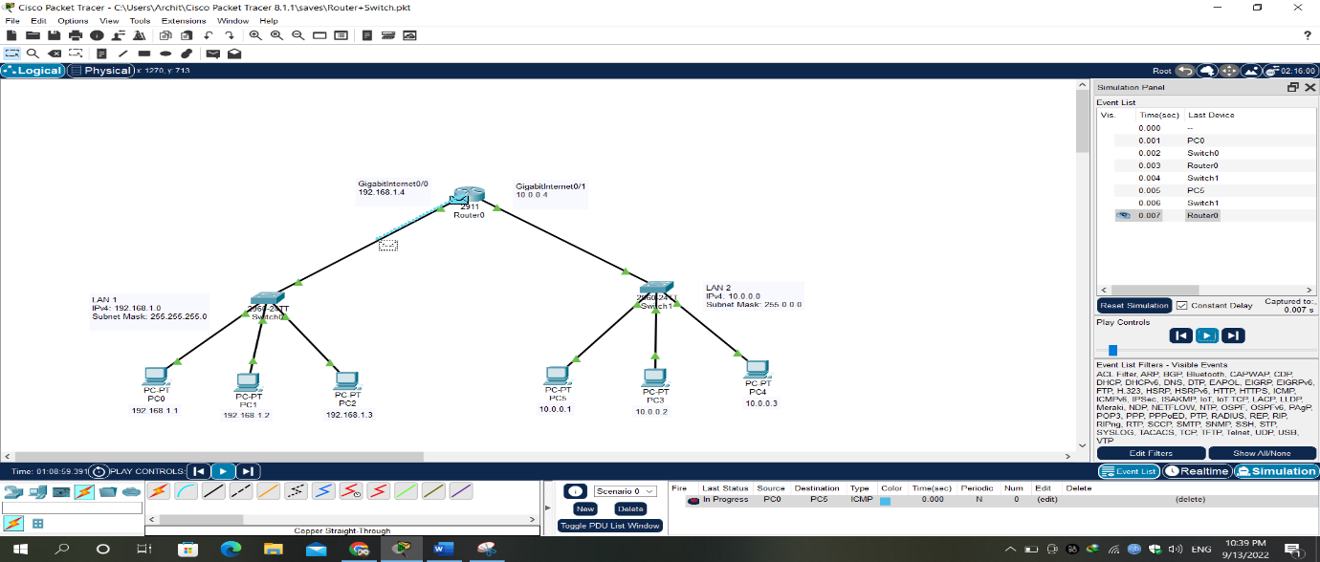

1. The switch transmits the message to the original source, which is also the destination of the response message.

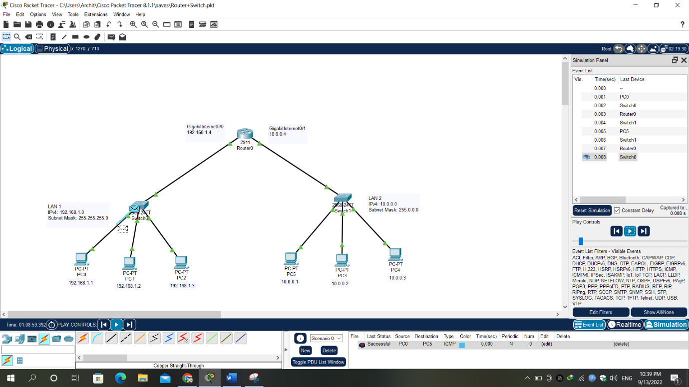

1. The source recieves the response and acknowledges it.

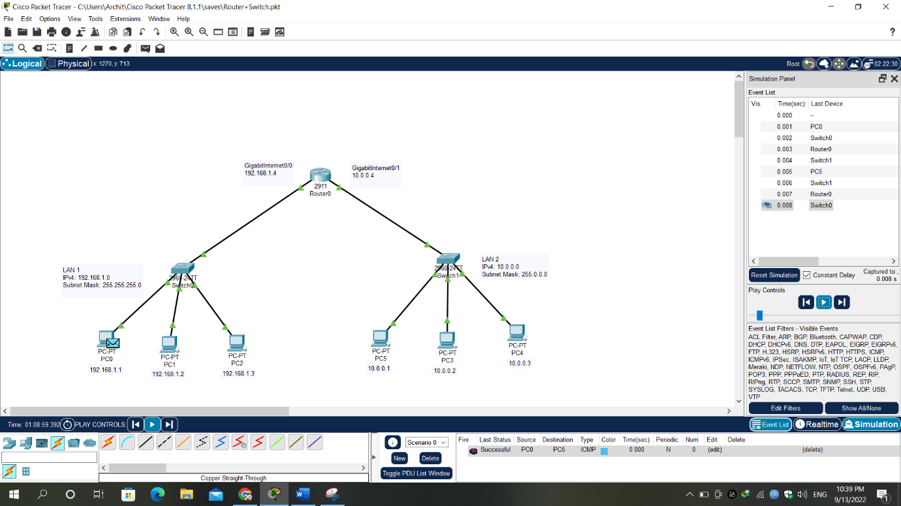

1. **Create a small network using a hub and show that the message transferred from one end device to other is successful.**

The steps involved are similar to the question 2, but now we are just using a hub instead of a switch.

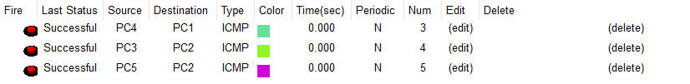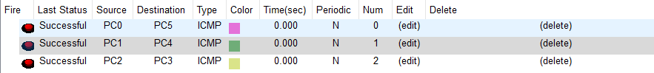

Trace the packets using simulation mode.

1. Source generates a message.

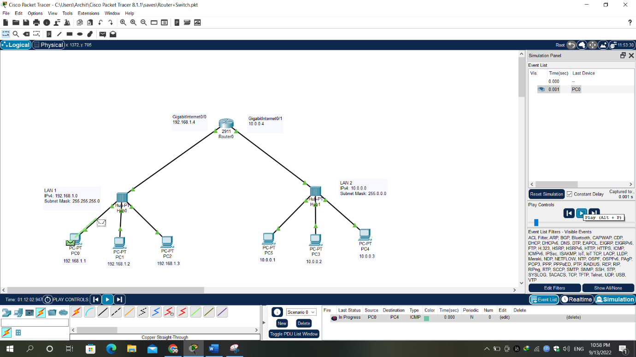

1. Packets are received by the hub, the hub broadcasts it to all the other PC’s and router (unlike Switch).

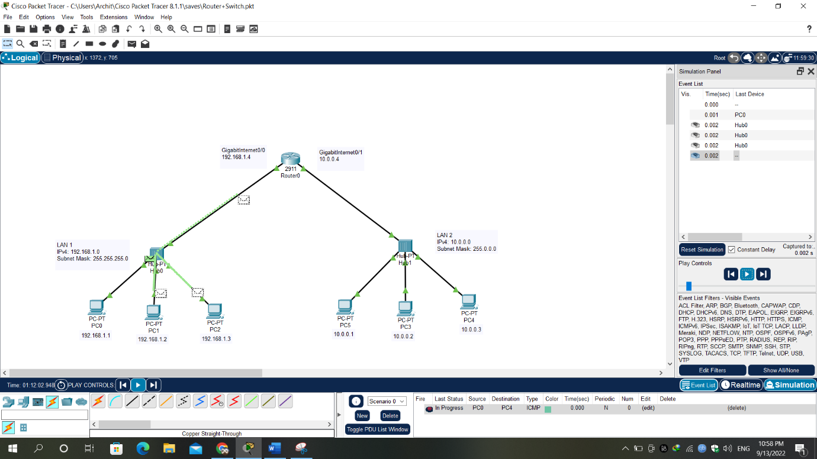

1. The other PC’s do not accept the message but the router transmits the message further.

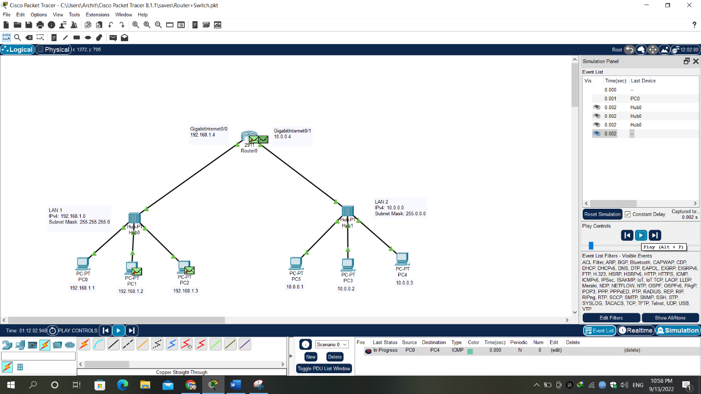

Everything else is similar to the situation in Question 2. Just that, whenever a hub receives a message, it broadcasts it to all other devices in the network, unlike switch which can either unicast, multicast or broadcast the message.

Finally, all the PC’s in LAN1 receive the acknowledgement sent by the original destination, but only the sender accepts it.

