CS361

Laboratory 3

NAME:

ARCHIT AGRAWAL

ROLL NO. :

202051213

SECTION:

2B

1. **What cable types are available?**

The most common type of cables that are used in networking are:

* **Co-axial Cables**: A single conductor is used in the centre of a coaxial cable. The dielectric, a type of insulator, surrounds the central conductor. Around the dielectric is placed a conductive shield. This shield serves as the circuit's second conductor and shields the inner conductor from outside interference. The whole cable is covered and protected by a plastic cover.

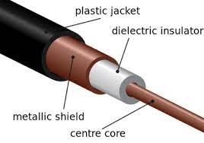

* **Twisted Pair Cables:** These are copper cables or wires that have been twisted into pairs. One wire is utilised for data transmission while the other wire serves as ground. These are twisted together such that they run parallel to one another. The most frequent issue with these cables is noise interference, but it can be solved by increasing the number of turns in each foot of twisted pair wire.

There are two types of Twisted-Pair cables:

* + 1. Unshielded Twisted Pair Cables (UTP): UTP cables are the most common twisted pair cables that are used in computer networks as well as in telecommunication. These cables are made up of 4 color-coded copper wires twisted together to cancel the disturbances from outer sources and the electromagnetic interference. Each pair has one solid colour and one stripped colour wire. Solid coloured wires are blue, brown, green, and orange. In stripped coloured wire, the solid colour is mixed with the white colour. This cable is also known as Ethernet cable.

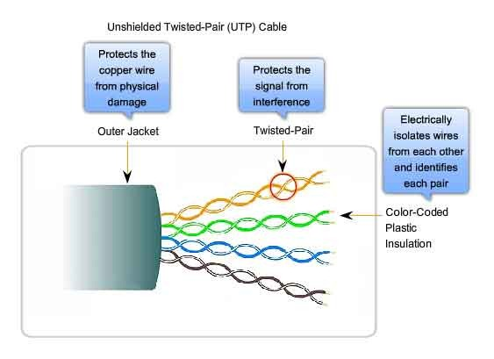

* + 1. Shielded Twisted Pair Cables (STP): Shielded twisted pair cables are more expensive than UTP cables and often constructed of insulated conductors and metal foil. Metal foils aid in enhancing the wire's quality, which would otherwise suffer from noise. These wires are used to lessen electromagnetic wave interference and crosstalk.

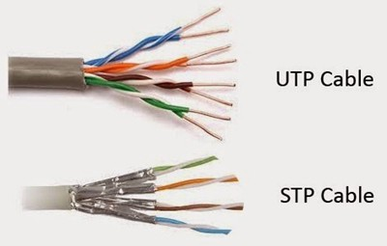

* **Fiber Optic Cables:** This cable consists of a core, cladding, buffer and jacket. The core is made from thin strands of glass or plastic that can carry data over a long distance. The core is wrapped in the cladding; the cladding is wrapped in the buffer, and the buffer is wrapped in the jacket. These are thin pipes made up of glass or plastic known as optic fibers and data or information flows via light in these cables. With higher bandwidth and high-quality performance optic fiber cables are best suited for long-distance data transfer and communication.

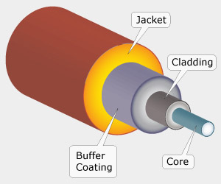

1. **How do cables work?**

The different types of cables discussed above works in different ways. The working of each type of cable is described below:

* **Co-axial Cables:** Copper wires are used in coaxial cables to carry higher frequency signals. When current flows through these wires, an insulated foil cover keeps a constant distance between the conductor and the next layer; next, a shielded wire prevents noise interference between transmissions; and finally, a plastic cover shields the entire cable from outside disturbances. Therefore, a coaxial cable transmits a signal so that when the current enters the metal shield and the centre copper wire, a magnetic field is produced at that location by the metal conductors. The insulators aid in preventing interference between the signals and also shield them from magnetic fields outside.
* **Twisted Pair Cables:** The twisted pair cable has an outer jacket that keeps the wires together, shield for protection of cable, and color-coded plastic insulation to uniquely identify each conductor, and twisting of wires to cancel the electromagnetic waves that create noise interferences during the transmission of data. When current flows through the cable then a small circular magnetic field is created around the wire. For the connection between two devices connectors are needed at both ends like RJ45 for computer connection.
* **Fiber Optic Cables:** Fiber optic cables carry information via light so at the transmitting side the light source is first encoded with data or information and then the data starts flowing in the core of the fiber optic cable in a complete bouncing manner with a complete internal reflection then there is cladding that helps the light to remain inside the cable after reaching the receiver side the data is then decoded like the original. So basically, fiber optic is a form of transmission media for the transfer of data via light with higher bandwidth and a higher rate of transmission.

1. **How are cables used in networking?**

The ways in which the cables are used in networking are mentioned below:

* You should use a crossover cable when you want to connect two devices of the same type.
* You should use straight-through cable when you want to connect two devices of different types.
* Fiber optic cable has the ability to transmit signals over much longer distances than coaxial and twisted pair. It also has the capability to carry information at vastly greater speeds. This capacity broadens communication possibilities to include services such as video conferencing and interactive services. It also provides higher bandwidth.
* In telecommunications and computer industry where there is significant electromagnetic interference (EMI) from external sources such as other devices using electromagnetic waves for data propagation, ‘Unshielded Twisted Pair Cables’ are preferred as they have conductors from a single circuit twisted around each other to cancel EMI.
* For long distance connections between networking devices ‘Coaxial Cables’ are preferred as they are highly resistant to signal obstruction (though difficult to install) and support a bandwidth of moderate range.

1. **How are connections made?**

The steps for connections are listed as follows

* Strip 1 – 1½” of insulating sheath
* Sort wires by insulation colours
* Arrange Wires
  + 1. TIA/EIA 568A: GW-G OW-Bl BlW-O BrW-Br
    2. TIA/EIA 568B: OW-O GW-Bl BlW-G BrW-Br
* Trim all wires evenly. Leave about ½” of wires exposed.
* Maintain wire order left to right with RJ45 facing downwards
* Check the wires are extending to the end or not and is the sheath well inside the connector.
* Squeeze firmly to crimp connector on to cable end.
* Use a tester to check if the cable works or not.