CS361

Laboratory 4

NAME:

ARCHIT AGRAWAL

ROLL NO. :

202051213

SECTION:

2B

1. **Make a small network with a few PCs, one web server, a switch, and a router (just to give an idea of how to assign a default gateway). Make sure that all the devices are connected (use straight-through cables as we are connecting different devices). Create a web page that should contain your name and your roll number.**

The network is shown below.

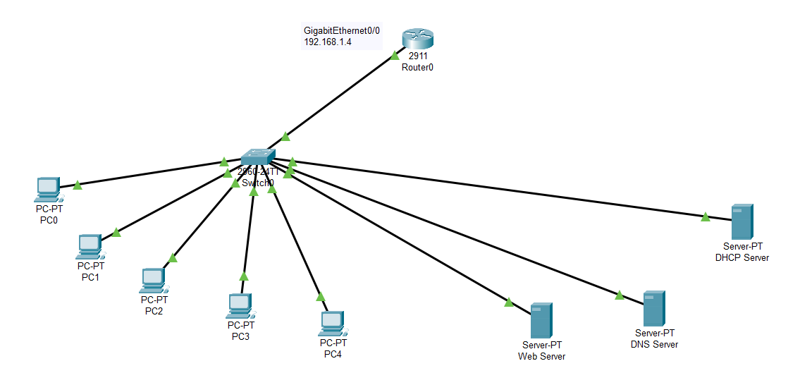

* Configure DHCP Server.

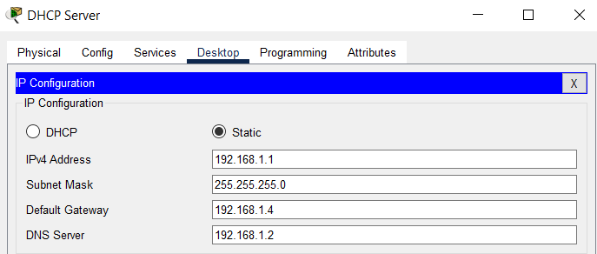

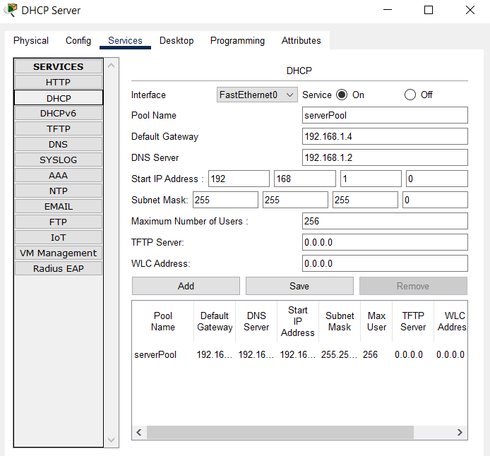

* Configure DNS Server

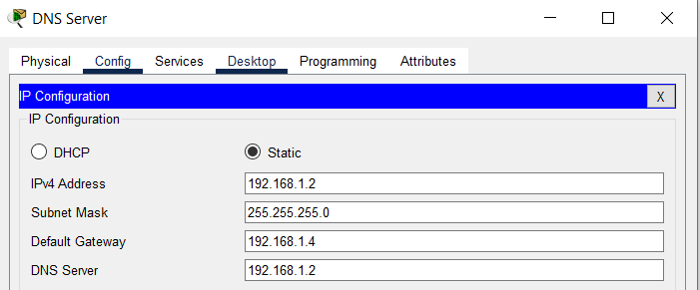

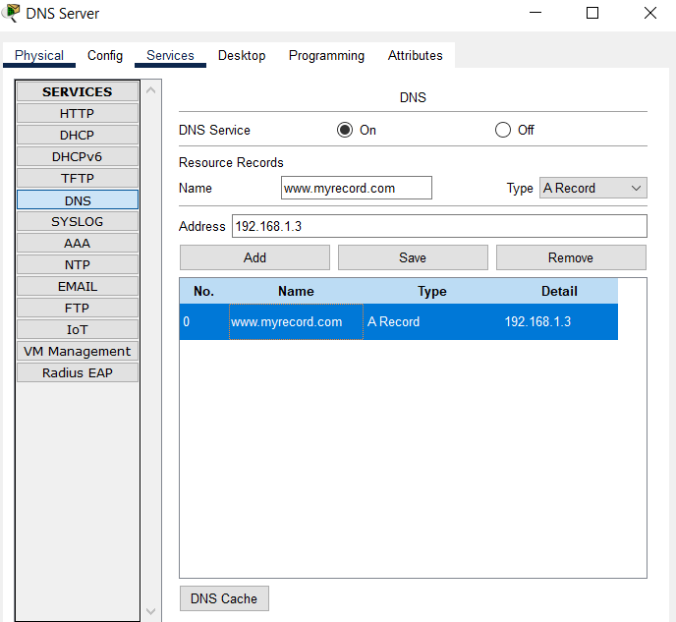

* Configure Web Server

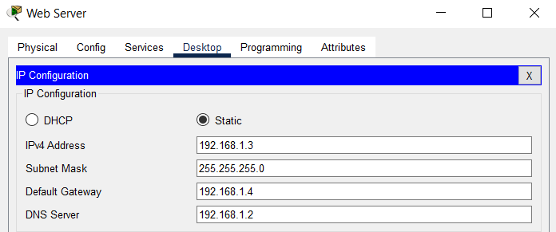

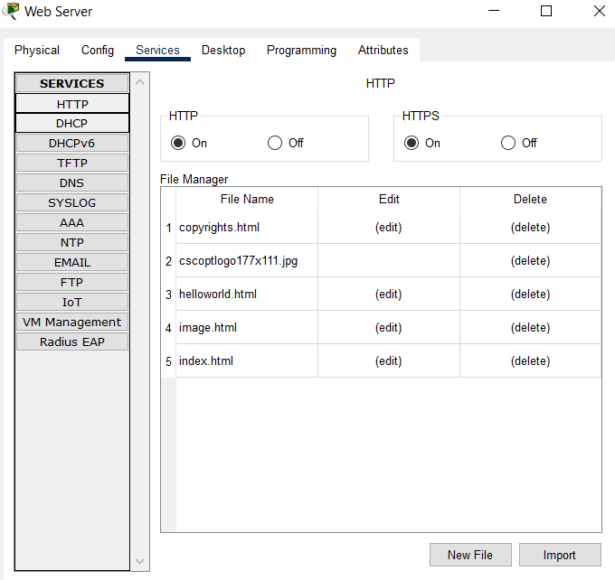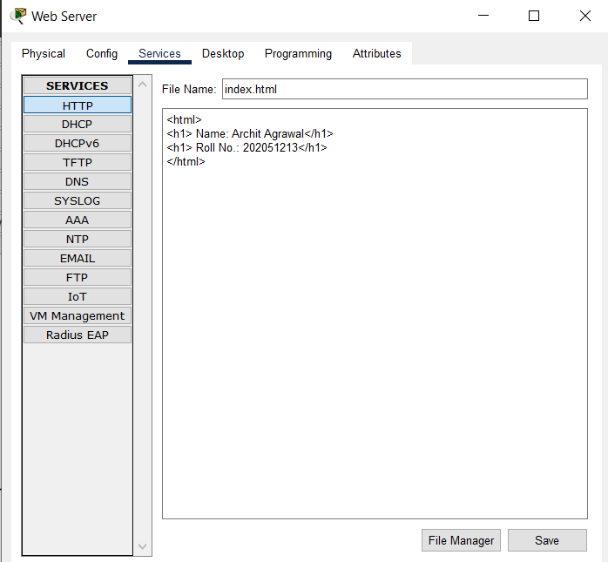

* Go to each PC’s IP configuration and set it to DHCP, rather than Static. The DHCP server will take care of the IP configuration for the PC.

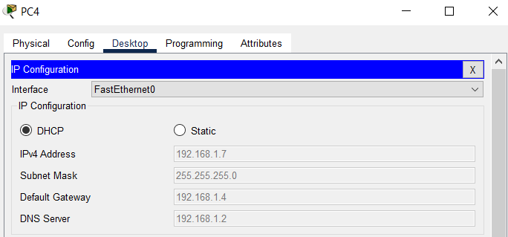

* Go to any PC, and open the Web Browser from desktop. Enter either the IP address of the web server (192.168.1.3) or the name assigned to this web server’s IP address in DNS server ([www.myrecord.com](http://www.myrecord.com)).

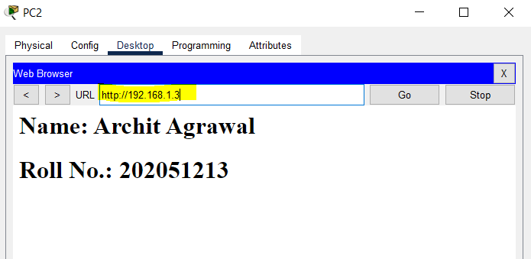

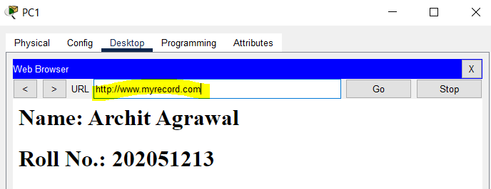

1. **Make a complex network having at least two different network addresses. You can use many PCs, switches, and routers. Again, create a web page through a PC. Note that this time the PC used to display the web page should be connected to another network address than a web server.**

The network is shown below.

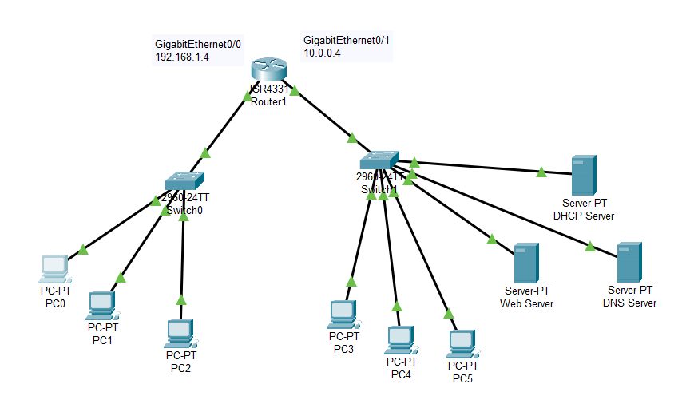

* Configure DHCP server, web server and DNS server as done in question 1.
* Configure the router, connect switch0 to GigabitEthernet0/0 interface and switch1 to GigabitEthernet0/1 interface.
* Now, go to each PC’s IP configuration and change it to DHCP from static. The IP configuration of each PC will be managed by DHCP server.

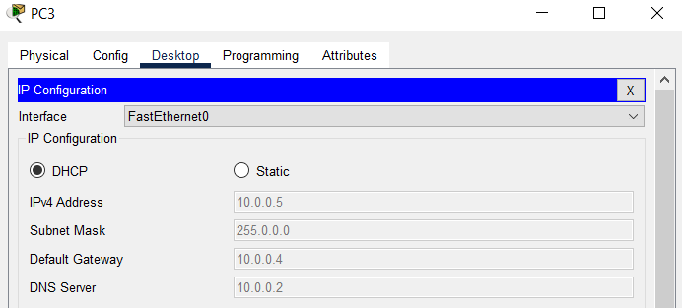

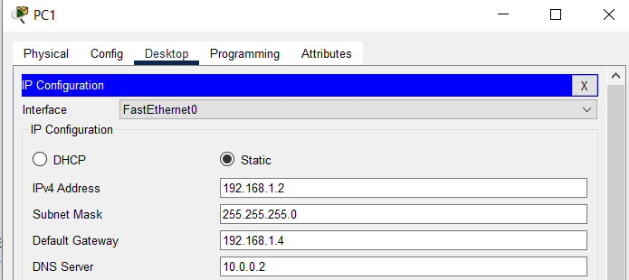

* Go to any PC, and open the Web Browser from desktop. Enter either the IP address of the web server (10.0.0.3) or the name assigned to this web server’s IP address in DNS server ([www.myrecord.com](http://www.myrecord.com)).

