CS361

Laboratory 5

NAME:

ARCHIT AGRAWAL

ROLL NO. :

202051213

SECTION:

2B

1. **Design a small network using a PC, switch, and router; send mail from one PC to another using a server.**

The network is shown below.

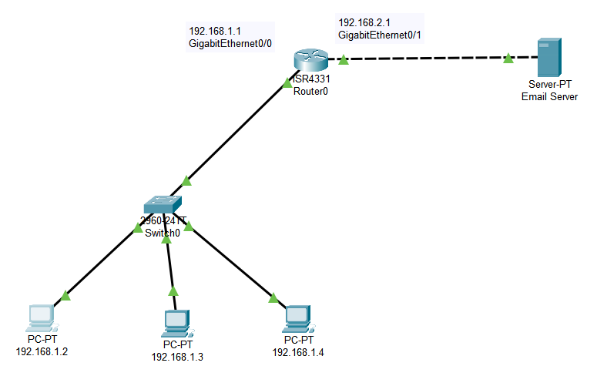

* Configure Email Server.

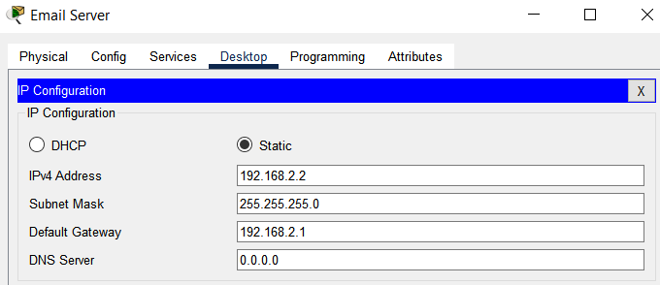

* Go to Services 🡪 Email. Set a domain name and add users.

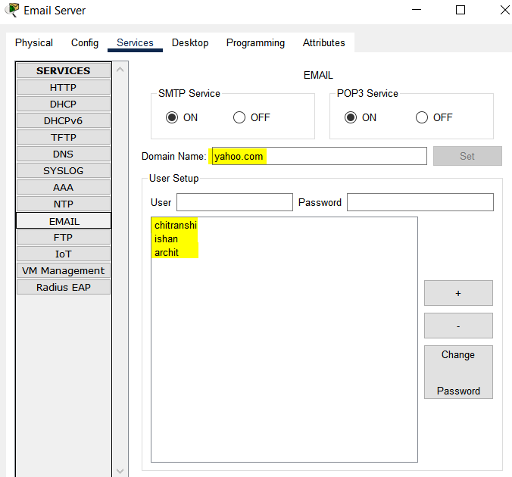

* Create a LAN and configure the router and PC’s.

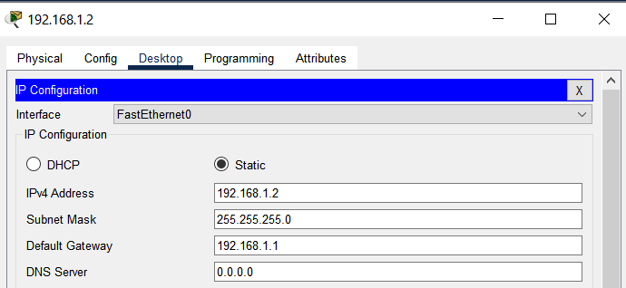

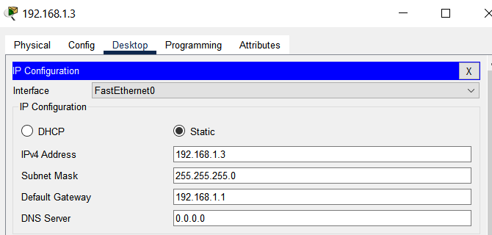

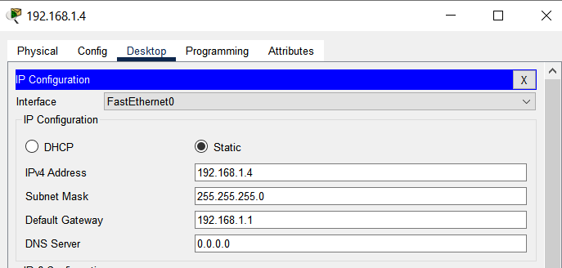

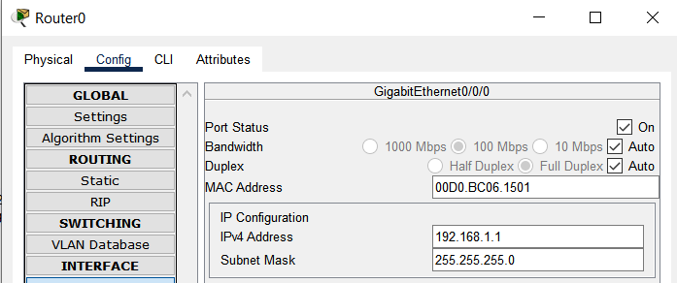

* Configure Email Services at each PC.

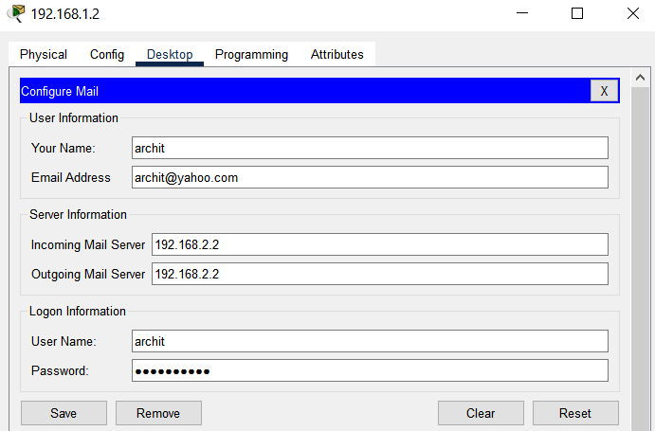

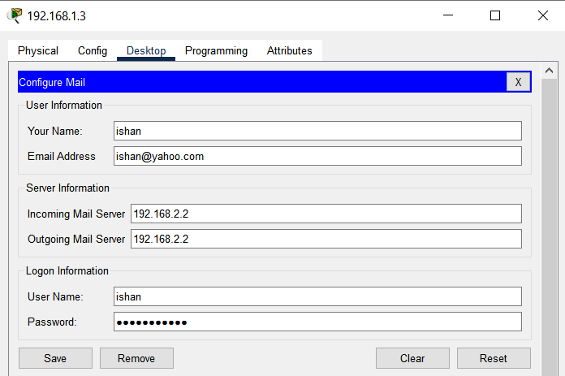

* Send and Receive from PC to PC. Go to PC from which mail is to be sent and click on ‘Compose’ and write the email and click on send.

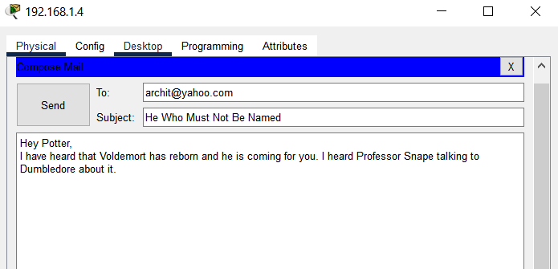

Go to the PC on which email is sent. Go to Email on Desktop and click on receive. You will see the received emails there.

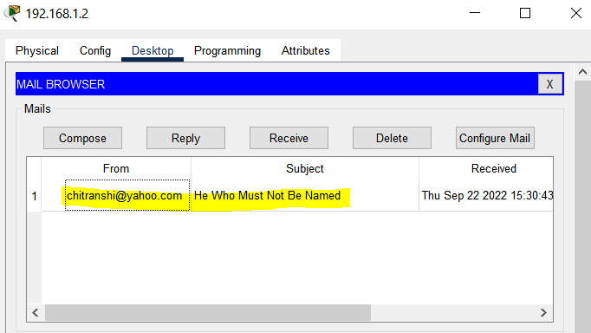

1. **Design a complex network with at least two different addresses (the network diagram shown in the laboratory). You can use many PCs, switches, and routers. Note that the PC used for sending and receiving mail should be connected to other network addresses this time.**

The network is shown below.

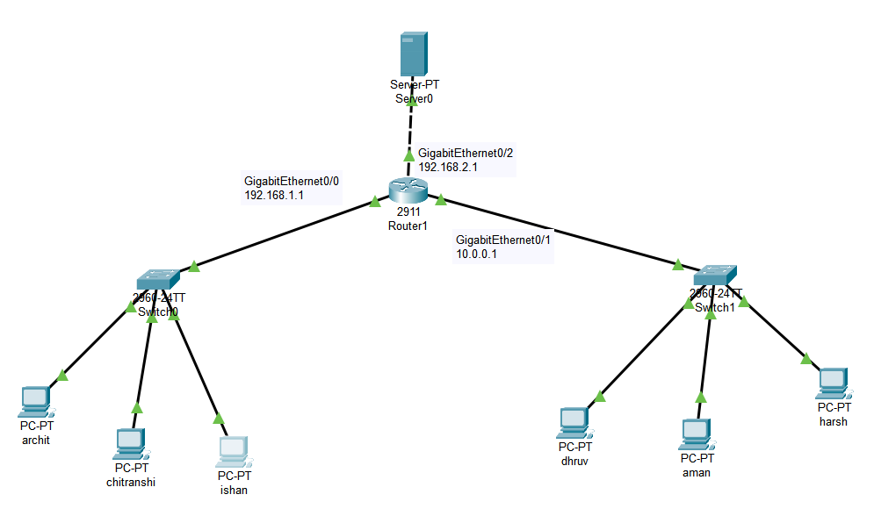

* Configure Email Server as done in question 1.
* Create two LAN’s and configure the router and PC’s.
* Configure Email Services at each PC as done in problem 1.
* Send emails from a PC in one LAN (archit) to a PC in other LAN (harsh) and from a PC in one LAN (chitranshi) to a PC in same LAN (ishan)

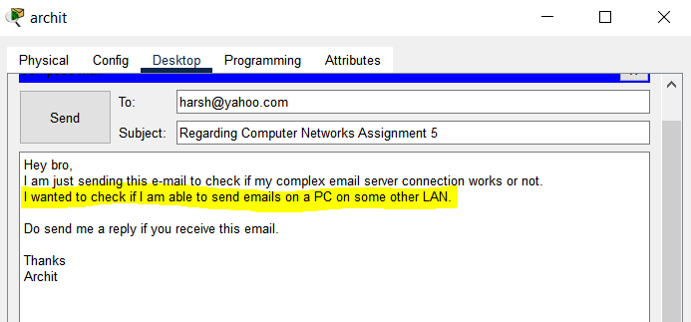

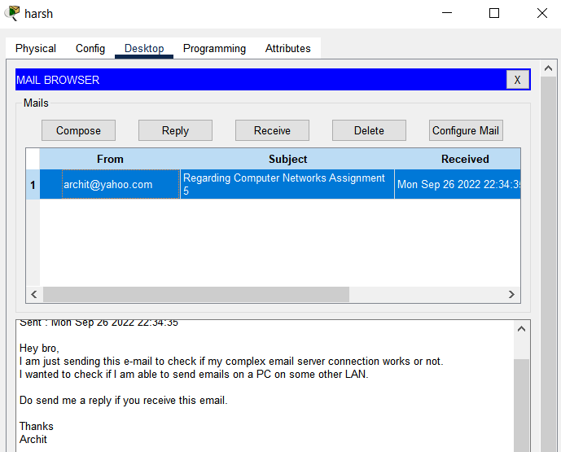

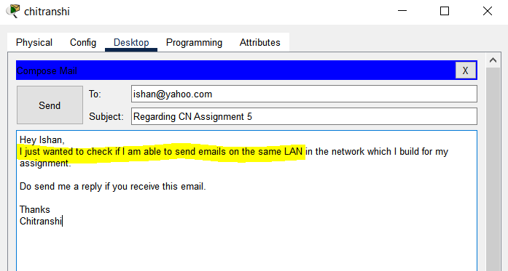

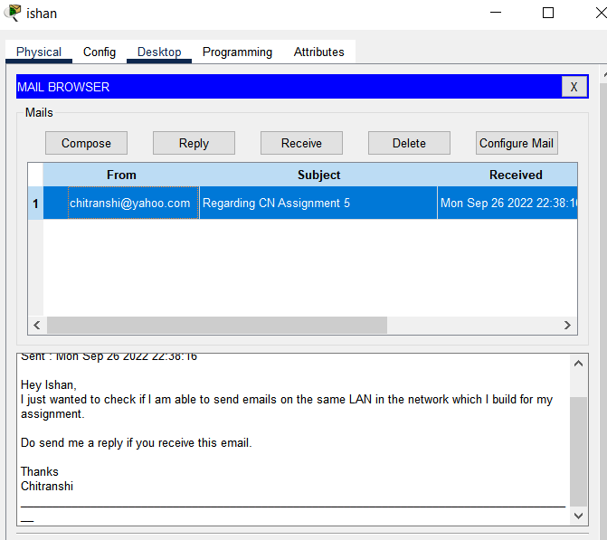

1. **Why do we use cross-over wire to connect a router and a server/PC?**

To permit communication between devices without the use of a hub or switch, a cross-over cable is connected differently than a straight through cable. Typically, a hub or switch will do some "crossing" while connecting devices to it. A crossover cable is used to facilitate connections between just two devices since direct communication is made possible by crossing some wires. The use of crossover wires is eliminated by modern networking equipment (network interface cards, switches, routers, etc.) having a function called auto mdi-x that automatically detects and configures the pin assignment to allow communication. With most current equipment, you can stop worrying about procuring a crossover cable