CS361

Laboratory 6

NAME:

ARCHIT AGRAWAL

ROLL NO. :

202051213

SECTION:

2B

1. **Make a network and transfer messages from one PC to another as demonstrated in the lab.**

The network is shown below.

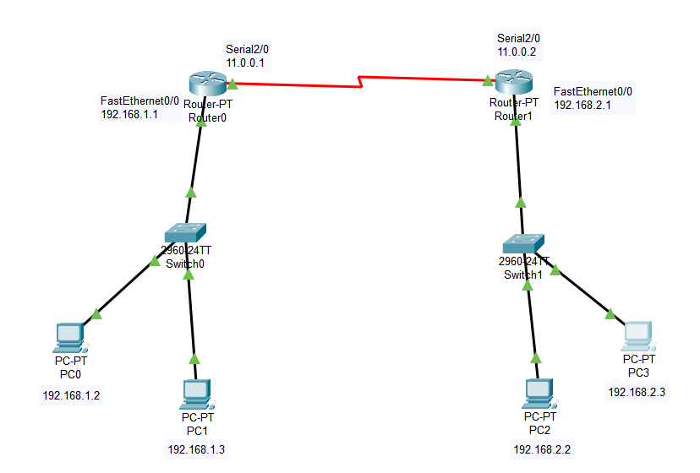

* Configure the IP for each PC.

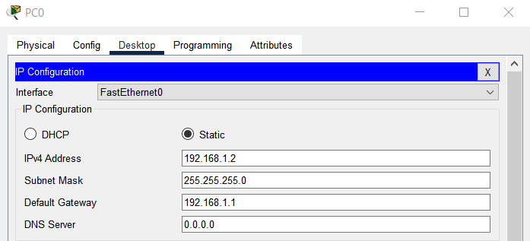

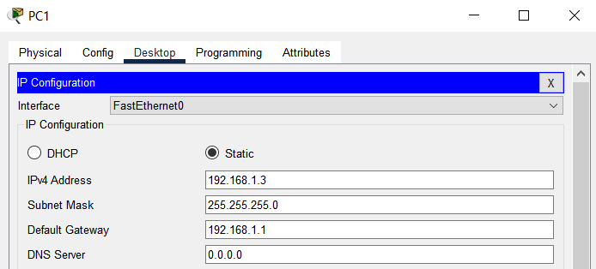

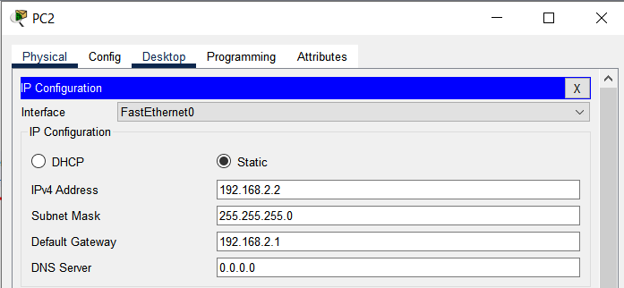

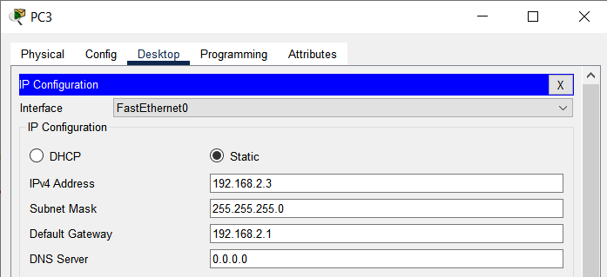

* Configure the routers for router – LAN connection. Go to router 🡪 Config 🡪 FastEthernet0/0.

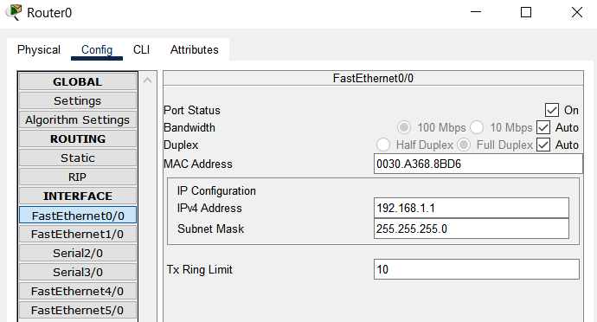

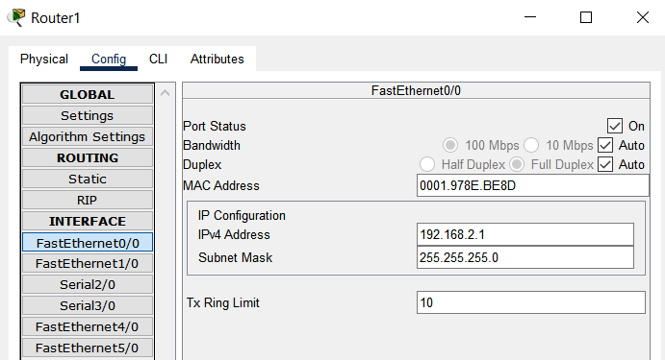

* Configure the routers for router – router connection. Go to router 🡪 Config 🡪 Serial2/0.

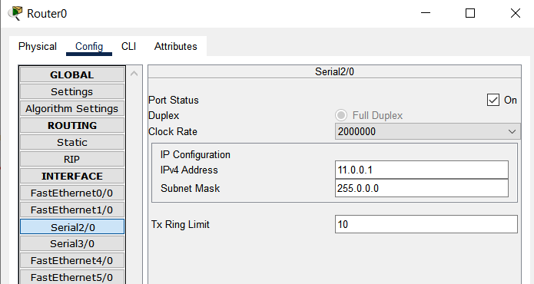

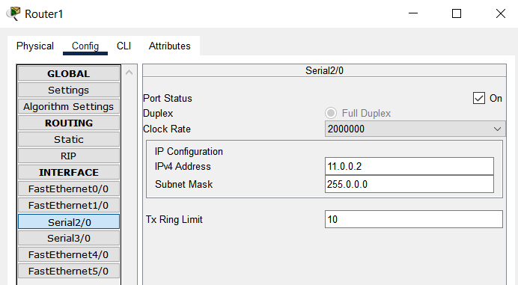

* Now go to Router0 🡪 Config 🡪 Static (in Routing) and update the routing table manually.

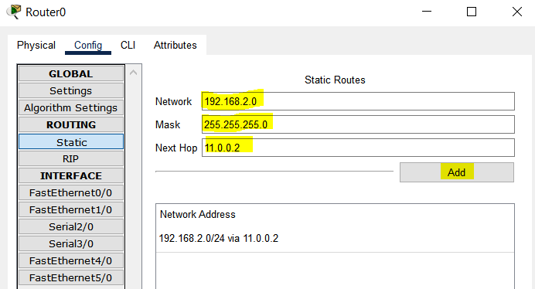

Do the same for Router1.

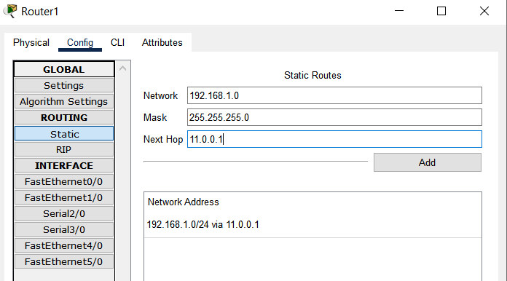

* Now, send messages from and to PC’s across network.

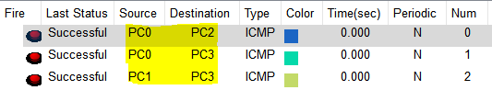

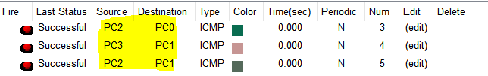

1. **Connect a server to the network designed in the previous problem and transfer mail between pcs or open a web page.**

The network is shown below.

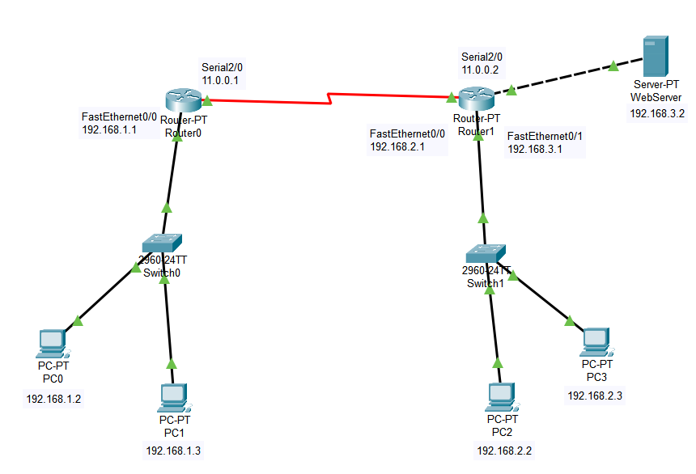

* The IP configuration of each PC and router is similar to that done in the first problem. Just the IP configuration of server is shown here.

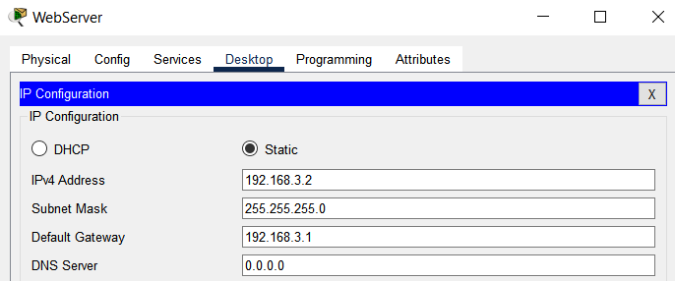

* We created a web server, hence, to use it we need to configure the HTTP services. Go to Server 🡪 Services 🡪 HTTP 🡪 index.html 🡪 edit

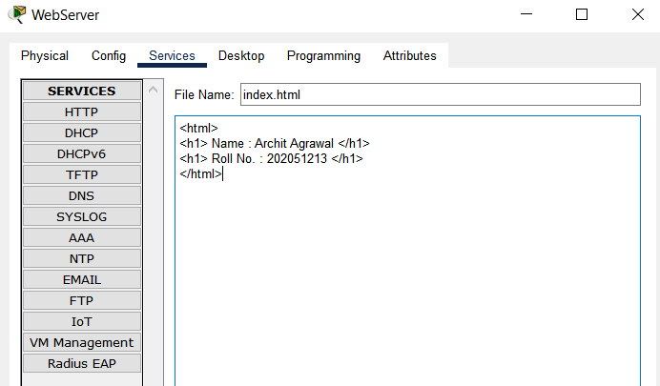

Click ‘Save’ after writing the above html in the editor. Make sure the HTTP service is turned on.

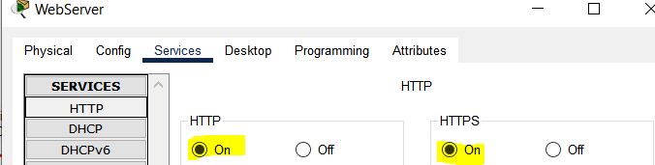

* Since the server is connected to Router1 in FastEthernet1/0 port, we need to configure the FastEthernet1/0 port for Router1.

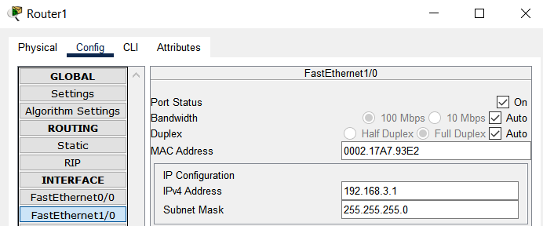

* Also, the routing table of Router0 has to be updated for connection with the web server.

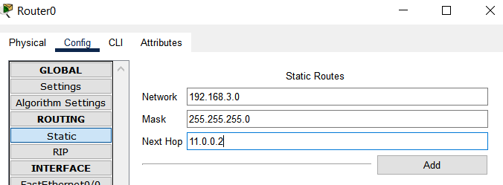

* Now, we can go to browser of any PC and hit the IP address of the web server to see the webpage (index.html).

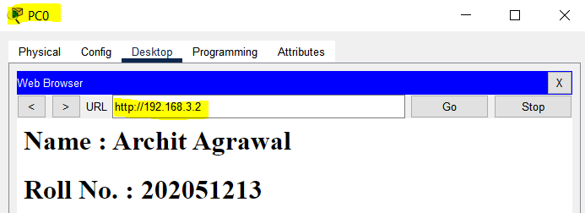

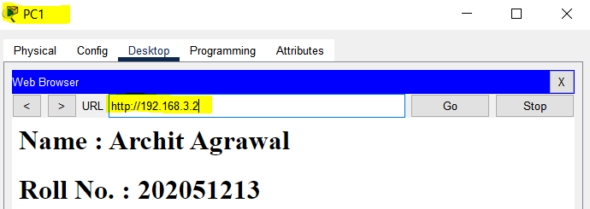

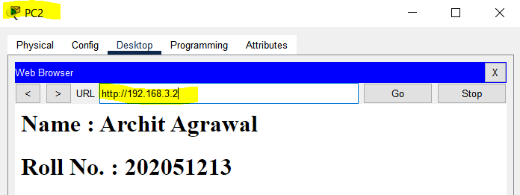

1. **Create a complex network using three or more routers and transfer messages from one network to another.**

The network is shown below.

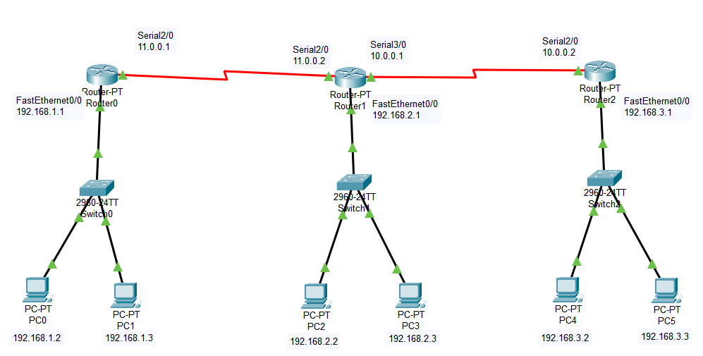

* The IP configuration of each PC and router is similar to that done in the first problem.
* Configure the Router0 for Router0-Router1 connection. Go to Router0 🡪 Config 🡪 Serial2/0.

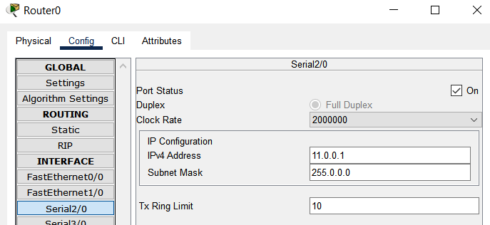

* Configure the Router1 for Router0-Router1 connection. Go to Router1 🡪 Config 🡪 Serial2/0.

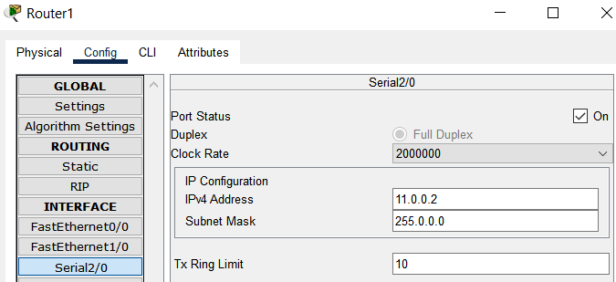

* Configure the Router1 for Router1-Router2 connection. Go to Router1 🡪 Config 🡪 Serial3/0.

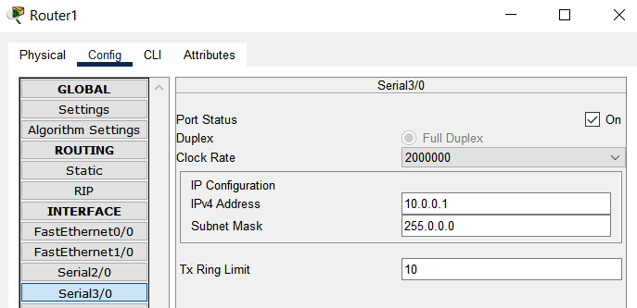

* Configure the Router2 for Router1-Router2 connection. Go to Router2 🡪 Config 🡪 Serial2/0.

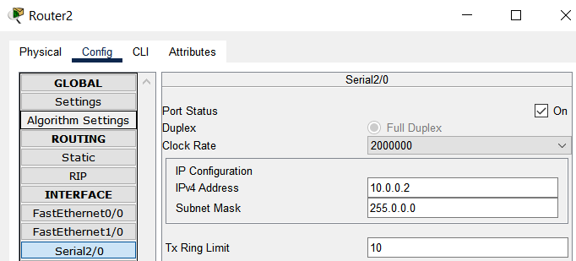

* Now, we need to add the networks in each router’s routing table. Go to Router 🡪 Config 🡪 Static (in Routing) and update the routing table manually.

***For Router0***:

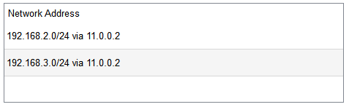

***For Router1***:

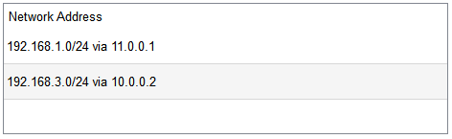

***For Router2***:

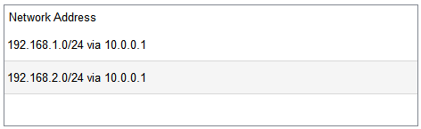

* Now, we can check by sending messages from PC’s on one network to PC’s on other networks.

