CS361

Laboratory 7

NAME:

ARCHIT AGRAWAL

ROLL NO. :

202051213

SECTION:

2B

1. **Define and differentiate between a server and a router.**

A **server** is a computer **program or a device** that provides functionality for called clients which are other programs or devices. Servers can provide various functionalities called services. These services include **sharing data or resources** among multiple clients, or performing computation for a client. It accepts and responds to requests made over a network.

Routers are networking devices operating at layer 3 or a network layer of the OSI model. They are responsible for receiving, analysing, and forwarding data packets among the connected computer networks. When a data packet arrives, the router inspects the destination address, consults its routing tables to decide the optimal route and then transfers the packet along this route.

1. **Make a complex network (as discussed in lab) with multiple PCs, servers (HTTP and Mail), switches and routers. The network should have a minimum of 4 subnets with IP address subnetting. Each server may be in different subnet. Demonstrate transfer of emails between two different domains (eg: gmail and yahoo). Also show the response of HTTP request from a PC that is in different subnet from the HTTP server.**

The network is shown in the figure below.

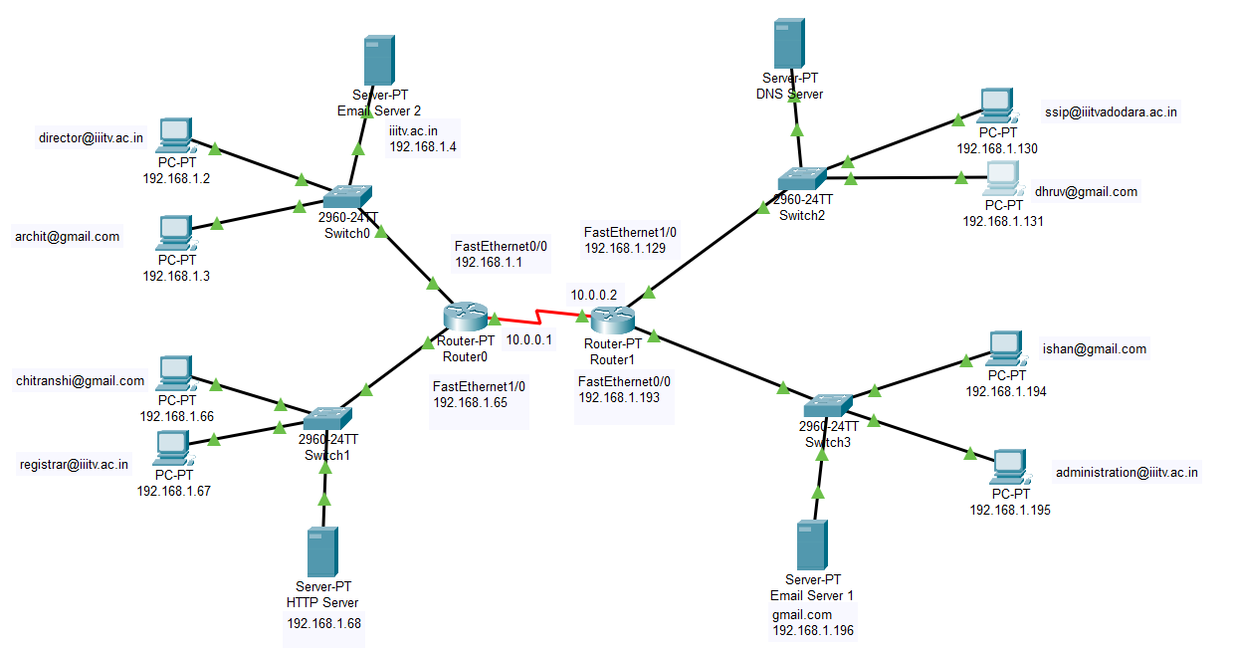

Here, I have used the domain 192.168.1.0 and created four subnets using the subnet mask 255.255.255.192 or /26.

The subnet ranges are:

1. 192.168.1.0 – 192.168.1.63
2. 192.168.1.64 – 192.168.1.127
3. 192.168.1.128 – 192.168.1.191
4. 192.168.1.192 – 192.168.1.255

The first and last address of each subnet are not used as they are reserves for network and broadcast address respectively.

* Setting up the servers.

1. **The DNS server**: It is setup in the subnet 192.168.1.128 – 192.168.1.192. The IP configuration of the DNS server is shown below.

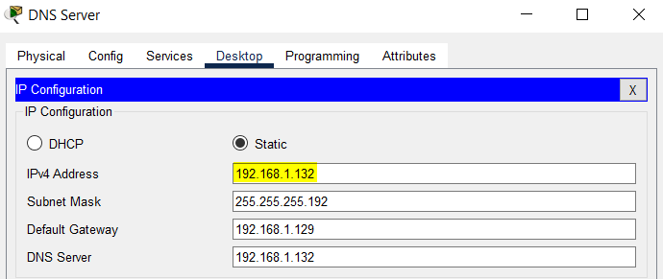

The other server addresses(set-up in next steps) and domain names are added in the DNS server.

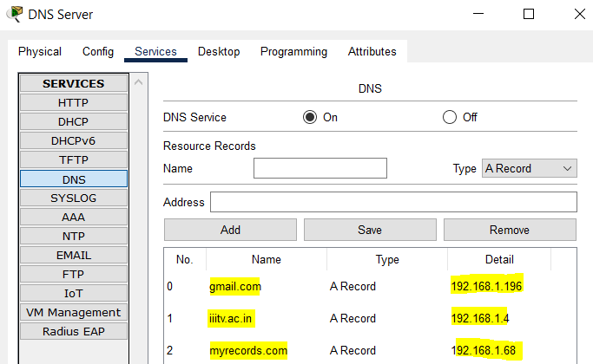

1. **The HTTP Server:** It is setup in the subnet 192.168.1.64 – 192.168.1.127. The IP configuration of the DNS server is shown below.

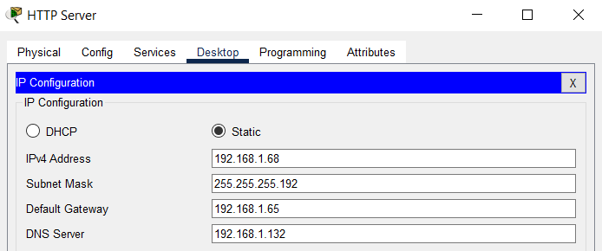

A webpage is set-up in the server that will be displayed on browser on hitting the IP or domain-name of this server.

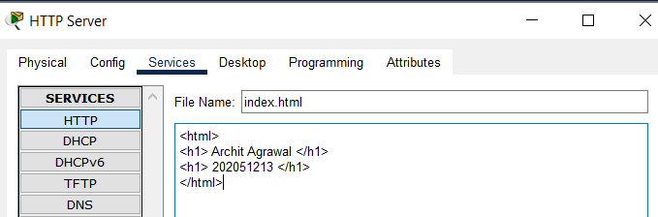

1. **The Email Server 1 (domain name: gmail.com):** It is setup in the subnet 192.168.1.192 – 192.168.1.255.

The IP configuration of the DNS server is shown below.

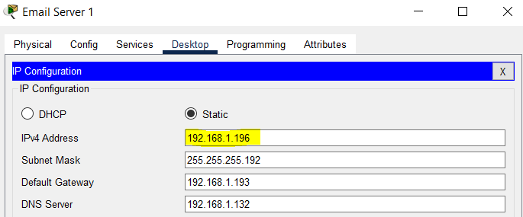

Some email accounts are added in this server.

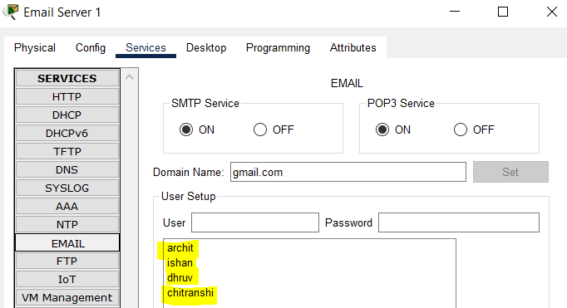

1. **The Email Server 2 (domain name: iiitv.ac.in):** It is setup in the subnet 192.168.1.0 – 192.168.1.63.

The IP configuration of the DNS server is shown below.

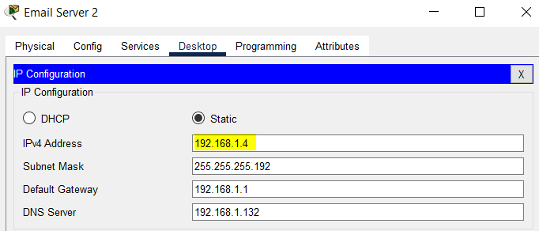

Some email accounts are added in this server.

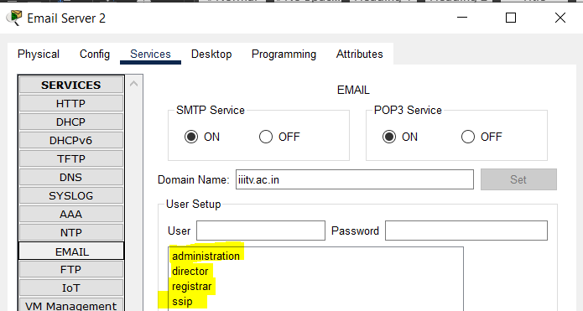

* Configuring the IP’s for each PC.

1. Each PC will have a unique IP in the subnet range of the subnet to which it belongs.
2. Each PC will use the subnet mask 255.255.255.192 or /26.
3. Each PC will have a default gateway address that will depend on the IP address of the router to which it is connected.
4. Each PC will have a DNS Server address which will be 192.168.1.132, the IP address of DNS Server.

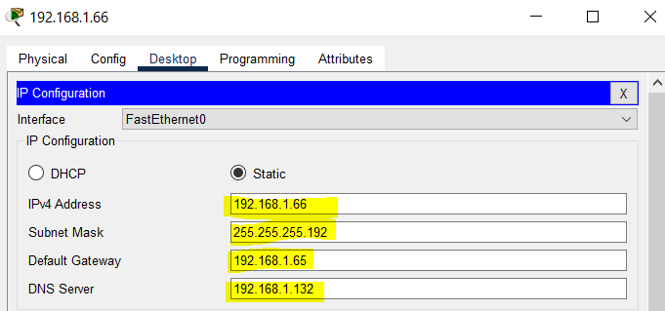

The IP address of each PC is written under the PC in the network image.

* Configuring the Router. Each router will use the subnet /26.

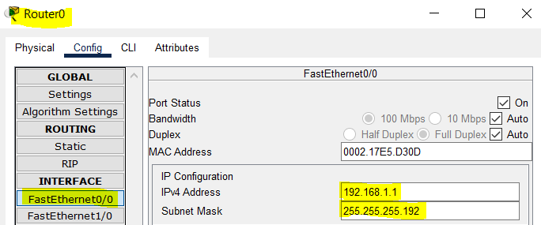

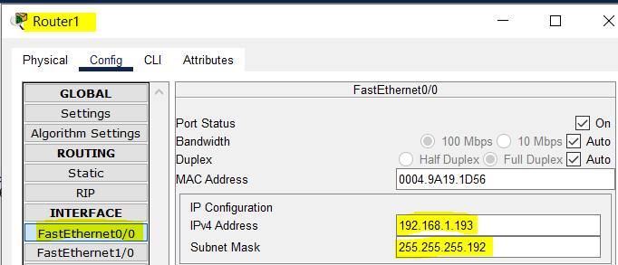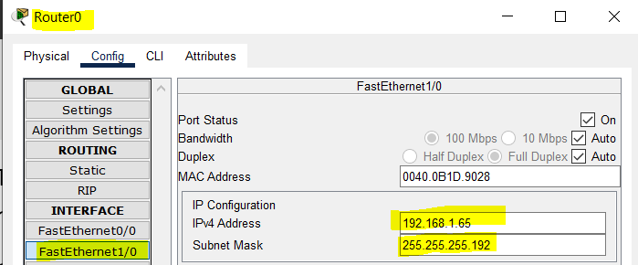

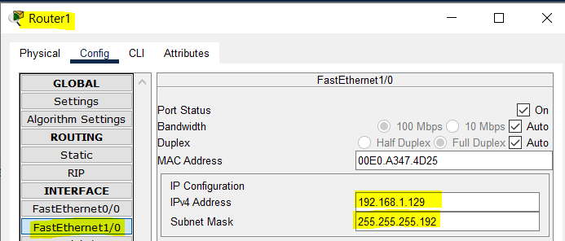

* Configuring the Serial Port of routers for inter-router connection. Each router uses a subnet mask /30 because it has a maximum of 3 devices connected to it (two switches and another router).

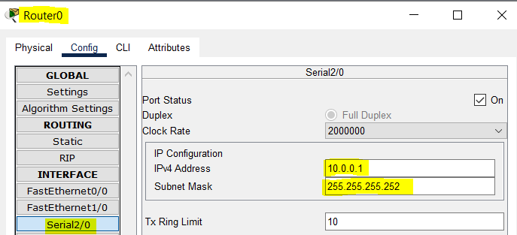

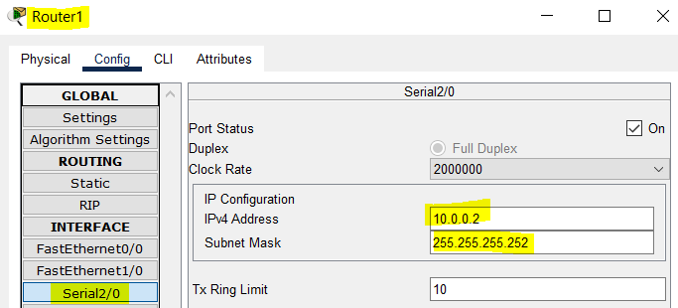

* For both routers, adding the networks connected to the other network in the static routing table.

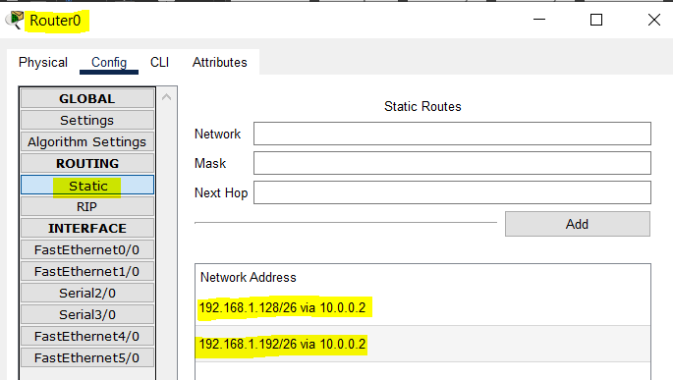

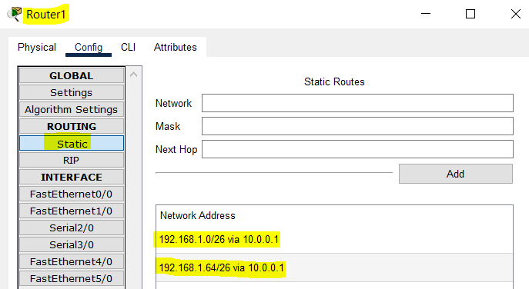

* The network is configured, now we can check if the servers are connected properly or not.

1. Checking the HTTP server by hitting its domain name from a computer on each subnet.

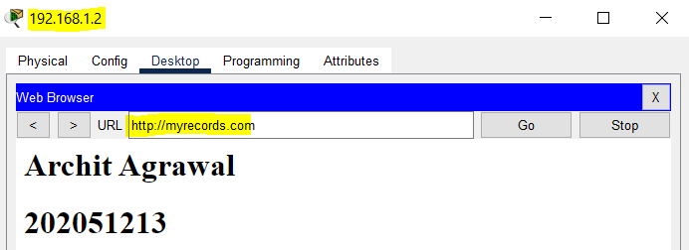

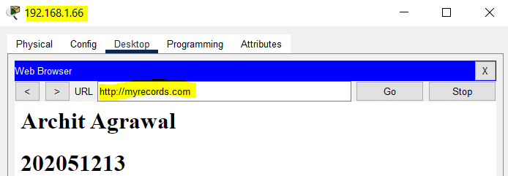

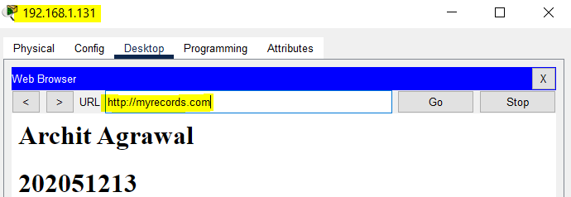

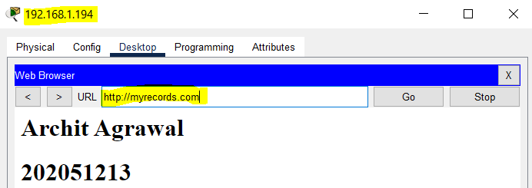

1. Checking email server by sending emails intra-domain and inter-domain. An email account is logged on each PC. The account that is logged on a PC is written near it in the network figure.

* gmail.com to gmail.com (archit@gmail.com to dhruv@gmail.com)

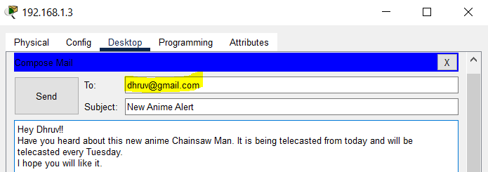

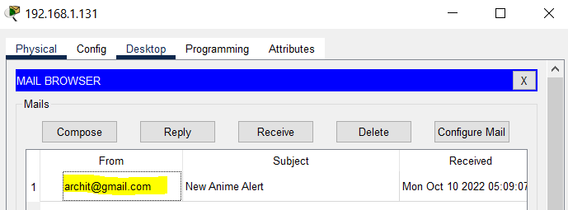

* iiitv.ac.in to iiitv.ac.in (director@iiitv.ac.in to registrar@iiitv.ac.in)

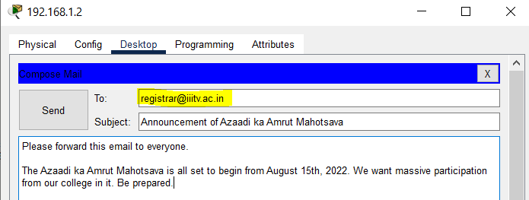

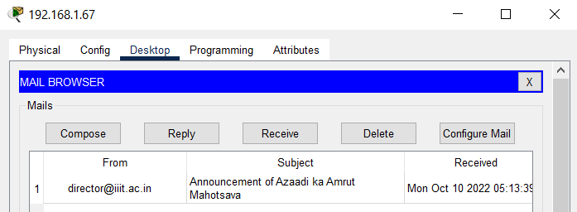

* gmail.com to iiitv.ac.in (chitranshi@gmail.com to director@iiitv.ac.in)

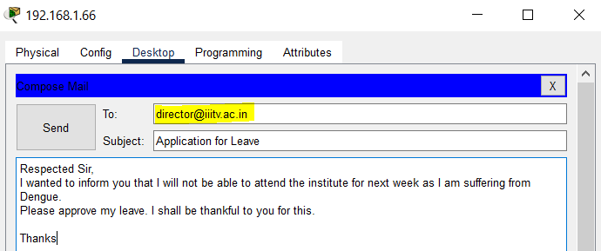

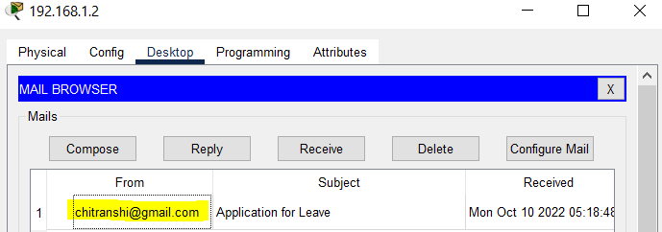

* iiitv.ac.in to gmail.com (director@iiitv.ac.in to chitranshi@iiitv.ac.in)

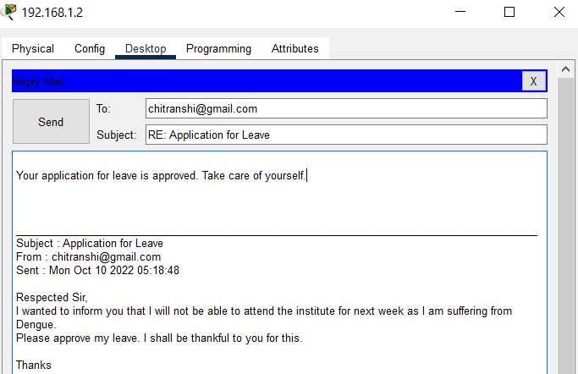

1. 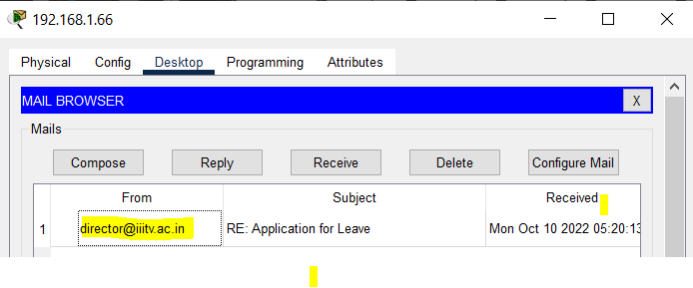Since the emails are sent properly and also by hitting the domain name of webserver, webpage is loaded, hence, the DNS server is working properly.