CS361

Laboratory 8

NAME:

ARCHIT AGRAWAL

ROLL NO. :

202051213

SECTION:

2B

**Problem:**

**1) Create a network between 3 pcs, Switch, Router and Server.  
2) And take two wireless access points and connect them to switch.  
3) Connect at least 10 wireless devices (wireless desktop, Laptop, Printers, wireless mobile, tabs & etc.) to each access point.     
4) Connect a wireless server to access point 0 & access point 1.**

* The network is shown in the image below.

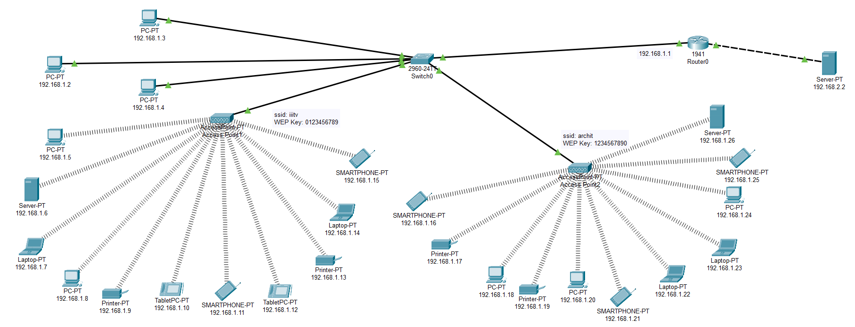

* Take 3 PC’s, connect them to a switch, connect switch with the router and server.

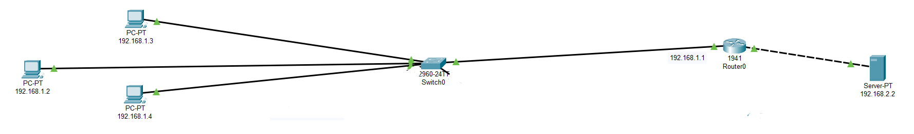

* Add two wireless access points to switch and connect at least 10 wireless devices (printers, laptops, desktop, tablet, smartphone etc.) with each access point and connect a server to each access point. (the whole network is shown at starting).

1. ***Configuring the Access Points***: Go to access point 🡪 Config 🡪 Port1. Set a SSID and WEP Key.

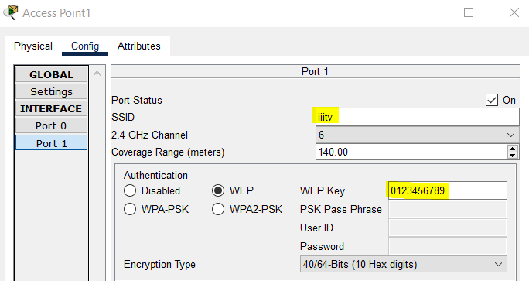

Set another SSID and WEP key for the other access point.

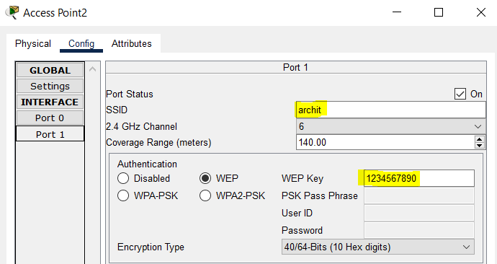

1. ***Configuring each PC, Laptop and Printer and Server***:

* Go to Physical 🡪 turn off the device 🡪 remove the inserted module by dragging it out 🡪 insert the WMP300N module for PC, Server and Printer, while the WPC300N for laptop 🡪 turn on the device.

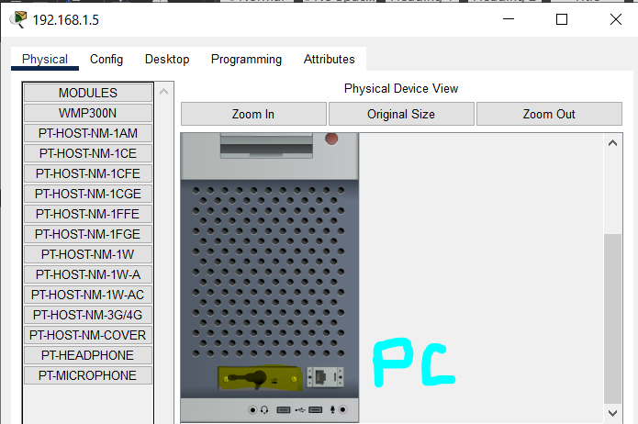

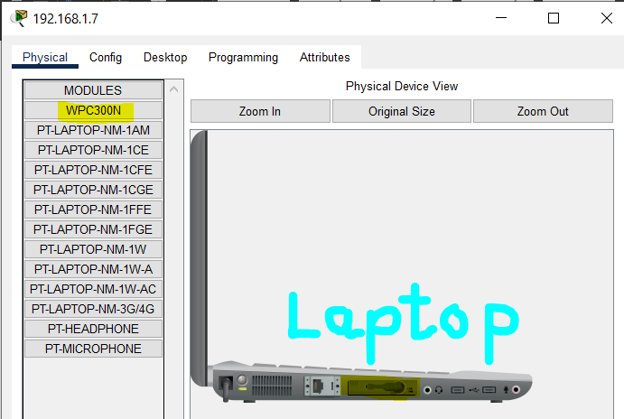

* Configure the IP for each of these devices.

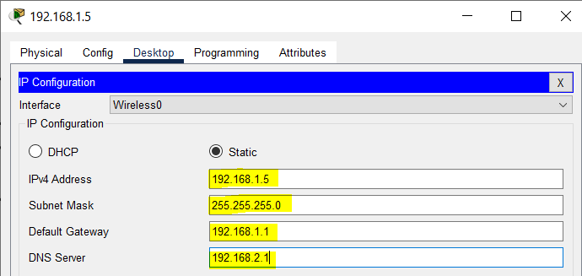

The DNS server is the server with IP 192.168.2.1 (shown later).

* Now, go to config 🡪 Wireless0 🡪 enter the SSID and WEP key of the access point to which you want to connect the device.

A device connected to access point 0.

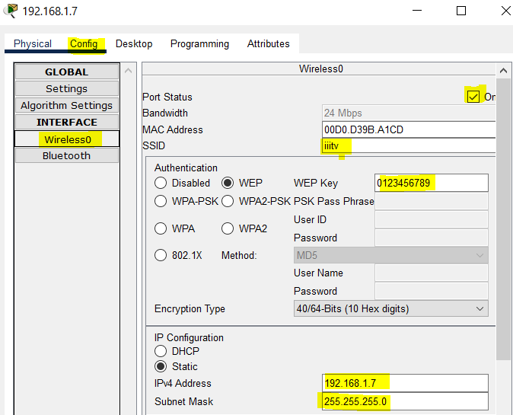

A device connected to access point 1.

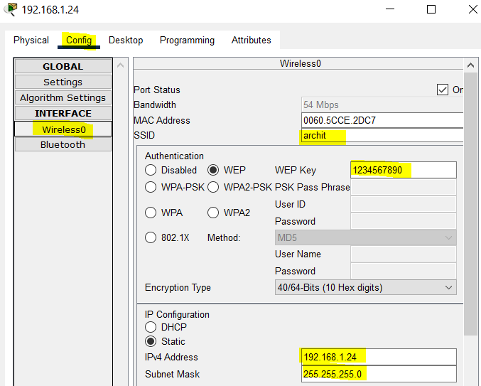

A wireless connection can be seen between device and access point in the network now.

1. ***Configuring each Smartphone and Tablet***: It is similar to PC or laptop as done in above, but we don’t need any physical configuration. Hence, configure the IP directly and then go to config 🡪 wireless0 🡪 enter the SSID and WEP key of the access point to which you want to connect the device.

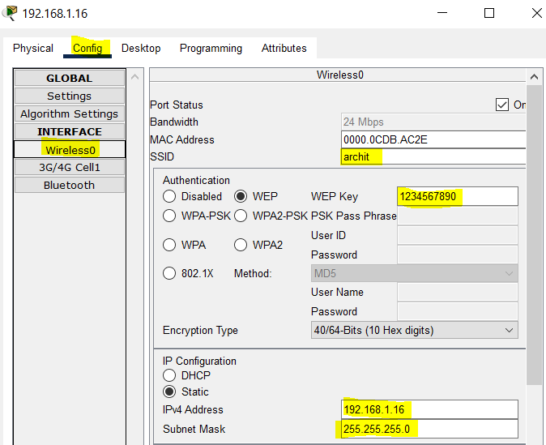

* Configure the server connected to the other network (192.168.2.0).

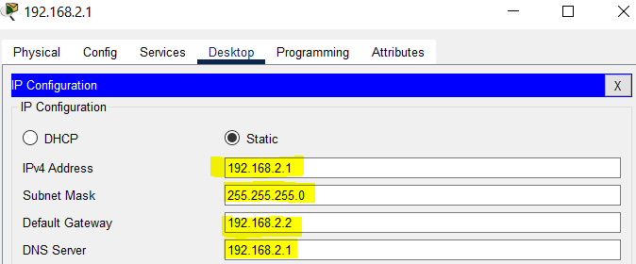

Use this server as DNS server.

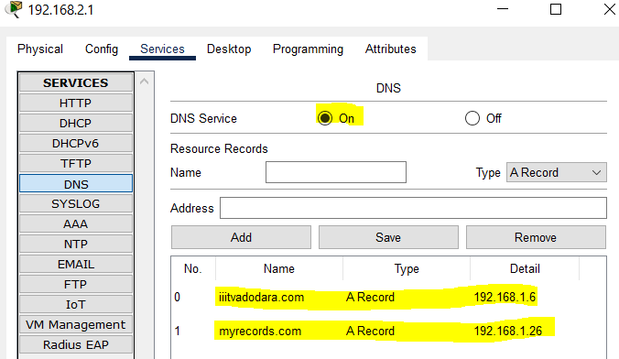

* Configure the server connected to “iiitv” access network (use as web server)

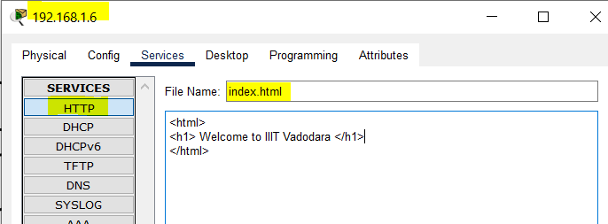

* Configure the server connected to “archit” access network (use as web server)

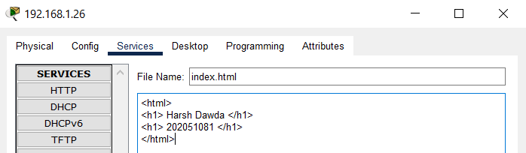

* Finally, configure the router.

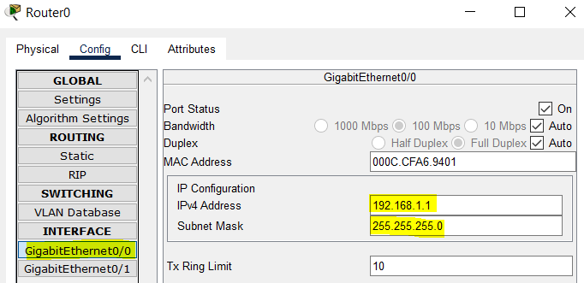

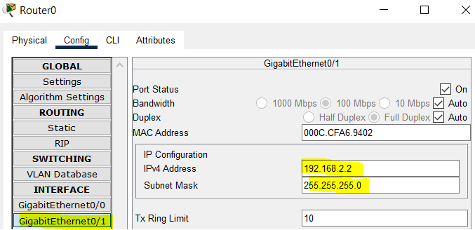

* The network is configured and we can check it by hitting the domain names of the websites from any end device in the network.

1. From PC’s connected to switch via cables.

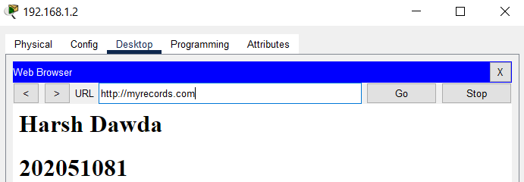

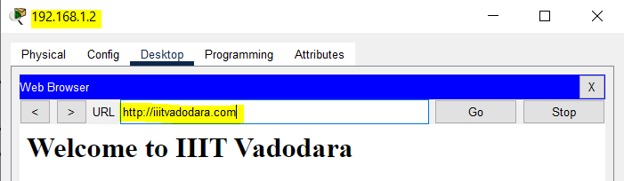

1. From devices connected to access point 0 wirelessly.

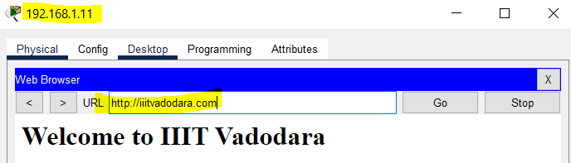

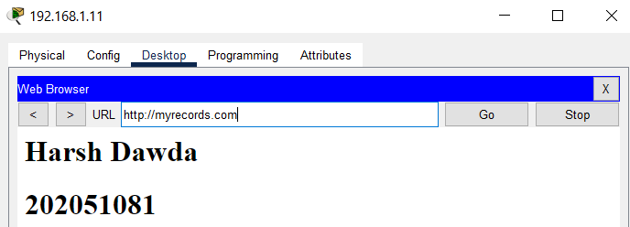

1. From devices connected to access point 1 wirelessly.

