CS361

Laboratory 9

NAME:

ARCHIT AGRAWAL

ROLL NO. :

202051213

SECTION:

2B

***Problem*:**

**Consider that you have two different houses with multiple IoT devices. The two houses are in different subnets and have different IoT servers. Demonstrate the following:  
(1) IoT devices of one house can be controlled from the Laptop/PC of another house.**

The network is shown below:

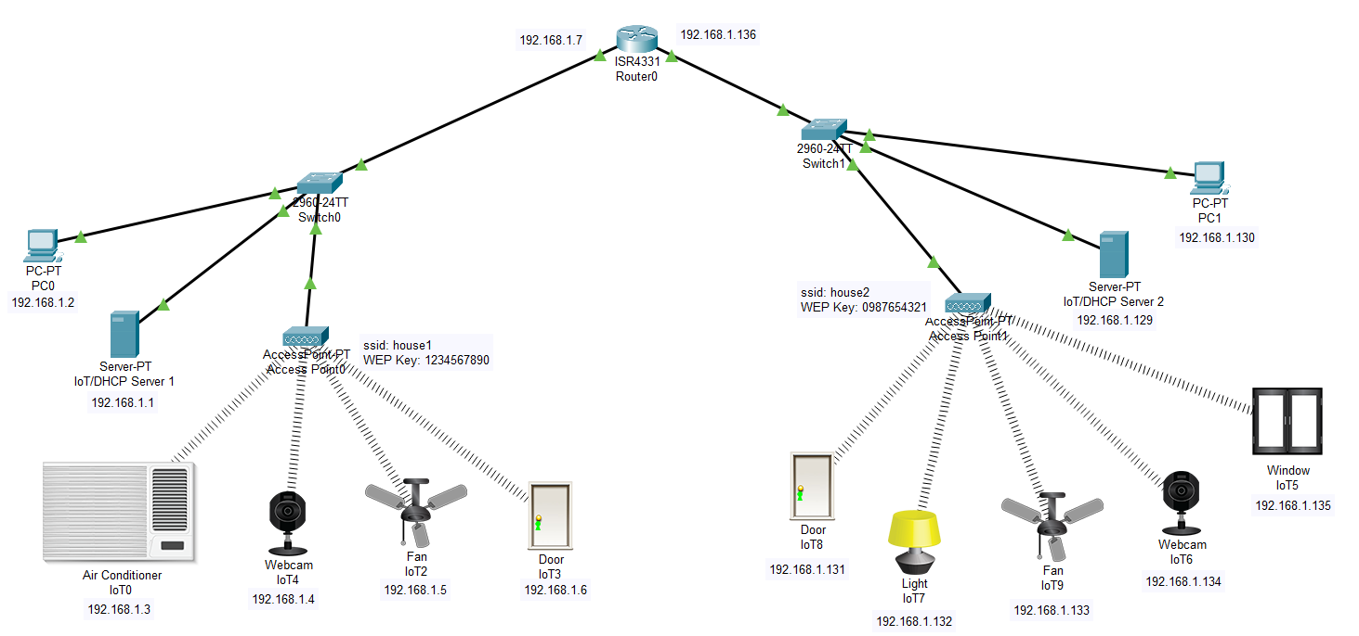

Used subnetting with subnet mask of /25. So, house on the left is in the range 192.168.1.0 – 192.168.1.127 while the house on the right is using the subnet range 192.168.1.128 – 192.168.1.255.

* Configuring IP address of servers of both the houses.

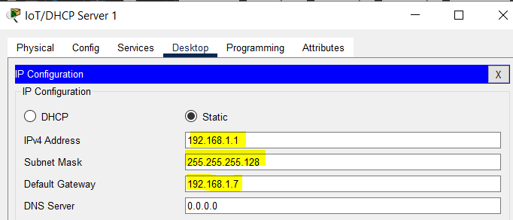

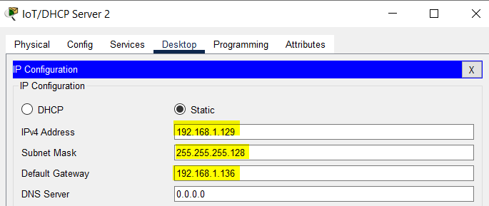

* Configuring DHCP servers of both the houses.

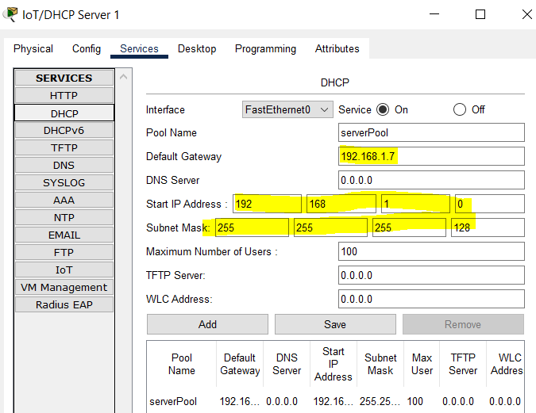

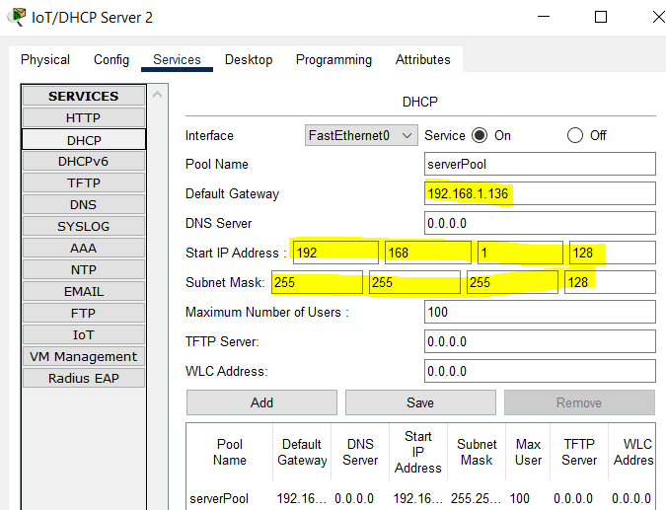

* Configuring access points in both the houses.

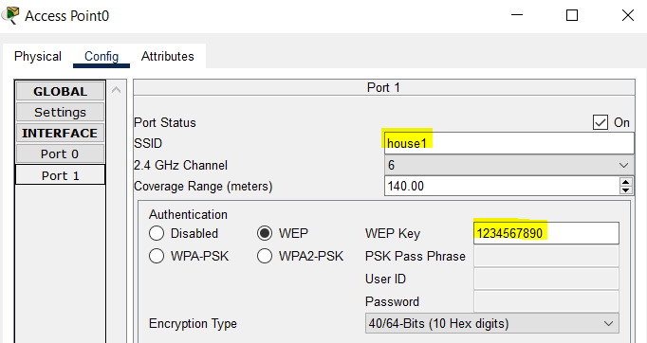

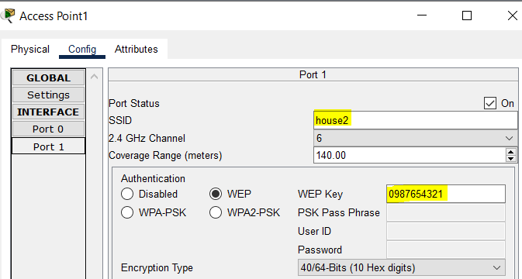

* Connecting each IoT device to the respective access points.

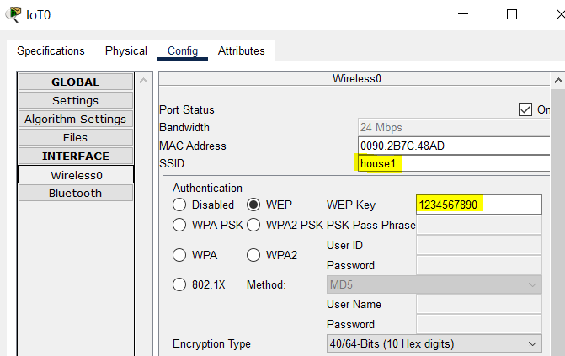

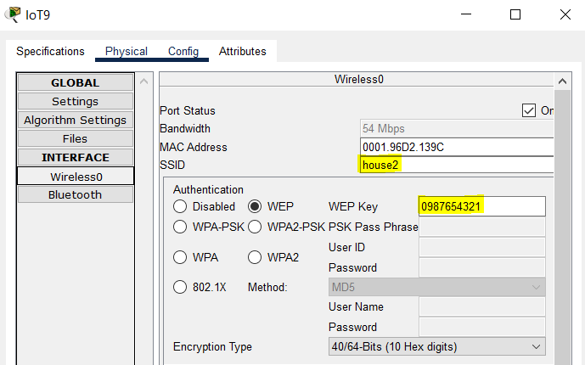

* Adding devices to respective IoT server.

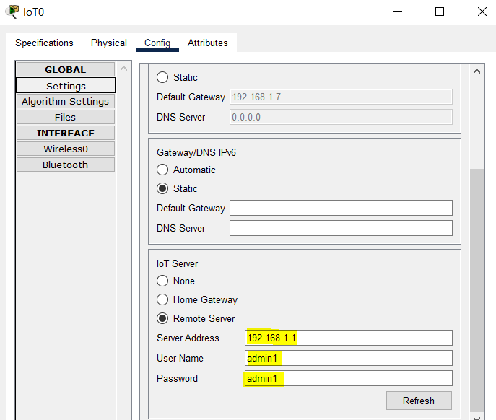

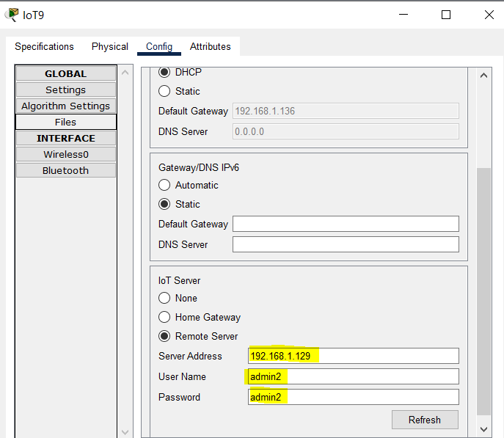

* Logging in to IoT account on PC of each house.

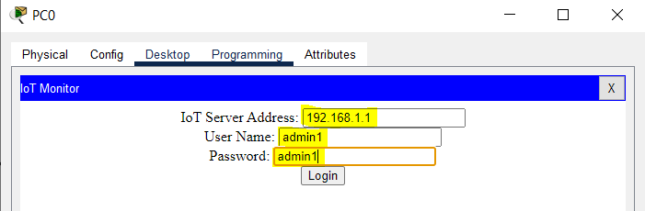

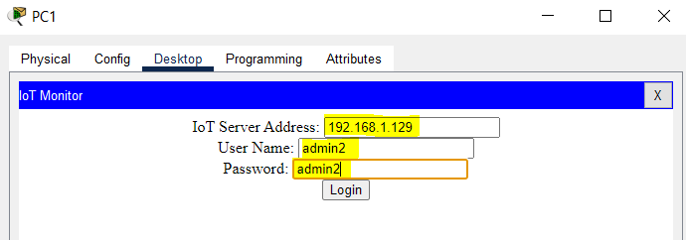

* Now, each device can be accessed using the PC in that house.
* 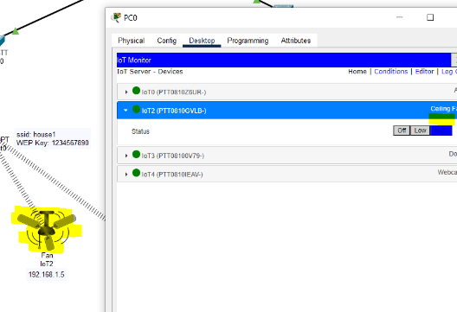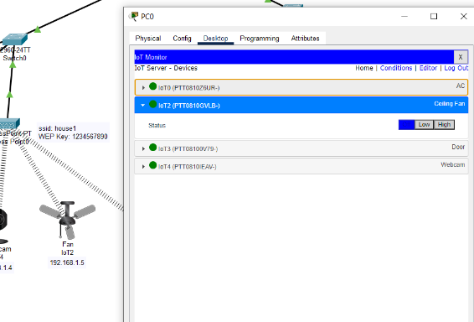House 1

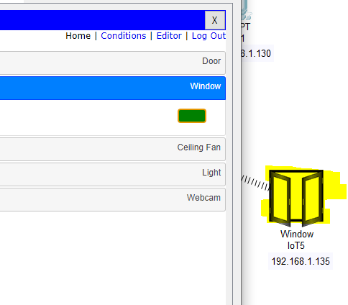

* House 2
* To access IoT devices of house2 from PC of house1 (or vice-versa), just log in to the IoT account of house2 in house1 PC (or IoT account of house1 in house2 PC).

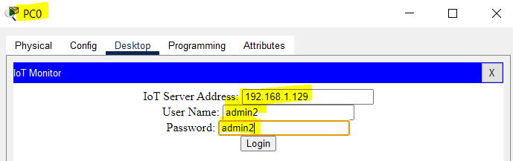

Now, all the IoT devices of house2 can be seen in the PC of house1.

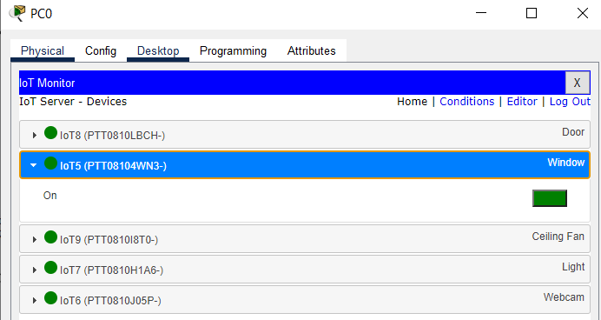

Devices of house2 can be controlled from PC of house1 now.

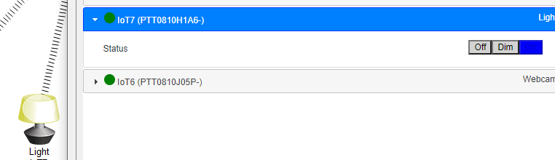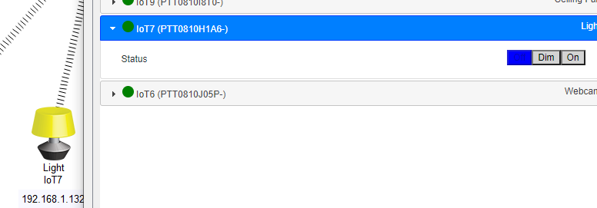

**(2) Use a mobile phone to communicate with IoT devices.**

The network is shown below:

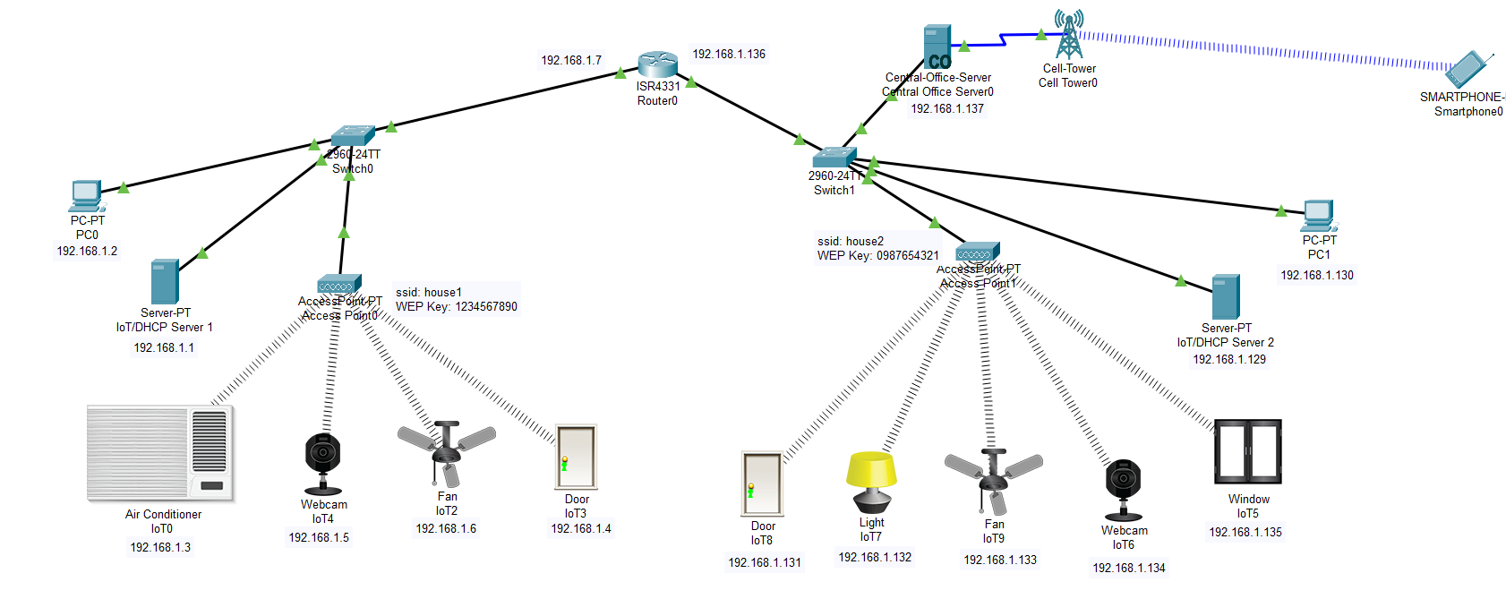

The network is similar as in part 1. There is one cell tower, CO server, and a smartphone is added.

* Configuring CO server.

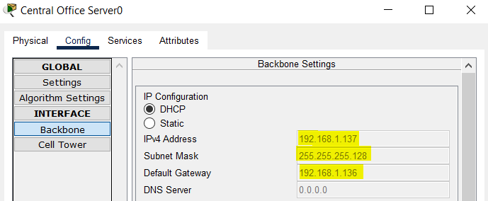

* Logging in to IoT account of house1 to access its IoT Devices.

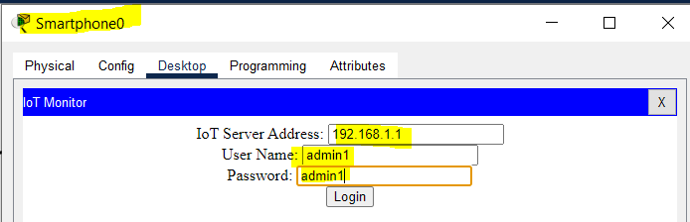

Devices of house1 can be seen, can be operated using this smartphone.

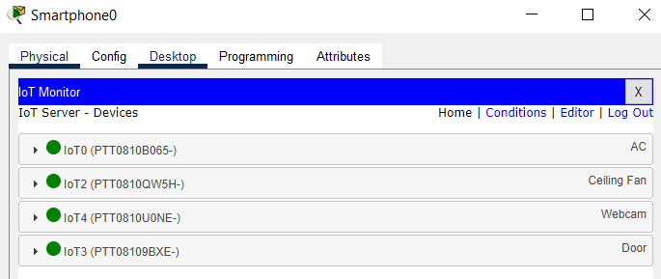

Now, let us log in to IoT account of house2.

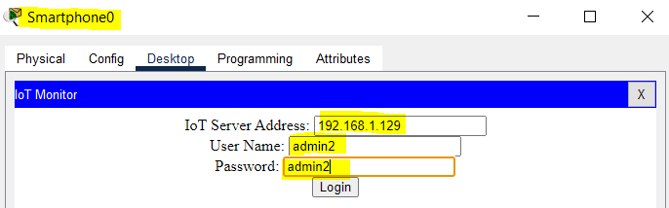

Devices of house2 can be seen, can be operated using this smartphone.

