Objectives -:
- Create and execute a MATLAB program for DC-DC buck converter.
- Simulate DC-DC buck converter using Simulink.

Theory -:
A buck converter (step-down converter) is a DC-to-DC power converter which steps down voltage (while drawing less average current) from its input (supply) to its output (load).
It is a class of switched-mode power supply (SMPS) typically containing at least two semiconductors (a diode and a transistor, although modern buck converters frequently replace the diode with a second transistor used for synchronous rectification) and at least one energy storage element, a capacitor, inductor, or the two in combination. To reduce voltage ripple, filters made of capacitors (sometimes in combination with inductors) are normally added to such a converter's output (load-side filter) and input (supply-side filter).
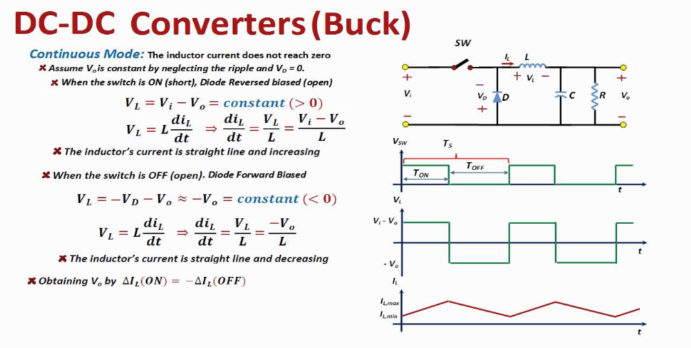
Matlab code -:
%Archit Agrawal
%202052307
% matlab program for dc-dc buck converter
%output voltage is varied by varying duty cycle

tsim=.1;

Vdcin=100;

Rload=100;
Lseries=100e-3;
Cparallel=50e-6;

fswitch=10000;
Tp=1/fswitch;

for i=1:19
D=i*5;
dd(i)=D;
sim('dc',tsim);
outv(i)=yout(end);
end
plot(dd,outv)

Procedure -:
Steps to draw the model in Simulink platform:
- Open a blank model in Simulink
- Clicking Simulink Library Browser button, open the library.
- On the search menu box type the following names of the components to search one by one and once found drag it to the Simulink window (representing the blank model location)
- Mosfet
- Diode
- DC source voltage
- Series RLC Branch
- Display
- Scope
- Pulse Generator
- Mux
- Mean value
- Voltage measuring device
- Powergui

Once these blocks are dragged to the model page, these are arranged as show in the figure given above.
- After completing the connections between the blocks as shown in the diagram given above, various parameter settings are carried out.
- Powergui block is double clicked and simulation type is set to continuous mode.
- Check the box, Use Ideal Switching Devices
- Then check the box to disable the snubbers in switching devices
- Check the box to disable On resistances in switching devices
- Check the box to disable forward voltage in switching devices
- Setting of the Pulse Generator
- Set ‘Period” as 1/10000 (10kHz switching)
- Set Pulse Width to the desired value as it represents Duty cycle which is to be varied to observe how the output voltage across the load varies with Duty cycle “D” because V out = D * V in
- Simulation time window can be set to 1 second
- Series RLC branch to be copied 3 times. Once representing R, second one denoting L and the third one shall reproduce as C.
- The DC source voltage is set to 100 volts
- The R value is set to 100 ohms
- The L value is set to 100e-3 Henry
- The C value is set to 50e-6 farad

Conducting the Experiment:
- A Duty cycle value is first chosen and is the simulation is run
- The Duty cycle value in % and the output voltage readings are taken.
- This is repeated 10 times for different values of duty cycle
- These readings can then be plotted Duty cycle (D) in % versus output voltage Vout
- This can be achieved by writing a matlab.m file and linking the Simulink model file with it
- Output voltage and Input voltage waveforms for auty cycle be printed from Scope by printing it to figure and then saving the figure file in matlab.fig format to be reproduced later.

observations -:
- Observation 1:
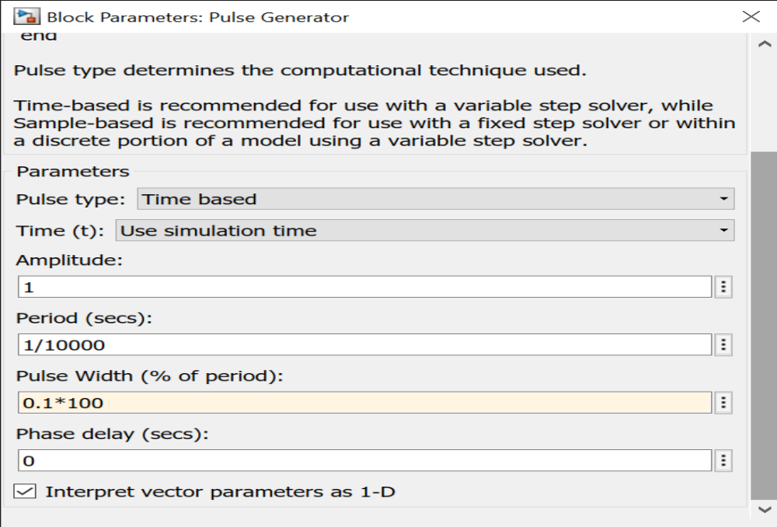

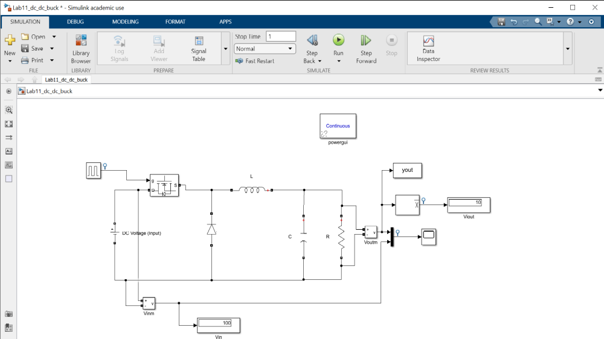
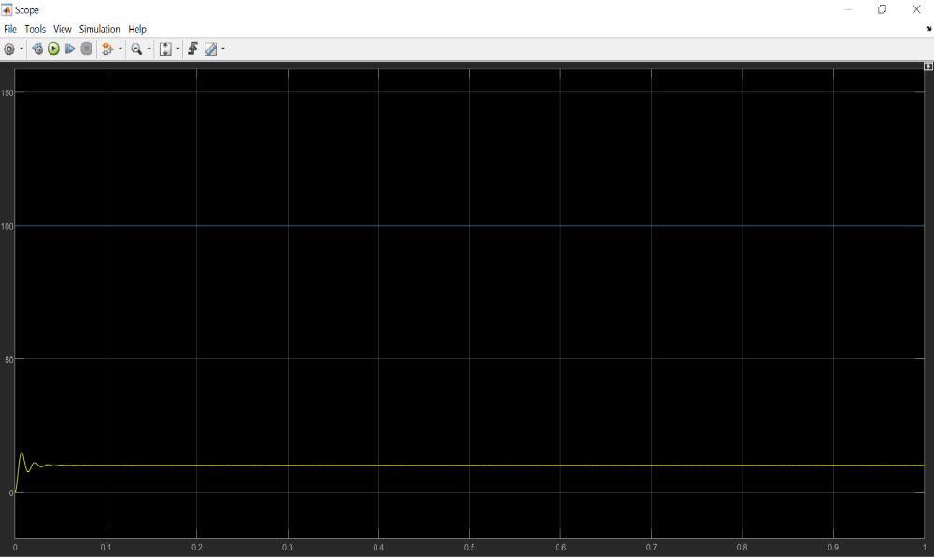

- Observation 2:

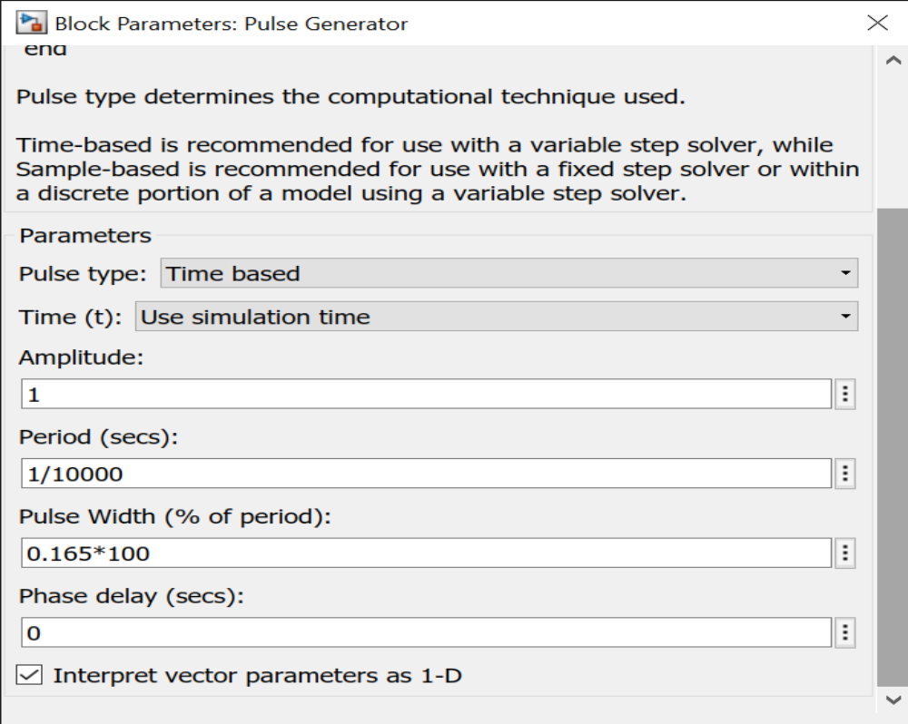
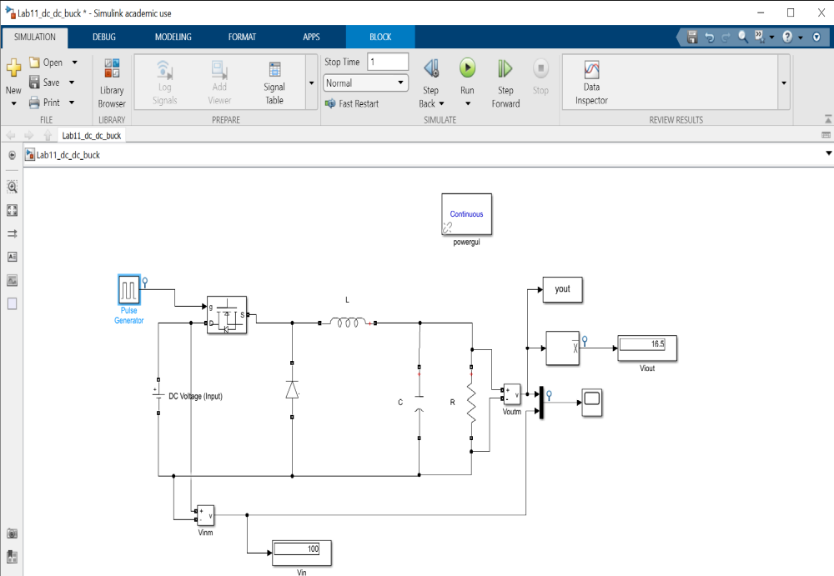

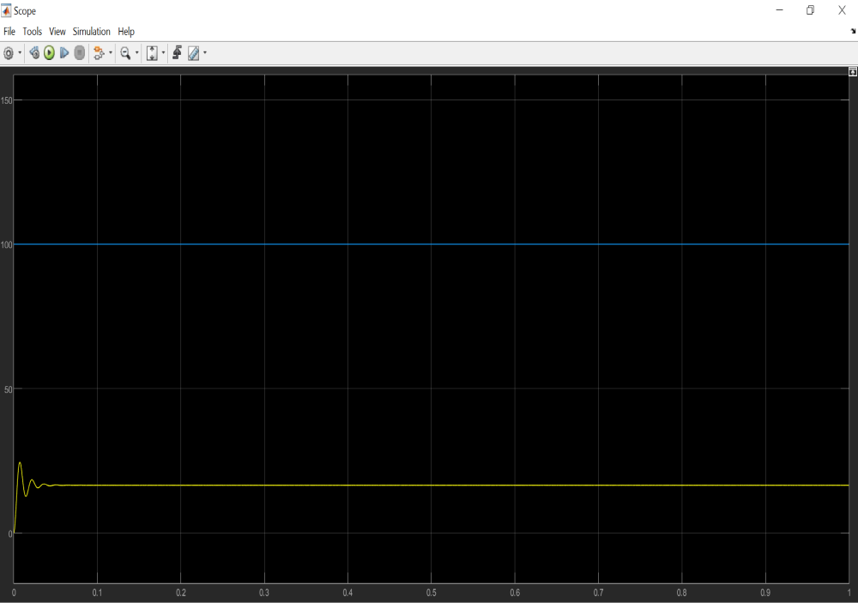
- Observation 3:

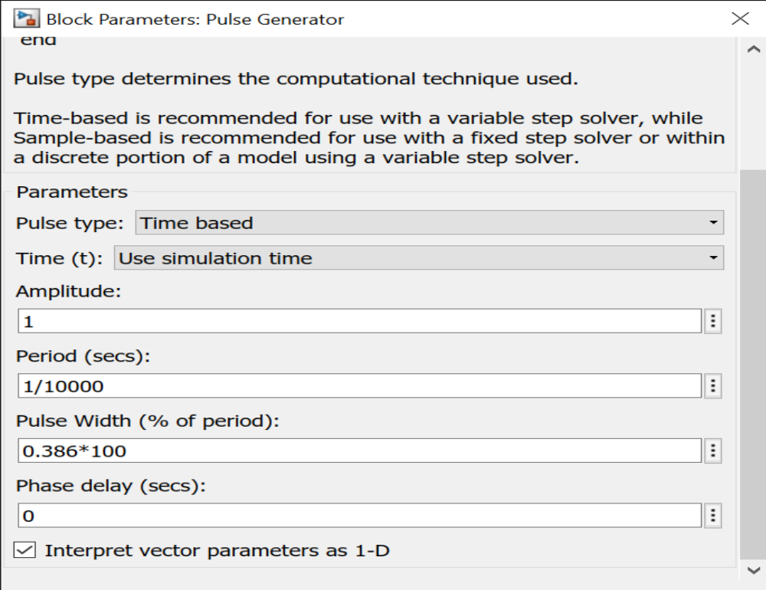

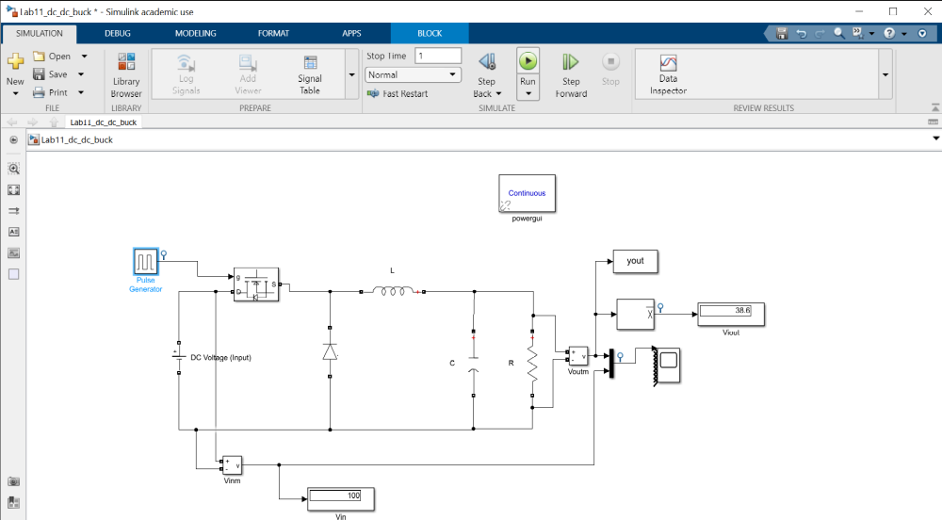
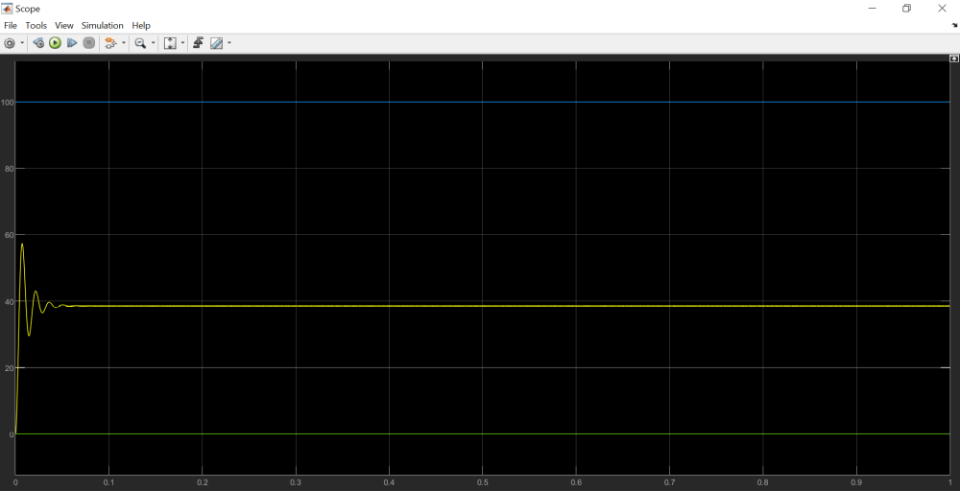

Observation Table:

S.No. | D | $$V_{in}$$ | $$V_{out}$$
1. | 0.1 | 100 | 10
2. | 0.198 | 100 | 19.8
3. | 0.386 | 100 | 38.6
4. | 0.64 | 100 | 64
5. | 0.763 | 100 | 76.3
6. | 0.57 | 100 | 57
7. | 0.864 | 100 | 86.4
8. | 0.456 | 100 | 45.6
9. | 0.69 | 100 | 69
10. | 0.987 | 100 | 98.7

$$V_{out}=DV_{in}$$

conclusion -:
- The inductor plays a major role in lowering the input voltage.
- The inductor absorbs energy from the source and stores the energy in the form of a magnetic field.
- Energy stored in the inductor, the inductor becomes a source to supply the load by releasing its stored energy.
- Vout = D * Vin is a Valid Expression.
- The output voltage and current of the converter contain harmonics due to the switching action. In order to remove the harmonics LC filters are used.
- Inductor and capacitor are ideal, the filter removes the switching harmonics without dissipation of power. Thus, the converter produces a DC output voltage whose magnitude is controllable via the duty cycle D, using circuit elements that (ideally) do not dissipate power.

