**IT WORKSHOP LAB**

ARGHA MALLICK – 11500122014

A1.**Write a program to find the value of the function :**

**F(x)=3x2+5 if x<= 10**

**=5x if x>10 and x<=20**

**=2x2-x+9 if x>20**

**Input value of x.**

def f(x):

    if x <= 10:

        return (3*x*x)+5

    elif x > 10 and x <= 20:

        return 5*x

    elif x > 20:

        return (2*x*x)-x+9

x = int(input("Enter value of x: "))

print(f(x))

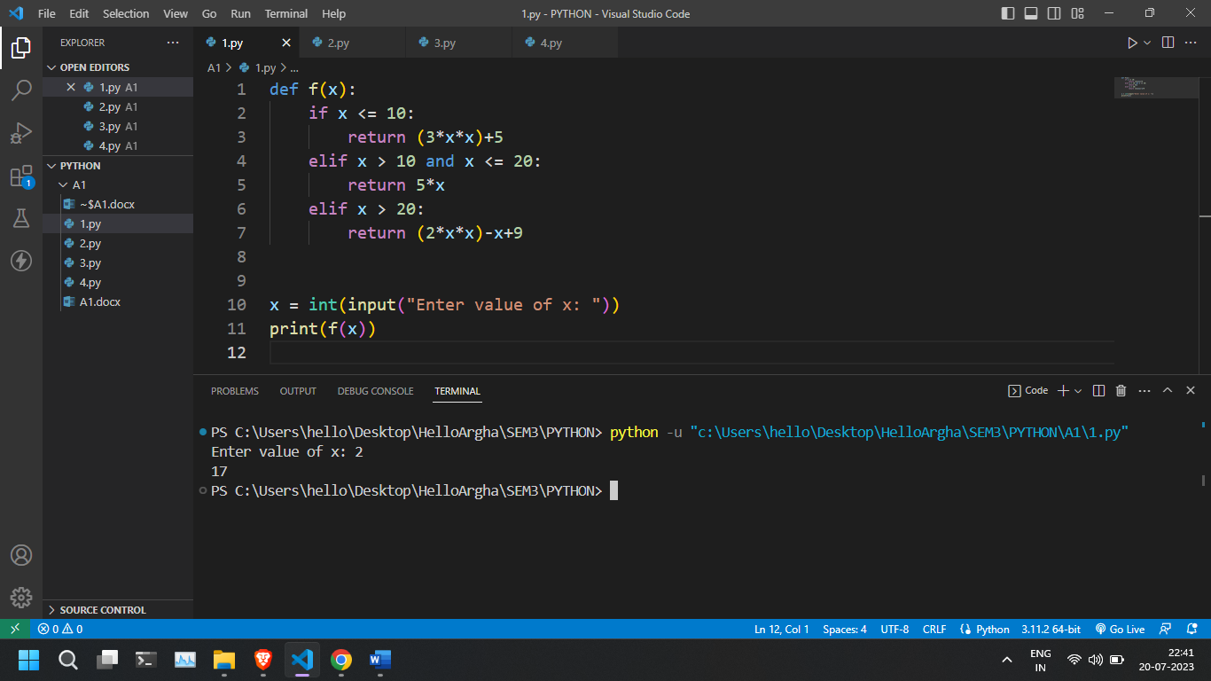

**A 2. Write a program to find the largest no among three numbers using nested if else statement.**

n1 = int(input("Enter first number: "))

n2 = int(input("Enter second number: "))

n3 = int(input("Enter third number: "))

largest = 0

if n1 > n2 and n1 > n3:

    largest = n1

elif n2 > n1 and n2 > n3:

    largest = n2

else:

    largest = n3

print("Largest:", largest)

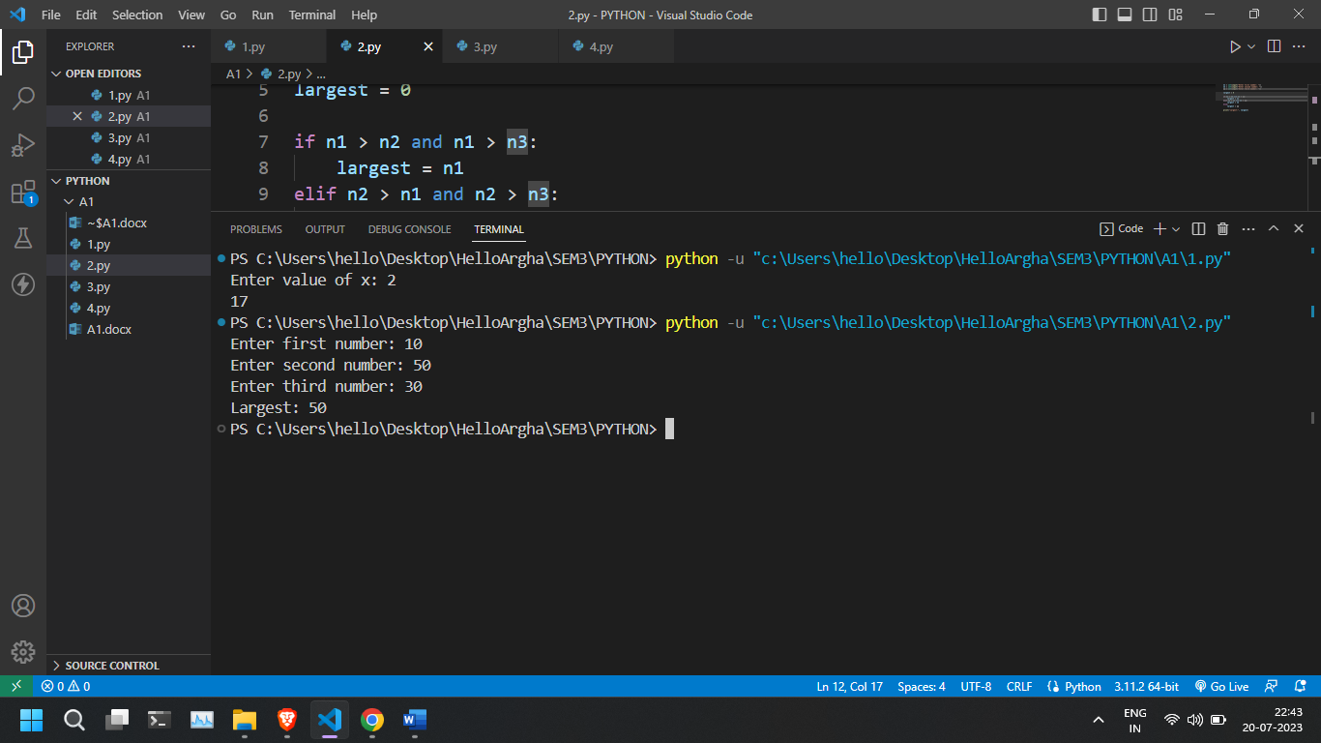

A3. **Write a program to print the following pattern, input number of lines.**

**\*\*\*\*\*\***

**\*\*\*\*\***

**\*\*\*\***

**\*\*\***

**\*\***

**\***

r = int(input("Enter number of rows: "))

for i in range(r):

    for j in range(r-i):

        print("* ", end="")

    print("\r")

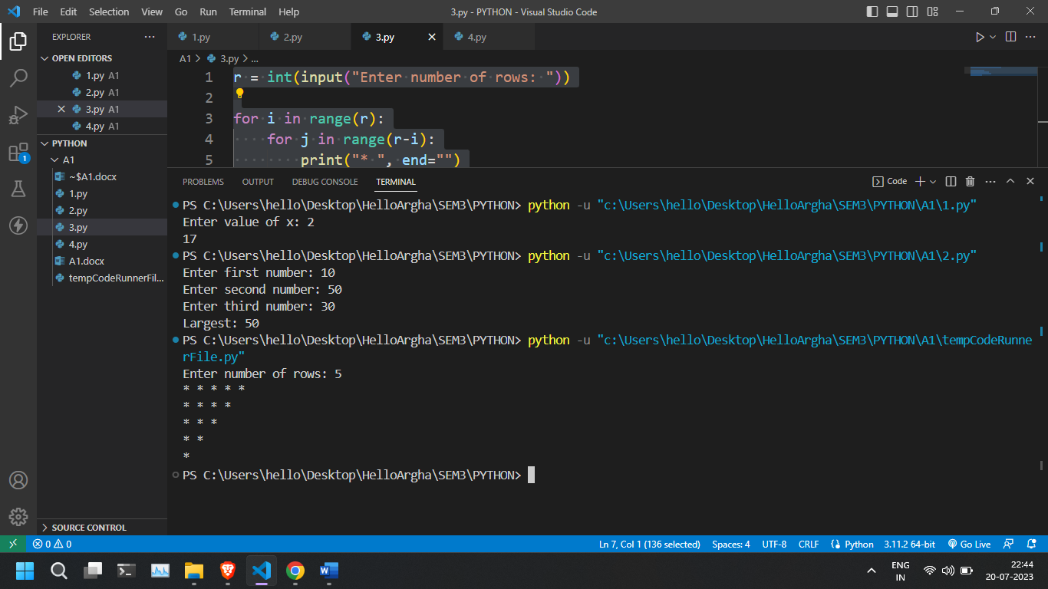

A4. **Take a sentence as input and print the words in dictionary order.**

**Take a sentence as input and print the words in dictionary order along with number of vowels in the word;**

[ Sample:

INPUT:

Python Jupiter Spyder

OUTPUT:

Jupiter,3

Python,1

Spyder,1

]

def count_vowels(word):

    vowels = "aeiouAEIOU"

    return sum(1 for char in word if char in vowels)

s = input("Enter a sentence: ")

w = s.split()

sorted_w = sorted(w)

dict = {}

for word in sorted_w:

    num_vowels = count_vowels(word)

    dict[word] = num_vowels

print(dict)

