**ASSIGNMENT 7 – Merge Sort & Quick Sort in Python**

**ARGHA MALLICK – 11500122014**

# Merge Sort

def merge_sort(lst):

    if len(lst) <= 1:

        return lst

    mid = len(lst) // 2

    left = lst[mid:]

    right = lst[:mid]

    left = merge_sort(left)

    right = merge_sort(right)

    return merge(left, right)

def merge(left, right):

    merged = []

    left_idx = right_idx = 0

    while left_idx < len(left) and right_idx < len(right):

        if left[left_idx] < right[right_idx]:

            merged.append(left[left_idx])

            left_idx += 1

        else:

            merged.append(right[right_idx])

            right_idx += 1

    merged.extend(left[left_idx:])

    merged.extend(right[right_idx:])

    return merged

if __name__ == "__main__":

    lst = [2,5,1,3,9,8,6,7]

    merged = merge_sort(lst)

    print(merged)

**OUTPUT**

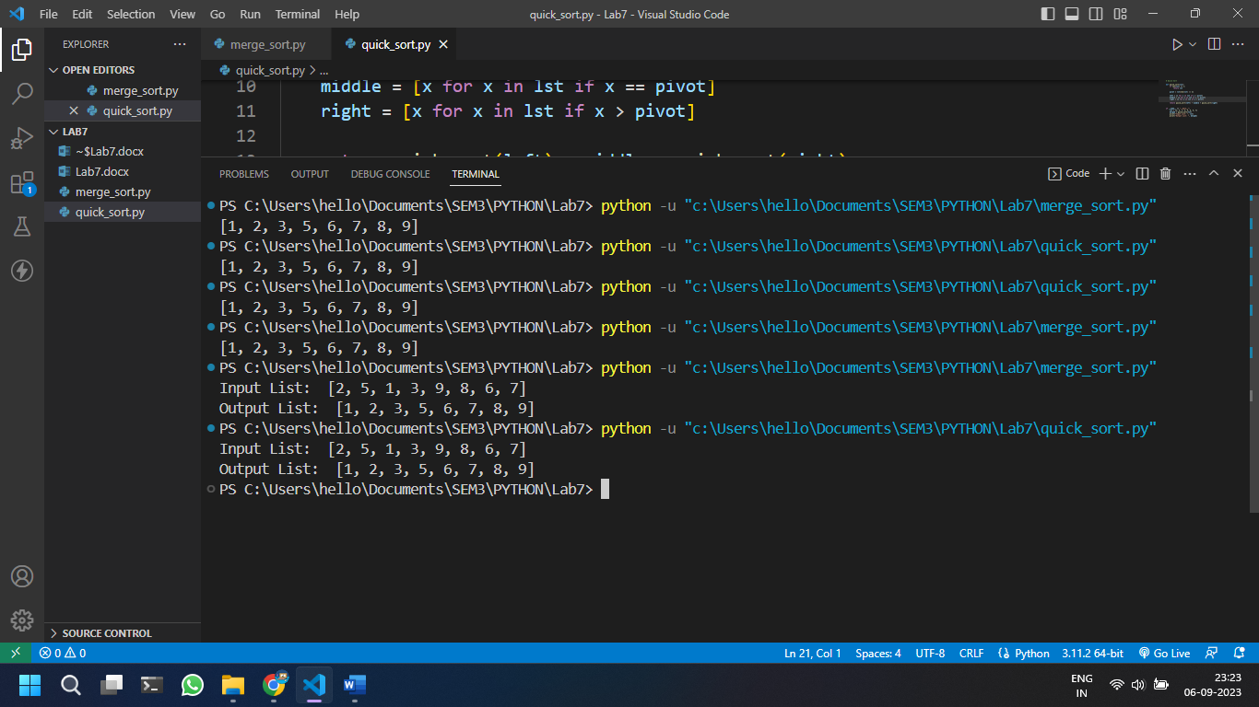

# Quick Sort

def quick_sort(lst):

    if len(lst) <= 1:

        return lst

    pivot = lst[len(lst) // 2]

    left = [x for x in lst if x < pivot]

    middle = [x for x in lst if x == pivot]

    right = [x for x in lst if x > pivot]

    return quick_sort(left) + middle + quick_sort(right)

if __name__ == "__main__":

    lst = [2, 5, 1, 3, 9, 8, 6, 7]

    merged = quick_sort(lst)

    print(merged)

**OUTPUT**

