**ASSIGNMENT – 8**

**Argha Mallick – 11500122014**

# Implement a module for creating simple calculator consisting of addition, subtraction, division, and multiplication operations and import the module into another program.

import calculator

n1 = int(input("Enter first number: "))

n2 = int(input("Enter second number: "))

res_add = calculator.add(n1, n2)

res_sub = calculator.subtract(n1, n2)

res_mul = calculator.multiply(n1, n2)

res_div = calculator.divide(n1, n2)

print(f"{n1} + {n2} = {res_add}")

print(f"{n1} - {n2} = {res_sub}")

print(f"{n1} * {n2} = {res_mul}")

print(f"{n1} / {n2} = {res_div}")

# calculator.py

def add(a, b):

    return a+b

def subtract(a, b):

    return a-b

def multiply(a, b):

    return a*b

def divide(a, b):

    if b==0:

        raise ValueError("Cannot divide by zero")

    return a/b

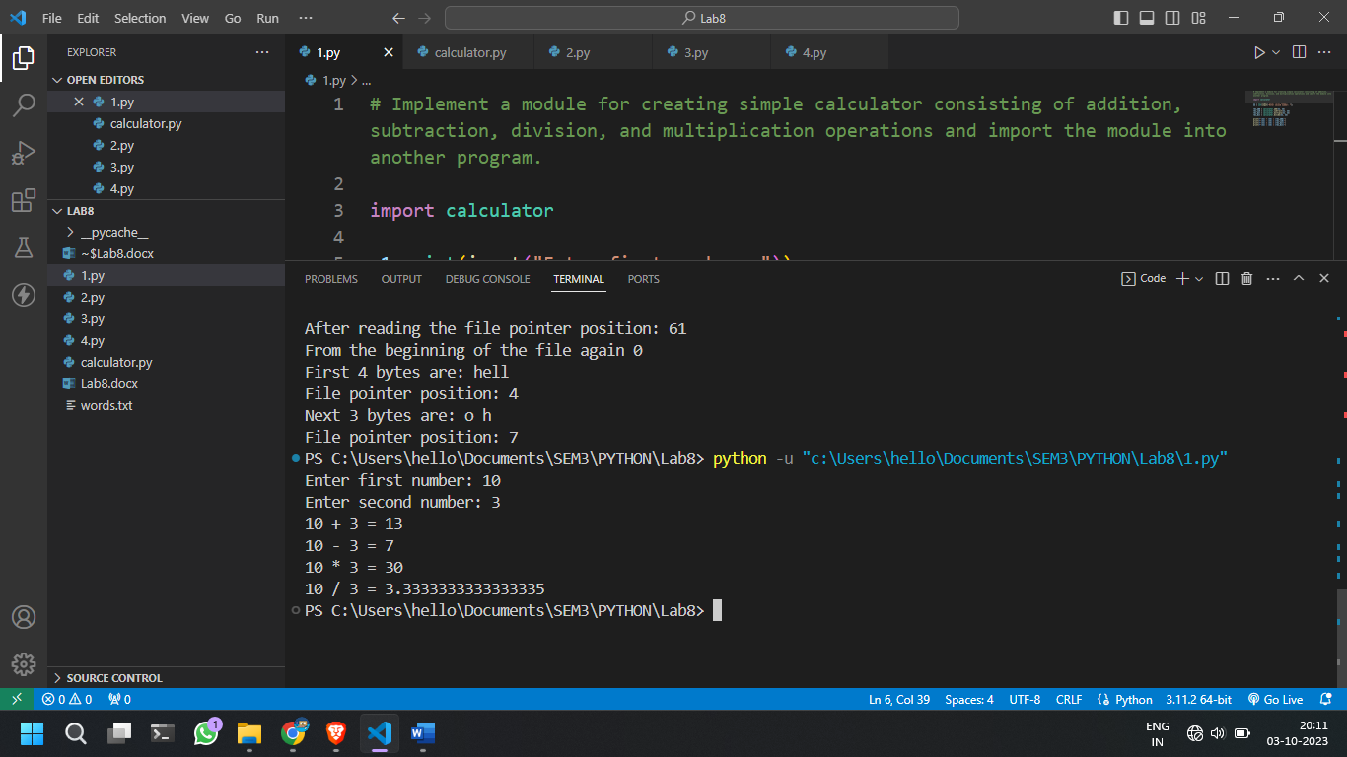

# Write a program to write the integer numbers from 1 to 20 in a file called “NUMBER.txt”. Copy the contents of the file into two files “EVEN” and “ODD” so that even numbers will the in the “EVEN” file and odd number will be in the “ODD” file. Display the contents of all the files.

f1 = open("NUMBER.txt", "a+")

for i in range(1, 21):

    f1.write(str(i) + " ")

f1 = open("NUMBER.txt", "r")

numbers = f1.read()

numbers = numbers.split(sep=" ")

# print(numbers)

f2 = open("EVEN.txt", "a+")

f3 = open("ODD.txt", "a+")

for number in numbers:

    try:

        if int(number)%2 == 0:

            f2.write(number + " ")

        else:

            f3.write(number + " ")

    except:

        continue

# Displaying the contents of each file

f1 = open("NUMBER.txt", "r")

f2 = open("EVEN.txt", "r")

f3 = open("ODD.txt", "r")

f1_text = f1.read()

f2_text = f2.read()

f3_text = f3.read()

print("Contents of NUMBER.txt", f1_text)

print("Contents of EVEN.txt", f2_text)

print("Contents of ODD.txt", f3_text)

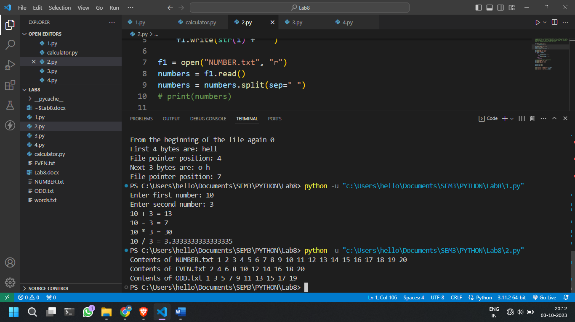

# To write a Python program to find the most frequent words in a text read from a file.

f = open("words.txt", "r")

text = f.read()

words = text.split(sep=" ")

d = {}

maxCount = 0

most_fre_word = ""

for word in words:

    if d.__contains__(word):

        d[word] = d[word] + 1

        if d[word] > maxCount:

            maxCount = d[word]

            most_fre_word = word

    else:

        d[word] = 1

print(d)

print("Most frequent word is:", most_fre_word)

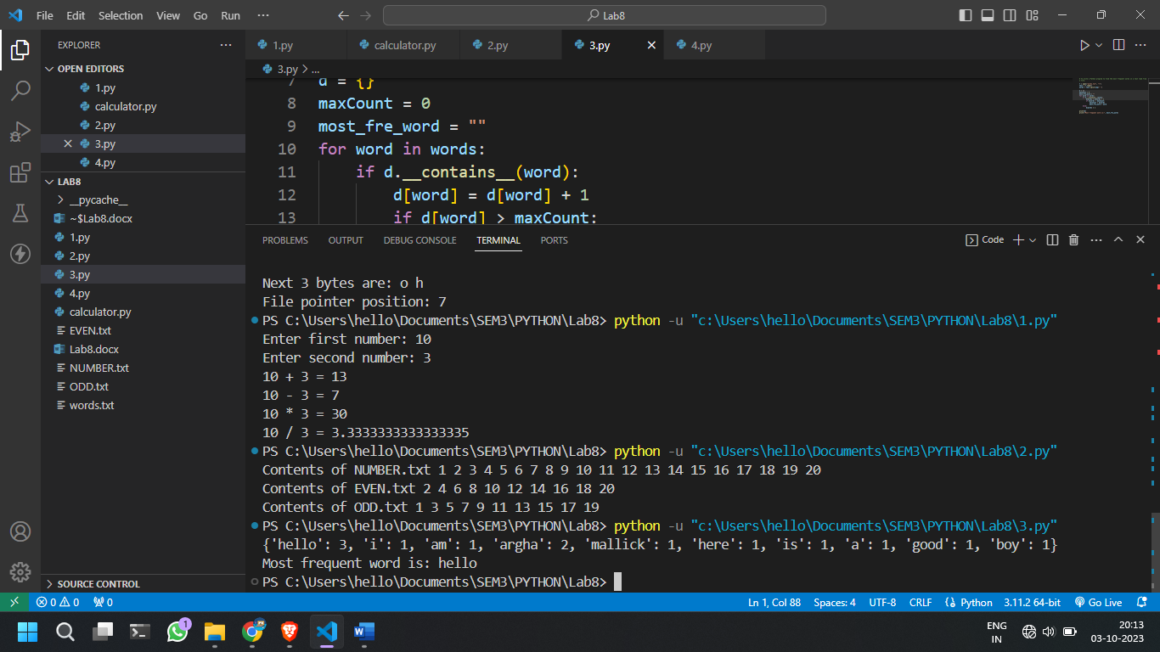

# Write a program to implement random access in a file.

f = open("words.txt", "r")

print("Before reading File pointer position:", f.tell())

s = f.read()

print("After reading the file pointer position:", f.tell())

f.seek(0)

print("From the beginning of the file again", f.tell())

s = f.read(4)

print("First 4 bytes are:", s)

print("File pointer position:", f.tell())

s = f.read(3)

print("Next 3 bytes are:", s)

print("File pointer position:", f.tell())

f.close()

