Shopping Centre Program

Arielli Ortega
https://github.com/iamarielliortegaa/shoppingcenter

Introduction
The aim of the project is to design, develop and test a shopping centre management project. The project handles inventory management of a set of products maintained in the shop and also to maintain a list of information about the customers purchasing in the shop. The project is developed using the Java FX framework which enables ability to develop GUI based applications in a very efficient way. The project mainly involves two user interfaces with one for Admin and another for regular users. Both the interfaces use their own client service behind the user interface as they both uses M V C (Model View Controller) architecture. This architecture allows the UI to either allow and not to allow certain features working. The admin user interface will be allowing admin users to perform add, remove and view the list of products and customers. But with the regular user interface, the user will be allowed to add and view the list of items but will not be able to remove any items.
The code re usability is achieved by re-using most of the views and modules from both the user interfaces. The same project is also enabled for improvements as the whole project is designed in modularity.
The data been handled in the project is permanently stored using a data manager module which will be keep tracking of any added or removed items and the same will be synced with the storage. The storage used in the project uses CSV files, where CSV files are very light and efficient to handle rather than the database involves complex initial setup and more complicated to implement.

Design

Overview
The project is about a shopping centre management tool, in which the inventory management and customer data management can be performed. The project is developed using Java FX framework which enables GUI development. The project is developed by following MVC architecture, using which the software turns in more modular, scalable, robust and easy to maintain. The project also has a storage management using which the data will be persisted permanently.
The project mainly has two separate user interfaces
1. Admin UI
2. User UI
Both the UI acts as a separate MVC application, and each of them has their own controller-view combo. These user interfaces reuses some of the common dialog windows and the storage module.

MVC Design

The project is designed using MVC architectural pattern which enables modularity by separating front end from its business logics.
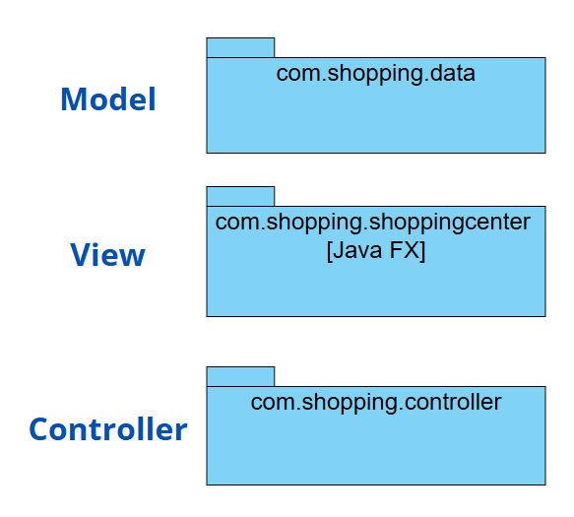

Figure 1: Architecture

Implementation

Packages
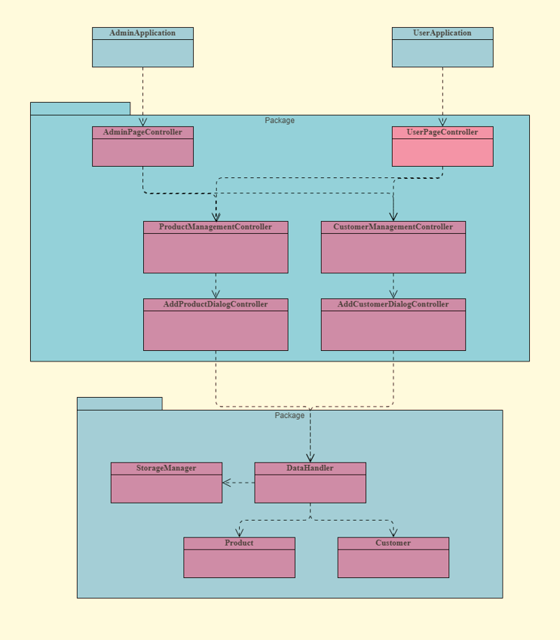
Figure 2: UML Class Diagram

The project mainly composes of 3 pacakges.
- com
  - shopping
    - shoppingcenter
    - controller
    - data
The com.shopping.shoppingcenter package mainly contains the Application classes.
- AdminApplication
The AdminApplication is an entry point for the admin uses, where the home page of the application contains manage products and manage customers buttons. The admin user has elevated privilege to perform addition and deletion operations over the product and customer data.
- UserApplication
The serApplication is an entry point for the regular uses, where the home page of the application contains manage products and manage customers buttons similar to Admin pade. The regular user has limited privilege to perform only addition operations over the product and customer data.

The com.shopping.controller package mainly contains the back end logics of all the views. The views are designed as FXML files using JavaFX application. Each of those views will be linked with its corresponding controller.

Contoller | View
AdminPageController | admin-view
UserPageController | user-view
ProductManagementController | product-management-view
CustomerManagementController | constomer-management-view
AddProductDialogController | add-product-view
AddCustomerDialogController | add-constomer-view

Admin Page
A home page for admin user with two buttons (one for manage products and another for manage customers)
User Page
A home page for regular user with two buttons (one for manage products and another for manage customers). It is very much similar to the admin page, but the internal controller restricts the deletion of any item.
Product Management Page
The product management page has a grid view with all products listed as a table. There will be an option to add new product and remove product. The same page will behave differently based on which home page invokes it (whether Admin page or User page). The remove item feature will be disabled for regular users.
Customer Management Page
The customer management page is also similar to product management page which has a grid view with all customers listed as a table. There will be an option to add new customer and remove customer. The same page will behave differently based on which home page invokes it (whether Admin page or User page). The remove item feature will be disabled for regular users.
Add Product Dialog
The Add product dialog allows user to enter all the required details of a product and the same will be added to the storage.
Add Customer Dialog
The Add customer dialog allows user to enter all the required details of a customer and the same will be added to the storage.


Development Tool
The tool used to develop the project is IntelliJ IDE.

The tool provides option to manage the code file structure efficiently by having multiple packages and folder hierarchy to maintain code modularity of MVC architecture.
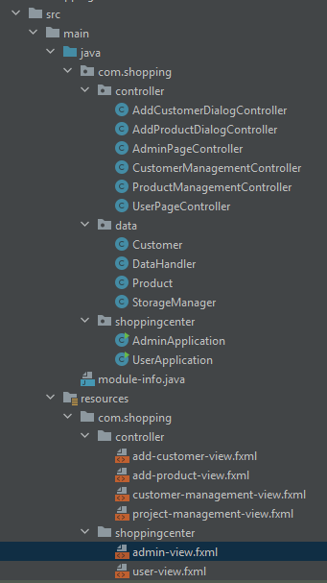
The tool has useful features such as
- Option to fix import related errors (will automatically finds the relevant package and imports it)
- Code completion auto fills the possible next statements
- Automatically identifies potential issues such as the reference of any UI element link to binding variable in the controller
- Automatically suggested to remove unused variables in the context
- Option to move any class or FXML files from one package to other

Figure 6: Architecture
The tool also provides scene builder which helps designing the UI effectively and user friendly.
The tool was very helpful while designing the UI. The tool has a pop-up dialog box helps choosing the color. The dialog automatically fills the corresponding hexcode of the chosen color.
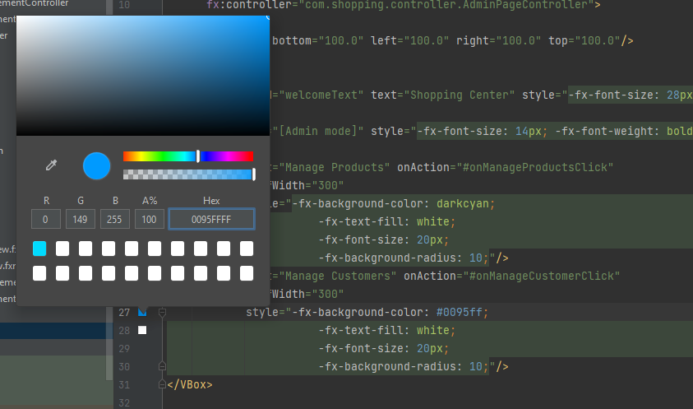

Testing
The controllers and Views are tested with manual effort by visually validating the required functionalities. The StorageManager and DataHandler classes must be tested with unit level tests as they involves major logics.

Project Management

The project follows an Incremental development approach ( alternatively called Waterfall model). The project work flow moves from various phases.
- Planning
- Design
- Development
- Test

The work flow is also monitored using a Gantt chart as shown below. Each phase and its sub development goals are monitored by plotting the planned start and duration vs actual start and durations. The unit of these charts are not in days, but it is monitored using man power hence the actual period (no. of day) will not be directly co-relates with the units in the Gantt chart.
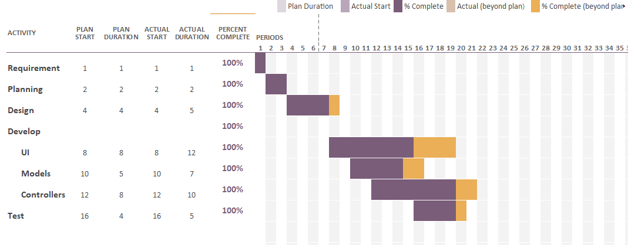

Version Controlling
The project is also maintained under a version control tool GIT. Each progress will be tracked and partial check-in made in order to keep tracking the progress as well as we can revert to a previous working version during catastrophe.

GitHub repository link : https://github.com/iamarielliortegaa/shoppingcenter

The GitHub Extensions tool has been used during the development for the checking in purpose.

Critical Review

Conclusion

Self-Evaluation
Design, Implementation & Testing : A
Project Management : A
Report : A+

References
https://docs.oracle.com/javase/8/javafx/api/javafx/scene/control/Dialog.html
https://stackoverflow.com/questions/8309981/how-to-create-and-show-common-dialog-error-warning-confirmation-in-javafx-2
https://www.tutorialspoint.com/how-to-create-a-dialog-in-javafx
https://www.youtube.com/watch?v=gLr5RcWz6x8
https://docs.oracle.com/javase/8/javafx/api/javafx/scene/layout/GridPane.html
https://jenkov.com/tutorials/javafx/gridpane.html
https://docs.oracle.com/javase/8/javafx/api/javafx/scene/control/TextField.html
https://stackoverflow.com/questions/66755318/binding-objects-in-javafx
https://www.programiz.com/java-programming/printwriter
https://www.geeksforgeeks.org/java/java-io-bufferedreader-class-java/
https://www.geeksforgeeks.org/java/file-exists-method-in-java-with-examples/
https://www.pragmaticcoding.ca/javafx/elements/observable-lists-basics
https://stackoverflow.com/questions/41920217/what-is-the-difference-between-arraylist-and-observablelist

Testing

