Age Detection
Arijit Das
ad2040@cse.jgec.ac.in

Aim :
In this project, I used Indian Movie Face database (IMFDB) to train a 4-layered Convolutional Neural Network to predict the age of a person (Young, Middle and Old) from his or her facial attributes .

Dataset :
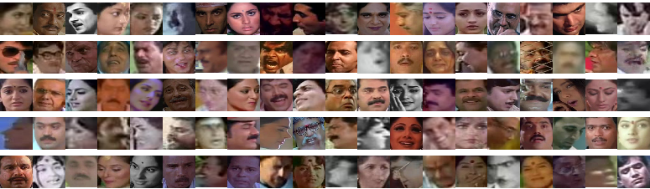
For this project I have used the IMFDB dataset which is large unconstrained face database consisting of 34512 images of 100 Indian actors collected from more than 100 videos. All the images are manually selected and cropped from the video frames resulting in a high degree of variability interms of scale, pose, expression, illumination, age, resolution, occlusion, and makeup. IMFDB is the first face database that provides a detailed annotation of every image in terms of age, pose, gender, expression and type of occlusion that may help other face related applications. The dataset is cleaned and formatted to give a total of 26742 images with 19906 images in train and 6636 images in test.

Methodology:

Data Preprocessing :
As the images are manually cropped and selected, the dataset contains images of various resolutions. As a result I resized all the images to a dimension of (28,28,3) and stored them in a numpy array of size (19906,28,28,3). Since pixel values ranges from 0 to 255 I standardized the data by dividing the pixel array by 255. All the image processing part is achieved using the opencv library of python.
The last step is One-Hot Encoding the class labels (Young, Middle, Old) for which the pandas library in python provides a handy function get_dummies().

Training :
Now comes the most crutial part – training our CNN to detect the age of an unknown face. Our model consist of the following layers – Convolutional Layer, Pooling Layer and Fully-Connected Layer. Also I used relu activation function in all the layers except the last layer where I used sigmoid activation function.

The loss function used is Categorical Crossentropy loss . It is written as :

L(y,ˆy)=−∑_{n}∑_{i}y^{(n)}_{i}logˆy^{(n)}_{i}

In the model I also use Adam optimizer for Gradient Descent Optimzation and Accuracy as our metric to measure performance.
The detailed summary of my model is as below :
_________________________________________________________________
Layer (type) Output Shape Param #
=================================================================
input_1 (InputLayer) (None, 28, 28, 3) 0
_________________________________________________________________
conv0 (Conv2D) (None, 26, 26, 32) 896
_________________________________________________________________
conv1 (Conv2D) (None, 24, 24, 64) 18496
_________________________________________________________________
bn0 (BatchNormalization) (None, 24, 24, 64) 256
_________________________________________________________________
activation_1 (Activation) (None, 24, 24, 64) 0
_________________________________________________________________
maxPool0 (MaxPooling2D) (None, 12, 12, 64) 0
_________________________________________________________________
dropout_1 (Dropout) (None, 12, 12, 64) 0
_________________________________________________________________
conv2 (Conv2D) (None, 10, 10, 128) 73856
_________________________________________________________________
bn1 (BatchNormalization) (None, 10, 10, 128) 512
_________________________________________________________________
activation_2 (Activation) (None, 10, 10, 128) 0
_________________________________________________________________
maxPool1 (MaxPooling2D) (None, 5, 5, 128) 0
_________________________________________________________________
dropout_2 (Dropout) (None, 5, 5, 128) 0
_________________________________________________________________
conv3 (Conv2D) (None, 3, 3, 256) 295168
_________________________________________________________________
bn2 (BatchNormalization) (None, 3, 3, 256) 1024
_________________________________________________________________
activation_3 (Activation) (None, 3, 3, 256) 0
_________________________________________________________________
maxPool2 (MaxPooling2D) (None, 1, 1, 256) 0
_________________________________________________________________
dropout_3 (Dropout) (None, 1, 1, 256) 0
_________________________________________________________________
flatten_1 (Flatten) (None, 256) 0
_________________________________________________________________
fc0 (Dense) (None, 128) 32896
_________________________________________________________________
dropout_4 (Dropout) (None, 128) 0
_________________________________________________________________
fc1 (Dense) (None, 64) 8256
_________________________________________________________________
dropout_5 (Dropout) (None, 64) 0
_________________________________________________________________
fc2 (Dense) (None, 3) 195
=================================================================
Total params: 431,555
Trainable params: 430,659
Non-trainable params: 896
_________________________________________________________________

Our network has 430,659 trainable parameters. For the entire training process, we used Keras library of python, which uses Tensorflow in the backend.
After training with epochs=150 we gained a training accuracy of 98.05% !

Results :
Some of the generated predictions on the test set is as follows :

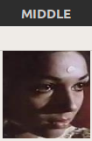

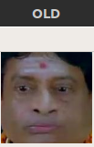

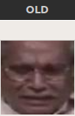
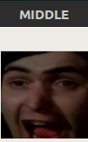
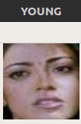

Conclusion and Future work :
Thus, we are able to train a CNN which successfully detects the age of a person . But the use of neural networks is not just limited to detecting ages . CNNs can also be used for the detection of emotions (Anger, Happiness, Sadness, Surprise, Fear, Disgust) , pose (Frontal, Left, Right, Up, Down) , gender (male, female) and other attributes from human face images. It can be applied to other fields as well such as Handwritten Digit Recognition, Object Recognition and various other domains which can futhur lead to the development of AI.

References :
- Convolutional Neural Networks for Visual Recognition by Stanford University
- A Beginner's Guide To Understanding Convolutional Neural Networks
- deeplearning.ai by Professor Andrew NG

