Employee MVC

This document outlines the step-by-step implementation of a basic **Employee Management System** (CRUD application) using **ASP.NET Core MVC** and **Entity Framework Core**.

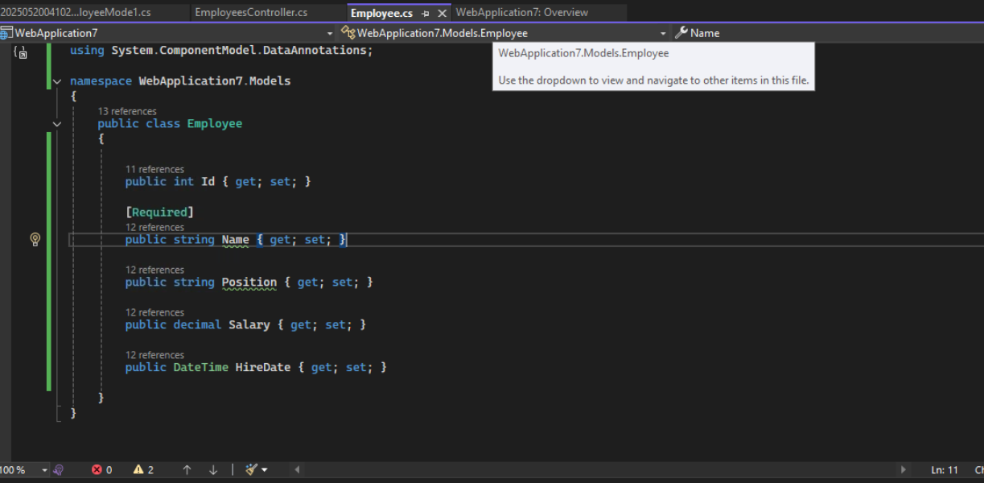

Creating Controller

Constructor injection is used to get access to the database context.

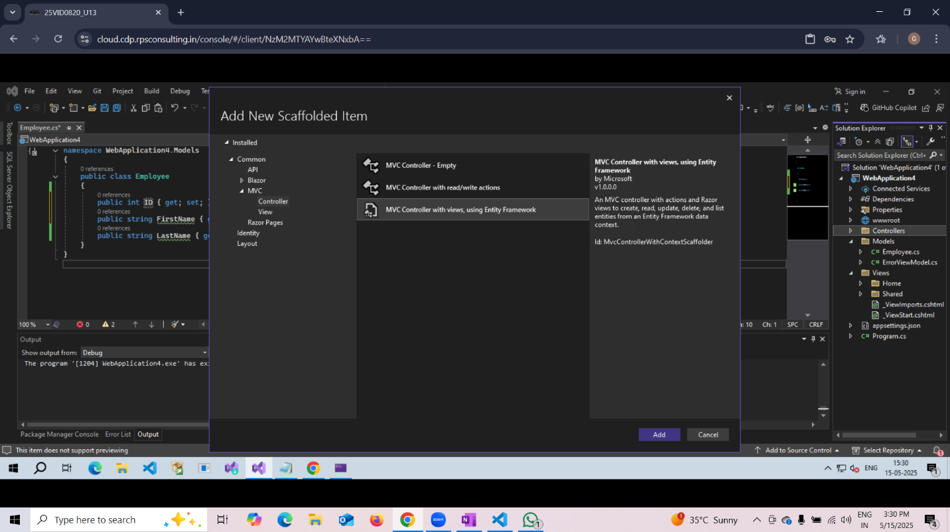

Adding Migration



Updating the database



After updating the database viewing and running the work on the web

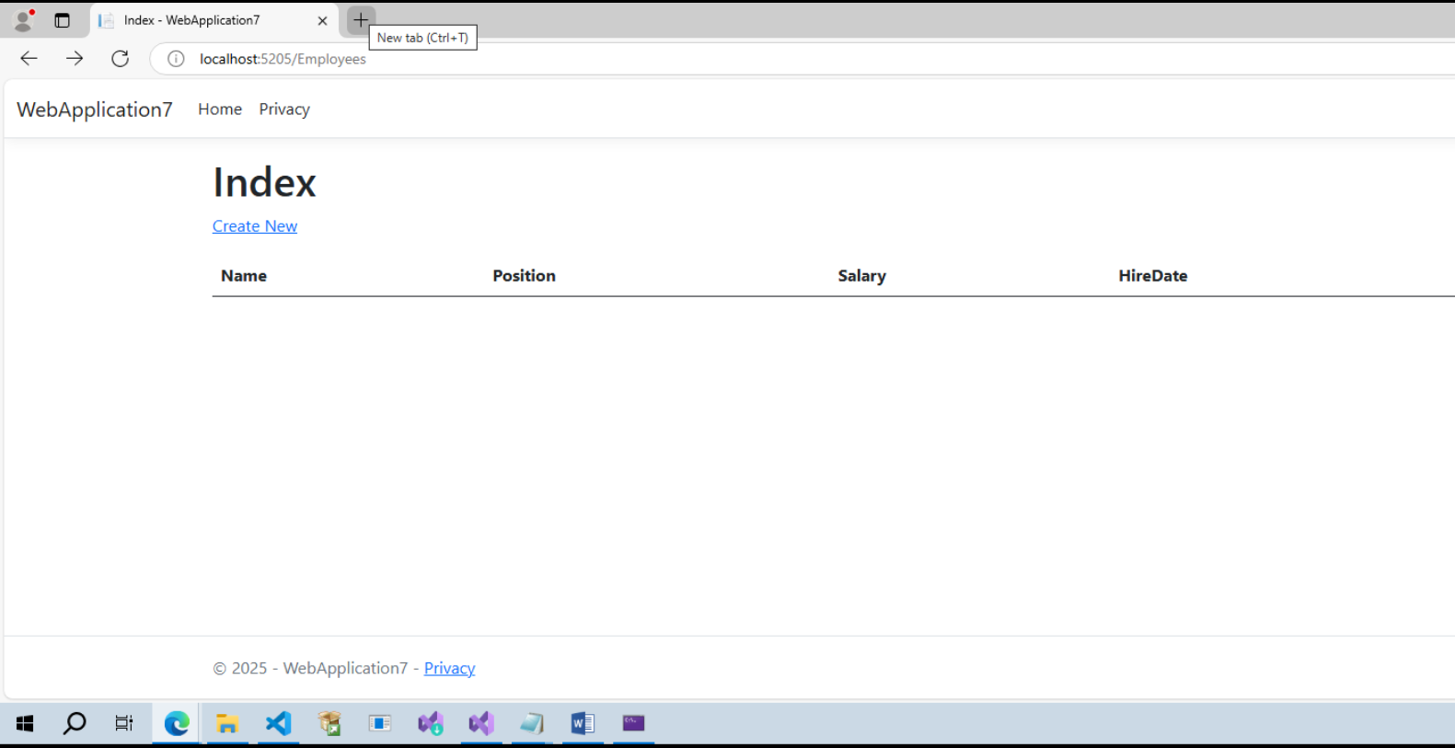

Adding data in the database (part of CRUD operations)



Updating the database from the web

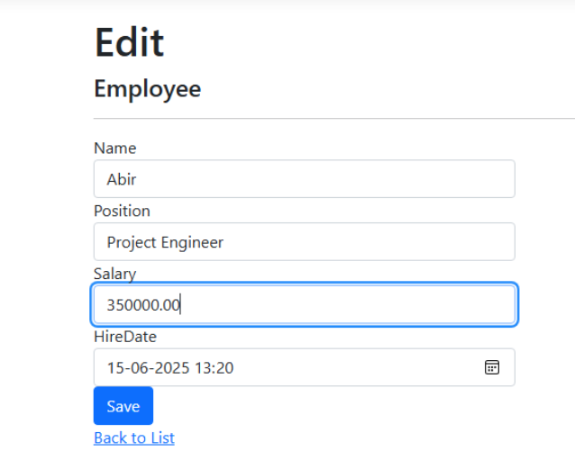

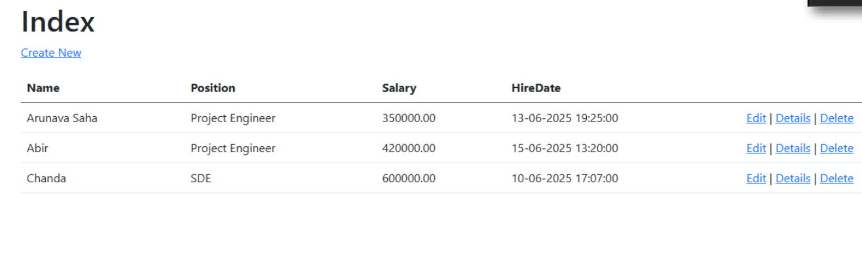

Deleting the data



