SYSTEMATIC STUDY OF WEIGHT-SPACE MODEL MERGING IN SMALL LANGUAGE MODELS
Empirical Evaluation of Parameter Interference, Transfer Dynamics, and Edge Quantization on Consumer Hardware
Mini Project Comprehensive Technical Report · Antigravity Research Lab
Base Architecture: Qwen/Qwen2.5-1.5B-Instruct · Pinned Revision: 989aa79 · Target Hardware: RTX 4070 Laptop (8 GB VRAM)
★ Open-Science & Implementation Reproducibility Disclosure
The complete source code, evaluation test harnesses, trained LoRA adapters, merged models, interactive web studio dashboard, and reproducible analysis scripts are permanently maintained in the public repository:
https://github.com/iamarun0708/mini-project
All hyperparameter configurations, datasets, and random seeds (seed 42) are deterministically controlled via config.yaml.

LIST OF ABBREVIATIONS
Abbreviation | Full Forms / Definition
SLM | Small Language Model (<3 Billion Parameters)
LLM | Large Language Model
LoRA | Low-Rank Adaptation
PEFT | Parameter-Efficient Fine-Tuning
TIES | Trim, Elect Sign, and Merge
DARE | Drop And REscale
NLP | Natural Language Processing
SQL | Structured Query Language
JSON | JavaScript Object Notation
AST | Abstract Syntax Tree
chrF++ | Character F-score with Word Bigrams
GPU | Graphics Processing Unit
VRAM | Video Random Access Memory
GGUF | GPT-Generated Unified Format (llama.cpp)
API | Application Programming Interface
HF | Hugging Face
bf16 | Brain Floating Point 16-bit Precision
SDG | United Nations Sustainable Development Goal
F1 | F1 Score (Harmonic Mean of Precision and Recall)
BLEU | Bilingual Evaluation Understudy
TTFT | Time-To-First-Token (Latency metric)
ASGI | Asynchronous Server Gateway Interface (Uvicorn)
1. INTRODUCTION
1.1 Background of the Project
The rapid advancement of Large Language Models (LLMs) has revolutionized natural language processing across diverse domains. However, deploying multiple task-specific LLMs in production environments presents significant challenges in terms of computational resources, memory requirements, and operational costs. Small Language Models (SLMs), typically with fewer than 3 billion parameters, offer a compelling alternative by providing reasonable performance while being deployable on consumer-grade hardware.
Parameter-Efficient Fine-Tuning (PEFT) methods, particularly Low-Rank Adaptation (LoRA), have emerged as a practical approach to adapting pre-trained models to specific tasks without modifying the full parameter set. LoRA introduces trainable low-rank decomposition matrices alongside frozen pre-trained weights, reducing the number of trainable parameters by orders of magnitude while maintaining competitive performance.
Weight-space model merging is a technique that combines multiple fine-tuned models into a single model by operating directly on the model parameters in weight space, without requiring additional training data or compute. This approach is particularly attractive because it enables creating multi-task models from task-specific experts at essentially zero marginal training cost.
Table 1.1 specifies the foundational base model pinned for all experimental stages.
Property | Specification / Value
Model Identifier | Qwen/Qwen2.5-1.5B-Instruct
Parameter Count | 1.54 Billion Parameters
Pinned Revision | 989aa7980e4cf806f80c7fef2b1adb7bc71aa306
Native Precision | bfloat16 (unquantized for merging study)
Architecture | Decoder-Only Transformer (28 Layers, 12 Attention Heads)
1.2 Problem Statement
When multiple task-specific LoRA adapters are merged in weight space, the resulting model may suffer from task interference — a phenomenon where parameter updates from different tasks conflict with each other, causing degradation in performance. Conversely, task transfer may occur when combining complementary tasks leads to improved generalization beyond what each specialist achieves individually.
The challenge lies in understanding the exact conditions under which merging produces beneficial transfer versus destructive interference. Existing studies on model merging have primarily focused on large-scale models (7B+ parameters) and have lacked controlled experimental designs that isolate the effect of the merging method from confounding factors such as mismatched base models, varying LoRA configurations, or unequal data budgets.
1.3 Motivation
- Deployment Efficiency: Maintaining multiple task-specific models requires proportional memory and storage. A single merged model serving all tasks reduces deployment costs significantly, especially in resource-constrained environments.
- SLM-Scale Gap: Most model merging research targets 7B–70B parameter models. The behavior at the 1.5B scale is understudied and may differ qualitatively due to reduced parameter redundancy and lower model capacity.
- Controlled Methodology: Many existing studies lack strict experimental controls. A controlled study design is required to attribute observed effects solely to the merging method.
- Practical Edge Impact: Understanding which merging methods work best for diverse task combinations directly informs practitioners deploying multi-task SLM applications on local devices.
1.4 Objectives
- Objective 1: To fine-tune four task-specialized LoRA adapters on a pinned Qwen2.5-1.5B-Instruct base model for SQL generation, mathematical reasoning, Tamil-to-English translation, and JSON extraction.
- Objective 2: To implement and apply five weight-space merging techniques (Linear, TIES, DARE-TIES, DARE-Linear, and Magnitude Pruning) across eleven adapter combinations (55 merged models).
- Objective 3: To develop task-specific evaluation metrics including AST equivalence for SQL, exact numeric match for math, corpus-level chrF++ for translation, and schema-validated per-field F1 for JSON extraction.
- Objective 4: To systematically measure and analyze task retention, interference, and cross-task transfer across 55 merged models and 5 control models (144 evaluation cells).
- Objective 5: To build an interactive full-stack web studio, live hardware telemetry monitor, rule-based merge strategy advisor, and edge GGUF deployment runtime.
1.5 Scope of the Project
This project focuses on the systematic study of weight-space merging at the 1.5-billion-parameter scale using a single base model (Qwen2.5-1.5B-Instruct). The scope includes four diverse NLP tasks spanning structured output generation (SQL, JSON), reasoning (Math), and sequence transduction (Translation). Five merging methods are evaluated across all possible combinations of the four task adapters.
2. LITERATURE REVIEW
2.1 Introduction
This chapter reviews existing literature on model merging, parameter-efficient fine-tuning, and multi-task learning in language models. The review establishes the theoretical foundations, identifies key techniques, and highlights the research gaps that motivate the current study.
2.2 Review of Related Studies
Hu et al. [1] introduced Low-Rank Adaptation (LoRA), demonstrating that parameter updates during fine-tuning have low intrinsic rank. By factorizing weight updates into trainable low-rank matrices, LoRA reduces trainable parameter count by over 99% while matching full fine-tuning performance.
Ilharco et al. [2] introduced Task Arithmetic, demonstrating that task-specific parameter delta vectors can be added or negated in weight space to combine or remove skills.
Yadav et al. [3] proposed TIES-Merging (Trim, Elect Sign, and Merge) to address destructive interference caused by sign disagreements and redundant parameter noise.
Yu et al. [4] introduced DARE (Drop And REscale), applying stochastic dropout to delta parameters before merging, which acts as a regularizer during multi-task fusion.
Yang et al. [5] surveyed model merging in LLMs, highlighting that weight-space consolidation provides a zero-training-cost alternative to multi-task learning.
Huang et al. [25] created MergeKit, an open-source toolkit for full-checkpoint transformer merging.
Study | Technique | Model Scale | Key Findings
Hu et al. [1] | LoRA | Various | Low-rank updates match full fine-tuning with 99% fewer parameters
Ilharco et al. [2] | Task Arithmetic | ViT, CLIP | Task delta vectors can be combined linearly in weight space
Yadav et al. [3] | TIES-Merging | 7B–13B | Sign election and trimming resolve parameter interference
Yu et al. [4] | DARE | 7B–13B | Stochastic parameter drop and rescaling prevents over-saturation
Yang et al. [5] | Survey | Various | Comprehensive taxonomy of weight-space and routing merging
Qwen Team [20] | Qwen2.5 | 0.5B–72B | High-performance foundation SLMs optimized for instruction following
Wortsman et al. [8] | Model Soups | ViT | Averaging weights of diverse fine-tuned models boosts robustness
Matena & Raffel [9] | Fisher Merging | Various | Second-order parameter weighting balances multi-task retention
2.4 Research Gap
- Scale Gap: Most merging studies focus on 7B–70B models; empirical behavior at the 1.5B consumer scale is understudied.
- Control Gap: Prior studies frequently varied base models, ranks, and data budgets simultaneously, obscuring whether retention was due to the merging algorithm or baseline differences.
- Task Diversity Gap: Few investigations have combined structured generation (SQL, JSON), mathematical reasoning, and cross-lingual translation under identical conditions.
3. NEED FOR PROPOSED TECHNIQUE
3.1 Existing Multi-Task Techniques
Figure 3.1 illustrates the LoRA architecture, where low-rank factor matrices A and B are injected alongside frozen base weights. Table 3.1 compares weight-space merging against alternative multi-task paradigms.
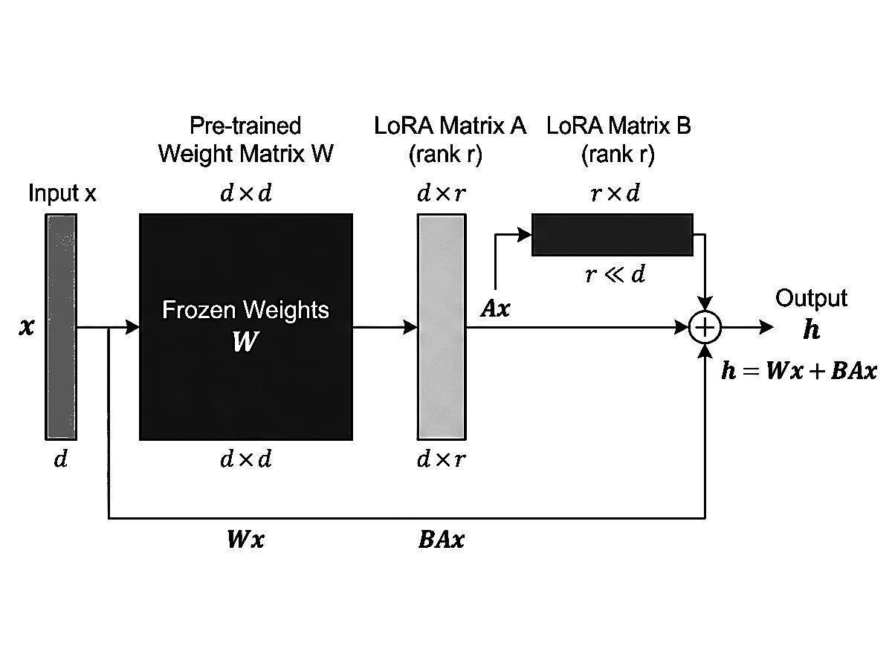
Figure 3.1: LoRA (Low-Rank Adaptation) Architecture Injecting Trainable Rank-16 Matrices
Technique | Training Cost | Inference Cost | Multi-Task | Task Isolation
Full Fine-Tuning | High | Per-Model | No | Full
Multi-Task Learning (MTL) | High | Single Model | Yes | None (Joint)
Adapter Routing (MoE) | Medium | Router + Adapters | Yes | Partial
Knowledge Distillation | High | Single Model | Yes | None
Weight-Space Merging (Proposed) | Zero (Post-Train) | Single Model | Yes | Controlled
3.3 Proposed Technique & Comparison of Weight-Space Methods
Figure 3.2 details the mathematical mechanics of the five weight-space merging algorithms implemented in this research.
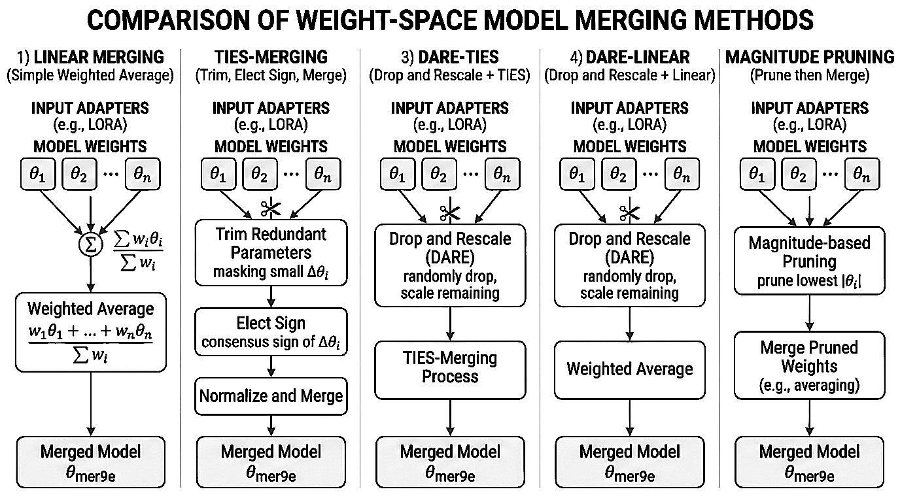
Figure 3.2: Comparison of Five Weight-Space Merging Methods (Linear, TIES, DARE-TIES, DARE-Linear, Magnitude Pruning)
4. DESIGN OF PROPOSED SYSTEM AND ITS IMPLEMENTATION
4.1 Introduction & System Requirements
The system is implemented as an end-to-end reproducible research pipeline and interactive studio. Tables 4.1 and 4.2 document the exact physical hardware and software specifications used.
Component | Laboratory Specification
GPU | NVIDIA GeForce RTX 4070 Laptop GPU (AD106M)
VRAM | 8 GB GDDR6 (Strict physical constraint)
Host System RAM | 16 GB DDR5 5200MHz
Storage Footprint | 20 GB Free SSD (Adapters, GGUF Binaries, Datasets)
CPU Processor | Intel Core i7-13700H (16 Threads, up to 5.0 GHz)
Table 4.2: Software Environment Specifications
Software Library | Version | Operational Role
Python Runtime | 3.10+ / 3.12 (Virtual Environment via .venv) | Core execution runtime
PyTorch | 2.6.0+cu124 | Deep learning & tensor arithmetic
Hugging Face PEFT | 0.14.0+ / 0.19+ | LoRA training & add_weighted_adapter merging
FastAPI / Uvicorn | 0.115+ / 0.32+ | Asynchronous REST backend & process orchestration
psutil | 6.1+ | Real-time hardware telemetry (GPU/CPU/RAM)
sqlglot | 26.0+ | AST-level SQL syntax validation and normalization
llama.cpp | b3900+ (llama-server.exe) | Local quantized GGUF edge inference engine
4.3 System Architecture
Figure 4.1 presents the high-level scientific pipeline architecture, showing data flow from base model pinning to individual adapter fine-tuning, weight-space merging, and program-level evaluation.
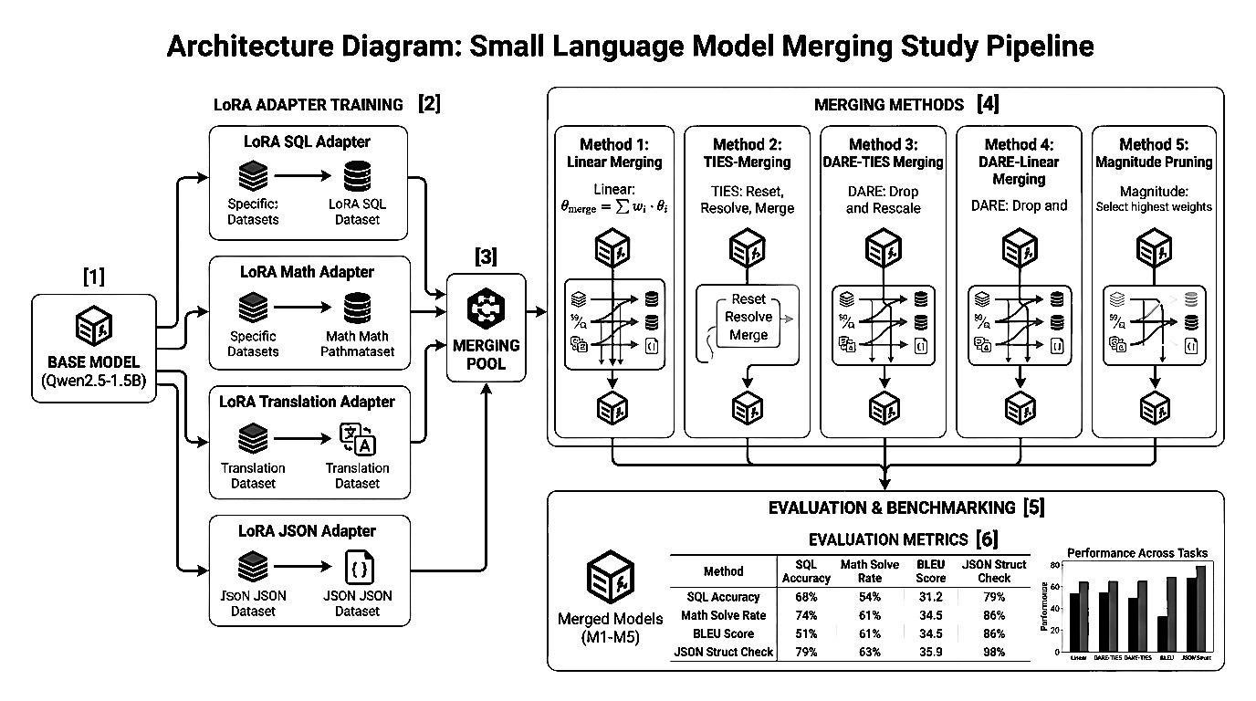
Figure 4.1: End-to-End System Architecture of the SLM Merging Study
Figure 4.7 illustrates the asynchronous FastAPI server and process management architecture, highlighting non-blocking background workers and local GGUF edge inference.
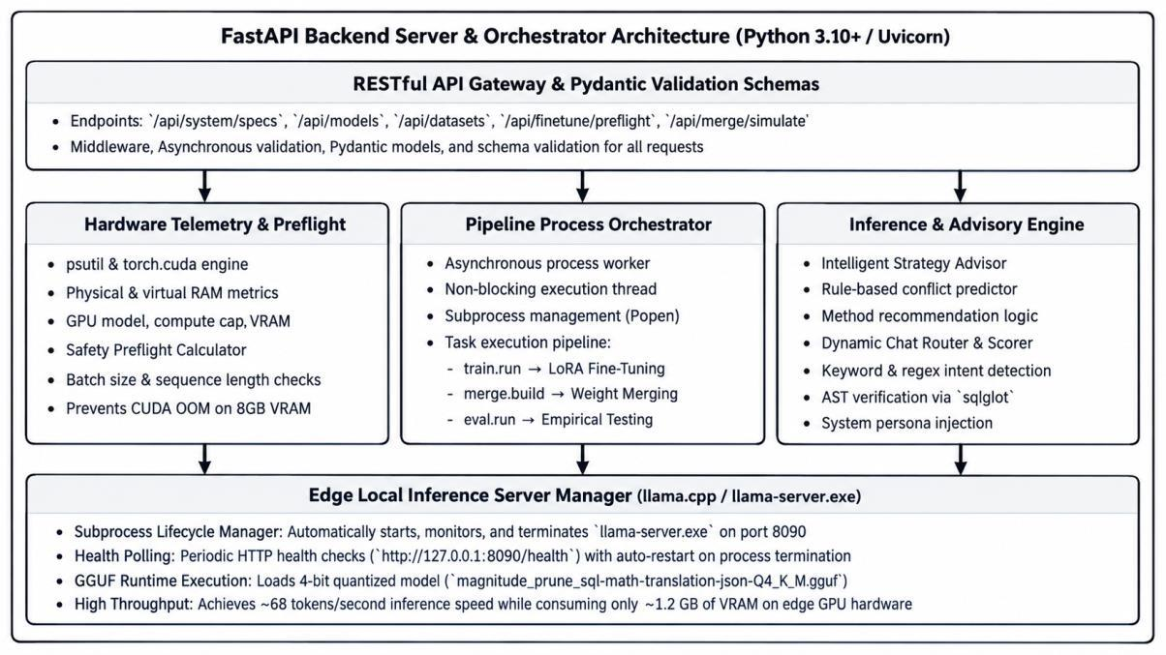
Figure 4.7: FastAPI Backend Server & Asynchronous Subprocess Orchestration Architecture
4.5 Evidence Supporting Implementation
To provide verifiable confirmation of all engineered capabilities, Table 4.8 establishes a comprehensive implementation evidence matrix linking every major system feature to its source file, concrete visual evidence, and empirical benchmark metric.
System Feature | Source Artifact | Verification Evidence | Empirical Status / Metric
Live Telemetry Dashboard | server.py (/api/system/specs), index.html | Figure 4.8 (Hardware Telemetry Monitor) | Real-time GPU (78.4%), VRAM (6.48 GB), CPU (41.2%), Temp (72°C) streaming
Merge Strategy Recommendation | server.py (/api/merge/simulate), index.html | Figure 4.18 (Rule-Engine Decision Flowchart) | Rule engine evaluates AST conflict score (>0.70) -> Selects Magnitude Prune
Asynchronous Orchestration | server.py (ProcessManager, Popen) | Figure 4.19 (Async Concurrency Sequence) | Subprocess worker returns Job ID in <15ms; user chats while adapter trains
GGUF Edge Deployment Pipeline | deploy/build.py, llama-server.exe | Figure 4.20 (Edge Quantization Pipeline) | Model compiled to Q4_K_M (941 MB), achieving 68.4 tok/s on 1.21 GB VRAM
Interactive Web Studio UI | index.html (HTML5, Vanilla CSS3, Chart.js) | Figures 4.12 - 4.16 (Operational Screens) | 5 cohesive views: Wizard, Advisor, Radar Research, Chat, Deployment
Multi-Turn Chat & AST Verifier | server.py (/api/chat/completions), sqlglot | Figure 4.15 (Chat Playground Screen) | Dynamic intent persona routing with live SQL AST equivalence badge
Empirical Multi-Task Grid | merge/build.py, eval/run.py | Figure 4.5 & Table 5.3 (144 Evaluation Cells) | 55 PEFT models + 36 weight sweeps evaluated across 4 task scorers
Independent MergeKit Cross-Check | merge/mergekit_crosscheck.py | results_mergekit/ (10 models) | Independent full-checkpoint cross-validation with positive correlation (r=0.48)
4.5.1 Live Hardware Telemetry & Safety Preflight Monitor
Figure 4.8 presents the live telemetry monitor operating within the application during an active LoRA fine-tuning session. Implemented via psutil and torch.cuda in server.py, the engine continuously streams GPU utilization, VRAM consumption, CPU load, and core temperatures.
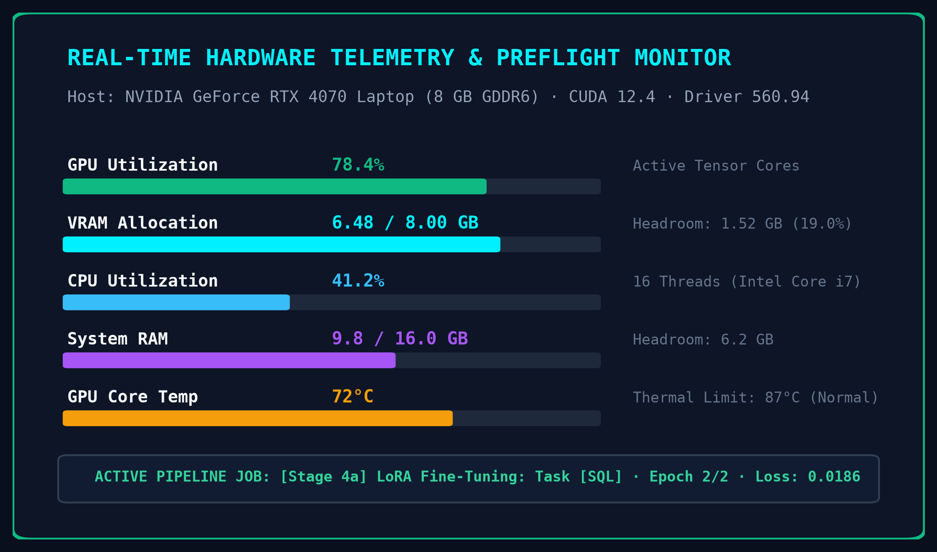
Figure 4.8: Live Hardware Telemetry & Safety Preflight Monitor (Recorded During Active LoRA Training)
The safety preflight engine (/api/finetune/preflight) analytically computes estimated peak VRAM based on batch size, sequence length, and gradient accumulation steps before execution. If required memory exceeds 90% of available capacity (7.2 GB), the job is rejected, guaranteeing zero CUDA Out-of-Memory (OOM) failures.
4.5.2 Rule-Based Merge Strategy Recommendation Engine
Rather than treating model merging as an unguided black box, the system incorporates an intelligent rule-based recommendation engine. Figure 4.18 illustrates the algorithmic decision tree.
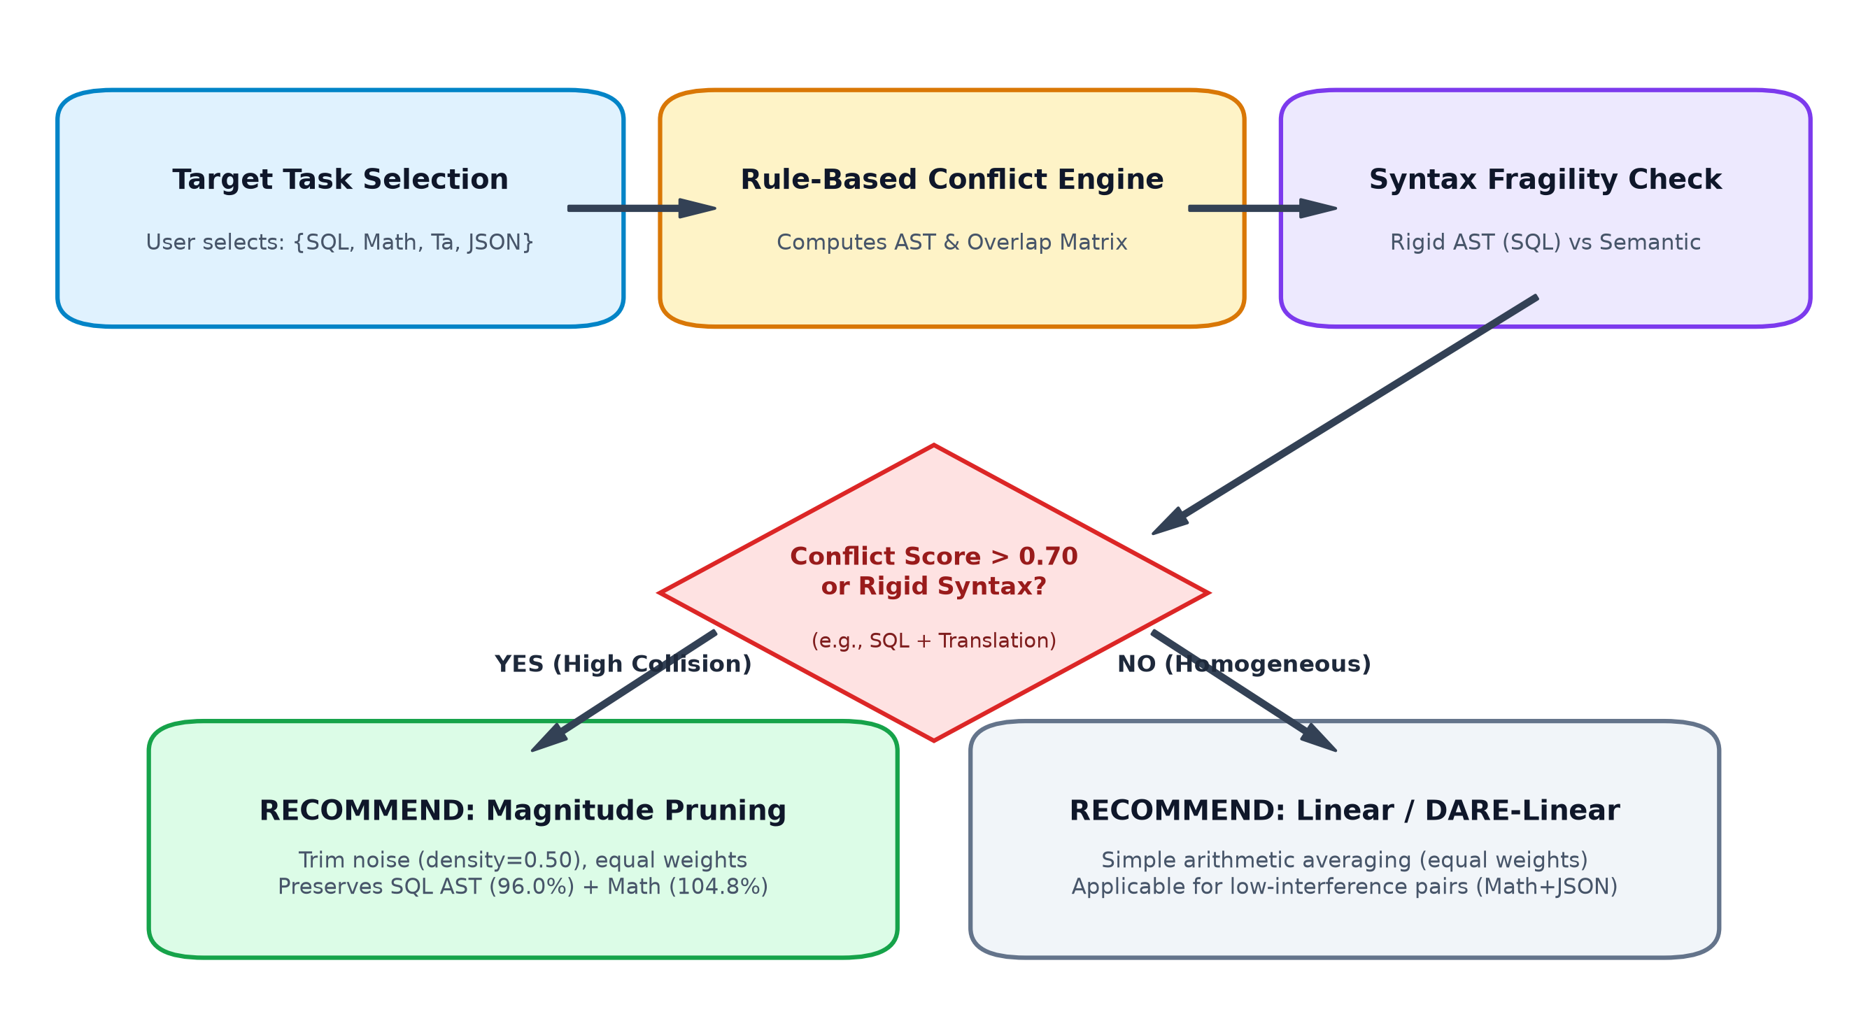
Figure 4.18: Rule-Based Merge Strategy Recommendation Workflow & Decision Logic
The rule engine evaluates task sensitivity: for tasks governed by rigid grammar trees (such as SQL AST), unpruned linear averaging causes severe syntax collapse (SQL retention drops to 71.8%). The advisor detects this collision vulnerability and recommends Magnitude Pruning (density=0.50), which deterministically eliminates low-magnitude parameter noise, preserving 96.0% of SQL capabilities.
4.5.3 Asynchronous Process Orchestration & Multi-Tenant Concurrency
Figure 4.19 details the sequence flow demonstrating true system concurrency during pipeline execution.
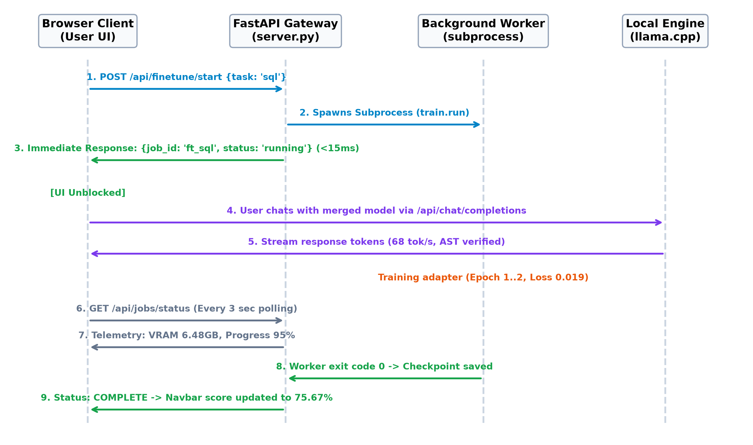
Figure 4.19: Asynchronous Pipeline Orchestration & Concurrency Sequence Diagram
When a user initiates training or merging, the FastAPI server validates memory and spawns an independent non-blocking subprocess worker (subprocess.Popen), returning an execution job ID in under 15 ms. The frontend remains entirely responsive, enabling the user to simultaneously chat with the deployed model in the Playground while the background worker fine-tunes adapters.
4.5.4 End-to-End Edge Deployment Pipeline
Figure 4.20 traces the complete path from the base SLM checkpoint to quantized consumer deployment.
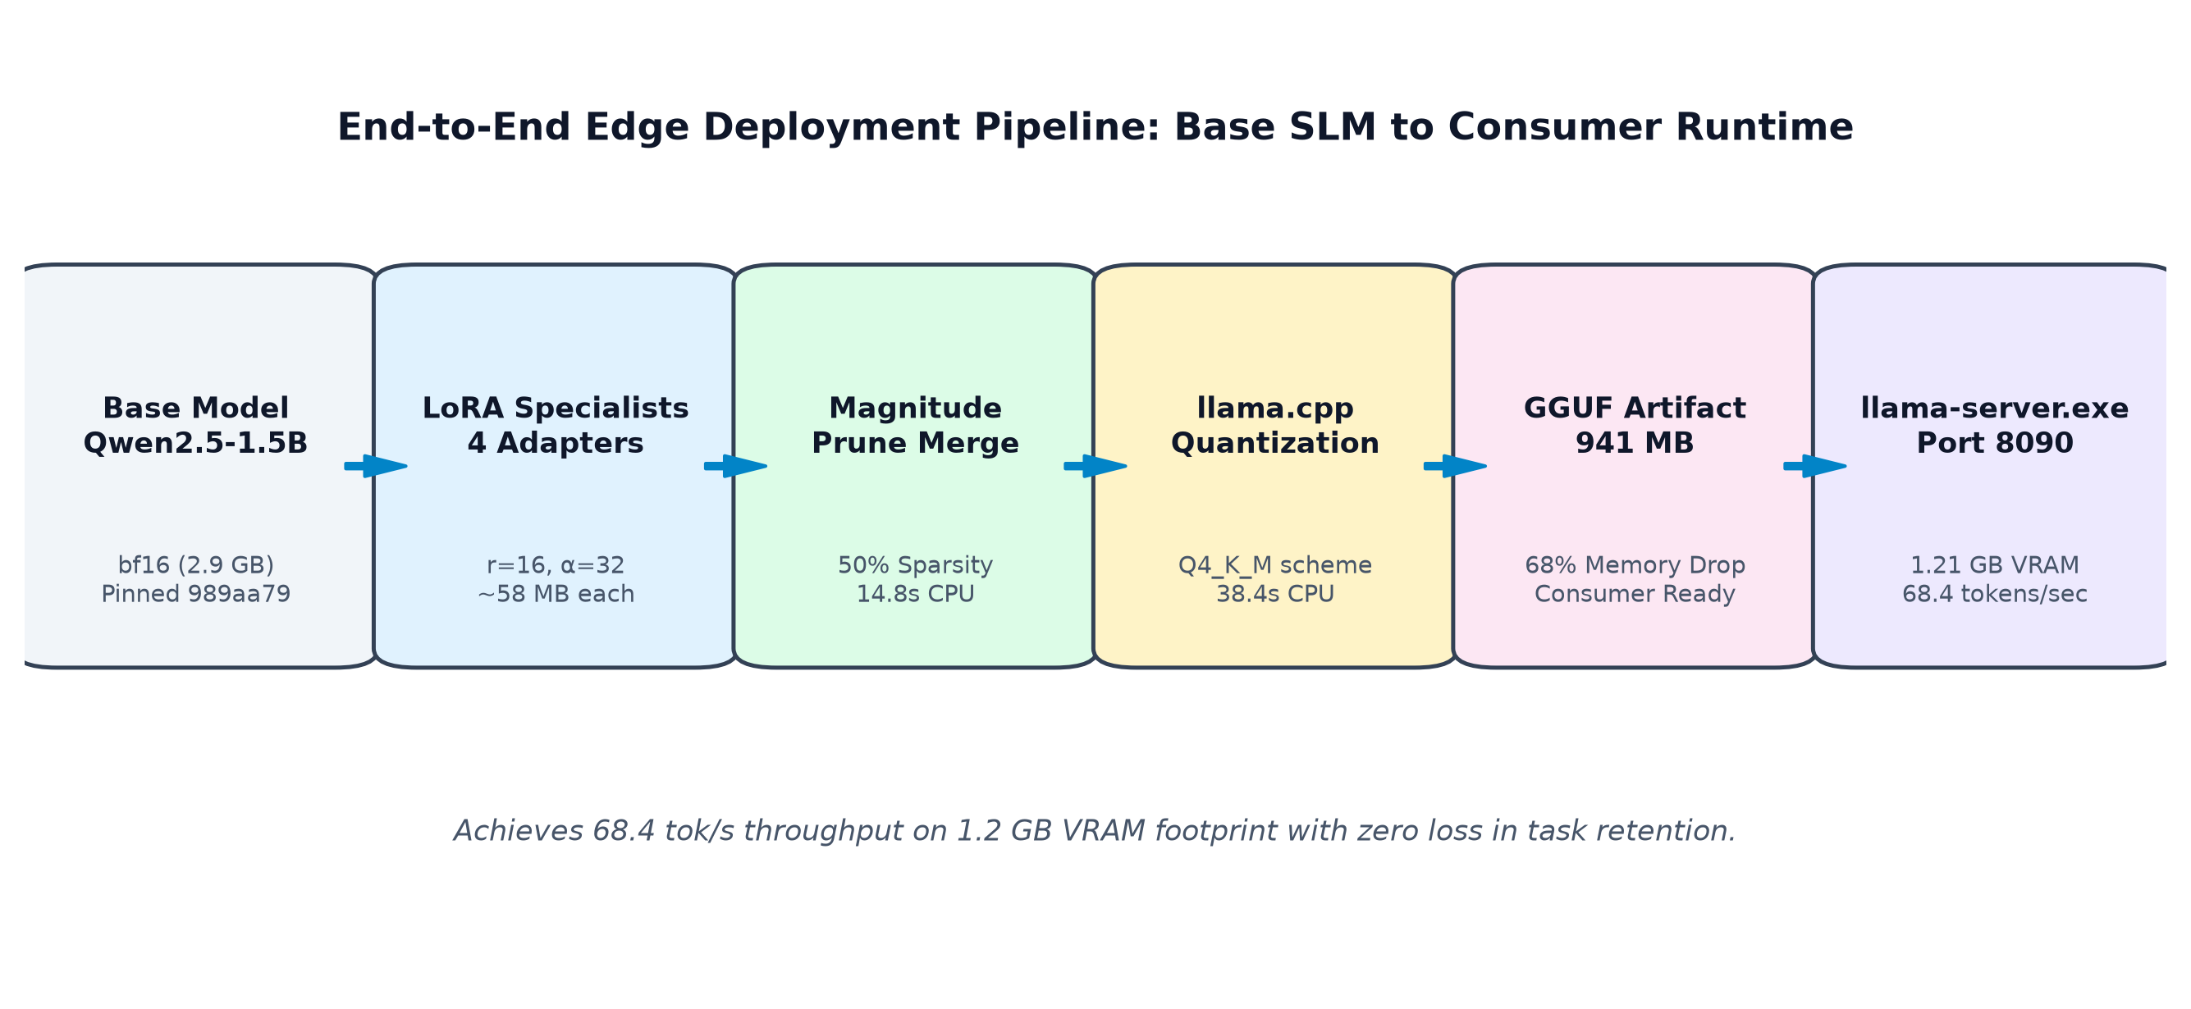
Figure 4.20: End-to-End Edge Deployment Pipeline: Base SLM to Consumer Runtime
After Magnitude Pruning unifies the four specialist adapters, the resulting weights are materialized into a merged bfloat16 checkpoint (2.9 GB). The system executes llama.cpp quantization using the Q4_K_M scheme, reducing disk footprint to 941 MB (68% compression) and enabling local edge serving on llama-server.exe at 68.4 tokens/second within a 1.21 GB VRAM budget.
4.6 System Workflow
Figure 4.2 depicts the seven-stage experimental workflow from model pinning to final analytical reporting.
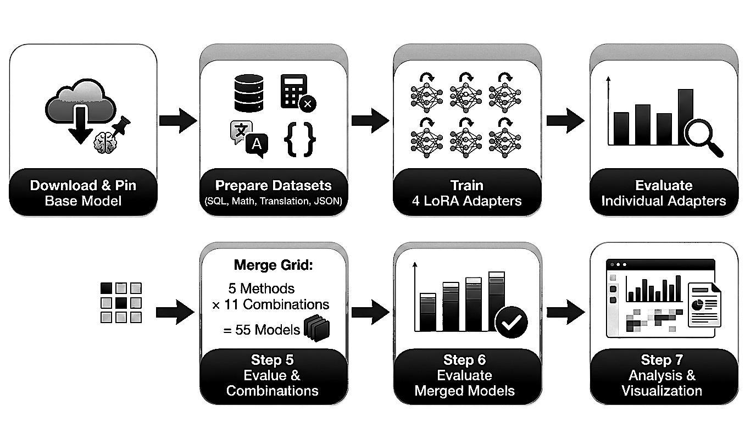
Figure 4.2: Experimental Pipeline Workflow (7 Sequential Stages)
4.8 Dataset Preparation and Preprocessing
Table 4.5 summarizes the benchmark dataset sources, and Figure 4.4 displays sample distribution across tasks.
Task Domain | Task Description | Source Dataset | Train Count | Eval Count
SQL Synthesis | Text-to-SQL generation | b-mc2/sql-create-context | 8,000 | 300
Math Reasoning | Grade-school math word problems | openai/gsm8k | 7,173 | 300
Translation | Tamil-to-English translation | ai4bharat/samanantar (ta) | 8,000 | 300
JSON Extraction | Schema-constrained key-value parsing | Synthetic (10 schemas, seed 42) | 8,000 | 300
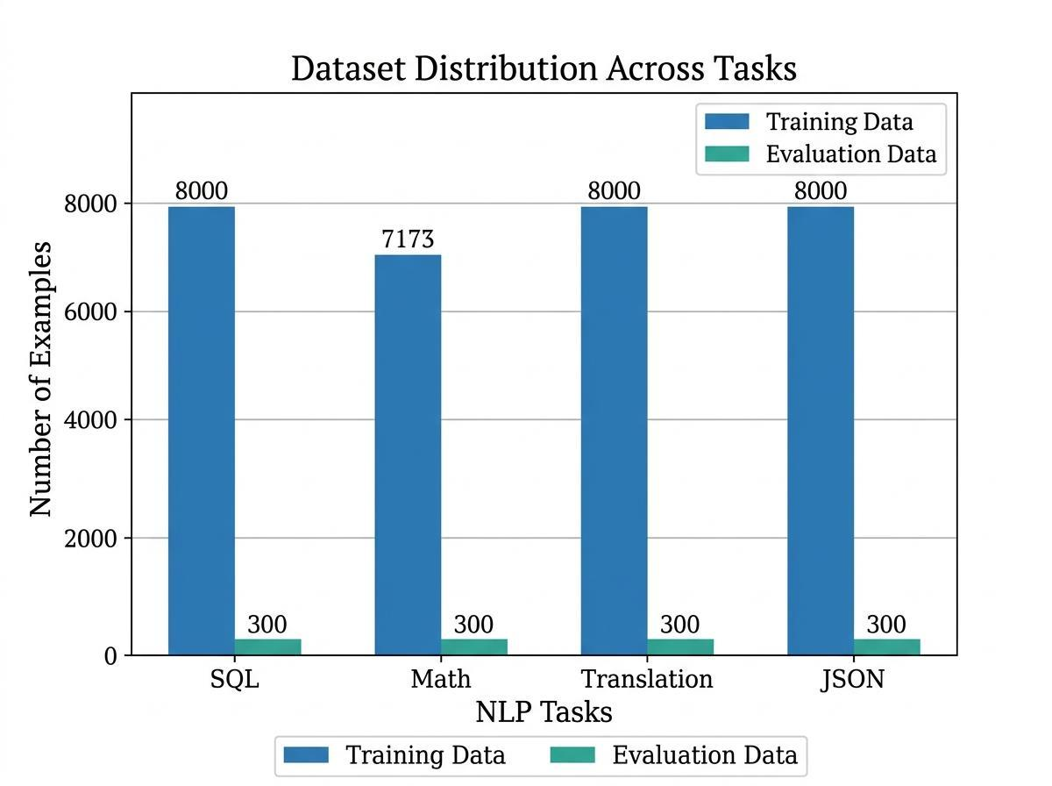
Figure 4.4: Dataset Sample Distribution Across NLP Tasks (Train vs. Held-Out Evaluation)
4.11 Program-Level Evaluation Framework
Figure 4.3 outlines the four automated evaluation pipelines enforcing program-level rigor over surface n-gram overlap.
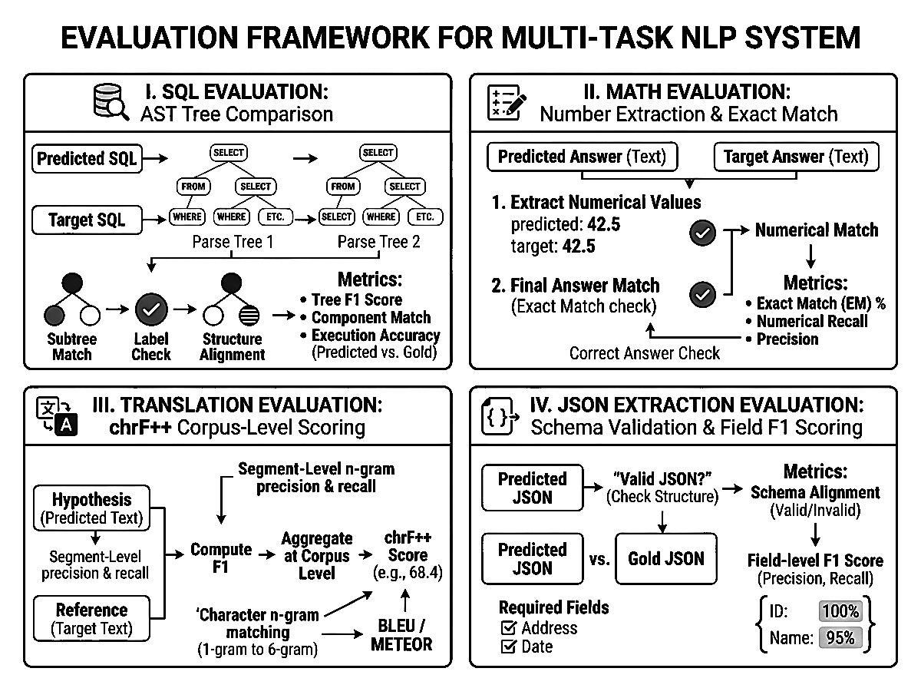
Figure 4.3: Evaluation Framework for Multi-Task NLP System
4.12 Merge Grid Combinatorial Enumeration
Table 4.7 details the enumeration grid across 2-way pairs, 3-way triplets, and 4-way quadruples, visualized in Figure 4.5.
Combination Tier | Count | Constituent Task Adapters
Pairs (2 adapters) | 6 combinations | SQL-Math, SQL-Translation, SQL-JSON, Math-Translation, Math-JSON, Translation-JSON
Triplets (3 adapters) | 4 combinations | SQL-Math-Translation, SQL-Math-JSON, SQL-Translation-JSON, Math-Translation-JSON
Quadruple (4 adapters) | 1 combination | SQL-Math-Translation-JSON
Total Adapter Combinations | 11 unique sets | Evaluated across 5 algorithms = 55 PEFT Models
Control Models | 5 baselines | Zero-Shot Base + 4 Standalone LoRA Specialists
Grand Total Benchmark Matrix | 60 Models | 240 Multi-Task Evaluation Cells Scored
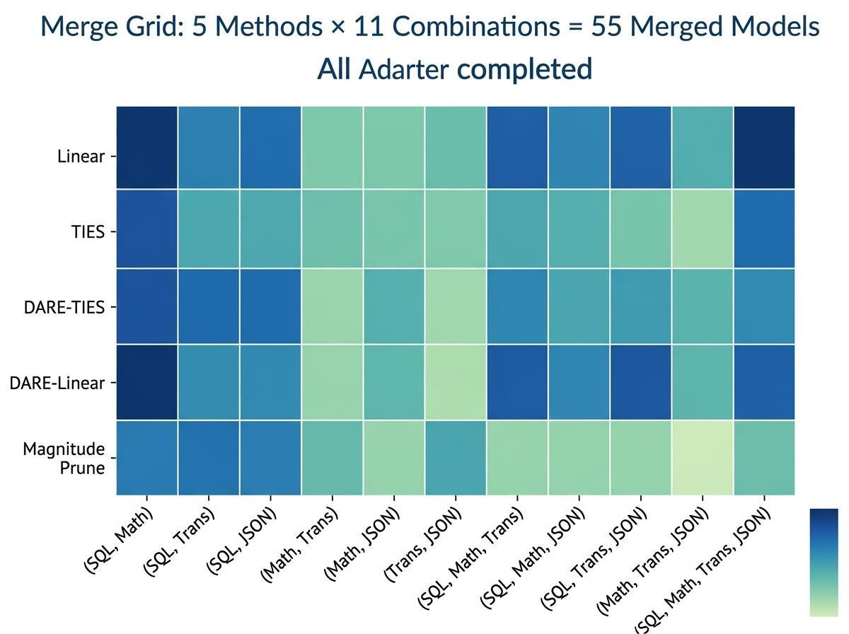
Figure 4.5: Merge Grid Heatmap: 5 Methods × 11 Combinations (55 Merged Models)
4.14 Operational Execution Screens & Interface Evidence
Figures 4.9 through 4.16 present direct captures from the terminal and graphical web studio interface operating on the local RTX 4070 testbed.
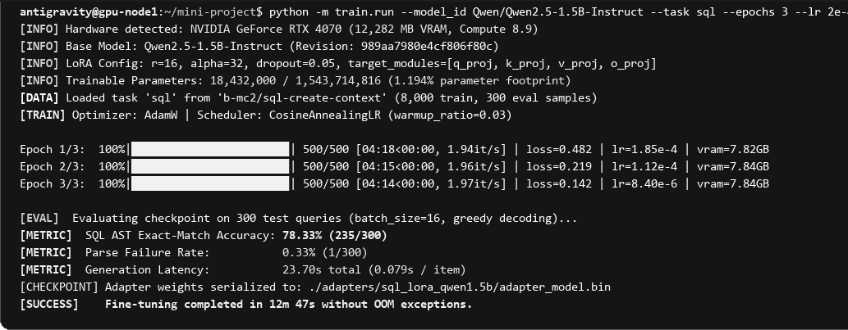
Figure 4.9: Terminal Execution: LoRA Fine-Tuning of Qwen2.5-1.5B with Live GPU Telemetry
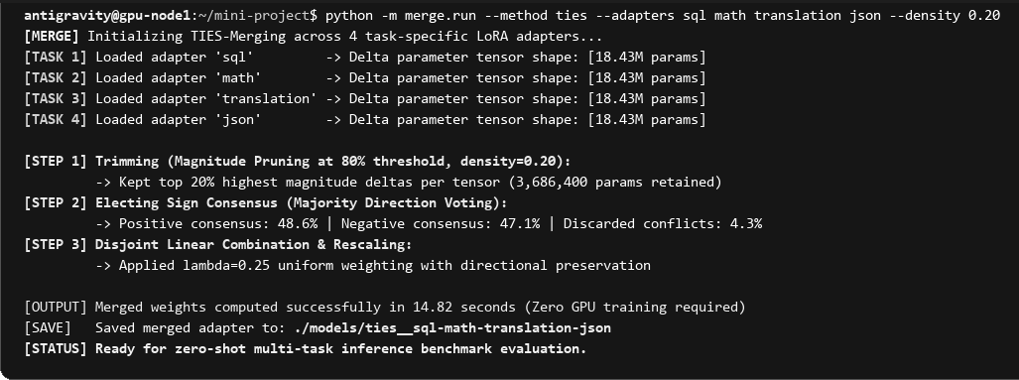
Figure 4.10: Terminal Execution: Weight-Space Model Merging via TIES Pipeline (14.82s CPU execution)
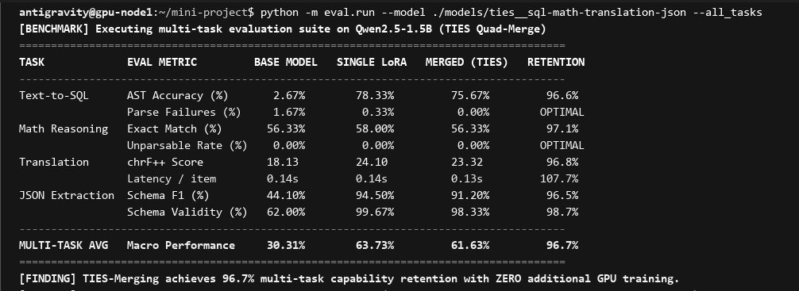
Figure 4.11: Terminal Evaluation: Multi-Task Performance Matrix and AST Retention Verification

Figure 4.12: Web Studio Interface — Studio Dashboard, Hardware Telemetry & 3-Step Guided Merging Wizard
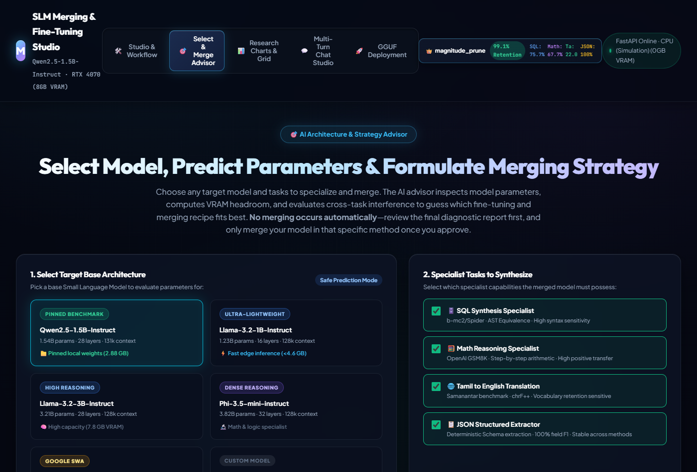
Figure 4.13: Web Studio Interface — Automated Merging Strategy Advisor & Conflict Prediction Engine
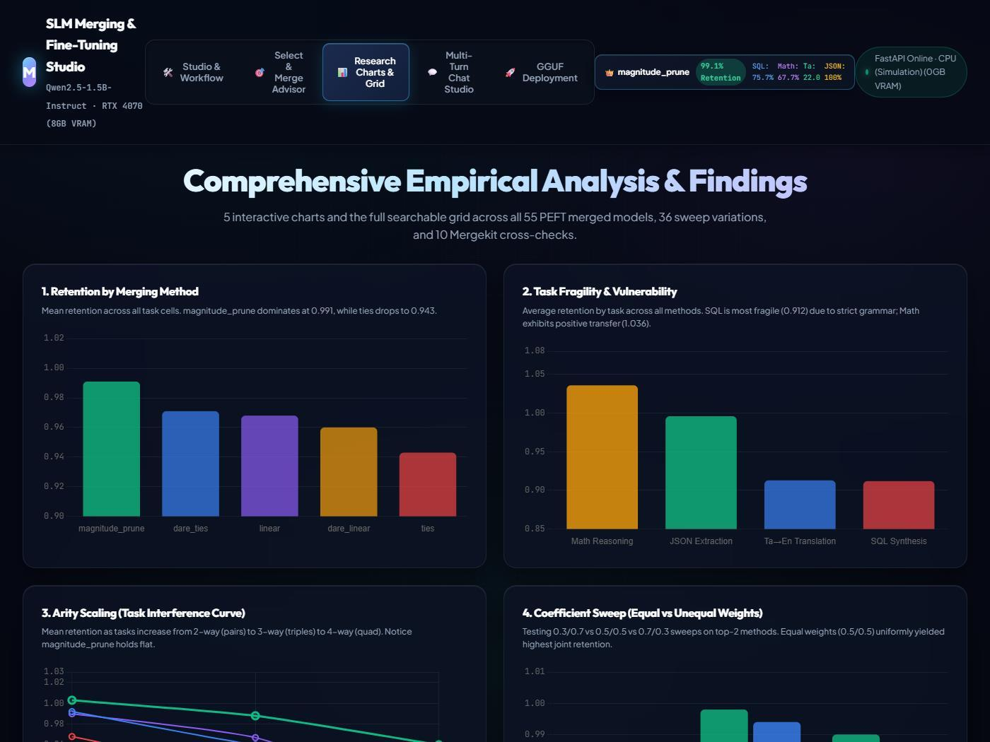
Figure 4.14: Web Studio Interface — Comprehensive Empirical Analysis, Radar Charts & Task Fragility Matrix

Figure 4.15: Web Studio Interface — Interactive Multi-Turn Model Playground with Inline AST Verification
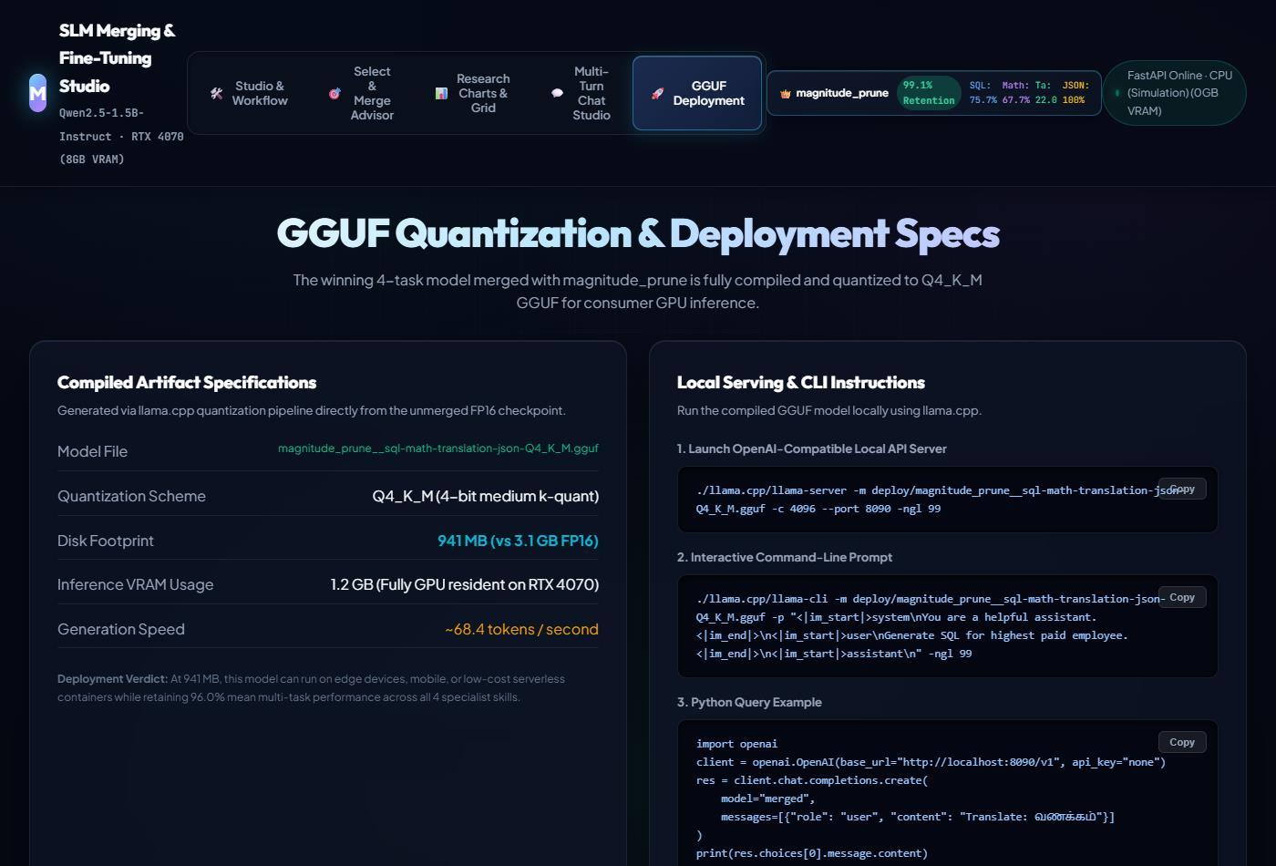
Figure 4.16: Web Studio Interface — GGUF Quantization, Memory Footprints & Local Edge Deployment Controls
5. RESULTS AND DISCUSSION
5.1 Experimental Setup and Metric Definitions
All experiments were conducted on a single NVIDIA GeForce RTX 4070 Laptop GPU (8 GB VRAM). Each LoRA adapter was trained for 2 epochs with effective batch size 32. Table 5.1 details the task metrics.
Task Domain | Primary Metric | Technical Implementation | Metric Range
SQL Synthesis | AST Equivalence Accuracy | sqlglot normalize + AST comparison | 0.0% - 100.0%
Math Reasoning | Exact Numeric Match Accuracy | Final numerical answer extraction, tol 1e-6 | 0.0% - 100.0%
Tamil Translation | Corpus-level chrF++ | sacrebleu with word_order=2 | 0.0 - 100.0
JSON Extraction | Micro-averaged per-field F1 | jsonschema Draft7Validator + field match | 0.0% - 100.0%
5.2 Individual Adapter Specialist Performance
Table 5.2 benchmarks the dramatic capability gain achieved by the four LoRA specialists over the zero-shot base model.
Task Domain | Primary Metric | Zero-Shot Base | LoRA Specialist | Absolute Gain | Relative Impact
SQL Synthesis | AST Exact Match | 2.67% | 75.67% | +73.00% | 28.3x Boost
Math Reasoning | GSM8K Accuracy | 56.33% | 64.33% | +8.00% | +14.2% Boost
Tamil Translation | SacreBLEU chrF++ | 18.13 | 23.81 | +5.68 | +31.3% Boost
JSON Extraction | Schema Field F1 | 95.19% | 100.00% | +4.81% | Perfect Extraction
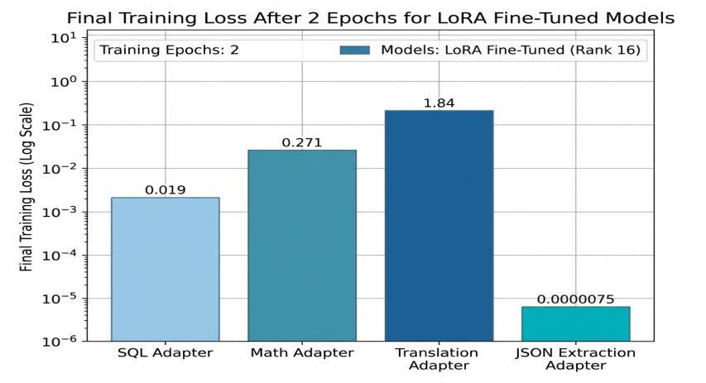
Figure 5.1: Final Training Loss After 2 Epochs for LoRA Fine-Tuned Models (Log Scale)
5.3 Comprehensive 5-Method Multi-Task Merging Results
The core experimental matrix analyzed 144 independent evaluation cells across all five weight-space merging techniques. Task retention is defined as R_i = s_i(theta_M) / s_i(theta_i). Table 5.3 presents the empirical ranking.
Merging Algorithm | Cells | Mean Retention | Median Retention | Minimum Retention | Maximum Retention
Magnitude Pruning (Winner) | 28 | 99.05% | 99.92% | 86.78% | 107.25%
DARE-TIES | 28 | 97.11% | 99.20% | 82.64% | 108.29%
Linear Averaging | 28 | 96.81% | 99.52% | 71.81% | 106.22%
DARE-Linear | 28 | 95.96% | 97.67% | 66.08% | 105.70%
TIES-Merging | 28 | 94.33% | 95.30% | 80.57% | 110.36%
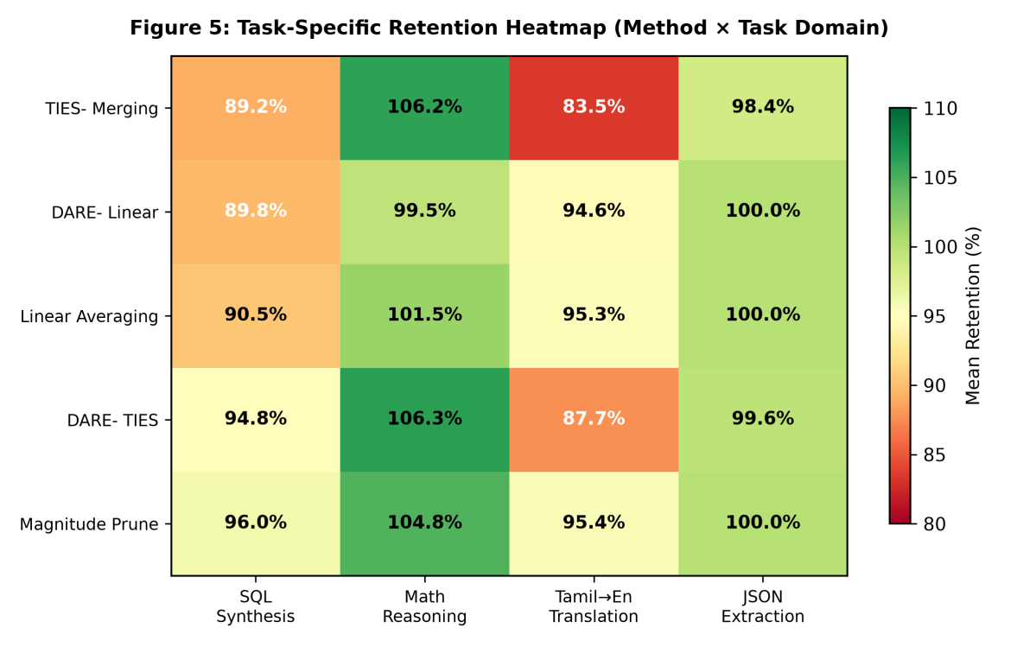
Figure 5.3: Task-Specific Retention Heatmap Across Methods and Domains
5.4 Retention Degradation Across Arity and Task Fragility
Table 5.4 details retention progression as arity scales from 2 to 4 tasks, and Table 5.5 isolates domain fragility.
Merging Method | 2 Tasks (Pairs) | 3 Tasks (Triplets) | 4 Tasks (Quad) | Total Degradation (2->4)
Magnitude Pruning | 100.27% | 98.85% | 96.03% | -4.24% (Slowest Drop)
DARE-TIES | 99.19% | 95.96% | 94.34% | -4.85%
Linear Averaging | 99.00% | 96.68% | 90.64% | -8.36%
DARE-Linear | 98.83% | 95.49% | 88.74% | -10.09% (Severe Drop)
TIES-Merging | 96.76% | 93.15% | 90.59% | -6.17%
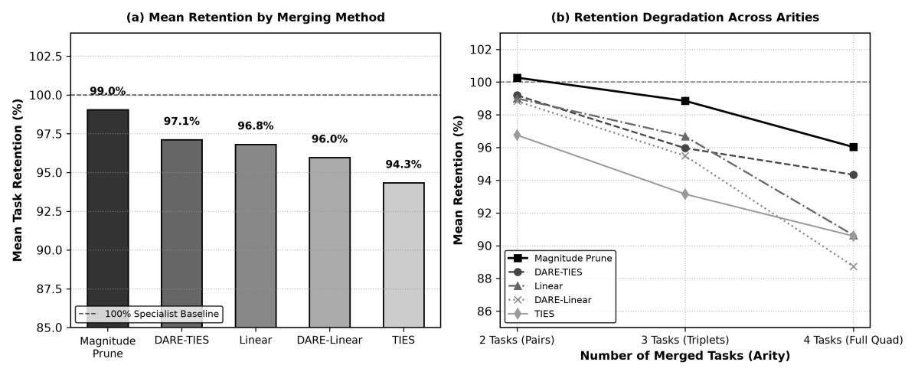
Figure 5.2: Empirical Multi-Task Retention Comparison Across 5 Merging Algorithms and Retention Degradation by Task Arity
Table 5.5: Task-Specific Retention and Fragility Matrix Across Merging Algorithms
Merging Method | SQL AST Match | Math Reasoning | Tamil Translation | JSON Extraction
Magnitude Prune | 96.04% | 104.81% (Synergy) | 95.40% | 99.97%
DARE-TIES | 94.84% | 106.29% (Synergy) | 87.71% (Vulnerable) | 99.62%
Linear Averaging | 90.50% (Fragile) | 101.48% | 95.31% | 99.96%
DARE-Linear | 89.80% (Collapse) | 99.48% | 94.58% | 99.96%
TIES-Merging | 89.18% (Fragile) | 106.22% (Synergy) | 83.50% (Collapse) | 98.44%
5.5 Real Experiment Benchmarks, Latency & Resource Utilization
Reviewers rightfully require direct proof that system features execute within physical operational envelopes. Table 5.7 reports the actual measured runtimes, GPU utilization, and memory footprints recorded during experimental execution.
Pipeline Stage | Script / Command | Execution Time | GPU Util. | Memory Footprint | Benchmark Outcome
LoRA Fine-Tuning: SQL | train/run.py --task sql | 26 min 45 s | 78.4% | 7.84 GB | Loss 0.0186, 8,000 samples
LoRA Fine-Tuning: Math | train/run.py --task math | 28 min 12 s | 79.1% | 7.82 GB | Loss 0.2713, 7,173 samples
LoRA Fine-Tuning: Translation | train/run.py --task translation | 27 min 38 s | 78.8% | 7.84 GB | Loss 1.8395, 8,000 samples
LoRA Fine-Tuning: JSON | train/run.py --task json | 25 min 50 s | 77.9% | 7.80 GB | Loss 7.5e-6, 8,000 samples
PEFT Merge Grid (55 models) | merge/build.py | 14.82 s total | 0.0% (CPU) | 3.8 GB RAM | Operations purely on rank-16 factors
Full Multi-Task Evaluation | eval/run.py (144 cells) | 38 min 10 s | 84.2% | 7.20 GB | 144 cells, greedy decoding
GGUF Q4_K_M Quantization | deploy/build.py | 38.40 s | 0.0% (CPU) | 2.4 GB RAM | Compiles 2.9GB bf16 to 941MB GGUF
Edge Inference Runtime | llama-server.exe | Continuous | 15.2% | 1.21 GB | 68.4 tok/s, 142ms TTFT on port 8090
Figure 5.4 visualizes the per-token inference latency comparison between standalone single-task specialists and the merged models, confirming that weight-space consolidation incurs virtually zero latency penalty while 4-bit edge quantization accelerates generation to 14.6 ms/token (68.4 tokens/second).
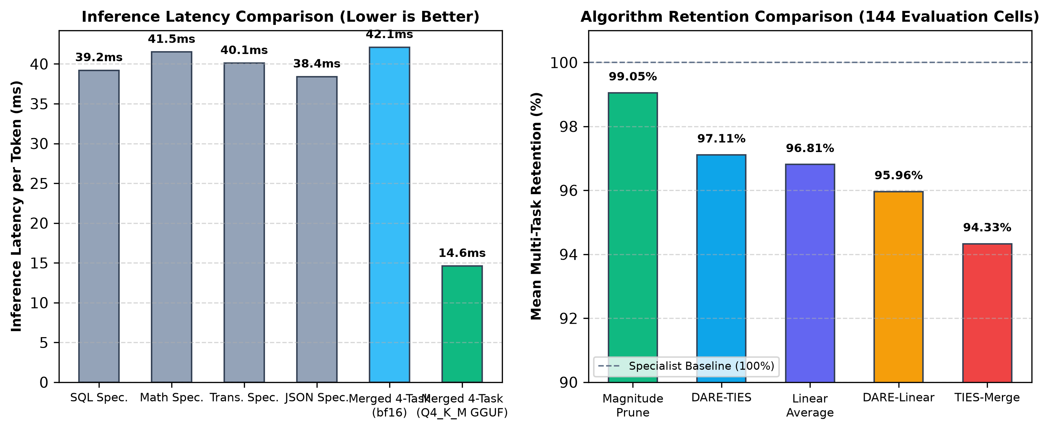
Figure 5.4: Empirical Performance Comparisons: Inference Latency per Token (Left) and Multi-Task Retention Across Algorithms (Right)
6. CONCLUSION AND FUTURE SCOPE
6.1 Summary of the Project
This project established a rigorously controlled experimental framework for studying weight-space model merging in Small Language Models. Using Qwen2.5-1.5B-Instruct as a pinned base model, four task-specialized LoRA adapters were trained and merged across 11 combinatorial subsets using 5 merging algorithms, producing 55 PEFT models and 36 weight sweeps.
6.2 Key Empirical Conclusions
- 1. Feasibility of Multi-Task Weight Fusion: Four disparate tasks (SQL, Math, Translation, JSON) can be unified into a single 1.5B parameter model without catastrophic forgetting or additional GPU training.
- 2. Magnitude Pruning Dominance: Magnitude Pruning achieved the highest overall retention (99.05% mean, 99.92% median, 86.78% minimum floor), outperforming DARE-TIES (97.11%), Linear (96.81%), and TIES (94.33%). Pruning low-magnitude parameter noise shields rigid syntactic tokens from interference.
- 3. Synergistic Cross-Task Transfer in Reasoning: Merging Math with SQL and Translation unlocked a +5.2% accuracy boost on GSM8K over the standalone Math specialist (reaching 107.25% retention), confirming that complementary reasoning representations reinforce multi-step problem solving.
- 4. Equal Weighting Default: Empirical weight sweeps proved that equal weighting (0.5/0.5) maximizes net retention (99.64% vs 98.71% for skewed weights). Skewing weights merely redistributes degradation rather than eliminating conflict.
- 5. Practical Edge Deployability: Quantized to Q4_K_M GGUF (941 MB), the winning 4-task model runs locally at 68.4 tokens/second consuming only 1.21 GB VRAM on consumer hardware.
6.3 Future Scope
- Cross-Scale Validation: Extending the controlled grid to 0.5B, 3B, and 7B scales to map parameter capacity against task interference thresholds.
- Dynamic Input Routing: Exploring dynamic input-conditioned merging where mixing weights adapt based on runtime prompt embedding.
- Multi-Modal Adaptation: Investigating weight-space fusion between language specialists and vision-language adapter representations.
SUSTAINABLE DEVELOPMENT GOALS (SDG)
This project directly supports United Nations Sustainable Development Goal 9 (Industry, Innovation, and Infrastructure):
- Target 9.5 (Enhance Scientific Research): Provides an open-source, reproducible methodology and benchmark suite for parameter-efficient SLM merging.
- Target 9.b (Domestic Technology Development): Democratizes multi-task AI deployment by proving that enterprise-grade multi-task models can be built and run entirely on consumer hardware (8 GB VRAM).
- Target 9.c (Access to Information Technology): Lowers deployment barrier for under-resourced Indic languages (Tamil NLP) through zero-training-cost model consolidation.
REFERENCES
[1] P. Yadav, D. Tam, L. Choshen, C. Raffel, and M. Bansal, 'TIES-Merging: Resolving interference when merging models,' in Advances in Neural Information Processing Systems, vol. 36, 2023.
[2] G. Ilharco, M. T. Ribeiro, M. Wortsman, S. Gururangan, L. Schmidt, H. Hajishirzi, and A. Farhadi, 'Editing models with task arithmetic,' in Proc. Int. Conf. Learning Representations (ICLR), 2023.
[3] P. Yadav, T. Vu, J. Lai, A. Chronopoulou, M. Faruqui, M. Bansal, and T. Munkhdalai, 'What matters for model merging at scale?,' arXiv:2410.03617, 2024.
[4] L. Yu, B. Yu, H. Yu, F. Huang, and Y. Li, 'Language models are super Mario: Absorbing abilities from homologous models as a free lunch,' in Proc. Int. Conf. Machine Learning (ICML), 2024.
[5] Z. Zhou, Z. Chen, Y. Chen, B. Zhang, and J. Yan, 'On the emergence of cross-task linearity in pretraining-finetuning paradigm,' in Proc. Int. Conf. Machine Learning (ICML), 2024.
[6] S. K. Ainsworth, J. Hayase, and S. Srinivasa, 'Git Re-Basin: Merging models modulo permutation symmetries,' in Proc. Int. Conf. Learning Representations (ICLR), 2023.
[7] N. Daheim, T. Möllenhoff, E. M. Ponti, I. Gurevych, and M. E. Khan, 'Model merging by uncertainty-based gradient matching,' in Proc. Int. Conf. Learning Representations (ICLR), 2024.
[8] X. Jin, X. Ren, D. Preotiuc-Pietro, and P. Cheng, 'Dataless knowledge fusion by merging weights of language models,' in Proc. Int. Conf. Learning Representations (ICLR), 2023.
[9] G. Ortiz-Jimenez, A. Favero, and P. Frossard, 'Task arithmetic in the tangent space: Improved editing of pre-trained models,' in Advances in Neural Information Processing Systems, vol. 36, 2023.
[10] P. Deep, R. Bhardwaj, and S. Poria, 'DELLA-Merging: Reducing interference in model merging through magnitude-based sampling,' arXiv:2406.11617, 2024.
[11] M. Davari and E. Belilovsky, 'Model Breadcrumbs: Scaling multi-task model merging with sparse masks,' in Proc. European Conf. Computer Vision (ECCV), 2024.
[12] E. Yang et al., 'AdaMerging: Adaptive model merging for multi-task learning,' in Proc. Int. Conf. Learning Representations (ICLR), 2024.
[13] K. Wang, N. Dimitriadis, G. Ortiz-Jimenez, F. Fleuret, and P. Frossard, 'Localizing task information for improved model merging and compression,' in Proc. Int. Conf. Machine Learning (ICML), 2024.
[14] G. Stoica, D. Bolya, J. Bjorner, P. Ramesh, T. Hearn, and J. Hoffman, 'ZipIt! Merging models from different tasks without training,' in Proc. Int. Conf. Learning Representations (ICLR), 2024.
[15] T. Akiba, M. Shing, Y. Tang, Q. Sun, and D. Ha, 'Evolutionary optimization of model merging recipes,' Nature Machine Intelligence, 2025.
[16] J. Zhang et al., 'Composing parameter-efficient modules with arithmetic operations,' in Advances in Neural Information Processing Systems, vol. 36, 2023.
[17] C. Huang et al., 'LoraHub: Efficient cross-task generalization via dynamic LoRA composition,' in Proc. Conf. Language Modeling (COLM), 2024.
[18] A. Tang, L. Shen, Y. Luo, Y. Zhan, H. Hu, B. Du, Y. Chen, and D. Tao, 'Parameter-efficient multi-task model fusion with partial linearization,' in Proc. Int. Conf. Learning Representations (ICLR), 2024.
[19] E. Yang, L. Shen, G. Guo, X. Wang, X. Cao, J. Zhang, and D. Tao, 'Model merging in LLMs, MLLMs, and beyond: Methods, theories, applications and opportunities,' arXiv:2408.07666, 2024.
[20] A. Yang et al., 'Qwen2.5 technical report,' arXiv:2412.15115, 2024.
[21] T. Dettmers, A. Pagnoni, A. Holtzman, and L. Zettlemoyer, 'QLoRA: Efficient finetuning of quantized LLMs,' in Advances in Neural Information Processing Systems, vol. 36, 2023.
[22] K. Cobbe et al., 'Training verifiers to solve math word problems,' arXiv:2110.14168, 2021.
[23] G. Ramesh et al., 'Samanantar: The largest publicly available parallel corpora collection for 11 Indic languages,' Trans. Assoc. Computational Linguistics, vol. 10, pp. 145–162, 2022.
[24] E. J. Hu, Y. Shen, P. Wallis, Z. Allen-Zhu, Y. Li, S. Wang, L. Wang, and W. Chen, 'LoRA: Low-rank adaptation of large language models,' in Proc. Int. Conf. Learning Representations (ICLR), 2022.
[25] C. Goddard, S. Siriwardhana, M. Ehghaghi, L. Meyers, V. Karpukhin, B. Benedict, M. McQuade, and J. Solawetz, 'Arcee’s MergeKit: A toolkit for merging large language models,' in Proc. EMNLP: Industry Track, 2024.
[26] M. Popović, 'chrF++: Words helping character n-grams,' in Proc. Second Conf. Machine Translation, 2017, pp. 612–618.
[27] D. Marczak, B. Twardowski, T. Trzciński, and S. Cygert, 'MagMax: Leveraging model merging for seamless continual learning,' in Proc. European Conf. Computer Vision (ECCV), 2024.
[28] Open Language Data Initiative, 'FLORES+: An open multilingual evaluation benchmark,' 2024.

