E-Commerce Sales Performance Analysis Report
Objective
The objective of this project is to analyze the Olist Brazilian E-Commerce dataset and identify patterns in sales performance, customer behavior, product performance, seller contribution, payment preferences, and customer retention.
Dataset Description
The dataset consists of multiple related e-commerce tables including:
- Customers: Customer information and location details.
- Orders: Order status and purchase timestamps.
- Order Items: Product-level transaction details.
- Products: Product information and categories.
- Sellers: Seller information.
- Payments: Payment methods and transaction values.
- Reviews: Customer review scores and feedback.
- Geolocation: Geographic information.
- Category Translation: Product category names translated into English.

Data Cleaning Summary
The following cleaning steps were performed:
- Checked and analyzed missing values.
- Identified and removed duplicate records.
- Converted date-related columns to datetime format.
- Validated merge consistency across multiple datasets.
- Verified key relationships between customers, orders, products, and sellers.
- Created a cleaned merged dataset for analysis.

Analysis Findings
Product Performance
- A small number of product categories generated the majority of total revenue.
- Certain products consistently outperformed others in both sales volume and revenue.
Geographic Performance
- Sales were concentrated in a few major cities and states.
- Some regions contributed significantly more revenue than others.
Customer Behavior
- Customer purchasing activity varied across different days and time periods.
- Most customers were one-time buyers, while a smaller group made repeat purchases.
Seller Performance
- A limited number of sellers contributed a large share of total revenue.
Payment Analysis
- Credit card payments dominated transactions and revenue generation.
- Customer payment preferences showed clear patterns.
Customer Satisfaction
- Review scores varied across product categories.
- High-rated categories demonstrated stronger customer satisfaction.
Time-Based Trends
- Monthly sales volume showed fluctuations, indicating seasonal demand patterns.

Visualizations
The following visualizations are created:
- Top Product Categories by Revenue
- Sales by City and State
- Customer Segment Revenue Comparison
- Customer Purchasing Pattern Trends
- Top Products by Revenue
- Revenue by Payment Method
- Top Sellers by Revenue
- Average Review Score by Category
- Monthly Sales Volume Trend
- Repeat vs One-Time Customer Analysis
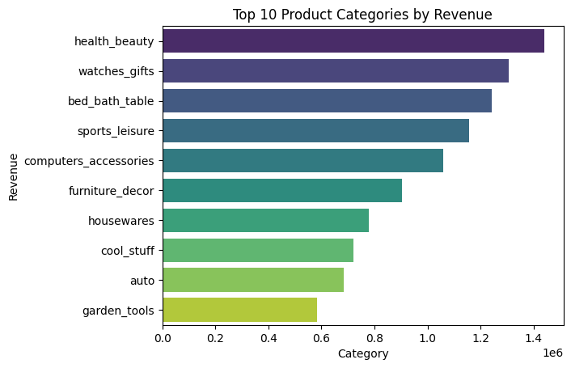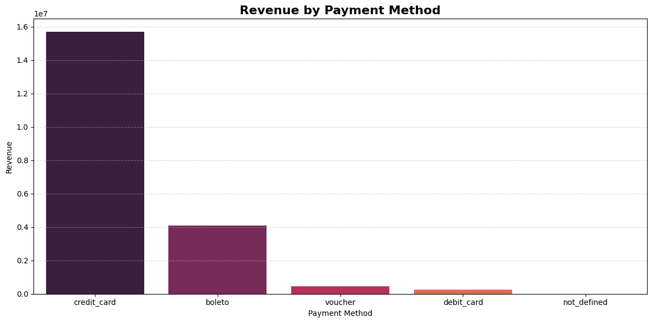

Final Conclusion
The analysis revealed that revenue is highly concentrated among specific product categories, regions, products, and sellers. Customer satisfaction is generally positive, some categories show opportunities for improvement.
Recommendations
- Increase investment in top-performing product categories.
- Strengthen partnerships with top-performing sellers.
- Improve lower-rated product categories through quality enhancements.
- Encourage repeat purchases through loyalty and retention programs.

