**Analysis of Balance Sheet using R**

This project has been built to analyze Balance sheet for a given company. The output should be a series of graphs and charts, pictorially representing the growth and decline of the business.

**PREREQUISITES**

* R Studio with R installed.
* “Quantmod” package preinstalled.

**TESTS**

* Balance Sheet from finance.yahoo.com were parsed using Quantmod commands.
* The parsed Balance sheet is converted to ‘finance’ type of data using the viewFin command.

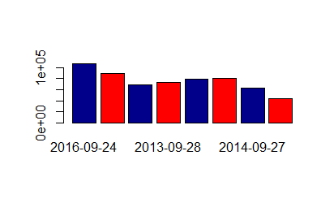

Assets vs Liabilities

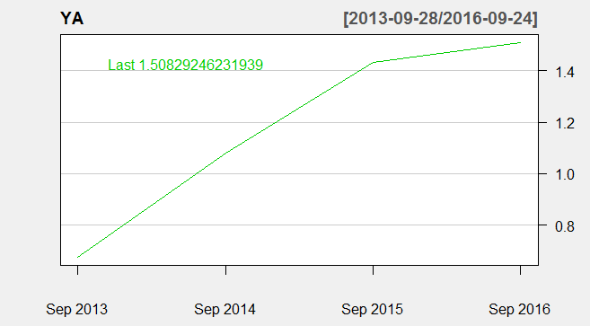

Debt to Equity

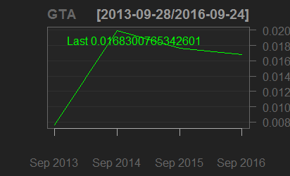

Goodwill to Assets

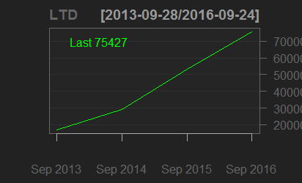

Long term debt

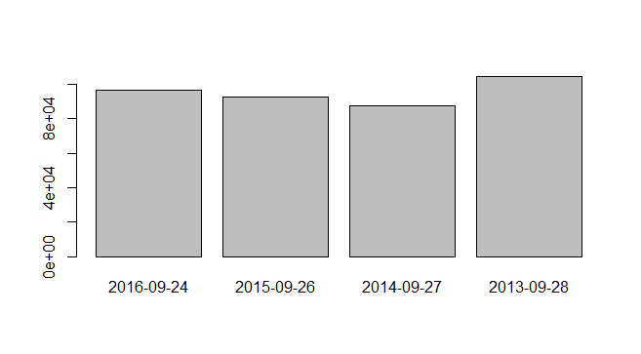

Retained Earnings

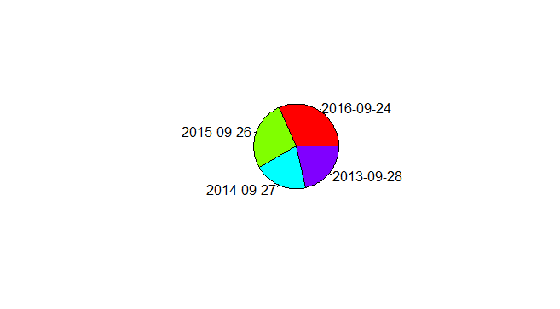

Share of Total Current Assets

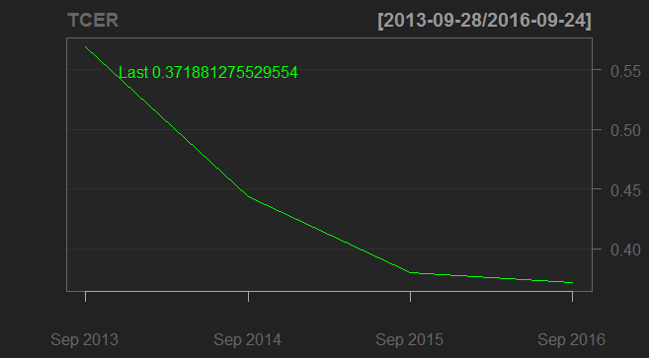

Tangible Common Equity Ratio

**MEMORY USAGE**

The command used for memory analysis

sort(sapply(ls(), function(x){object.size(get(x))}))

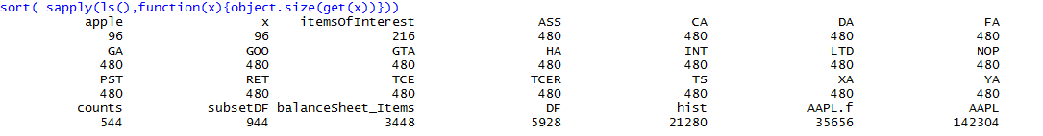

**PROGRAM THRESHOLD**

The program ran for multiple hours without stoppage, and computed the operations within microseconds. So, for balance sheet of an average size didn’t cause any trouble to program.

**Authors**

Ashutosh Agarwal (1310110085)

Paarth Saxena (1310110225)

Satyapriya Khanna (1310110290)

**Acknowledgments**

Professor Anirban Mondal for giving the opportunity to create this Software.