PHYF214 PHYSICS LAB1 REPORT SEM1 2018-2019

EXP. No.: EM 1 EXP Name: Ferromagnetic Hysteresis (MB Curve)

Name: Nikhil Pratap Singh Bisht ID No.:2017B5A70610G

Group ID: 8

Date of performing the experiment: 20th September, 2018

Date of Submission: 24th September, 2018

1. AIM:

The Experiment aims at:

1. Studying the magnetization (M) of a ferromagnetic material due to an applied magnetic field B and to plot the hysteresis (M vs. B) curve.
2. Calculating the retentivity and coercivity of the material.
3. Theory:

In Ferromagnetic materials, atoms, which behave like magnetic dipoles, are divided in to several domains, resulting in a net dipole moment of the domain. Normally, these moments are randomly oriented making the net dipole moment of the material 0, but upon an external magnetic field, these re-align in the direction of the applied field, resulting in a net magnetic field.

Given the cross section (α), length (l) of the ferromagnetic material (considering a rod), the distance (r) to the point of effect and horizontal component of the Earth’s magnetic field (BE) one can relate the magnetization of the rod as a function of deflection from BE as:

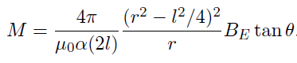

When ferromagnetic materials are magnetized, upon removing the applied magnetic field, there still remains some internal field of the material, called its retentivity (M0). When a certain amount of field is applied in the opposite direction to decrease this extra magnetization back to 0, it is called the material’s coercivity (B0).

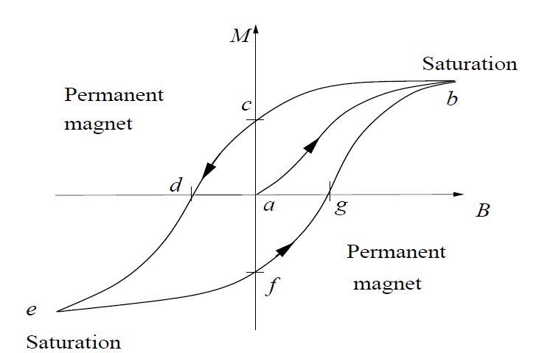M0 is equal to M when tan(Ɵ0) =

B0 = μ0nI0 where I0 =

1. Observation Table and Graphs:

Pre experiment quantities:

|  |  |
| --- | --- |
| Diameter of rod (mm) | 4 |
| Number of turns of solenoid (n) | 1080 |
| Length of rod (cm) (l) | 52 |
| Distance from center of rod to magnetometer (cm) (r) | 40 |

Experimental Observations:

|  |  |  |  |  |
| --- | --- | --- | --- | --- |
| Current | Θ1 | Θ2 | Θ = (Θ1+ Θ2)/2 | Tan(θ) |
| Increase | | | | |
| 0 | 0 | 0 | 0 | 0 |
| 0.2 | 11 | 10 | 10.5 | 0.18533904 |
| 0.3 | 22 | 21 | 21.5 | 0.39391048 |
| 0.4 | 31 | 30 | 30.5 | 0.58904502 |
| 0.5 | 35 | 34 | 34.5 | 0.68728096 |
| 0.6 | 38 | 37 | 37.5 | 0.76732699 |
| 0.7 | 40 | 39 | 39.5 | 0.82433639 |
| 0.8 | 42 | 41 | 41.5 | 0.88472526 |
| 0.9 | 43 | 42 | 42.5 | 0.91633117 |
| 1 | 44 | 43 | 43.5 | 0.94896457 |
| Decrease | | | | |
| 0.9 | 44 | 43 | 43.5 | 0.94896457 |
| 0.8 | 44 | 43 | 43.5 | 0.94896457 |
| 0.7 | 44 | 43 | 43.5 | 0.94896457 |
| 0.6 | 44 | 43 | 43.5 | 0.94896457 |
| 0.5 | 44 | 43 | 43.5 | 0.94896457 |
| 0.4 | 44 | 43 | 43.5 | 0.94896457 |
| 0.3 | 43 | 42 | 42.5 | 0.91633117 |
| 0.2 | 42 | 41 | 41.5 | 0.88472526 |
| **Reverse Key** | | | | |
| Increase | | | | |
| -0.2 | 0 | 0 | 0 | 0 |
| -0.3 | -22 | -23 | -22.5 | -0.4142136 |
| -0.4 | -32 | -33 | -32.5 | -0.6370703 |
| -0.5 | -38 | -38 | -38 | -0.7812856 |
| -0.6 | -41 | -41 | -41 | -0.8692867 |
| -0.7 | -43 | -43 | -43 | -0.9325151 |
| -0.8 | -45 | -45 | -45 | -1 |
| -0.9 | -46 | -46 | -46 | -1.0355303 |
| -1 | -47 | -47 | -47 | -1.0723687 |
| -1.1 | -48 | -48 | -48 | -1.1106125 |
| -1.2 | -48 | -48 | -48 | -1.1106125 |
| -1.3 | -48 | -48 | -48 | -1.1106125 |
| Decrease | | | | |
| -1.2 | -48 | -48 | -48 | -1.1106125 |
| -1.1 | -48 | -48 | -48 | -1.1106125 |
| -1 | -48 | -48 | -48 | -1.1106125 |
| -0.9 | -48 | -48 | -48 | -1.1106125 |
| -0.8 | -48 | -48 | -48 | -1.1106125 |
| -0.7 | -48 | -48 | -48 | -1.1106125 |
| -0.6 | -48 | -48 | -48 | -1.1106125 |
| -0.5 | -48 | -48 | -48 | -1.1106125 |
| -0.4 | -47 | -47 | -47 | -1.0723687 |
| -0.3 | -47 | -47 | -47 | -1.0723687 |
| -0.2 | -46 | -46 | -46 | -1.0355303 |
| **Reverse Key** | | | | |
| Increase | | | | |
| 0.3 | 19 | 18 | 18.5 | 0.33459532 |
| 0.4 | 30 | 30 | 30 | 0.57735027 |
| 0.5 | 35 | 34 | 34.5 | 0.68728096 |
| 0.6 | 38 | 37 | 37.5 | 0.76732699 |
| 0.7 | 40 | 39 | 39.5 | 0.82433639 |
| 0.8 | 42 | 41 | 41.5 | 0.88472526 |
| 0.9 | 43 | 42 | 42.5 | 0.91633117 |
| 1 | 44 | 44 | 44 | 0.96568877 |

1. Analysis:



Where tan(θ) = $\frac{\left|c\right|+|f|}{2}$

From the graph, tan(θ) = 0.49

Horizontal component of earth’s Magnetic Field (BE) = 39.26 μT

Distance from center of rod to magnetometer (r) = 0.4 m

Length of rod (l) = 0.52 m

Cross sectional area of the rod (α) = π (0.002)2 = 12.57 μm2

M0 = 2.26x104 weber/m2

Number of turns (n) = 1080

From the graph (I0) = 0.19 A

B0 = 2.58 x10-4 oersted

1. Results with error:

Since,

Least count of bench = 0.1cm

Least count of micrometer screw = 0.02 mm

Least count of the Multimeter = 0.01 A

Error in measuring retentivity is ± 0.19 x 104 weber/m2

Error in measuring coercivity is ± 0.14 x 10-4 oersted

So,

M0 = (2.26± 0.19) x 104 weber/m2

B0 = (2.58 ±0.14) x 10-4 oersted

Therefore, under experimental errors (less than 5%), the retentivity and coercivity of the given material are measured.