**GDSC – RECRUITMENTS**

**PROJECT 1 : GOOGLE CHROME EXTENSION DEVELOPMENT**

**( SCREENSHOTS FOR REFERENCE )**

* **EXTENSION – TAB ORGANIZER**

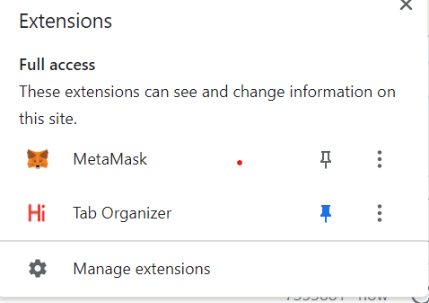

* **VISIBILITY WHEN CLICKED**

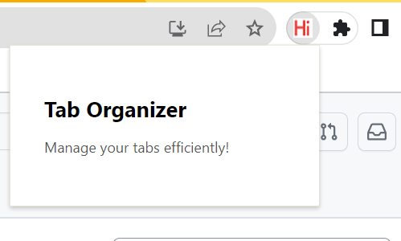

* **When Extension Is Disabled**

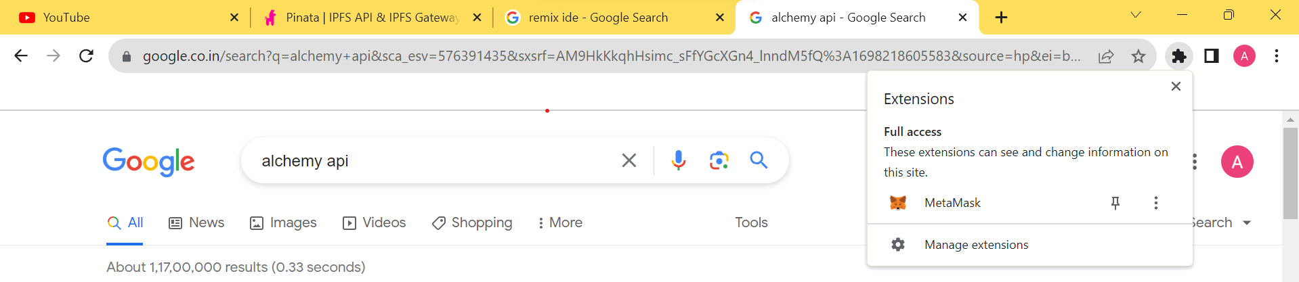

* **When Extension Is Enabled**



