**Instagram User Analytics Project**

**Project Description**

First we will do user analysis ie this is the process through which we will get to know about the trends analysis and growth analysis of our business by tracking how users interact with our application by this way we can track many other interrelated things like recent users,oldest users,their average time of using our application,how many users interact with the application regularly etc.

These insights are then used by other teams across the business to launch the new marketing campaign These datas or insights are further used by other departments to enhance user engagement and the decisions either to add on new features or remove previous one to help the business grow and expand.

You are working with the product team of the Instagram you are given a task by the product manager to give insights on the questions asked by management team of the company.

**Approach**

It seems that you were analyzing data from a database provided to understand how users interact with your product. To do this, I analysed data from the database provided. By understanding our users' needs, we can create a product that is tailored to their needs and make sure that it meets all their expectations. Additionally, I wanted to use this project as an opportunity to learn more about user experience design principles so that I can apply them in future projects so on.

**Tech-Stack Used**

To complete this project the software that I used **MySQL ver 8.0.33** because it has better performance for Read/Write workloads and it is aislo easy to use.

**THESE QUESTIONS HAVE BEEN ANSWERED BY ME ARE AS FOLLOWS:**

1. **Marketing:** The marketing team wants to launch some campaigns, and they need your help with the following.
2. **Rewarding Most Loyal Users**: People who have been using the platform for the longest time.

My Task: Find the 5 oldest users of the instagram from the database provided.

**Command-**

SELECT id, username, created_at FROM ig_clone.users

ORDER BY created_at ASC LIMIT 5;

**Output:-**

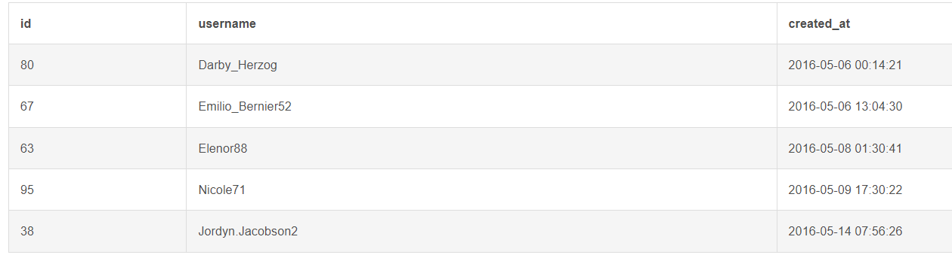

1. **Remind Inactive Users To Start Posting:** By sending them proportional emails to their 1st photo.

My task: Find the user h=who have never posted a single photos on instagram.

**Command-**

SELECT users.id, username, users.created_at

FROM ig_clone.users

LEFT JOIN ig_clone.photos

ON users.id = ig_clone.photos.user_id

WHERE ig_clone.photos.user_id IS NULL;

**Output:-**

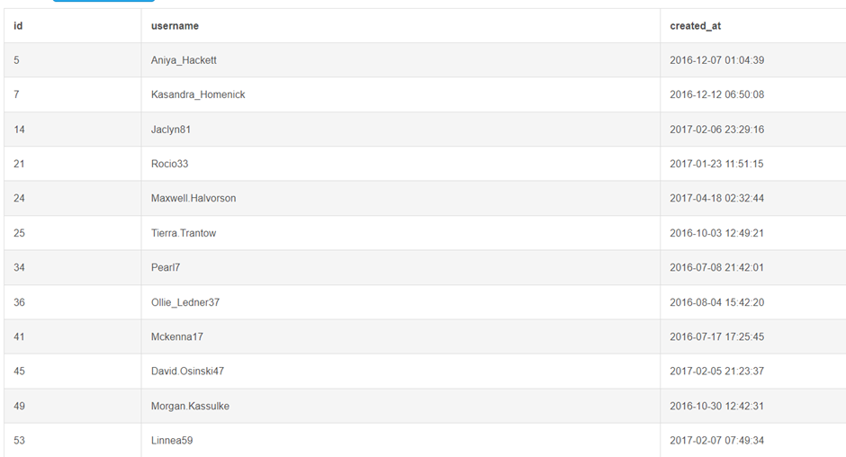

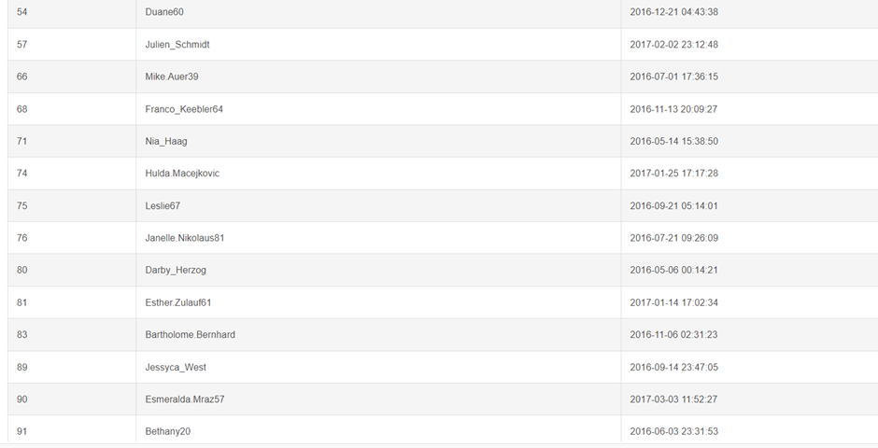

1. **Declaring Contest Winner:** The team started a contest and the user who gets the most likes on a single photo will win the contest now they wish to declare the winner.

My Task: Identify the winner of the contest and provide their details to the team.

**Command-**

SELECT users.id AS user_id, username, photos.id AS photo_id, photos.image_url,

COUNT(*) AS total_likes_count

FROM ig_clone.photos JOIN ig_clone.likes

ON photos.id = likes.photo_id

JOIN ig_clone.users ON users.id = photos.user_id

GROUP BY photos.id

ORDER BY total_likes_count DESC

LIMIT 1;

**Output:-**



1. **Hashtag Researching:** A partner brand wants to know which hashtags to use in the post to reach the most people on the platfrom.

My task: Identify and suggest the top 5 most commonly used hashtag on the platform.

**Command-**

SELECT ig_clone.tags.id AS tag_id, ig_clone.tags.tag_name,

COUNT(*) as total

FROM ig_clone.tags

JOIN ig_clone.photo_tags

ON ig_clone.tags.id = ig_clone.photo_tags.tag_id

GROUP BY ig_clone.tags.id

ORDER BY total DESC LIMIT 5;

**Output:-**

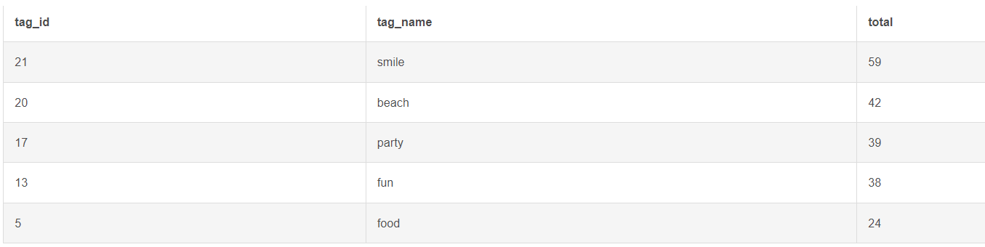

1. **Launch AD Campaign:** The team wants to know which day would be the best day to launch ADs.

My task: What day of the week do most user register on? Provide insights on when to schedule and ad campaign.

**Command-**

SELECT DAYNAME(created_at) AS day_of_the_week,

COUNT(*) AS total_count

FROM ig_clone.users

GROUP by day_of_the_week

ORDER by total_count DESC;

**Output:-**

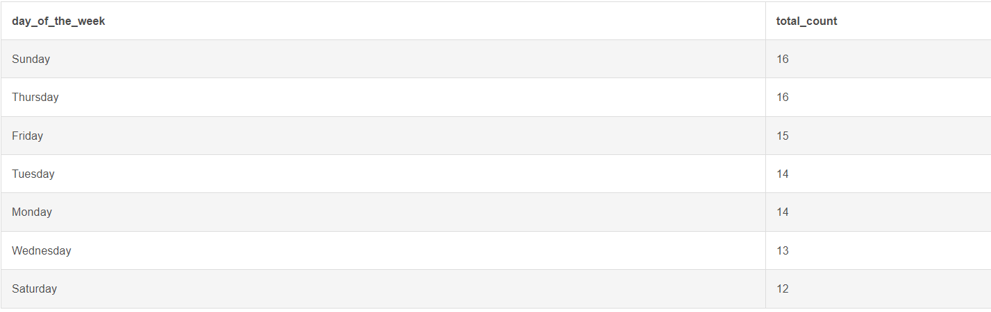

1. **Investor Metrics:** Our investors wants to know if instagram is performing well and is not becoming redundant like Facebook, they want to assess the app on the following grounds.
2. **User Engagement:** Are users still as active and post on instagram or they are making fewer posts.

My Task: Provide how many times an average user posts on intagram. Also, provide the total number of photos on instagram/total number of users.

**Command-**

SELECT ROUND(( SELECT COUNT(*) FROM ig_clone.photos ) / ( SELECT COUNT(*) FROM ig_clone.users ),2 ) AS avg_user_photo_post;

**Output:-**

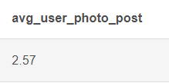

1. **Bots & Fake Accounts:** The investors wants to know if the platform is crowded with fake and dummy accounts.

My task: Provide data on users(bots) who have liked every single photo on the site (since any normal users would not be able to do this).

**Command-**

SELECT ig_clone.users.id AS user_id, ig_clone.users.username, COUNT(*) AS

total_user_likes FROM ig_clone.users JOIN ig_clone.likes

ON ig_clone.users.id = ig_clone.likes.user_id

GROUP BY users.id

HAVING total_user_likes = (

SELECT COUNT(*) FROM ig_clone.photos);

**Output:-**

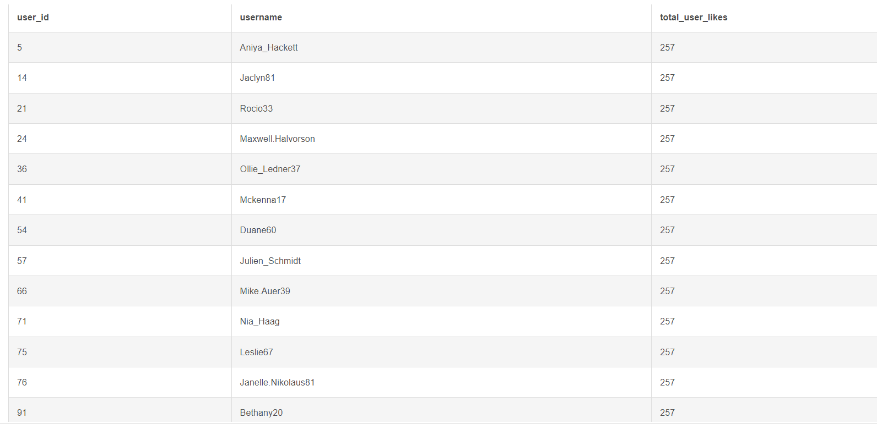

**Result**

Through this project, we were able to gain insights and analysis into how users think and behave when interacting with a product and their demand needs and expectations with our product. We discovered a number of key insights about user behaviour, preferences, and expectations that can be used to inform future product design decisions and also to enhance user engagement participations. we identified trends in user behaviour that could be used to improve user experience, such as providing helpful feedback from present and past users for specific tasks. Overall, our user analysis project has provided us with valuable insights that can help us create better products in the future.