Kubernetes-Native Financial Risk Analytics Platform

Project Objective
The goal of this project is to design and implement a containerized, production-style financial risk analytics platform using Kubernetes.
This platform simulates a real-world portfolio risk monitoring system similar to what investment banks and financial institutions use to track:
- Portfolio performance
- Daily returns
- Rolling volatility
- Sharpe Ratio
- Value at Risk (VaR)
- PnL trends
The system is fully deployed on a local Kubernetes cluster and designed using modern data engineering best practices.

High-Level Architecture
End-to-End Data Flow:
Yahoo Finance API
↓
Kubernetes CronJob (Data Ingestion)
↓
Raw Market Data (PostgreSQL - Bronze Layer)
↓
Apache Spark Job (Risk Computation - Silver/Gold)
↓
Analytical Fact Tables (Star Schema)
↓
Metabase Dashboard
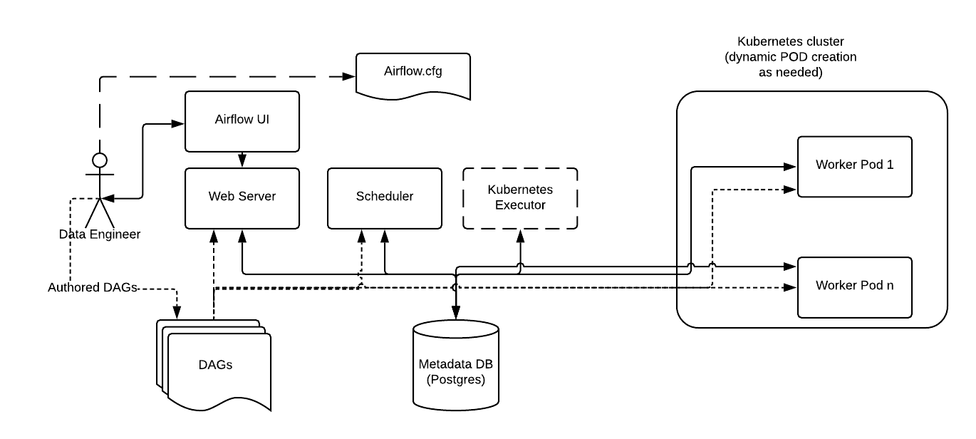

Technology Stack

Infrastructure Layer
- k3s – Lightweight Kubernetes cluster
- Rancher – Kubernetes management UI
- Docker – Containerization
- kubectl – Cluster management

Data Processing Layer
- Apache Spark (PySpark)
• Distributed risk metric computation
• Rolling aggregations
• Portfolio analytics

Orchestration Layer
- Apache Airflow
• DAG-based pipeline execution
• Retry handling
• Scheduled jobs
• Dependency management

Data Warehouse Layer
- PostgreSQL
• Star schema modeling
• Analytical fact tables
• Indexed queries for dashboard performance

Visualization Layer
- Metabase
• Portfolio dashboard
• Risk trend visualization
• KPI monitoring

Data Architecture (Star Schema)

Fact Table: fact_portfolio_metrics
- date
- ticker
- close_price
- daily_return
- rolling_volatility
- sharpe_ratio
- var_95
- pnl

Dimension Tables
dim_stock:
- ticker
- sector
- industry
dim_date:
- date
- month
- quarter
- year

Engineering Best Practices Applied
- Kubernetes Namespaces (data-platform)
- StatefulSets for databases
- Persistent Volume Claims (PVCs)
- Containerized Spark jobs
- CronJobs for ingestion
- Resource limits for pods
- Star schema modeling
- Idempotent data loads
- Modular folder structure
- Clean Git commit history

Project Structure
k8s-financial-risk-analytics/
│
├── ingestion/ # Market data ingestion scripts
├── spark_jobs/ # Risk metric computation
├── dags/ # Airflow pipelines
├── k8s/ # Kubernetes manifests
├── docker/ # Dockerfiles
├── sql/ # Schema definitions
├── docs/ # Architecture diagrams
└── README.md

Key Learning Outcomes
- Kubernetes-native data engineering
- Distributed processing with Spark
- Financial risk modeling concepts
- Analytical schema design
- Production-style orchestration
- Containerized application deployment

Resume Summary Line
Built a Kubernetes-native financial risk analytics platform using k3s, Apache Spark, Airflow, PostgreSQL, and Metabase. Designed a star schema data model and implemented distributed Spark jobs to compute portfolio risk metrics including VaR, Sharpe Ratio, and rolling volatility.

