Markup Task

Below you can see the new banner design for HealthUnlocked community homepages. Using any techniques, libraries, and frameworks you like you will need to convert this banner design to semantic HTML/CSS.

A few specifications:

* The max width of the surrounding page (which includes the banner) is 1100px
* We should be able to re-use these styles to create a user profile header which is structured identically
* The header must be responsive (preferably written in a mobile-first fashion)
* Don’t worry about displaying retina images for now
* The font used is “Open Sans”
* Browsers the markup should support are >IE8 and latest versions of Chrome, Mobile Chrome, Safari, iOS Safari & Firefox.
* Transitions are not in the required spec but feel free to add some spice at your own will

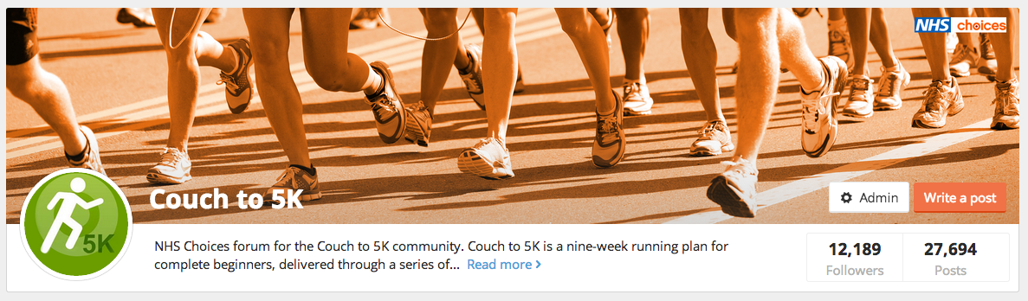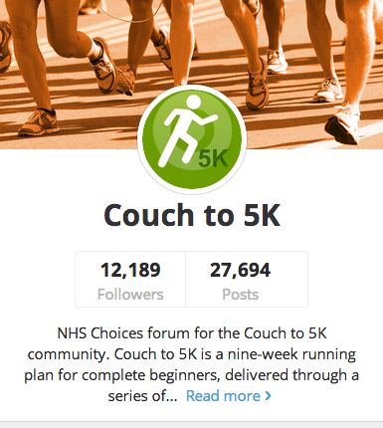

[For assets download this folder.](https://www.dropbox.com/sh/pux9ztu9sxq6iwt/AAAjcGwpRS_BvQ9gGfS0nAlma)