NATIONAL ECONOMICS UNIVERSITY
FACULTY OF Data Science and Artificial Intelligence

MAJOR ASSIGNMENT
Course: Deep Neural Networks
TOPIC: Automated Chest X-ray Classification for Respiratory Diseases

Instructor: Dr. Nguyen Thi Kim Ngan
Students:
1. Phan Thi Anh Quynh
2. Chu Vu Thao Hien
3. Nguyen Minh Quang
4. Le Duy Quyen

Hanoi, October 2026
Part 1: Theory
Convolutional neural networks (CNNs) are one of the main types of neural networks used for image recognition and classification. CNNs have several uses, some of which are object recognition, image processing, computer vision, and face recognition. Input for convolutional neural networks is provided through images. Convolutional neural networks are used to automatically learn a hierarchy of features that can then be utilized for classification, as opposed to manually creating features. In achieving this, a hierarchy of feature maps is constructed by iteratively convolving the input image with learned filters. Because of the hierarchical method, higher layers can learn more intricate features that are also distortion and translation invariant.
A CNN is built from a few types of layers. The most important ones are described below.
1. Convolutional layer. A convolutional layer has a set of small filters (kernels), for example of size 3 × 3. Each filter slides over the input image. At every position, the filter weights are multiplied with the pixels under it, the results are added up and a bias is added. The output of one filter is called a feature map. Because the same filter is used at every position, the number of weights does not depend on the image size, and a pattern can be found wherever it appears in the image. The output size is calculated by W_out = (W − K + 2P) / S + 1, where W is the input size, K the kernel size, P the padding and S the stride. For example, in our simple CNN a 3 × 3 filter with no padding and stride 1 turns a 128 × 128 image into a 126 × 126 feature map.
2. Activation function. After each convolution an activation function is applied. We use ReLU, f(x) = max(0, x). It is simple and fast, and it makes the network non-linear. Without it, many layers stacked together would act like one linear layer.
3. Pooling layer. A pooling layer makes the feature maps smaller. Max pooling with a 2 × 2 window keeps the largest value in each window, so the width and height are halved. This reduces computation and makes the network less sensitive to small shifts. Global average pooling takes the average of each whole feature map, so each channel becomes one number.
4. Fully connected layer and Softmax. At the end of the network, the feature maps are flattened into a vector and passed to fully connected (dense) layers, where every neuron is connected to all inputs. The last layer has one neuron for each class. The Softmax function turns these outputs into probabilities that add up to 1, and the class with the highest probability is the prediction. The network is trained with the cross-entropy loss, L = −log(p_y), where p_y is the predicted probability of the true class.
5. Training. The weights are learned with backpropagation and gradient descent. The data is divided into mini-batches; after each batch the gradient of the loss is computed and the weights are updated. The learning rate decides how big each update step is, and one epoch means the network has seen the whole training set once. We use AdamW, a version of the Adam optimizer with weight decay.
6. Overfitting and regularization. Overfitting happens when the model learns the training images too well but does badly on new images. Common ways to reduce it are: Dropout (randomly turning off some neurons during training), Batch Normalization (normalizing the output of a layer, which also makes training faster and more stable), data augmentation (randomly changing the training images), weight decay, and early stopping (stopping training when the validation loss no longer improves).
7. Well-known CNN architectures. LeNet-5 was one of the first CNNs, with convolution and pooling layers followed by fully connected layers. GoogLeNet introduced the Inception block, where several convolutions with different kernel sizes run in parallel and their outputs are concatenated. ResNet introduced the residual block, where the input is added to the output (F(x) + x); this shortcut makes very deep networks easier to train. MobileNet uses depthwise separable convolutions so the model is small and fast.
8. Transfer learning and fine-tuning. Transfer learning means reusing a model that was already trained on a large dataset such as ImageNet (1.2 million images, 1,000 classes). Its early layers have learned general features like edges and textures, which are also useful for X-ray images. Usually we first freeze these layers and only train a new last layer (feature extraction), then unfreeze some of the last layers and train them with a small learning rate (fine-tuning).
9. Evaluation metrics. Accuracy is the percentage of correct predictions. For one class, precision is the share of images predicted as that class that really belong to it, and recall is the share of images of that class that the model finds. F1-score = 2 · Precision · Recall / (Precision + Recall). We report the macro average, which is the mean over the three classes. A confusion matrix shows, for each true class, how many images were predicted as each class.
10. Grad-CAM. Grad-CAM is a method to see which part of an image a CNN uses for its decision. It uses the gradients of the predicted class with respect to the last convolutional feature maps to build a heatmap over the image.
Part 2: Practical Application
I. Problem Description
- Title: Automated Chest X-ray Classification for Respiratory Diseases
- Research objectives: Develop and evaluate a CNN model capable of automatically classifying chest X-ray images into COVID-19, Pneumonia, and Normal categories, while also analyzing the model's capabilities and limitations.
- Input of the problem: A Chest X-ray image
- Output of the problem: Multiclass classification with 3 mutually exclusive labels:
  - Class 0: COVID-19
  - Class 1: Normal
  - Class 2: Pneumonia
- Main Steps:
  - Collect and preprocess the X-ray image dataset.
  - Split the data into training, validation, and testing sets.
  - Build a CNN model to learn image features.
  - Train the model and tune hyperparameters.
  - Evaluate performance using Accuracy, Precision, Recall, F1-score, and Confusion Matrix.
  - Optionally experiment with Transfer Learning (using ResNet or MobileNet) to compare against the custom CNN model.

II. Dataset Description
- Download link for the dataset: https://www.kaggle.com/datasets/sachinkumar413/covid-pneumonia-normal-chest-xray-images
- It is a medical images directory structure branched into 3 subfolders (COVID, NORMAL, PNEUMONIA) which contains the Chest X-ray (CXR) Images.
  - COVID: 1626 images
  - NORMAL: 1802 images
  - PNEUMONIA: 1800 images
Total: 5,228 images. The images are PNG files of size 232 × 232 (4,228 images) or 256 × 256 (1,000 images). They are saved in RGB format but the content is grayscale.
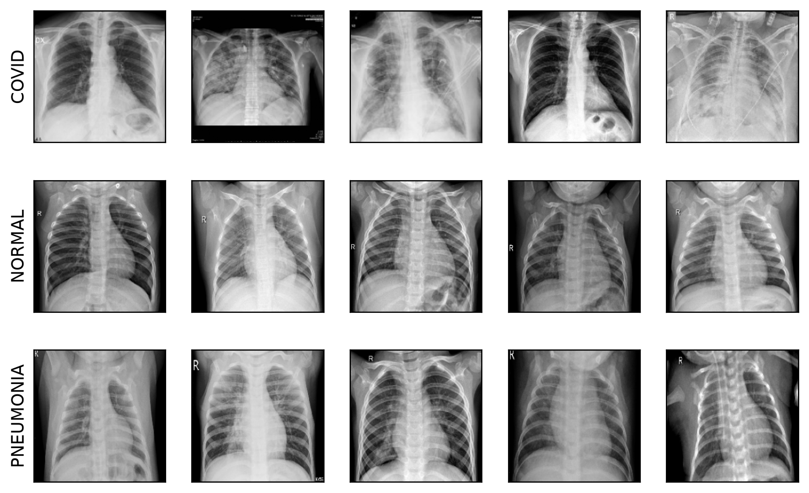
Figure 1: Sample images of each class (rows: COVID, NORMAL, PNEUMONIA).
III. CNN Model Design
- Preprocess the data
  - Data Cleaning: The dataset consists of chest X-ray images belonging to three classes: COVID, NORMAL, and PNEUMONIA. Only PNG image formats are included. Images are converted to grayscale and resized to 224 × 224 pixels (128 × 128 for the simple CNN) to ensure a uniform input size for the CNN models.
  - Removing duplicates: When checking the data we found many repeated images. If the same image is in both the training set and the test set, the model only needs to remember it, and the test score becomes higher than it really is (data leakage). We removed 0 broken files, 229 exact duplicates (files with the same MD5 hash), 819 near duplicates (the same image with a small change in contrast or position, found by comparing a 16 × 16 difference hash of each image) and 3 images whose copies had different labels. After cleaning, 4,177 images are left: COVID 1,077, NORMAL 1,425, PNEUMONIA 1,675.
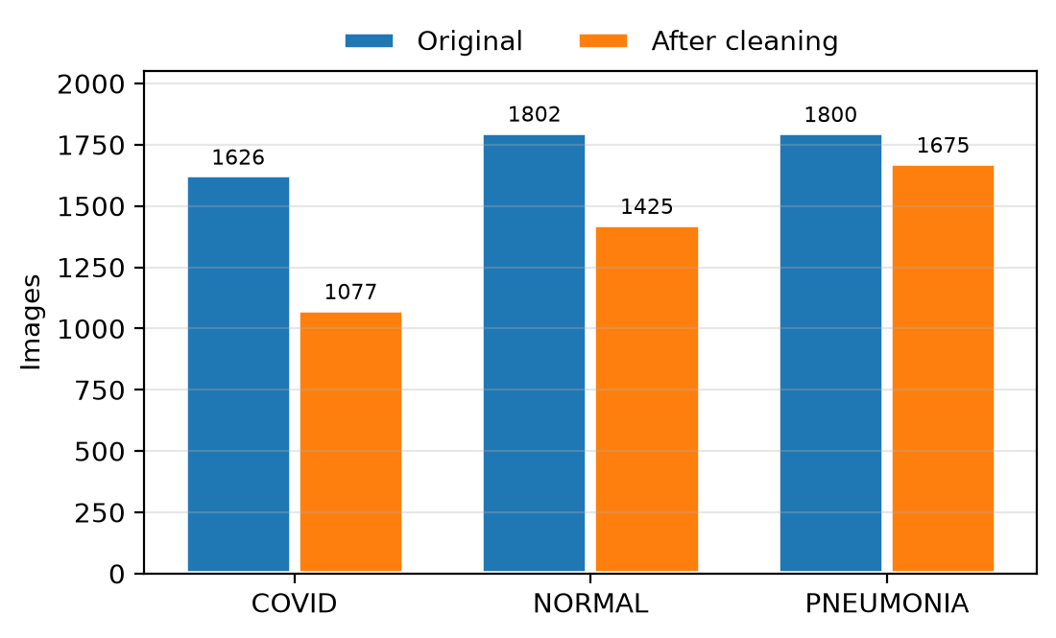
Figure 2: Number of images per class before and after cleaning.
  - Data Normalization: Pixel values ​​are scaled from the [0, 255] range to [0, 1] by dividing each value by 255. This helps stabilize the training process.
  - After scaling, the values are standardized with (x − 0.5) / 0.25 for our own CNN models. For the pretrained models (ResNet-50 and MobileNetV3), the gray channel is copied three times to get an RGB image and normalized with the ImageNet mean and standard deviation.
  - Data Augmentation: Only the training images are augmented. Every epoch, each image is changed randomly: rotation up to ±10°, shift up to 5 %, zoom between 90 % and 110 %, and brightness and contrast change up to ±20 %. We do not flip the images horizontally because the heart is on the left side of the chest, so a flipped image would not be a real X-ray. Because the COVID class has fewer images, each class also gets a weight in the loss function that is inversely proportional to its number of training images.
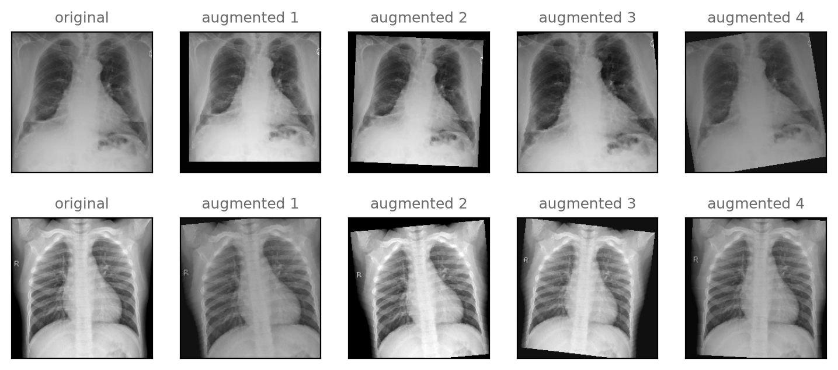
Figure 3: Original images and some random augmented versions.
  - The dataset is divided into three subsets using a 70:15:15 ratio. The split is done separately for each class (stratified) with random seed 42:
  - Training set (70%): Used to train the CNN model.
  - Validation set (15%): Used to monitor model performance during training and assist in fine-tuning model parameters.
  - Test set (15%): Used for the final evaluation of the trained model on previously unseen data.
Table 1: Number of images in each subset.
Subset | COVID | NORMAL | PNEUMONIA | Total
Training | 754 | 997 | 1,172 | 2,923
Validation | 162 | 214 | 251 | 627
Test | 161 | 214 | 252 | 627

- Simple CNN model
The proposed CNN model is designed to classify chest X-ray images into three categories: NORMAL, PNEUMONIA, and COVID.

The model accepts grayscale images of size 128 × 128 × 1 as input. Two convolutional layers—each consisting of 32 filters with a 3 × 3 kernel size and the ReLU activation function—are used to extract key features from the images. A MaxPooling2D layer with a 2 × 2 pool size reduces the spatial dimensions of the feature maps.

Next, a Flatten layer converts the extracted feature maps into a one-dimensional vector. A fully connected (Dense) layer with 128 neurons and the ReLU activation function learns higher-level feature representations. A Dropout layer with a rate of 0.5 is included to help mitigate overfitting.

Finally, the output layer consists of three neurons using the Softmax activation function to estimate the probability for each class. The class with the highest predicted probability is selected as the model's final prediction.
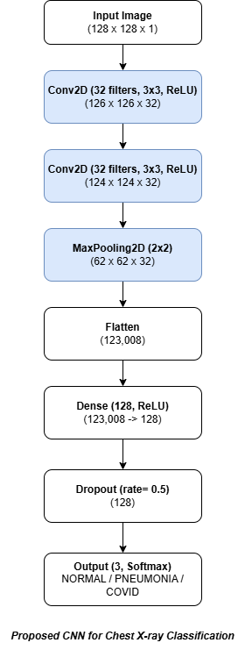
Figure 4: Architecture of the simple CNN.
The model has 15,755,107 parameters, and almost all of them (15,745,152) are in the dense layer after Flatten. It is trained with the AdamW optimizer and the weighted cross-entropy loss. The learning rate is reduced when the validation loss stops improving, and training stops early when the validation loss does not improve for 8 epochs; the weights of the best epoch are kept.
To choose the learning rate and the batch size, we tried 6 combinations (with augmentation, at most 25 epochs) and compared them on the validation set only, so the test set was not used for this choice (Table 2).
Table 2: Learning rate and batch size search for the simple CNN (validation set).
Learning rate | Batch size | Val accuracy | Val F1-score | Best epoch
0.003 | 32 | 0.4003 | 0.1906 | 4
0.003 | 64 | 0.9346 | 0.9374 | 23
0.001 | 32 | 0.9219 | 0.9236 | 14
0.001 | 64 | 0.9537 | 0.9558 | 22
0.0003 | 32 | 0.9394 | 0.9418 | 14
0.0003 | 64 | 0.9426 | 0.9451 | 14

The best setting is learning rate 0.001 with batch size 64 (validation F1 = 0.9558), so we use it for the final model. With learning rate 0.003 and batch size 32 the model did not learn and predicted almost only one class, because the large dense layer is not stable with such a big step. We trained the final simple CNN two times, without and with data augmentation, to see the effect of augmentation.
- Complex CNN model
Our complex CNN combines two well-known types of blocks: the Inception block from GoogLeNet and the residual block from ResNet (Figure 5).
  - Inception block: the input goes through 4 branches at the same time: a 1 × 1 convolution; a 1 × 1 then a 3 × 3 convolution; a 1 × 1 then a 5 × 5 convolution; and a 3 × 3 max pooling then a 1 × 1 convolution. The outputs are concatenated along the channels, so the block can look at details of different sizes at once.
  - Residual block: two 3 × 3 convolutions with Batch Normalization, and the input x is added to the output (output = F(x) + x). When the number of channels changes, a 1 × 1 convolution is used on the shortcut. This shortcut helps the gradient flow back, so deeper networks can be trained.
The whole model takes a 1 × 224 × 224 image and has these parts: a stem (7 × 7 convolution with stride 2, 3 × 3 max pooling, 1 × 1 convolution, 3 × 3 convolution, 3 × 3 max pooling), 2 Inception blocks (128 and 224 output channels), a max pooling layer, 4 residual blocks (256, 256, 384 and 384 channels), global average pooling, and the classifier (Dropout 0.4, Dense 128 with ReLU, Dropout 0.3, Dense 3 with Softmax). Every convolution is followed by Batch Normalization and ReLU. The model has about 7.6 million parameters. It is trained like the simple CNN, with learning rate 0.001, batch size 32 and data augmentation.
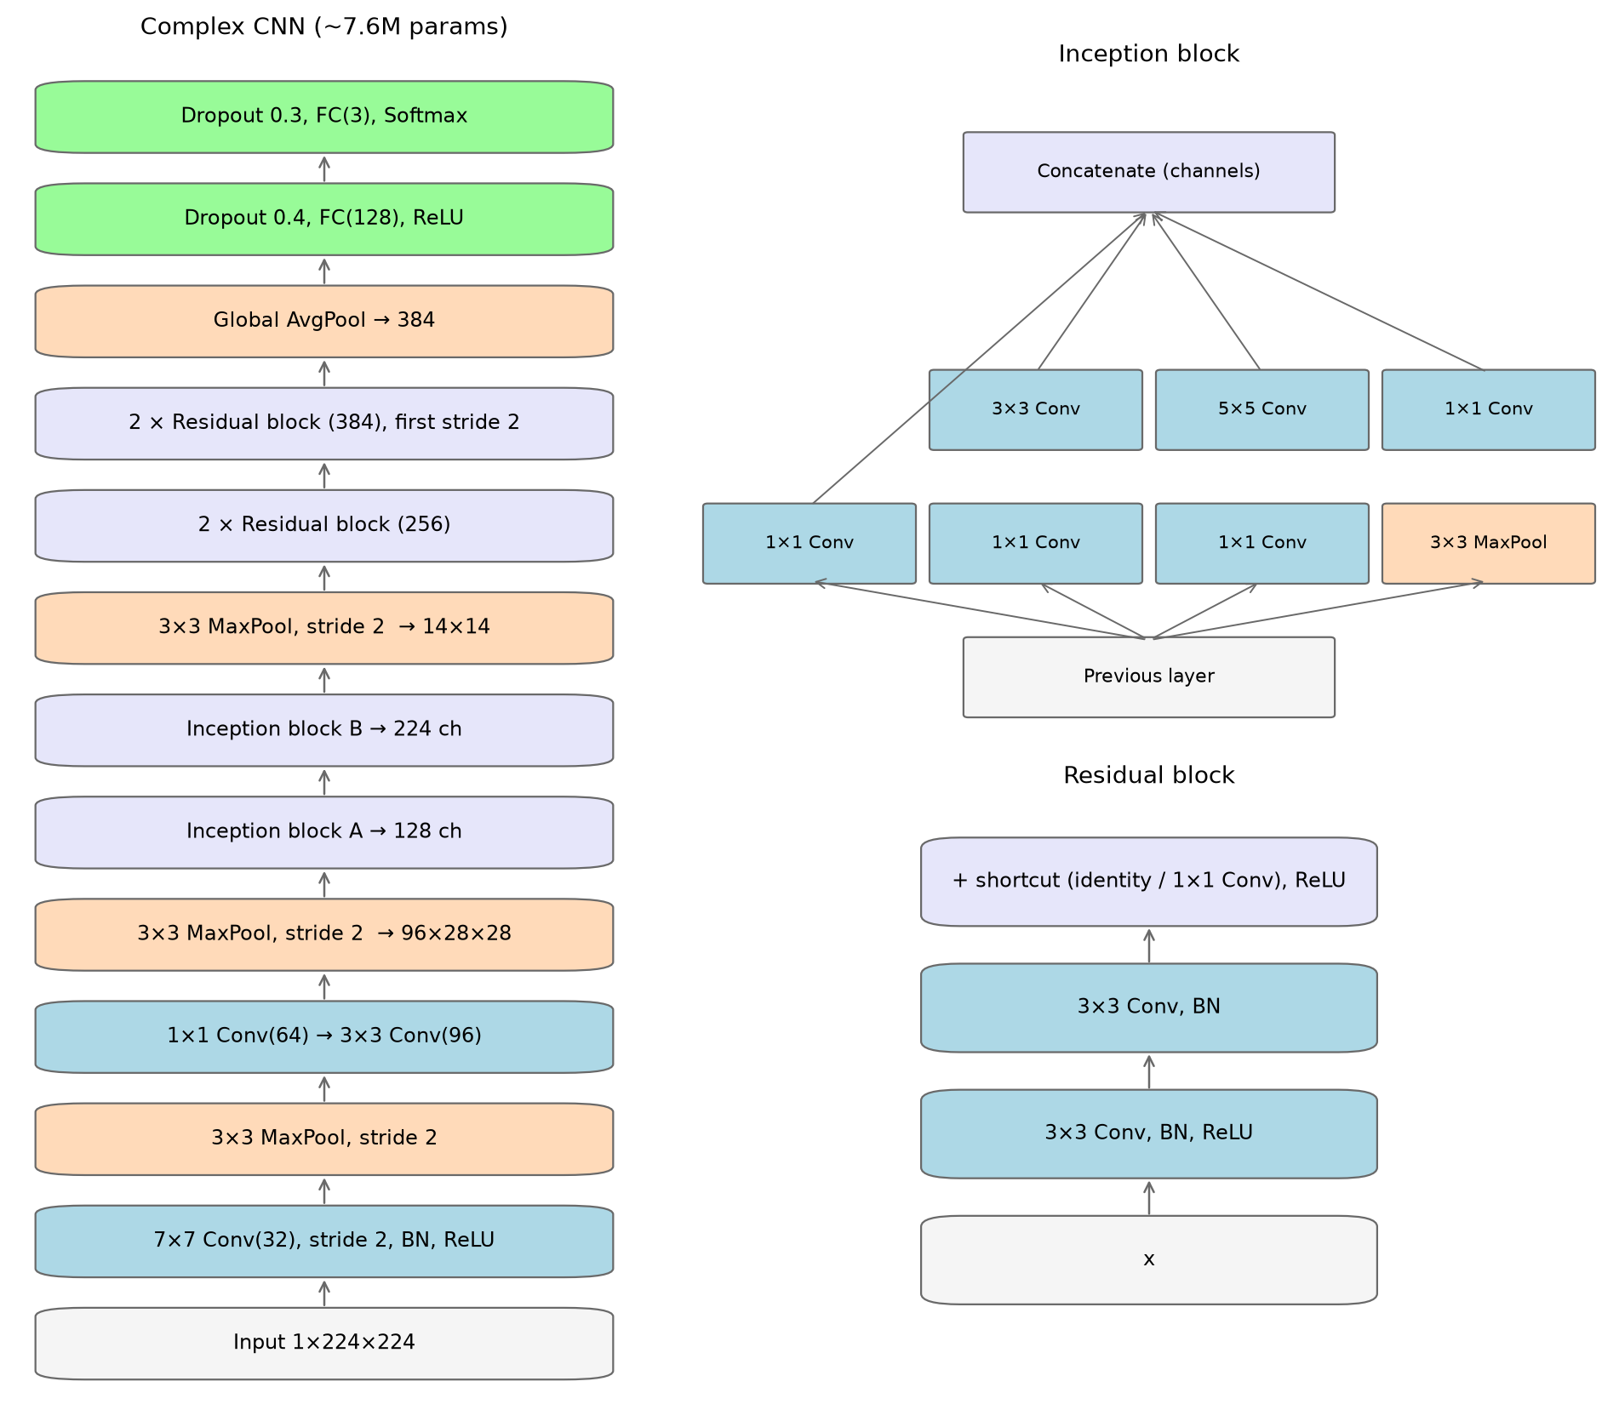
Figure 5: Architecture of the complex CNN, with the Inception block and the residual block.
- CNN model using Transfer Learning / Fine-Tuning
We use two models that were pretrained on ImageNet: ResNet-50 (23.5 million parameters) and MobileNetV3-Large (4.2 million parameters, much lighter and faster). The last layer of each model is replaced by a new fully connected layer with 3 outputs. The gray X-ray image is copied to 3 channels to match the RGB input of these models. Training has two phases (Figures 6 and 7):
  - Phase 1 – feature extraction (5 epochs): all pretrained layers are frozen and only the new last layer is trained with learning rate 0.001.
  - Phase 2 – fine-tuning: the last stage is unfrozen (layer4 of ResNet-50 and the last 4 blocks of MobileNetV3) and trained together with the new layer using a smaller learning rate of 0.0001, for at most 25 more epochs with early stopping. This leaves 15.0 million trainable parameters in ResNet-50 and 2.2 million in MobileNetV3. The small learning rate keeps the pretrained weights from being destroyed, and the early layers stay frozen because their general edge and texture filters already work well and our training set is small.
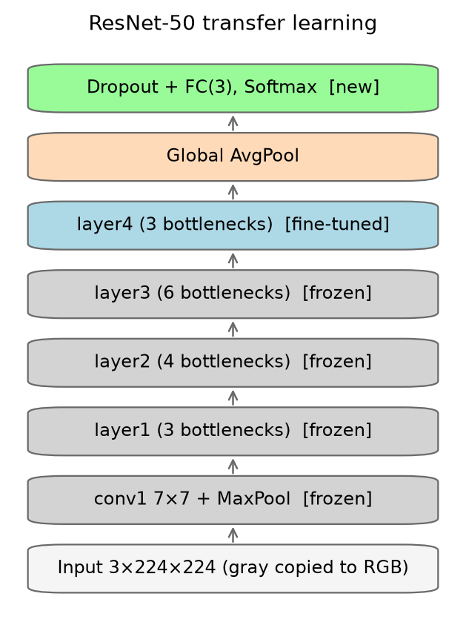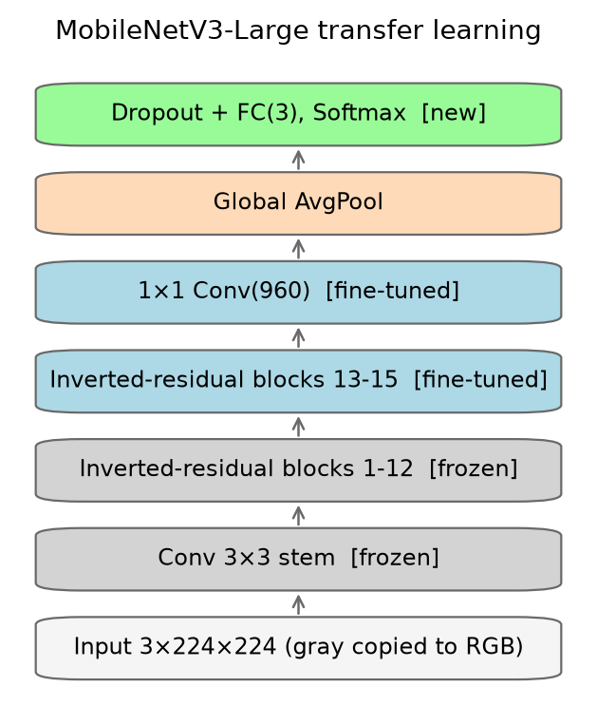
Figure 6 (left): ResNet-50 with transfer learning. Figure 7 (right): MobileNetV3-Large with transfer learning. Gray layers are frozen, blue layers are fine-tuned.
IV. Experimental Results
All five models were evaluated once on the test set (627 images). Table 3 shows the accuracy and the macro average of precision, recall and F1-score.
Table 3: Results of all models on the test set.
Model | Accuracy | Precision | Recall | F1-score
Simple CNN | 0.9490 | 0.9492 | 0.9519 | 0.9504
Simple CNN + Aug | 0.9474 | 0.9491 | 0.9515 | 0.9498
Complex CNN + Aug | 0.9569 | 0.9605 | 0.9594 | 0.9596
ResNet-50 (TL) + Aug | 0.9729 | 0.9744 | 0.9761 | 0.9752
MobileNetV3 (TL) + Aug | 0.9761 | 0.9780 | 0.9785 | 0.9781

Transfer learning gave the best results. MobileNetV3 reached 97.61 % accuracy and an F1-score of 0.9781, and ResNet-50 was close with 97.29 % and 0.9752. Our two CNNs trained from scratch reached 94.7–95.7 %. With only 2,923 training images, a model that already learned features from 1.2 million images has a clear advantage. MobileNetV3 is also 5.6 times smaller than ResNet-50 and trained faster (278 s compared to 467 s).
The complex CNN was better than the simple CNN (F1 0.9596 against 0.9498 with augmentation), even though it has about half as many parameters (7.6 M against 15.8 M). Most weights of the simple CNN are in one large dense layer, while the complex CNN uses global average pooling instead. Augmentation did not improve the test score of the simple CNN (0.9498 with and 0.9504 without), but Figure 8 shows its effect on training: without augmentation the training loss went almost to zero while the validation loss stopped improving after epoch 4, so early stopping ended training at epoch 12. With augmentation the training and validation curves stayed close and the model kept improving until epoch 22.
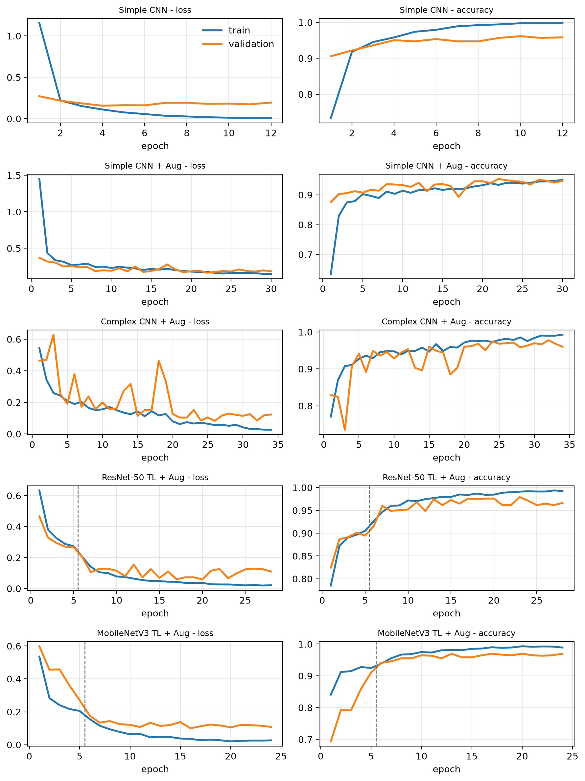
Figure 8: Loss and accuracy during training (blue: training, orange: validation). The dashed line is where fine-tuning starts.
Table 4: Results for each class on the test set.
Model | Class | Precision | Recall | F1-score
Simple CNN + Aug | COVID | 0.9691 | 0.9752 | 0.9721
 | NORMAL | 0.9115 | 0.9626 | 0.9364
 | PNEUMONIA | 0.9665 | 0.9167 | 0.9409
Complex CNN + Aug | COVID | 0.9936 | 0.9689 | 0.9811
 | NORMAL | 0.9248 | 0.9766 | 0.9500
 | PNEUMONIA | 0.9631 | 0.9325 | 0.9476
MobileNetV3 (TL) + Aug | COVID | 1.0000 | 0.9938 | 0.9969
 | NORMAL | 0.9502 | 0.9813 | 0.9655
 | PNEUMONIA | 0.9837 | 0.9603 | 0.9719

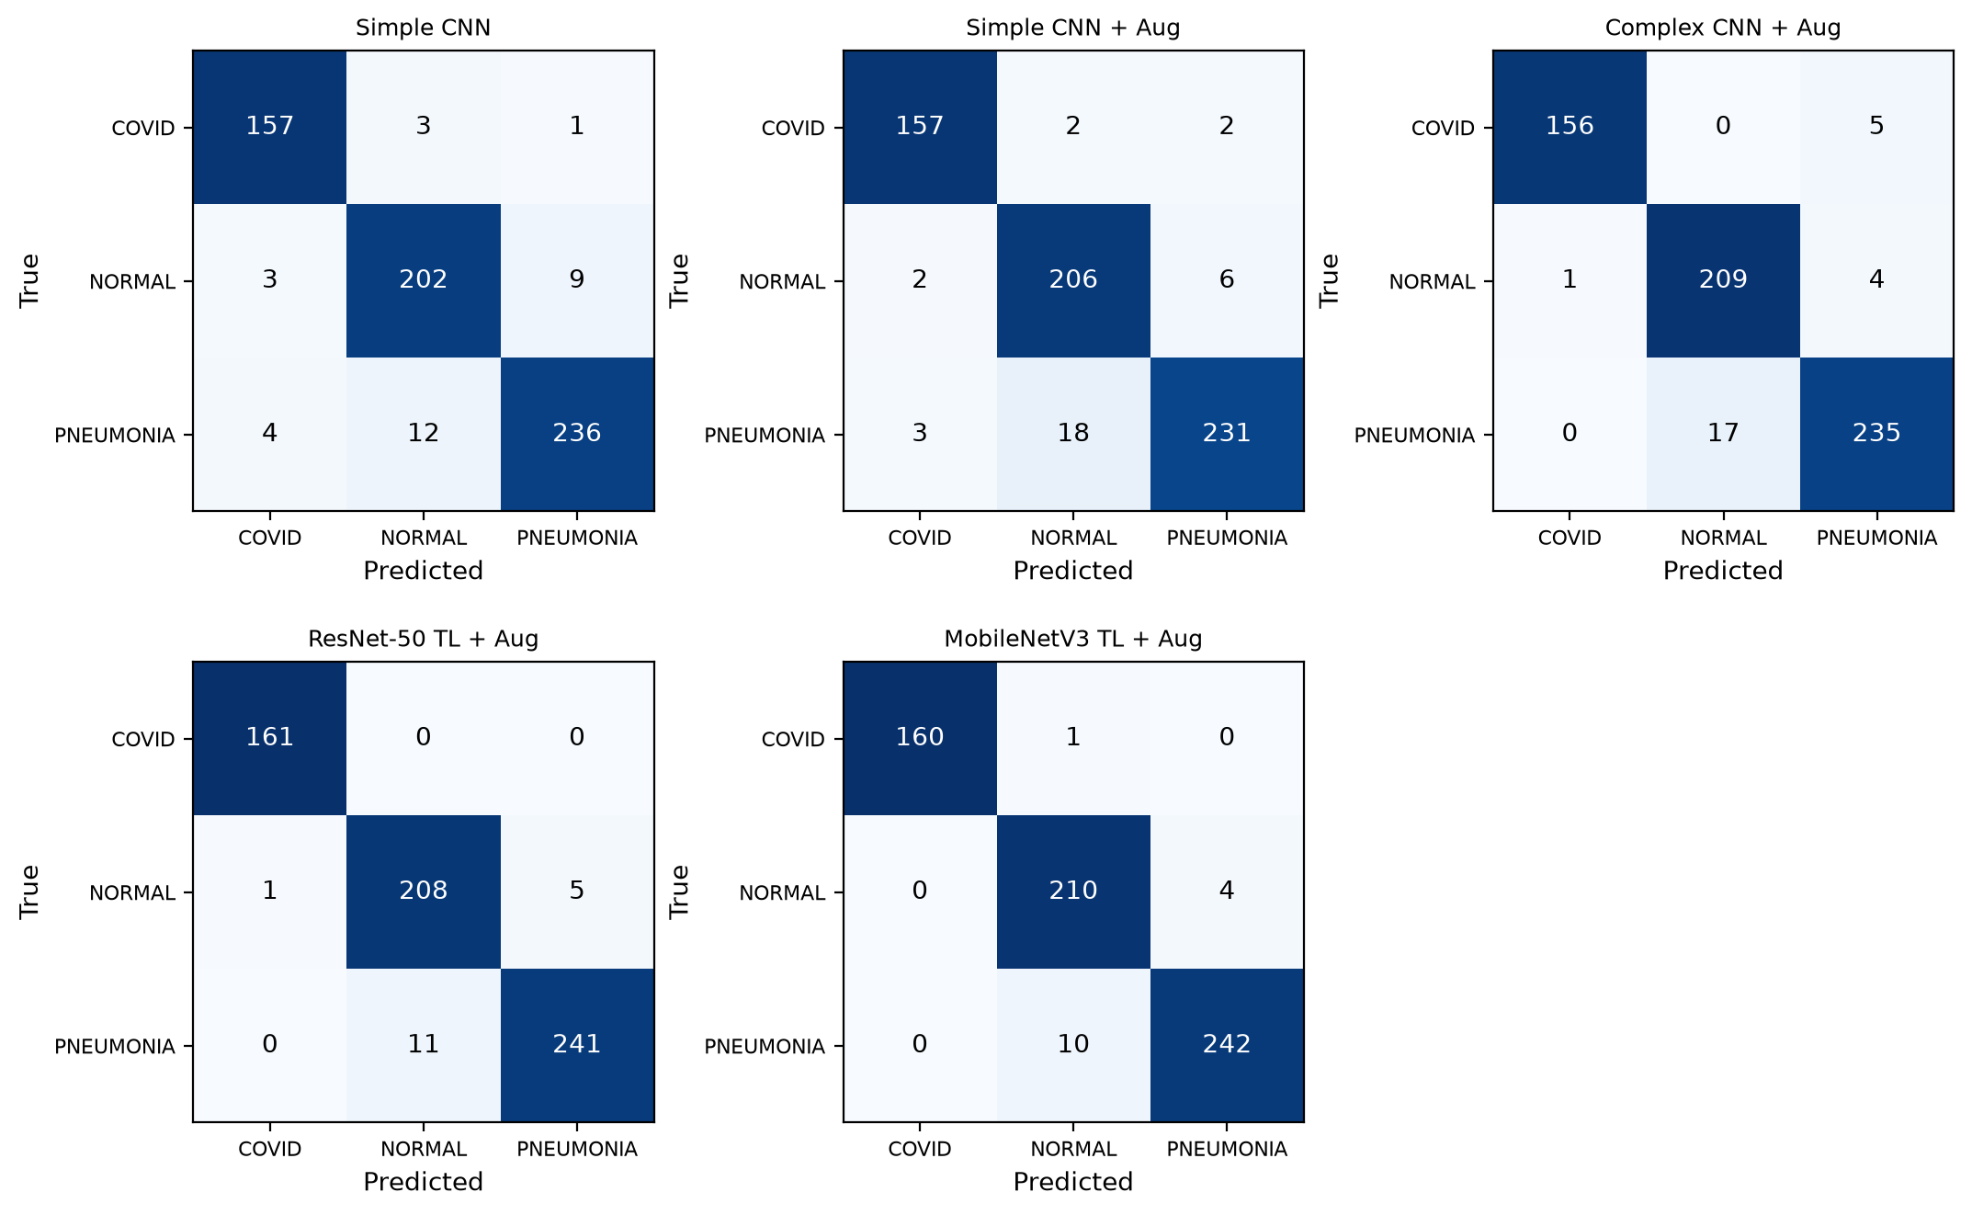
Figure 9: Confusion matrices on the test set (rows: true class, columns: predicted class).
Does the model confuse COVID-19 with Pneumonia? Almost never. The recall of COVID-19 is above 0.96 for every model, and ResNet-50 found all 161 COVID-19 test images. The complex CNN predicted 5 COVID-19 images as Pneumonia and the simple CNN 1–2 images, and only the two simple CNNs predicted some Pneumonia images as COVID-19 (4 without and 3 with augmentation).
Which class is the hardest? Normal and Pneumonia. Almost all remaining errors are between these two classes. The most common error is a Pneumonia image predicted as Normal: 10 to 18 of the 252 Pneumonia test images depending on the model (10 for MobileNetV3, 11 for ResNet-50). In medicine this is a false negative, which is more dangerous because a sick patient would be told they are healthy.
Where does the CNN look? Figure 10 shows Grad-CAM heatmaps of ResNet-50 (red means more important). For correct Pneumonia predictions the heatmap is mostly inside both lungs. However, for many images, especially the wrong ones, the heatmap is on the abdomen, the diaphragm or the neck, outside the lungs. This means the model sometimes uses things that are not related to the disease.
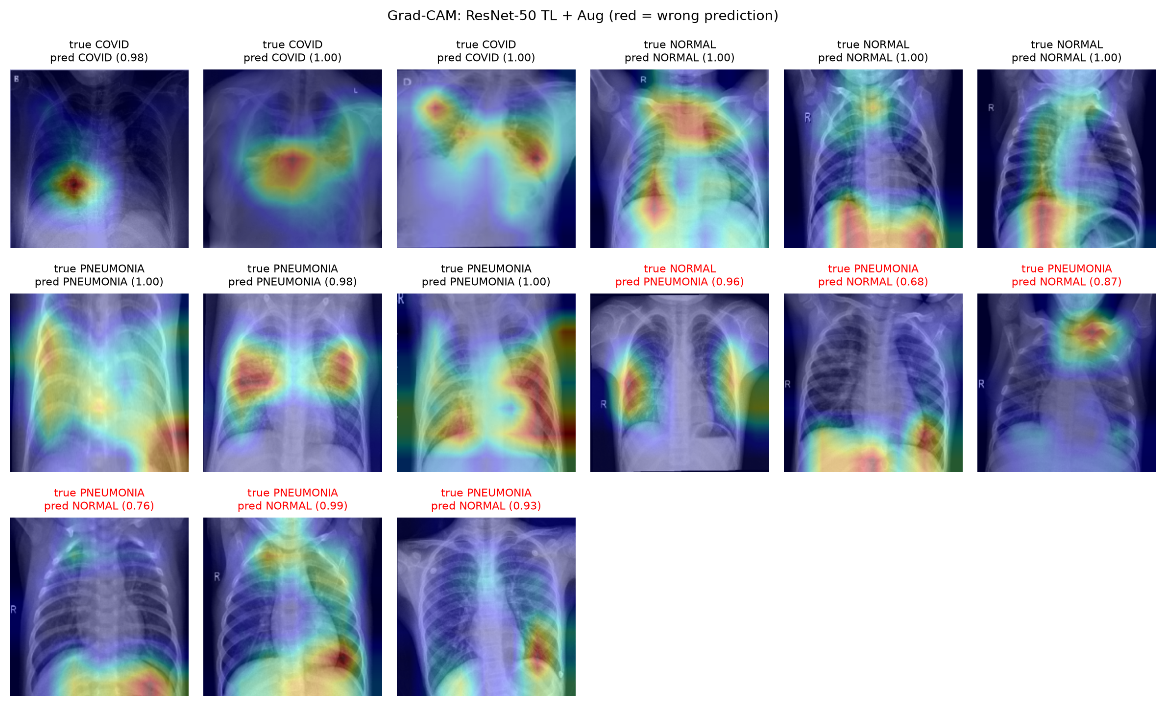
Figure 10: Grad-CAM of ResNet-50 on test images (red title = wrong prediction).

Limitations. The NORMAL and PNEUMONIA images in this dataset are X-rays of children, while the COVID images are adult X-rays from other sources, often with different markers and text. So part of the very high COVID accuracy may come from recognizing the image source or the age of the patient, not the disease itself (DeGrave et al., 2021). The dataset also has no patient IDs, so two different images of the same patient could still be in different subsets. Each model was trained only once with one seed, so the small difference between ResNet-50 and MobileNetV3 (0.3 %, about 2 images) is not enough to say which one is better. The models are for study only and cannot be used for real diagnosis.
V. Conclusion
We built a full pipeline to classify chest X-rays into COVID-19, Pneumonia and Normal, and covered all five requirements of the assignment. Cleaning the data was an important step: 1,051 of the 5,228 images were duplicates, near duplicates or label conflicts, and removing them avoided a test score that is too optimistic. On the cleaned data, our simple CNN with two convolutional layers reached 94.9 % accuracy, and the complex CNN with Inception and residual blocks reached 95.7 %. Transfer learning gave the best results: MobileNetV3 reached 97.6 % accuracy and an F1-score of 0.978. The most common error is predicting Pneumonia as Normal, and Grad-CAM shows that the models sometimes look outside the lungs. In the future we could segment the lungs before classification, train with several seeds or k-fold cross-validation, and test on another dataset.
References
[1] Y. LeCun, L. Bottou, Y. Bengio and P. Haffner, "Gradient-based learning applied to document recognition," Proceedings of the IEEE, 1998.
[2] C. Szegedy et al., "Going deeper with convolutions," CVPR, 2015.
[3] K. He, X. Zhang, S. Ren and J. Sun, "Deep residual learning for image recognition," CVPR, 2016.
[4] A. Howard et al., "Searching for MobileNetV3," ICCV, 2019.
[5] S. Ioffe and C. Szegedy, "Batch normalization: Accelerating deep network training by reducing internal covariate shift," ICML, 2015.
[6] N. Srivastava et al., "Dropout: A simple way to prevent neural networks from overfitting," JMLR, 2014.
[7] I. Loshchilov and F. Hutter, "Decoupled weight decay regularization," ICLR, 2019.
[8] R. R. Selvaraju et al., "Grad-CAM: Visual explanations from deep networks via gradient-based localization," ICCV, 2017.
[9] A. Zhang, Z. C. Lipton, M. Li and A. J. Smola, Dive into Deep Learning, https://d2l.ai.
[10] A. J. DeGrave, J. D. Janizek and S.-I. Lee, "AI for radiographic COVID-19 detection selects shortcuts over signal," Nature Machine Intelligence, 2021.
[11] Covid-Pneumonia-Normal Chest X-Ray Images, Kaggle: https://www.kaggle.com/datasets/sachinkumar413/covid-pneumonia-normal-chest-xray-images

