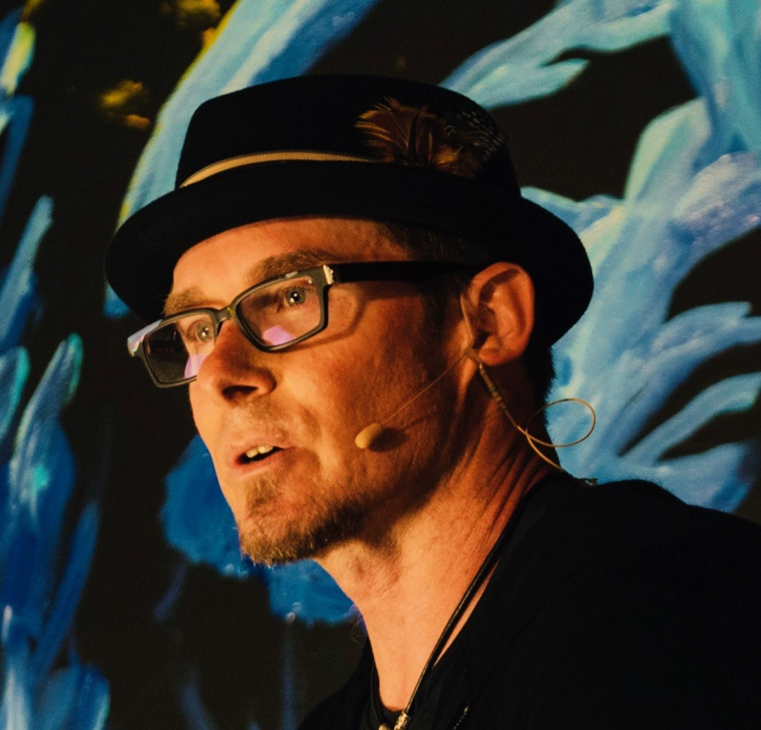
BIO
Erik Wahl is a globally acclaimed artist, TED speaker, and No. 1 bestselling author, recognized as one of the most sought-after corporate speakers of 2025. With a unique blend of artistry and entrepreneurial expertise, Erik delivers dynamic keynotes that inspire organizations to embrace creativity, innovation, and mental agility in a world where disruption is the new normal.
His bestselling book, The Spark and the Grind, has been praised as a transformative guide for turning ideas into action. Another of his best selling books, Unthink, is hailed by Forbes as "The blueprint to actionable creativity" and by Fast Company as “provocative with a purpose.”
Drawing inspiration from street art, Erik became an acclaimed graffiti artist, using his talents to raise funds for charitable causes. His performances seamlessly integrate his passion for art and business, leaving audiences both inspired and empowered.
Erik has collaborated with leading organizations such as AT&T, Disney, London Business School, Microsoft, FedEx, ExxonMobil, Ernst & Young, and XPrize. To date, he has delivered over 1,500 keynotes worldwide, captivating audiences with his innovative perspective.
To learn more or see Erik in action, visit theartofvision.com.


