CDE DevOps

Project Use Case-Requirements Document

Groovy and Jenkins

Contents

1.0 Problem statement 1

2.0 Skills to develop the project 2

3.0 Architecture Diagram for the Problem Statement 2

4.0 Expected Deliverables 3

# Problem statement

The objective of the document is to provide associate with a practice case study for Jenkins Groovy Scripting

You will be provided with an input file.

Please follow the below steps to start with the assignment:

1. Create a simple SharedLib in GitHub repo and configure it as Jenkins SharedLibrary in Jenkins
2. Create a Groovy script in Jenkins which be used as Shared Library on your Jenkins file
3. Store the input file as well inside GitHub Repo
4. Checkout GitHub repo (password should not be displayed in Jenkins Console output
5. Read through the Input file provided

**Case study:**

This input file is a CSV file with sample application release info. Prepare a status report of the application release in each environment. Create the report and store in Release_Status.CSV. Also display it on to the Console Output of the Jenkins Job.

Find attached input file below:



Status of App Releases in each environment.

**Example:**

**App ID,App Name,Release Version, Environments Passed, Environment Failed, Comments**  
132,CustomerService,1.0.0,DEV|SIT,UAT,QA Failed  
132,CustomerService,1.0.1,DEV|SIT|UAT|PROD,NA, Business Signed Off

Here the comments will be the latest comment of the release (from the last successful/failed release).

Associate should have knowledge to setup sharedlibrary in Jenkins and to create a Jenkins pipeline job.

# Skills to develop the project

Associate will choose any one of the technology stack and develop the application.

Below are the skill details.

|  |  |
| --- | --- |
| **Tower Name** | **Skill Names** |
| DevOps | Jenkins – Pipeline as Code |

# Architecture Diagram for the Problem Statement

Release Report Jenkins Pipeline

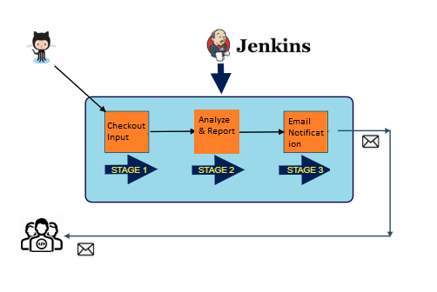

# Expected Deliverables

* Release_Status.CSV
* Send out email notification to a specific user with the result attached.