Traffic Sign Recognition: Project Report
Bekzod Boboev
July 2026
Table of Contents

Executive Summary
This project set out to teach a computer to recognize traffic signs from a photograph, the same way a driver glances at a sign and instantly knows what it means. Working from a public dataset of 200 sign classes and 116,642 images, the project moved through data auditing, careful preprocessing, a baseline model, a targeted improvement driven directly by what the baseline’s mistakes revealed, and finally a working demonstration that anyone can use through Telegram.
The final model — a pretrained ResNet18 network, fine-tuned on this dataset — reached 99.37% accuracy on a held-out test set it never influenced any decision on, up from an 87.84% baseline. More importantly, the specific weaknesses discovered in the baseline model were not just generically improved but specifically resolved: the exact sign pairs the baseline model confused were, one by one, fixed.
This report walks through the project stage by stage. At every stage, the emphasis is on what was measured, what that measurement showed, and what decision followed from it — the goal is that this document should be readable on its own, without needing to look at any code.

1. Introduction and Motivation
Traffic is easy to ignore until something goes wrong. Roads in Uzbekistan are getting busier every year, and in cities like Tashkent, congestion and complicated intersections are now the norm. Signs are how the road talks to a driver, but they are not always easy to read — faded paint, dust, poor lighting, or a driver who is simply tired or unfamiliar with the area. A system that can recognize signs automatically, even in imperfect conditions, ties directly into road safety.
It also fits where the country is heading. Cars increasingly come with driver-assistance features built on this exact kind of technology, and Uzbekistan’s push toward smart-city transport and digitalization will need more people who can build it locally — for local roads, local signage, local driving habits, not just models trained elsewhere. This project is a small step in that direction.
The task, precisely defined: given a photograph of a traffic sign as input, output which of 200 known sign types it is.

2. Project Setup and Dataset
The project was built stage by stage, deliberately in small steps, so that each part was working and understood before moving to the next. Git and GitHub were set up first, with a Python 3.12 environment (PyTorch, torchvision, pandas, scikit-learn, MLflow, and supporting libraries) pinned in a requirements.txt so the whole pipeline can be reproduced later.
Dataset: Traffic Signs in Post-Soviet States, a public Kaggle dataset — 200 sign classes, 116,642 images, roughly 14.9GB. The dataset also ships its own folder of clean reference icons per class, which turned out later to be useful for the final demo.
Because model training needs a GPU and this project’s own machine doesn’t have one, actual training was done in free cloud notebook environments (Google Colab, and later Kaggle Notebooks — more on why in Section 6), while all code, data decisions, and results were tracked in this project’s own GitHub repository as the permanent source of truth.

3. Data Audit and Exploratory Analysis
Before writing a single line of model code, the dataset was audited thoroughly. This mattered because several of the audit’s findings directly shaped decisions made much later in the project.
Integrity check: all 116,642 images were verified to open correctly. Zero corrupt files, all 200 class folders present.
Class distribution: class sizes ranged from 248 to 1,845 images, with a mean of 583. This is a real but moderate imbalance — no class had only a handful of images.
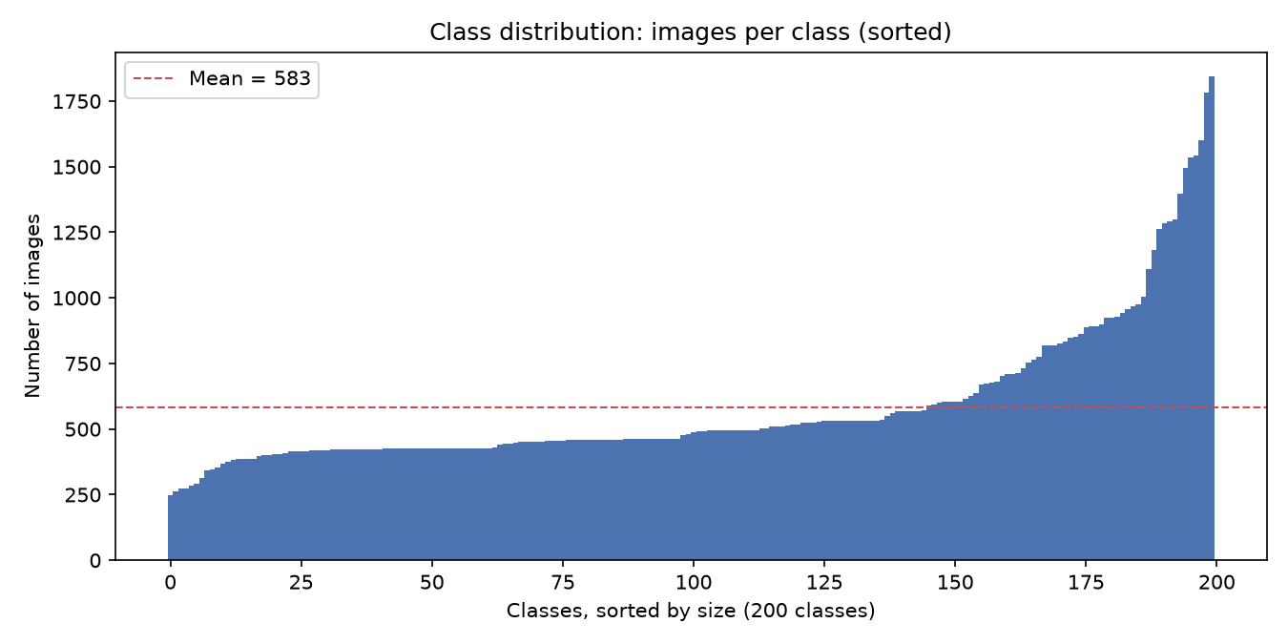
Sorted class sizes across all 200 classes. The imbalance is real but gradual — most classes cluster between 250 and 1,000 images, with a handful of larger classes pulling the tail up toward 1,845.
Decision made from this statistic: because the imbalance was moderate rather than extreme, the plan going forward was a WeightedRandomSampler during training (to oversample smaller classes) plus modest data augmentation — not drastic measures like discarding large classes or synthetic oversampling.
Image properties: widths ranged from 25px to 2,749px, with a median of only 191×157 — a long tail of larger images pulled the average up. Aspect ratios were mostly close to square, but with a real tail up to 5.88:1 for wide, thin signs such as information plates. The color mode was mostly RGBA (96,444 images) rather than plain RGB (20,198 images) — no grayscale images at all.
Decisions made from these statistics: a modest target size (64×64) was chosen rather than trying to preserve the resolution of the rare large images. Because of the aspect-ratio tail, images would later be letterboxed (padded to a square, not stretched) before resizing, to avoid distorting wide plates. The RGBA majority meant every image needed flattening to RGB before training.
Visual sample audit: a grid of images from 8 random classes (4 images each) was inspected by eye. All were internally consistent — no mislabeled folders were found.
Class name mapping: a class ID → human-readable name table was built directly from the dataset’s own folder structure (not hand-typed, to avoid transcription errors across 200 rows). One data quirk was found and flagged rather than silently guessed: class 81 has two conflicting names in the source taxonomy (“Height limit – 3.5” vs. “– 4.5”). This does not affect training, since the model only ever sees the numeric class ID — only the human-readable label is ambiguous.
The most consequential finding of this stage — data leakage risk: filenames suggested that many images were near-duplicate frames of the same physical sign, photographed moments apart (e.g. 00000_00000_00017.png, read as class/track/frame). This was confirmed for the roughly 10.3% of files with a cleanly parseable filename pattern — about 900 groups, averaging 13 images each, visually confirmed as the same sign photographed in quick succession. However, filename parsing only reliably covered about 10% of the dataset; the rest used other naming conventions, consistent with the dataset having been merged from multiple original sources.
Decision made from this finding: filename parsing alone was not sufficient to safely build a train/validation/test split. The project would need content-based near-duplicate detection across the whole dataset (not just the 10% with parseable filenames), and would split data by duplicate group, never by individual image — otherwise near-identical photos of the same sign could leak across the split and inflate validation/test accuracy artificially.

4. Preprocessing and Leakage Prevention
Directly following from the stage 3 finding above, a perceptual hashing approach was implemented: a 64-bit average hash was computed for every image, and images within the same class were grouped together if their hash distance was small enough (Hamming distance ≤ 6) to be considered near-duplicates. This was computed once, deterministically (a fixed random seed), so that results stayed comparable across every later experiment rather than being re-randomized each time the project was touched.
The dataset was then split by group, not by image: 70% / 15% / 15% train/validation/test, working out to 31,820 / 6,822 / 6,822 groups (roughly 70.9% / 15.5% / 13.5% of images, since group sizes vary). This split was saved once as a manifest file (a table mapping each image to its assigned split) rather than physically copying files around, and was validated to confirm every file path existed, the row count matched the dataset exactly, and no duplicate group ever spanned more than one split.
Known limitation, stated honestly: the near-duplicate grouping is fairly strict (about 2.6 images per group on average, versus about 13 per group for the filename-confirmed tracks found in stage 3). It reliably catches exact and near-exact duplicates, but may miss some more visually-different frames of the same physical sign — for example, a longer zoom sequence. This meaningfully reduces leakage risk compared to a naive per-image split, but it is not a perfect guarantee, and is worth stating plainly rather than glossing over.
Preprocessing pipeline decisions, each tracing back to a stage 3 finding:
- 64×64 target size, letterbox resize (pad to a square canvas, then resize) rather than a plain stretch — because stage 3.3 found a real aspect-ratio tail, and stretching would have distorted wide, thin signs.
- RGBA → RGB conversion — because stage 3.3 found the dataset was majority RGBA.
- ImageNet-style normalization — chosen deliberately even before any transfer-learning experiment was planned, specifically to keep the option of using a pretrained backbone open later (this decision paid off directly in Stage 6).
- Light augmentation (rotation + color jitter) on training data only — a modest response to the moderate class imbalance found in stage 3.2, combined with a WeightedRandomSampler that oversamples minority classes during training.
A sanity-check batch was loaded and visually inspected in the cloud notebook environment to confirm all of this worked as intended before moving on: batch shape correct, letterbox padding visible, augmentation visible, and class names matching their images.

5. Baseline Model
Setup: a simple 3-convolutional-block CNN with batch normalization, trained from scratch. Before committing to a full run, the training loop was first proven to work on a trivial 3-class subset. Experiment tracking was set up via MLflow (with results persisted to cloud storage so they would survive between sessions).
Result: the baseline was trained for 15 epochs on the full 200-class dataset, reaching a final validation accuracy of 87.84% — climbing steadily every single epoch (from about 40.5% to 87.8%), with no plateau and no sign of overfitting (validation accuracy stayed at or above training accuracy throughout, as expected since augmentation and dropout were only active during training). For context, random guessing across 200 classes would score about 0.5%.
The single most important statistic in the whole project came next, from evaluating this baseline in detail. The working assumption going in — based on stage 3’s finding of class imbalance — was that the smaller classes would be the weakest performers. The evidence flatly contradicted this: the correlation between a class’s validation accuracy and how many training images it had was only -0.124 — essentially no relationship at all. The WeightedRandomSampler already in place was handling the imbalance adequately; imbalance was not what was limiting this model.
So what was? A close look at the confusion matrix (which sign types the model mixed up with which) revealed the real pattern: specific, systematic confusion between visually or semantically similar sign pairs, not scattered random error. The clearest examples:
True sign | Confused with | Times confused (of validation set)
44 — Minor road, right | 45 — Minor road, left (mirror image) | 92
184 — Coverage area | 183 — Distance to the object | 52
184 — Coverage area | 193 — Limitation of parking duration | 46
189 — Validity period | 192 — Paid services | 51
190 — Method of parking | 196 — Dangerous roadside | 122 (the single biggest confusion in the model)
42 — End of overtaking-by-lorries restriction | 32 — End of all restrictions | 85
Class 184 (“Coverage area”) was the single worst-performing class overall, at only 17.9% accuracy — nearly all of its errors were the two confusions listed above.
Decision made from this evidence: the project’s next move should prioritize whatever improves the model’s ability to discriminate fine visual detail — more model capacity, or ideally a pretrained backbone — rather than any further imbalance-focused change, since the data had already shown imbalance was not the bottleneck. It was also noted that a quick, cheap visual sanity-check on the class 184 confusions specifically would be worthwhile, to rule out an actual data-labeling problem before assuming this was purely a modeling issue.

6. Model Selection

6.0 — A cheap sanity check before spending compute
Before committing to any expensive retraining, a quick, free check was done entirely on the local machine (no cloud, no GPU): a handful of real sample images from class 184 (“Coverage area”) and its two biggest confusions, 183 (“Distance to the object”) and 193 (“Limitation of parking duration”), were pulled directly from the dataset and visually compared.
Finding: this was not a labeling bug. All three classes were genuinely distinct, correctly-labeled sign types — but 184 and 183 are near-visual-twins (the same white rectangular plate, same font, same “distance in meters” text, differing mainly by the presence of a small arrow), and 184 and 193 differ mainly by “M” (meters) versus “мин” (minutes) in small text. This confirmed the stage 5 hypothesis directly: genuine visual similarity, not a mislabeling issue. It also raised a new question worth remembering: the distinguishing detail in these signs is small text and small arrows — exactly the kind of fine detail that a 64×64 target resolution might not preserve.

6.1 — Transfer learning experiment
Decision: try a pretrained ResNet18 backbone (fine-tuned on this dataset), rather than simply making the from-scratch CNN deeper. The reasoning followed directly from the stage 5 finding: the baseline’s weakness was a lack of fine-grained visual discrimination, not a lack of raw model size — and a network pretrained on roughly 1.4 million diverse photographs brings far richer visual features than a small CNN trained only on this one dataset.
To keep the comparison fair, only the model architecture changed: the same 64×64 letterbox pipeline, the same data split, the same batch size, and the same 15 training epochs were kept identical to the baseline (the learning rate was lowered, since fine-tuning pretrained weights calls for gentler updates than training from random initialization).
Along the way, a few practical engineering problems surfaced and were fixed — training initially took 2–3 hours instead of the baseline’s 15–50 minutes (fixed with mixed-precision training, since the heavier model wasn’t using the GPU’s hardware efficiently); reopening the notebook was initially forcing a full retrain every time (fixed by checking whether a finished result already existed before training again); and partway through, the free cloud GPU quota on Google Colab ran out, so the work was moved to Kaggle Notebooks, which conveniently already hosts this exact dataset natively. None of this affected the actual experiment or its result — it’s mentioned here only for an honest account of how the work actually happened.
Result: validation accuracy 99.03%, against the baseline’s 87.84%. More tellingly, every one of the specific confusions flagged in stage 5 dropped to almost nothing:
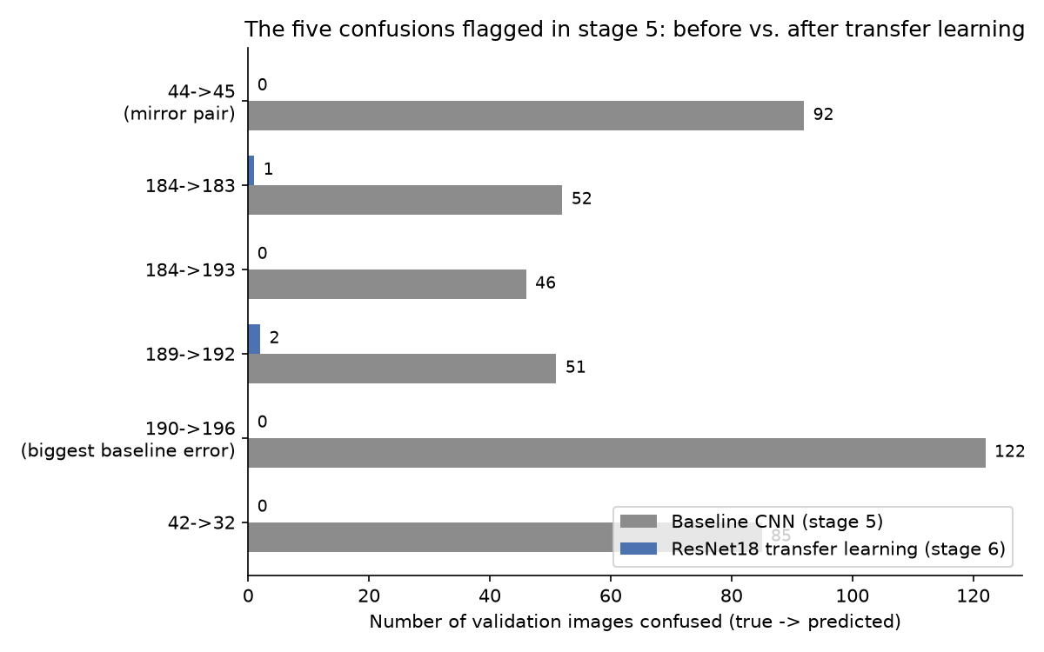
The six specific confusions identified in Stage 5, before and after transfer learning. Every one collapsed to near zero.
This is a direct, targeted confirmation of the stage 5 hypothesis: the baseline’s weakness really was insufficient visual discrimination, not class imbalance — and a pretrained backbone fixes it, even while still working at the same 64×64 resolution that stage 6.0 had flagged as a possible limiting factor.

6.2 — Comparing models properly
Overall accuracy alone can be a misleading way to compare models — a model can post a great accuracy number while still failing badly on a handful of classes. So the two models were compared on a broader set of statistics: overall accuracy, the accuracy of the single worst class, a macro-averaged F1 score (which treats all 200 classes equally, regardless of how many images each one has), the spread (standard deviation) of per-class accuracy, and the same imbalance-sensitivity correlation computed for the baseline in stage 5.
Metric | Baseline CNN | ResNet18 (transfer learning)
Overall validation accuracy | 87.84% | 99.03%
Worst single-class accuracy | 17.9% | 80.3%
Per-class accuracy std. deviation | — | 0.021 (tight, consistent)
Macro-averaged F1 (all classes weighted equally) | — | 98.77%
Correlation: accuracy vs. training-set size | -0.124 | 0.038 (still ~none)
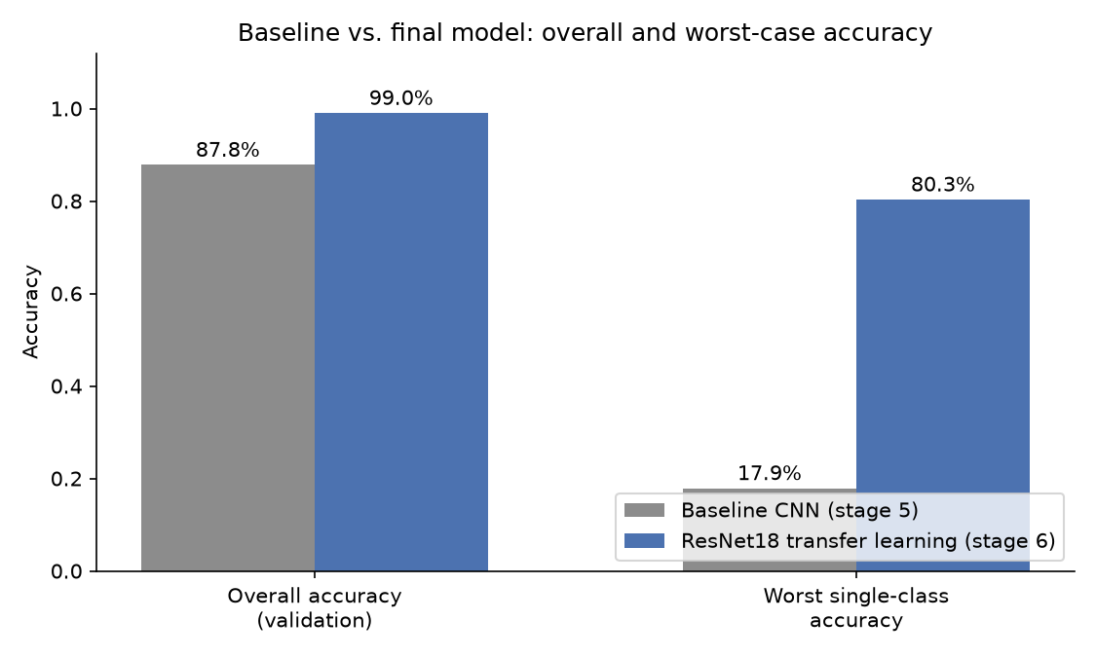
Overall accuracy and worst-case accuracy, baseline vs. final model.
ResNet18 won on every axis measured. Its worst-performing class (a different class than before, since the previous worst classes had been fixed) still scored 80.3% — a world away from the baseline’s 17.9% floor. Its macro-F1 sat almost exactly at its overall accuracy, meaning its strength was consistent across all 200 classes rather than concentrated in the frequent ones. And its correlation with training-set size stayed close to zero, meaning it was, if anything, even less sensitive to the original class imbalance than the baseline had been.
Decision: ResNet18 was selected as the final model.

6.3 — Final, one-time test evaluation
With the model already chosen, it was evaluated exactly once on the held-out test set — data that had not influenced any decision up to this point, specifically so the final number would not be quietly tuned against.
Final test accuracy: 99.37% — slightly above the validation accuracy of 99.03%. This is a reassuring, not a suspicious, result: it means the process of comparing experiments on the validation set did not end up overfitting the model to that validation set. Test macro-F1 came out to 99.37% as well, and the worst-performing class on the test set (“Phone,” at 88.46%) was still comfortably strong.
An honest caveat worth stating for the record: stage 4 already documented that the near-duplicate deduplication used to build the data split is not perfect. A 99%+ accuracy is a high number, and it’s fair to ask whether that reflects some remaining data leakage rather than true generalization. The strongest argument against that reading is that the improvement was targeted: it specifically resolved the exact confusions predicted by the stage 5 statistical analysis, rather than producing a uniform, unexplained accuracy bump across the board — a pattern that is much harder to produce by accident through leakage than through a genuinely better model.

7. Deployment: A Working Telegram Bot
With a final, chosen model in hand, the last stage turned it into something a person could actually use.
Exporting the model: the trained weights were downloaded once from the training session and saved locally as a plain file — no retraining is ever needed again to use this model; the file simply gets loaded from disk. The class-name mapping built back in stage 3 was reused as-is.
Local inference script: a small script was written that loads the model and predicts a sign from any single photo, running entirely on an ordinary CPU with no GPU, dataset, or network connection required — prediction on one photo takes a fraction of a second. It was tested against 6 real sample photos spanning different classes, including the previously-confused pairs from stage 5 (44/45 and 184). All 6 predicted correctly, at 99.99–100% confidence.
Choosing the interface: a Telegram bot was chosen over a web app. This decision was made easy by what the project already had on hand: the class-name table already included a sign category column (Priority, Warning, Prohibitory, Mandatory, Special regulations, Information, Service, Additional) from stage 3’s work — no new labeling was needed — and the dataset’s own folder of clean reference icons meant a “here’s what that sign should look like” reply picture could be added cheaply, with one representative icon extracted per class (all 200 resolved without any ambiguity).
The bot: a user sends a photo of a sign; the bot replies with the predicted sign name, its category, the model’s confidence, and a clean reference picture of that sign type for visual comparison. It was verified working end-to-end on a live Telegram chat, with a real photo producing the correct name, category, confidence, and reference image in reply.

8. Results Summary
 | Baseline (Stage 5) | Final model (Stage 6, ResNet18)
Validation accuracy | 87.84% | 99.03%
Test accuracy (final, one-time) | — | 99.37%
Worst-class accuracy | 17.9% | 80.3% (val) / 88.5% (test)
Macro-averaged F1 | — | 98.8% (val) / 99.4% (test)
Biggest single confusion | 122 images (190→196) | 0 images
Every specific weakness identified along the way was traced to a statistic, and every major decision in the project can be pointed back to a specific number: the imbalance correlation that ruled out one hypothesis and pointed at another; the confusion-matrix pairs that named exactly which signs needed fixing; the stage 6.0 spot-check that ruled out a labeling bug; the stage 6.2 comparison table that made the model choice unambiguous; and the final test number that confirmed none of it was overfitting.

9. Limitations, Stated Honestly
- Near-duplicate deduplication is not perfect (Section 4): it reliably catches exact and near-exact duplicate frames, but may miss some more visually different frames of the same physical sign. This keeps leakage risk low but not provably at zero.
- One class-name ambiguity: class 81 has two conflicting names in the source data (“Height limit – 3.5” vs. “– 4.5”). This does not affect the model, which only uses the numeric class ID, only the human-readable label shown to a person.
- 99%+ accuracy deserves scrutiny, and the strongest evidence that it reflects real generalization rather than leakage is that the improvement was targeted at exactly the confusions the statistics predicted, not a generic, unexplained lift.
- The Telegram bot currently only runs while it’s actively started on a local machine — it is not hosted on an always-on server. This is a deliberate, appropriately-scoped choice for a course demo, not an oversight; making it permanently available would be a separate, future infrastructure decision.

10. Conclusion and Possible Future Work
This project took a 200-class, 116,642-image dataset from raw files to a working, tested, and reasonably well-understood traffic sign recognition system — and, importantly, one where every major turn in the road can be traced back to a specific statistic that justified it, rather than to guesswork. The final model recognizes traffic signs from a photograph with 99.37% accuracy on data it never influenced, and it’s usable today through a Telegram bot.
Natural next steps, if the project continues beyond this course:
- Higher input resolution: the current model still works at 64×64 pixels. Since stage 6.0 flagged that some remaining confusions involve small text and arrows, retraining at a higher resolution is a natural, isolated next experiment.
- Always-on hosting: moving the bot to a small always-on server, so it works independent of any particular laptop being on.
- A web app alternative: for users who would prefer a browser-based upload instead of Telegram.
- Broader real-world testing: testing against photos taken in more varied real-world conditions (weather, lighting, sign wear) than the training dataset covers.

