Output

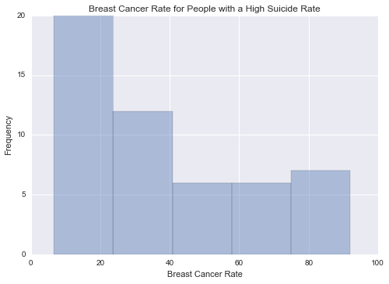

This graph is unimodal, with its highest pick at 0-20% of breast cancer rate. It seems to be skewed to the right as there are higher frequencies in lower categories than the higher categories.

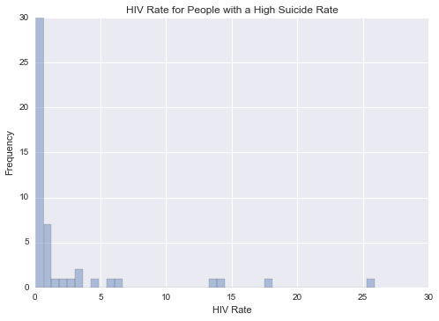

This graph is unimodal, with its highest pick at 0-1% of HIV rate. It seems to be skewed to the right as there are higher frequencies in lower categories than the higher categories.

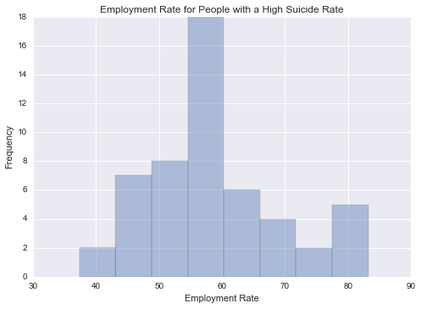

This graph is unimodal, with its highest pick at the median of 55-60% employment rate. It seems to be a symmetric distribution as there are lower frequencies in lower and higher categories.

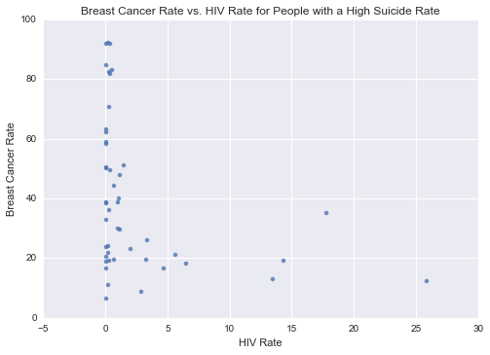

This graph plots the breast cancer rate vs. HIV rate for people with a high suicide rate. It shows that people with breast cancer are not infected with HIV.

-------------------------------------------------------------------------

Python Program

"""

Created on Sun Oct 25 2015

@author: violetgirl

"""

import pandas as pd

import numpy as np

import seaborn as sb

import matplotlib.pyplot as plt

# load gapminder dataset

data = pd.read_csv('gapminder.csv',low_memory=False)

# lower-case all DataFrame column names

data.columns = map(str.lower, data.columns)

# bug fix for display formats to avoid run time errors

pd.set_option('display.float_format', lambda x:'%f'%x)

# setting variables to be numeric

data['suicideper100th'] = data['suicideper100th'].convert_objects(convert_numeric=True)

data['breastcancerper100th'] = data['breastcancerper100th'].convert_objects(convert_numeric=True)

data['hivrate'] = data['hivrate'].convert_objects(convert_numeric=True)

data['employrate'] = data['employrate'].convert_objects(convert_numeric=True)

# display summary statistics about the data

# print("Statistics for a Suicide Rate")

# print(data['suicideper100th'].describe())

# subset data for a high suicide rate based on summary statistics

sub = data[(data['suicideper100th']>12)]

#make a copy of my new subsetted data

sub_copy = sub.copy()

# Univariate graph for breast cancer rate for people with a high suicide rate

plt.figure(1)

sb.distplot(sub_copy["breastcancerper100th"].dropna(),kde=False)

plt.xlabel('Breast Cancer Rate')

plt.ylabel('Frequency')

plt.title('Breast Cancer Rate for People with a High Suicide Rate')

# Univariate graph for hiv rate for people with a high suicide rate

plt.figure(2)

sb.distplot(sub_copy["hivrate"].dropna(),kde=False)

plt.xlabel('HIV Rate')

plt.ylabel('Frequency')

plt.title('HIV Rate for People with a High Suicide Rate')

# Univariate graph for employment rate for people with a high suicide rate

plt.figure(3)

sb.distplot(sub_copy["employrate"].dropna(),kde=False)

plt.xlabel('Employment Rate')

plt.ylabel('Frequency')

plt.title('Employment Rate for People with a High Suicide Rate')

# Bivariate graph for association of breast cancer rate with HIV rate for people with a high suicide rate

plt.figure(4)

sb.regplot(x="hivrate",y="breastcancerper100th",fit_reg=False,data=sub_copy)

plt.xlabel('HIV Rate')

plt.ylabel('Breast Cancer Rate')

plt.title('Breast Cancer Rate vs. HIV Rate for People with a High Suicide Rate')

# END