**Date-**

**Assignment No. :**

**Problem Statement:**

Program in C to find the least common multiple and highest common factor of a set of integers.

**Theory:**

The **highest common factor** of two or more integers, which are not all zero, is the largest positive integer that divides each of the integers. The **lowest common multiple** of two integers *a* and *b*, is the smallest positive integer that is divisible by both *a* and *b*. Since division of integers by zero is undefined, this definition has meaning only if *a* and *b* are both different from zero.

**Example :** The HCF of 25 and 20 is 5. The LCM of 25 and 20 is 100.

**Algorithm:**

**Input specification:**

1. I : The incidence matrix of dimension (n x n) of the given graph
2. vs : The source vertex to start the search from

**Output specification:**

1. A two dimensional array I[1..n][1..n] whose starting index is 1 and ending index is n, size of the array being (n x n).
2. A stack to store the intermediate vertices, say S.

**Steps:**

/*1 is the adjacency matrix of a graph G, and vs ¡s the source vertex from

which traversal would start */

1. Repeat step 2 For(all v E V)
2. Status[v]=unvisited //initially all node is made unvisited

[End of For loop]

1. Set Status[vs]=visited
2. Set U=vs
3. Push(S, vs) //Push is a function to push an element into any stack S

[Starting Do-While loop]

found = FALSE

1. Repeat through step 9 to step 21 For(all y E V)
2. If(status[v]=unvisited AND v is adjacent to u)
3. Print u, v
4. Push(S, v) // insert an element into stack S
5. status[v] =visited
6. u=v
7. found = TRUE
8. Break

[End of If structure]

1. If (found=FALSE)
2. u=POP(S) // delete an element from stack S

[End of If structure]

[End of For loop]

1. Repeat through step 7 to step 20 while(Q is not empty OR v is visited)

[End of Do-While loop]

1. End

**Source Code:**

#include<stdio.h>

#include<conio.h>

#include<stdlib.h>

struct node //Creation of node

{

int data;

struct node *next;

} *h=NULL;

struct node *getnode(int data) //Dynamic allocation

{

struct node *temp;

temp= (struct node *) malloc (sizeof (struct node));

temp->data=data;

temp->next=NULL;

return temp;

}

void push(int data) //Definition of the push function

{

struct node *t,*x;

x=getnode (data);

if (h==NULL)

{

h=x;

}

else

{

x->next=h;

h=x;

}

}

int pop() //Definition of the pop function

{

int u;

if (h==NULL)

printf ( “UNDERFLOW”);

else

{

u=h—>data;

h=h—>next;

}

return u;

}

int status(int s[30],int n) //Definition of the status function

{

int i;

for (i=1; i<=n; i++)

{

if(s[i]==0)

return 1;

}

return 0;

}

void dfs(int l[10][10],int n,int vs) //Function for the searching algorithm

{

int i, u, s[30] , found;

for (i=1; i<=n; i++)

s [i]=0;

s [vs]=1;

u=vs;

push(vs);

do

{

do

{

found=0;

for (i=1; i<=n; i++)

{

if(s[i]==0&&l[u][i]==1)

{

printf(”\n%d %d”,u,i);

push(i);

s[i] =1;

found=1;

u=i;

break;

}

}

if (found==0)

{

u=pop();

}

}while(h!=NULL) ;

for ( i=1; i<=n; i++)

{

if(s[i]==0)

{

s[i]=1;

push(i);

u=i;

break;

}

}

for (i=1 ; i<=n; i++)

{

if(l[u][i]==1&&s[u]!=2)

{

printf(”\n%d to %d”,u,i);

s[u]=2;

break;

}

}

}while (status (s, n));

}

void show(int l[10][10],int n)

{

int i,j;

printf(”\n”) ;

for (i=1; i<=n; i++)

{

for(j=1; j<=n;j++)

printf(” %d “,l[i][j]);

printf(”\n”);

}

}

int main()

{

int choice;

int l[10][10],n,i,j,vs;

printf(”Enter order of the adjacency matrix : “);

scanf (“%d”, &n);

for (i=1; i<=n; i++)

for(j=1; j<=n; j++)

{

printf(”Enter weight between %d & %d”,i,j);

scanf(”%d”,&l[i][j]);

}

printf(”\nAdjacency matrix is . . .\n”);

show (l, n) ;

printf(“Enter source vertex :”);

scanf(“%d”,&vs);

dfs(l,n,vs);

getch();

return 0;

}

**Input & Output:**

Input graph:

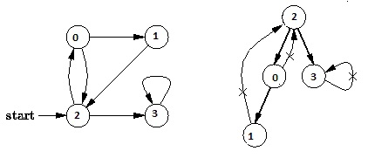

Output of program:

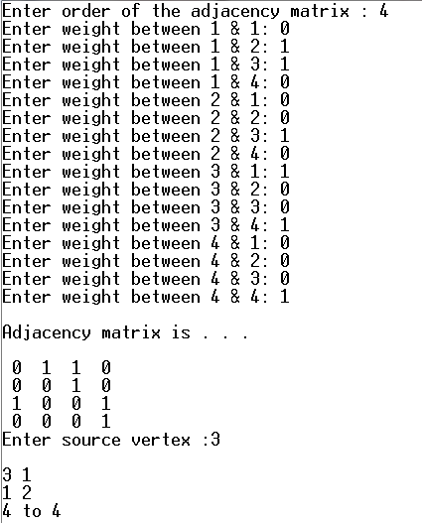

**Discussion:**

1. Setting a nodes ( with Stack ) label takes O( 1 ) time.
2. Each Nodes Is labeled twice:
   1. Once as Unexplored.
   2. Once as Visited.
3. Each Edge is labeled twice:
   1. Once as Unexplored.
   2. Once as Discovery or BACK.
4. Because the adjacency list of each nodes is scanned only when the nodes is Pop, each adjacency list is scanned at most once. Total time spent in scanning adjaceny list is O ( E ) [ in worst case ]. As initializations, takes O( V ) times, then total running time of DFS is O( V + E ).