**Date-**

**Assignment No. :**

**Problem Statement:**

Program in C to find the shortest path between the nodes of a given graph by Dijkstra’s algorithm.

**Theory:**

Dijkstra’s algorithm is very similar to [Prim’s algorithm for minimum spanning tree](https://www.geeksforgeeks.org/archives/27455). Like Prim’s MST, we generate a SPT (shortest path tree) with given source as root. We maintain two sets, one set contains vertices included in shortest path tree, other set includes vertices not yet included in shortest path tree. At every step of the algorithm, we find a vertex which is in the other set (set of not yet included) and has minimum distance from source.

For a given source node in the graph, the algorithm finds the shortest path between that node and every other. It can also be used for finding the shortest paths from a single node to a single destination node by stopping the algorithm once the shortest path to the destination node has been determined. For example, if the nodes of the graph represent cities and edge path costs represent driving distances between pairs of cities connected by a direct road, Dijkstra's algorithm can be used to find the shortest route between one city and all other cities.

Dijkstra's algorithm initially marks the distance (from the starting point) to every other intersection on the map with infinity. This is done not to imply there is an infinite distance, but to note that those intersections have not yet been visited; some variants of this method simply leave the intersections' distances unlabeled. Now, at each iteration, select the current intersection. For the first iteration, the current intersection will be the starting point, and the distance to it (the intersection's label) will be zero. For subsequent iterations (after the first), the current intersection will be a closest unvisited intersection to the starting point (this will be easy to find).

From the current intersection, update the distance to every unvisited intersection that is directly connected to it. This is done by determining the sum of the distance between an unvisited intersection and the value of the current intersection, and [relabeling](https://en.wikipedia.org/wiki/Graph_labeling) the unvisited intersection with this value (the sum), if it is less than its current value. In effect, the intersection is relabeled if the path to it through the current intersection is shorter than the previously known paths.

**Algorithm:**

**Input specification:**

1. I : The incidence matrix of dimension (n x n) of the given graph
2. vs : The source vertex to start the search from

**Output specification:**

1. A two dimensional array I[1..n][1..n] whose starting index is 1 and ending index is n, size of the array being (n x n).
2. A stack to store the intermediate vertices, say S.

**Steps:**

/*1 is the adjacency matrix of a graph G, and vs ¡s the source vertex from

which traversal would start */

1. Repeat step 2 For(all v E V)
2. Status[v]=unvisited //initially all node is made unvisited

[End of For loop]

1. Set Status[vs]=visited
2. Set U=vs
3. Push(S, vs) //Push is a function to push an element into any stack S

[Starting Do-While loop]

found = FALSE

1. Repeat through step 9 to step 21 For(all y E V)
2. If(status[v]=unvisited AND v is adjacent to u)
3. Print u, v
4. Push(S, v) // insert an element into stack S
5. status[v] =visited
6. u=v
7. found = TRUE
8. Break

[End of If structure]

1. If (found=FALSE)
2. u=POP(S) // delete an element from stack S

[End of If structure]

[End of For loop]

1. Repeat through step 7 to step 20 while(Q is not empty OR v is visited)

[End of Do-While loop]

1. End

**Source Code:**

#include<stdio.h>

#include<conio.h>

#include<stdlib.h>

struct node //Creation of node

{

int data;

struct node *next;

} *h=NULL;

struct node *getnode(int data) //Dynamic allocation

{

struct node *temp;

temp= (struct node *) malloc (sizeof (struct node));

temp->data=data;

temp->next=NULL;

return temp;

}

void push(int data) //Definition of the push function

{

struct node *t,*x;

x=getnode (data);

if (h==NULL)

{

h=x;

}

else

{

x->next=h;

h=x;

}

}

int pop() //Definition of the pop function

{

int u;

if (h==NULL)

printf ( “UNDERFLOW”);

else

{

u=h—>data;

h=h—>next;

}

return u;

}

int status(int s[30],int n) //Definition of the status function

{

int i;

for (i=1; i<=n; i++)

{

if(s[i]==0)

return 1;

}

return 0;

}

void dfs(int l[10][10],int n,int vs) //Function for the searching algorithm

{

int i, u, s[30] , found;

for (i=1; i<=n; i++)

s [i]=0;

s [vs]=1;

u=vs;

push(vs);

do

{

do

{

found=0;

for (i=1; i<=n; i++)

{

if(s[i]==0&&l[u][i]==1)

{

printf(”\n%d %d”,u,i);

push(i);

s[i] =1;

found=1;

u=i;

break;

}

}

if (found==0)

{

u=pop();

}

}while(h!=NULL) ;

for ( i=1; i<=n; i++)

{

if(s[i]==0)

{

s[i]=1;

push(i);

u=i;

break;

}

}

for (i=1 ; i<=n; i++)

{

if(l[u][i]==1&&s[u]!=2)

{

printf(”\n%d to %d”,u,i);

s[u]=2;

break;

}

}

}while (status (s, n));

}

void show(int l[10][10],int n)

{

int i,j;

printf(”\n”) ;

for (i=1; i<=n; i++)

{

for(j=1; j<=n;j++)

printf(” %d “,l[i][j]);

printf(”\n”);

}

}

int main()

{

int choice;

int l[10][10],n,i,j,vs;

printf(”Enter order of the adjacency matrix : “);

scanf (“%d”, &n);

for (i=1; i<=n; i++)

for(j=1; j<=n; j++)

{

printf(”Enter weight between %d & %d”,i,j);

scanf(”%d”,&l[i][j]);

}

printf(”\nAdjacency matrix is . . .\n”);

show (l, n) ;

printf(“Enter source vertex :”);

scanf(“%d”,&vs);

dfs(l,n,vs);

getch();

return 0;

}

**Input & Output:**

Input graph:

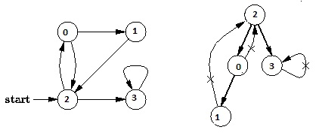

Output of program:

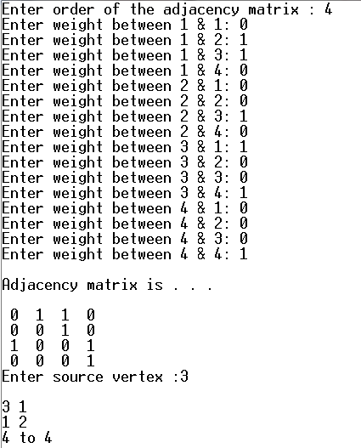

**Discussion:**

1. Setting a nodes ( with Stack ) label takes O( 1 ) time.
2. Each Nodes Is labeled twice:
   1. Once as Unexplored.
   2. Once as Visited.
3. Each Edge is labeled twice:
   1. Once as Unexplored.
   2. Once as Discovery or BACK.
4. Because the adjacency list of each nodes is scanned only when the nodes is Pop, each adjacency list is scanned at most once. Total time spent in scanning adjaceny list is O ( E ) [ in worst case ]. As initializations, takes O( V ) times, then total running time of DFS is O( V + E ).