OV32C Setting Application Notes

- Initial Setting (revision 220422)
The initial setting initializes sensor registers after power on. The setting for each format only includes different registers between different formats.

Initial Revision 220422
Registers | Description
0x340c | 0x20 (default) -> 0x30
(Added reg06)

- 01_6528x4896 15.0fps (revision 220422)
  - Input clock: 24 MHz
  - MIPI DPHY 4 lane, RAW 10, 1500 Mbps/lane,
  - MIPI clock: 750 MHz (1500 Mbps)
  - Frame rate: 15.0 fps (= 96000000 / 1224 / 5228)
  - Sensor internal clock: 96 MHz and 180 MHz
  - HTS: 1224 clocks
  - VTS: 5228 lines
  - V-blank: 4.208 ms (330 lines)
  - Bayer pattern: The 1st line is BCGC…, the 2nd line is CBCG…, the 3rd line is GCRC…, and the 4th line is CGCR…
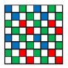
  - Minimum exposure: 4 lines
  - Maximum exposure: VTS - 8 = 5228 - 8 = 5220 lines
  - Output is mirror off, flip normal
  - Sensor orientation: pad 1 is oriented up on PCB
  - Image on full array:
Full Array (0, 0) --- (6559, 4927).
Perform windowing to 6528x4896.

Revision 220422
Registers | Description

- 02_3264x2448 30.0fps (revision 220422)
  - Input clock: 24 MHz
  - MIPI DPHY 4 lane, RAW 10, 800 Mbps/lane
  - MIPI clock: 400 MHz (800 Mbps)
  - Frame rate: 30.0 fps (= 96000000 / 1224 / 2614)
  - Sensor internal clock: 96 MHz and 180 MHz
  - HTS: 1224 clocks
  - VTS: 2614 lines
  - V-blank: 2.091 ms (164 lines)
  - Bayer pattern (Fusion): First line is BGBG…, second line is GRGR… for VC0
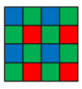
  - Minimum exposure: 2 lines
  - Maximum exposure: VTS - 4 = 2614 - 4 = 2610 lines
  - Output is mirror off, flip normal
  - Sensor orientation: pad 1 is oriented up on PCB
  - Image on full array:
Full Array (0, 0) --- (6559, 4927), as shown in the left-side in the figure below:
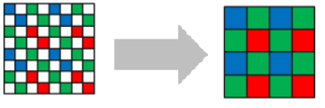
2C1-diagonal bin to 3280x2464, then perform windowing to 3264x2448.

Revision 220422
Registers | Description

- 03_1920x1080 60.0fps (revision 220422)
  - Input clock: 24 MHz
  - MIPI DPHY 4 lane, RAW 10, 800 Mbps/lane
  - MIPI clock: 400 MHz (800 Mbps)
  - Frame rate: 60.0 fps (= 96000000 / 1224 / 1306)
  - Sensor internal clock: 96 MHz and 180 MHz
  - HTS: 1224 clocks
  - VTS: 1306 lines
  - V-blank: 2.856 ms (224 lines)
  - Bayer pattern (Fusion): First line is BGBG…, second line is GRGR… for VC0
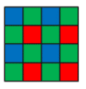
  - Minimum exposure: 2 lines
  - Maximum exposure: VTS - 4 = 1306- 4 = 1302 lines
  - Output is mirror off, flip normal
  - Sensor orientation: pad 1 is oriented up on PCB
  - Image on full array:
Full Array (0, 0) --- (6559, 4927), as shown in the left-side in the figure below:

Crop to (1344, 1368) --- (5215, 3559), 2C1-diagonal bin to 1936x1096, then perform windowing to 1920x1080.

Revision 220422
Registers | Description

- 04_1280x720 120.0fps (revision 220422)
  - Input clock: 24 MHz
  - MIPI DPHY 4 lane, RAW 10, 700 Mbps/lane
  - MIPI clock: 350 MHz (700 Mbps)
  - Frame rate: 120.3 fps (= 96000000 / 1224 / 652)
  - Sensor internal clock: 96 MHz and 180 MHz
  - HTS: 1224 clocks
  - VTS: 652 lines
  - V-blank: 3.698 ms (290 lines)
  - Bayer pattern (Fusion): First line is BGBG…, second line is GRGR… for VC0

  - Minimum exposure: 2 lines
  - Maximum exposure: VTS - 4 = 652 - 4 = 648 lines
  - Output is mirror off, flip normal
  - Sensor orientation: pad 1 is oriented up on PCB
  - Image on full array:
Full Array (0, 0) --- (6559, 4927), as shown in the leftmost-side in the figure below:
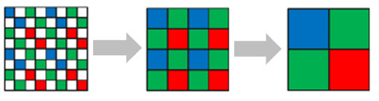
Crop to (656, 1008) --- (5903, 3919), 2C1-diagonal bin + 2x2 analog bin to 1312x728, then perform windowing to 1280x720.

Revision 220422
Registers | Description

- 05_1632x1224 30.0fps (revision 220422)
  - Input clock: 24 MHz
  - MIPI DPHY 4 lane, RAW 10, 800 Mbps/lane
  - MIPI clock: 400 MHz (800 Mbps)
  - Frame rate: 30.0 fps (= 96000000 / 1224 / 2614)
  - Sensor internal clock: 96 MHz and 180 MHz
  - HTS: 1224 clocks
  - VTS: 2614 lines
  - V-blank: 2.066 ms (162 lines)
  - Bayer pattern (Fusion): First line is BGBG…, second line is GRGR… for VC0

  - Minimum exposure: 2 lines
  - Maximum exposure: VTS - 4 = 2614 - 4 = 2610 lines
  - Output is mirror off, flip normal
  - Sensor orientation: pad 1 is oriented up on PCB
  - Image on full array:
Full Array (0, 0) --- (6559, 4927), as shown in the leftmost-side in the figure below:

2C1-diagonal bin + 2x2 analog bin to 1640x1232, then perform windowing to 1632x1224.

Revision 220422
Registers | Description

- 06_1632x1224 30.0fps (revision 220426)
  - Input clock: 24 MHz
  - MIPI DPHY 4 lane, RAW 10, 800 Mbps/lane
  - MIPI clock: 400 MHz (800 Mbps)
  - Frame rate: 30.0 fps (= 96000000 / 1224 / 2614)
  - Sensor internal clock: 96 MHz and 180 MHz
  - HTS: 1224 clocks
  - VTS: 2614 lines
  - V-blank: 2.066 ms (162 lines)
  - Bayer pattern (RAW): First line is BGBG…, second line is GRGR… for VC0
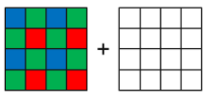
  - Minimum exposure: 2 lines
  - Maximum exposure: VTS - 4 = 2614 - 4 = 2610 lines
  - Output is mirror off, flip normal
  - Sensor orientation: pad 1 is oriented up on PCB
  - Image on full array:
Full Array (0, 0) --- (6559, 4927), as shown in the leftmost-side in the figure below:
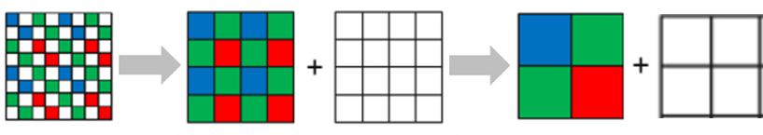
2C1-diagonal bin + 2x2 analog bin to 1640x1232, then perform windowing to 1632x1224.

Revision 220426
Registers | Description
Newly added.

