NTT InsightEngine – First-run setup
Notes for the developer of the custom InsightEngine UI. From: Phindani Gama (network engineer). Status: draft for review.
Everything here comes from the stack bundle (docs/setup-api.md, which is the authority for the API, plus the README, install.sh, .env.example, Caddyfile and docker-compose.yml) and from me. Anything that is a proposal and not yet in the bundle starts with “Suggested:”. Things not decided yet are in section 13, Open items.

1. Purpose and what you need to know first
InsightEngine is one client per server: it is installed on one monitoring server at one client’s site. It is sized, as an estimate, for about 20,000 devices per client. It replaces my old Docker Compose monitoring stack.
- install.sh asks no questions. It writes CLIENT_NAME='unconfigured', creates the setup token file secrets/setup/token, prints only that file’s path, and starts the stack.
- The first time someone opens the web address, a first-run setup page appears before the main UI. The main UI stays locked until setup is complete.
- We built the setup page and its API ourselves. They are plain HTML and JavaScript served by a small setup service, so first-run works before your UI exists.
What I need from you:
- Do not break the setup page. Do not replace, restyle or proxy around /setup and /setup/*.
- Reuse its API for the Settings pages (client name, Move from old stack, Prometheus history, status and log).
- Take over the same address once setup is complete. Your UI replaces the placeholder container insightengine-ui. On load, your UI checks the setup state and sends the user to /setup/ if setup is not complete.

2. What is in the stack
Part | What it does (short)
Caddy | TLS front door. Sends the address to the setup page or to your UI (section 5).
Setup service (ie-setup) | First-run page and /setup API. Only part allowed to recreate containers (through a filtered Docker proxy).
Prometheus, snmp-exporter, snmp-generator, blackbox-exporter | Metrics collection: SNMP, ping/probes.
Alertmanager (+ alert-relay webhook) | Alert routing. The relay forwards alerts to webhook destinations.
Grafana | Dashboards.
Telegraf | API collector (firewalls, controllers), host metrics, syslog.
NetBox, Netdisco | Inventory and source of truth; discovery. NetBox moved off “/” to its own port PORT_NETBOX (8444).
Activepieces | Automation; replaces n8n (n8n flows are not migrated).
Loki, Oxidized, SNMP trap receiver | Syslog storage, config backups, traps (optional profiles).
PostgreSQL (one per app) | netbox-postgres, activepieces-postgres, netdisco-postgres, insightengine-postgres.

3. The first-run flow, step by step
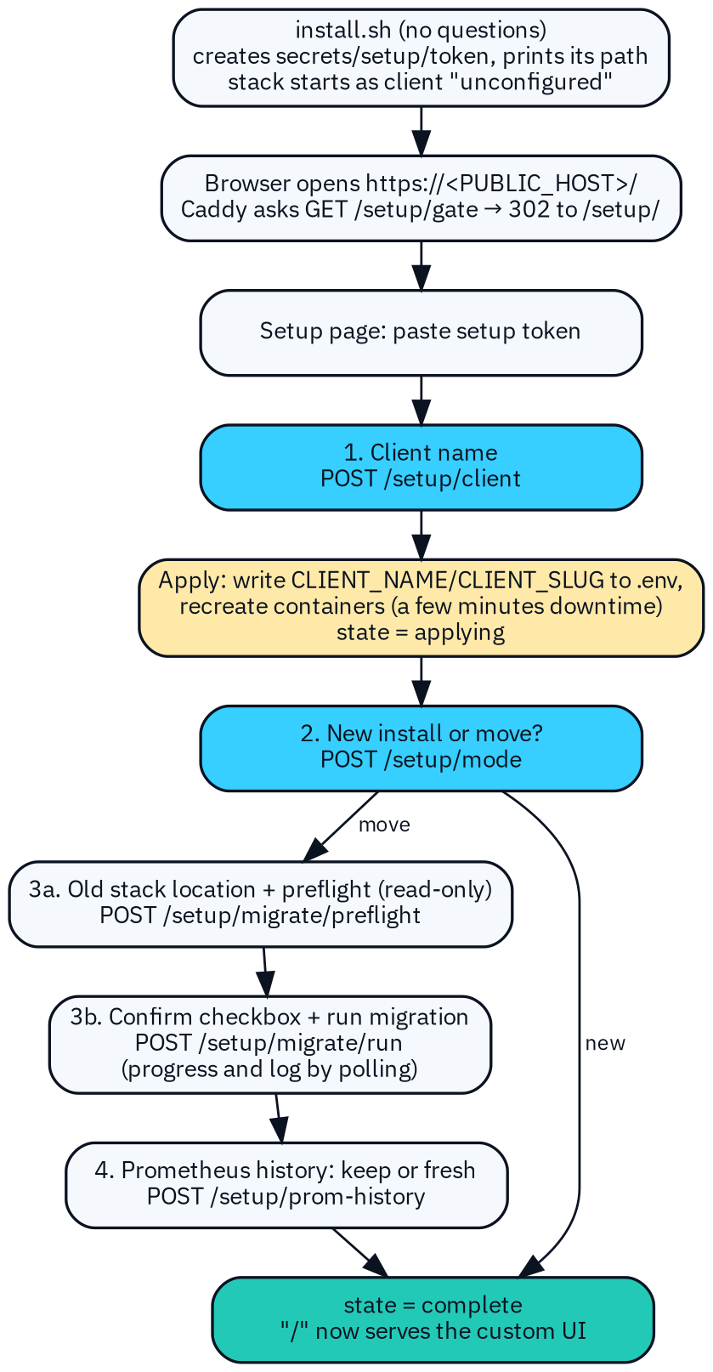  Figure 1 – First-run flow (README section 2.2, setup-api.md section 2). | 1. Token. The operator opens https://<PUBLIC_HOST>[:PORT_HTTPS]/setup/ and pastes the setup token, read on the server with sudo cat secrets/setup/token. The page keeps it in memory only (section 6.1).  2. Client name. POST /setup/client. The service writes the name into .env and recreates every container except itself and the Docker proxy. That means a few minutes of downtime. The page keeps polling and shows “Waiting for the service (containers may be restarting)” while Caddy restarts.  3. New install or move. POST /setup/mode with new finishes setup. move opens the migration steps.  4. Move from the old stack. Enter the old stack’s location and file paths, then run the read-only preflight (dry run). Show its report, then the user must tick “I confirm: copy the data into the new stack (the old stack is only read)”. Only then can Run migration start. Progress and log are polled.  5. Prometheus history. Keep the old history (optional import) or start fresh. Either choice completes setup.

Rules that the UI must state clearly:
- The old stack is only read. It is never stopped, changed or deleted. The new and old stacks can run side by side.
- Database passwords are never typed into the UI. The user gives the path of a file that contains the password.
- Rollback: nothing in the old stack was changed, so rollback means keep using the old stack. To drop the new one: docker compose down without -v, and restore the old ports if they were moved.

4. Setup state values
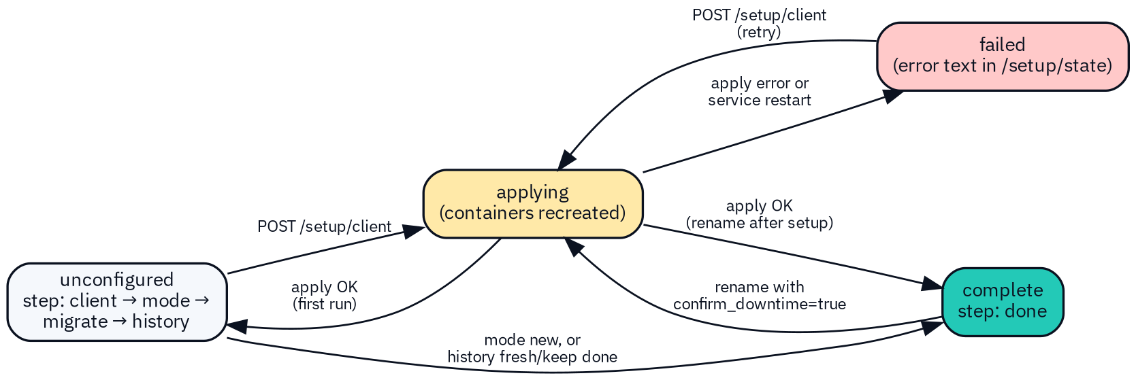
Figure 2 – Setup states and the calls that move between them.
state | Meaning | What the UI shows
unconfigured | Setup not finished. step says where the user is. | Setup page only. Your UI redirects to /setup/.
applying | Client name saved; containers are being recreated. | Progress and log; all buttons disabled; expect the connection to drop for a while.
complete | Setup done (step = done). | Your UI. Setup page is no longer reachable through Caddy (section 5).
failed | The apply step failed, or the service restarted during it. error has the reason. | Error message, log, and a retry (send the client name again).

While unconfigured, step names the next call: client → POST /setup/client; mode → POST /setup/mode; migrate → POST /setup/migrate/preflight, then /run; history → POST /setup/prom-history.
Background jobs have their own state: running, succeeded or failed, and a kind: apply, preflight, migrate or prom-history. Only one job runs at a time. A second action returns HTTP 409. A failed preflight, migration or history import fails only the job; it does not set the setup state to failed.

5. Routing: who serves the address
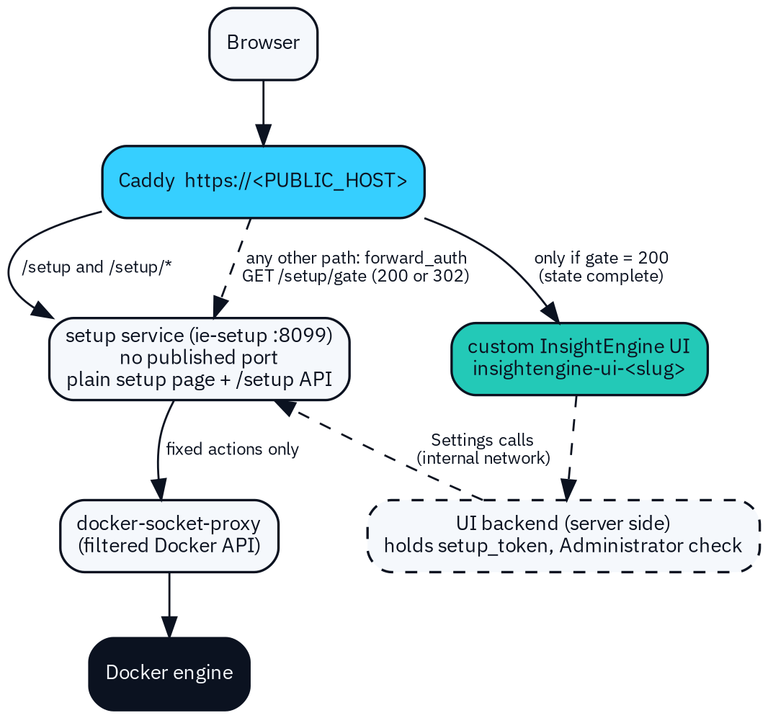  Figure 3 – Routing in the Caddyfile, and the internal path for Settings calls (setup-api.md section 3). | • /setup and /setup/* always go to the setup service.  • Every other path: Caddy first asks the setup service GET /setup/gate. 200 (state complete) → your UI. Anything else (302 to /setup/) goes back to the browser. If the setup service is down, “/” returns an error (fails closed).  • Your UI must also check on load: call GET /setup/state without a token (it returns only state and step). If state is not complete, do location.replace('/setup/'). The placeholder page in config/ui-placeholder/index.html shows exactly this.  • After setup is complete, the setup service answers only /setup/state, /setup/gate and /setup/healthz through Caddy (unless SETUP_PUBLIC_AFTER_COMPLETE=yes). Everything else returns 404 on the public address.  • So your Settings pages call your own backend. It holds the token as the secret mount setup_token, checks that the user is an Administrator, and calls http://setup:8099/setup/... on monitoring-net. Internal callers are not affected by the lockdown. The browser never sees the token.  • Your UI container is insightengine-ui-<slug>. Its image and port come from IE_UI_IMAGE (empty = placeholder page) and IE_UI_PORT (default 8080) in .env. It is recreated, with the new name, every time the client name is applied.

6. Setup API contract
Base path /setup. JSON in and out (Content-Type: application/json, request body up to 64 KB). Responses carry Cache-Control: no-store. Names and shapes follow docs/setup-api.md (the authority), implemented in setup/server.py. Browser base URL https://<PUBLIC_HOST>/setup; internal base URL http://setup:8099/setup.

6.1 Authentication
- Every call except /setup/ (page files), /setup/healthz, /setup/gate and /setup/state without a header needs Authorization: Bearer <setup token>.
- install.sh creates a random token in secrets/setup/token (mode 0400/0600) and prints only the file path. It is mounted as /run/secrets/setup_token, and is never logged, returned or put in the page.
- Ten failed attempts per minute from one address → HTTP 429 for the rest of that minute. To rotate: write a new value to the file, then docker compose restart setup.
- After setup, your backend may hold the token as the setup_token secret mount. Admin-only access to the Settings screens is your UI’s job (role check), in addition to the token. How users sign in to your UI is still open (Open item 1).

6.2 Polling and progress
- After any call that returns 202 (a job started), poll GET /setup/state (with token) every 3 seconds, as the setup page does. For preflight, migration and history import jobs, also poll GET /setup/migrate/status. Refresh GET /setup/log?lines=200 for the log view.
- Stop polling when job.state is succeeded or failed and state is not applying.
- Network errors while applying are expected (Caddy and your UI are being recreated). Keep retrying quietly; do not show a hard error.
- A running job survives a page reload: on load, read /setup/state and resume polling if job.state is running. There is no cancel call.

6.3 Errors
Every error is HTTP 4xx/5xx with one JSON shape: {"error": "<plain text message>"}. Show the message as is; it never contains secrets.
HTTP | When
400 | Bad input: invalid client name, unknown field, path not under the old-stack mount, confirm missing.
401 | Missing or wrong token. Ask for the token again.
404 | Unknown path, or a blocked path after setup is complete.
409 | Wrong state for this call, another action is running, preflight not passed, settings changed since preflight, or a rename without confirm_downtime.
413 / 429 / 500 | Body over 64 KB / too many failed token attempts / internal error (details only in the server log).

6.4 Endpoints
Method and path | Auth | Purpose | Success
GET /setup/ | no | The plain first-run page (+ app.js, style.css). | 200 HTML
GET /setup/healthz | no | Liveness check. | 200
GET /setup/gate | no | Used by Caddy: complete or not. | 200 or 302
GET /setup/state | optional | No token: state, step. With token: full state. | 200
POST /setup/client | yes | Save client name and apply (recreate containers). | 202 + job
POST /setup/mode | yes | new or move. | 200
POST /setup/migrate/preflight | yes | Save old-stack settings and start the read-only preflight. | 202 + job
POST /setup/migrate/run | yes | Start the migration after a passing preflight. | 202 + job
GET /setup/migrate/status | yes | Job, preflight result, progress steps, log tail. | 200
POST /setup/prom-history | yes | keep (import job) or fresh. | 200 or 202
GET /setup/log?lines=N | yes | Last N lines of the setup log (1–1000, default 200). | 200

6.5 Example requests and responses
All values in the examples (names, IDs, times, paths) are made up. Times are in UTC, as the API sends them.
GET /setup/state (no token) — Example data – illustrative only
{"state": "unconfigured", "step": "client"}

GET /setup/state (with token) — Example data – illustrative only
{
"state": "unconfigured", "step": "migrate",
"client_name": "Example Client Ltd", "client_slug": "example-client-ltd",
"mode": "move", "history": null, "migrated": false, "error": null,
"updated_at": "2026-10-24T15:41:03Z",
"job": {"id": "3f2a9c1b7d4e", "kind": "apply", "state": "succeeded",
"started": "2026-10-24T15:37:10Z", "finished": "2026-10-24T15:40:58Z",
"exit_code": 0, "error": null},
"last_preflight": null
}

GET /setup/gate — Example data – illustrative only
200 {"state": "complete"}
302 Location: /setup/ (when not complete)

POST /setup/client — Example data – illustrative only
Request: {"client_name": "Example Client Ltd"}
(rename after setup: add "confirm_downtime": true)
Response: 202 {"state": "applying", "job_id": "3f2a9c1b7d4e",
"client_name": "Example Client Ltd", "client_slug": "example-client-ltd"}

Client name rules (enforced by the service): 1–60 characters; no quotes, $, backticks, backslashes or control characters; at least one letter or digit; it cannot be “unconfigured”. The slug is the name in lower case with other characters turned into “-”, up to 40 characters.
POST /setup/mode — Example data – illustrative only
Request: {"mode": "move"} ("new" finishes setup)
Response: 200 {"state": "unconfigured", "step": "migrate"}
(for "new": 200 {"state": "complete", "step": "done"}; 409 if the name is not applied yet)

POST /setup/migrate/preflight — Example data – illustrative only
Request: {"old_stack": {
"compose_file": "/opt/arg/docker-compose.yml",
"netbox_pg_container": "netbox-postgres",
"netbox_db": "netbox", "netbox_db_user": "netbox",
"netbox_db_password_file": "/opt/arg/secrets/netbox_db_password",
"netdisco_pg_container": "netdisco-postgres",
"netbox_media_path": "/opt/arg/netbox/netbox/media",
"grafana_data_path": "/opt/arg/grafana",
"alertmanager_config_path": "/opt/arg/alertmanager/alertmanager.yml",
"caddyfile_path": "/opt/arg/caddy/Caddyfile",
"keep_dumps": true }}
Response: 202 {"job_id": "a1b2c3d4e5f6", "preflight_id": "a1b2c3d4e5f6"}

Required: netbox_pg_container and netbox_db_password_file. Other accepted fields: stack_dir, netbox_container, netdisco_db, netdisco_db_user, netdisco_db_password_file, grafana_provisioning_path, grafana_container, prom_container. Every path must be absolute, contain no .., lie under SETUP_OLD_STACK_ROOT (default /opt, mounted read-only) and not inside the install folder. Unknown fields are rejected. Allowed in the move flow (step migrate or history) or when state is complete (Settings).
POST /setup/migrate/run — Example data – illustrative only
Request: {"preflight_id": "a1b2c3d4e5f6", "confirm": true}
Response: 202 {"job_id": "0c9d8e7f6a5b"}

GET /setup/migrate/status — Example data – illustrative only
{
"job": {"id": "0c9d8e7f6a5b", "kind": "migrate", "state": "running",
"started": "2026-10-24T15:52:00Z", "finished": null, "exit_code": null, "error": null},
"preflight": {"id": "a1b2c3d4e5f6", "passed": true, "errors": 0, "warnings": 1,
"time": "2026-10-24T15:47:31Z", "conf_sha256": "9b1e…"},
"preflight_log": "data/migration/migrate-20261024-154702.log",
"progress": [
{"time": "2026-10-24T15:52:01Z", "step": "prepare", "state": "done", "detail": ""},
{"time": "2026-10-24T15:52:40Z", "step": "netbox-db", "state": "running", "detail": ""}
],
"log_tail": ["2026-10-24T15:52:40Z step netbox database: dump (old, read-only) -> restore (new)"]
}

progress is the last 100 lines of data/migration/progress.json; log_tail is the last 40 lines of the setup log. Step names are defined by scripts/migrate.sh (today: preflight, prepare, netbox-db, netdisco-db, grafana, config-review, complete, plus fatal). state: running, done, failed (preflight: passed/failed). Show them as a checklist.
POST /setup/prom-history — Example data – illustrative only
Request: {"mode": "fresh"}
Response: 200 {"state": "complete", "step": "done"}

Request: {"mode": "keep", "method": "snapshot",
"old_url": "http://host.docker.internal:9090",
"old_data_dir": "/opt/arg/prometheus/data"}
(method "dir" copies complete blocks; no old_url needed)
Response: 202 {"job_id": "7e6d5c4b3a29"}

Poll GET /setup/migrate/status for the keep job. Tell the user: “snapshot” needs --web.enable-admin-api on the old Prometheus, reachable from the setup container (host.docker.internal maps to the host). “dir” loses about the last 2 hours. Only the new Prometheus is stopped during the copy (short gap in new graphs).
GET /setup/log?lines=200 and an error — Example data – illustrative only
200 {"lines": ["2026-10-24T15:37:10Z render: .env <- client 'Example Client Ltd' (example-client-ltd)",
"2026-10-24T15:37:11Z $ docker compose ... config --services"],
"size": 18342}

409 {"error": "another action is running"}

6.6 What applying the client name changes
Where | Uses the client name or slug
Containers | <service>-<slug>, all recreated except ie-setup and ie-docker-proxy. Fixed project name insightengine, so volumes insightengine_<volume> keep their data.
Prometheus | external_labels client and client_name. After a rename, new series carry the new label; old series keep the old one.
NetBox | Tenant and root region from the client name, created by scripts/seed-netbox.sh after setup. Not renamed automatically on a rename (README TODO).
Grafana / Alertmanager | Grafana folder “InsightEngine - <name>”; Alertmanager notification titles.
Single store | data/setup/config.json holds the client identity; every apply copies it to CLIENT_NAME/CLIENT_SLUG in .env. Nobody edits these in .env by hand.
Caddy, Loki | Caddy site names, certificate names and X-Client header; Loki/syslog client label.

7. Security rules for the setup service
- The web UI never gets Docker access. Not the socket, not the Docker API, not shell commands. Your UI only calls the backend API.
- Only the setup service can change containers. It has no published port, and its only Docker access is through docker-socket-proxy, which blocks image build, secrets, swarm, system and other API families.
- The service runs a fixed set of actions (render .env, compose up, migrate.sh, prom-history.sh); no endpoint runs an arbitrary command. Old-stack folders are mounted read-only; passwords are file paths only.
- The setup page has a strict Content-Security-Policy (own scripts only, no inline code). No secrets in front-end code, URLs, local storage or logs.
- Still a risk: the proxy filters by API family, not by project, so a holder of the setup token could act as root on the host. Keep the token server-side. The service can be stopped after setup (docker compose stop setup docker-socket-proxy), which disables rename and move.
- Suggested: every Settings action that calls the setup API is written to your audit log with user and time.

8. What the custom UI must build (Settings)
The setup page stays as the fallback. In your UI, the Settings area reuses the same API (through your backend, see section 5):
Settings item | Build | API
Client name | Show the current name and slug. Rename = warning about several minutes of downtime (estimate) and the label side effects (section 6.6) + checkbox, then progress. | GET /setup/state, POST /setup/client with confirm_downtime: true
Move from old stack (button) | Same flow as first run: location form → preflight report → checkbox “I understand the old stack is only read; data is copied” → run → progress and log. Show the rollback note; afterwards, tell the user to recreate NetBox API tokens (scripts/set-secret.sh). | /setup/migrate/preflight, /run, /status
Prometheus history | Keep or start fresh; for keep, method, old URL and old data folder. | POST /setup/prom-history
Status and log | Current state, last job, errors, log viewer with refresh. | GET /setup/state, GET /setup/log?lines=500
Database tab (read-only) | Each app’s database and its tables. No editing. | None yet (Open item 2)
Alertmanager webhook page | Manage webhook destinations for the alert relay (destinations.json). URLs can contain secrets. Suggested: show them masked. | None yet (Open item 2)
Users and roles | User-based views and roles (below). | Your backend

Suggested roles (to be confirmed):
Role | Setup / migration / rename | Settings view | Webhooks | Monitoring screens
Administrator | Yes | Yes | Edit | Yes
Engineer | No | Yes (read-only) | View | Yes
Operator | No | No | No | Yes
Read-only | No | No | No | View only

9. UI states
State | Setup page and Settings panels
Empty / not started | Short explanation and the first input. Nothing pre-filled except saved values from /setup/state.
Running | Buttons disabled; progress checklist; log with the newest line visible; “containers may be restarting” note during applying.
Error | The error text from the API, the log, and the one action that fixes it (retry, rerun preflight, re-enter token).
Success | Clear done message; for first run, a link to “/”. For migration, the follow-up steps (recreate NetBox API tokens, merge old Alertmanager routes by hand).
Locked | Your UI while not complete: never render data, always redirect to /setup/.

10. Accessibility and branding
- Follow the NTT InsightEngine brand in the design pack: Midnight Navy #0B1220 background, Signal Cyan #36CFFF accent, Intelligence Teal #23C9B7 secondary accent, Cloud White #F5F8FC text, the N/E monogram, IBM Plex Sans and IBM Plex Mono (use Mono for logs and JSON).
- The product name is InsightEngine everywhere. Do not use names of other monitoring products in user-facing text.
- Never show state by colour alone: always text or an icon too. Accessible contrast, full keyboard use, real labels on every input.
- Suggested: announce progress and errors with an aria-live region, and move focus to the new step heading when the step changes.
- Do not edit the plain setup page (setup/static/). Its look stays simple on purpose; we own it.

11. Testing without the real stack
- Option A – real service, fake Docker. setup/tests/test_setup_api.py (10 tests) runs the real setup/server.py against a stub docker command in a temporary folder (python3 setup/tests/test_setup_api.py). It proves the API and state logic only.
- Option B – Suggested: a small mock that you run beside your dev server. The example below answers with the section 6.5 shapes; extend it with the other endpoints.
mock_setup.py — Example data – illustrative only (Suggested)
# Mock of the setup API for UI work. Example data only. python3 mock_setup.py
import json, time
from http.server import BaseHTTPRequestHandler, ThreadingHTTPServer
S = {"state": "unconfigured", "step": "client", "client_name": "unconfigured",
"client_slug": "unconfigured", "until": 0}
TOKEN = "mock-token"
class H(BaseHTTPRequestHandler):
def out(self, code, obj, loc=None):
b = json.dumps(obj).encode(); self.send_response(code)
if loc: self.send_header("Location", loc)
self.send_header("Content-Type", "application/json")
self.send_header("Content-Length", str(len(b))); self.end_headers(); self.wfile.write(b)
def tick(self): # "applying" ends 20 s after POST /setup/client
if S["state"] == "applying" and time.time() > S["until"]:
S.update(state="unconfigured", step="mode")
def do_GET(self):
self.tick(); p = self.path.split("?")[0]
if p == "/setup/gate":
if S["state"] == "complete":
return self.out(200, {"state": "complete"})
return self.out(302, {}, "/setup/")
if p == "/setup/state":
pub = {"state": S["state"], "step": S["step"]}
if self.headers.get("Authorization") == "Bearer " + TOKEN:
pub.update(client_name=S["client_name"], client_slug=S["client_slug"])
return self.out(200, pub)
if self.headers.get("Authorization") != "Bearer " + TOKEN:
return self.out(401, {"error": "missing or invalid token"})
self.out(404, {"error": "not found"})
def do_POST(self):
self.tick(); n = int(self.headers.get("Content-Length") or 0)
body = json.loads(self.rfile.read(n) or b"{}")
if self.headers.get("Authorization") != "Bearer " + TOKEN:
return self.out(401, {"error": "missing or invalid token"})
if self.path == "/setup/client":
S.update(state="applying", client_name=body.get("client_name", ""),
client_slug="example-client", until=time.time() + 20)
return self.out(202, {"state": "applying", "job_id": "3f2a9c1b7d4e",
"client_name": S["client_name"], "client_slug": "example-client"})
if self.path == "/setup/mode" and body.get("mode") == "new":
S.update(state="complete", step="done")
return self.out(200, {"state": "complete", "step": "done"})
self.out(409, {"error": "another action is running"})
ThreadingHTTPServer(("127.0.0.1", 8099), H).serve_forever()

Test these cases against the mock: (1) “/” redirects to /setup/, and /setup/state without a token returns only state and step; (2) a client name gives applying for about 20 seconds with failed requests in between, then step mode; (3) a wrong token gives 401, a 409 shows as a plain message, and failed shows the retry; (4) mode new gives complete, your UI loads, and a reload during a job resumes polling.

12. Checklist for “done”
☐ /setup and /setup/* still reach the plain setup page; nothing in your build or proxy shadows them.
☐ Your UI calls GET /setup/state on load and redirects to /setup/ unless state is complete.
☐ Your UI runs as the insightengine-ui service image (IE_UI_IMAGE, IE_UI_PORT) and survives being recreated with a new name.
☐ No Docker access, no setup token and no secrets in the browser; Settings calls go through your backend, which reads the setup_token secret.
☐ Every endpoint in section 6.4 used by Settings handles 400, 401, 404, 409, 429 and 500.
☐ Empty, running, error, success and locked states exist for every Settings panel; the section 11 mock cases pass.
☐ Rename asks for the downtime confirmation and sends confirm_downtime: true.
☐ Migration needs a passing preflight and the confirm checkbox before Run is enabled; rollback note shown.
☐ Polling every 3 seconds, quiet retry during applying, resume after reload.
☐ Brand colours and fonts applied; keyboard and screen-reader checks pass; no colour-only states.
☐ Only Administrators can start setup, migration, history import or rename.

13. Open items
# | Item | Status
1 | Settings access after setup: the internal backend path is defined (section 5), but sign-in to your UI, the identity provider and the role check are not decided, nor whether the setup service is stopped after setup (that disables rename and move). | Open
2 | No API yet for the Database tab (each app’s database and tables) or the Alertmanager webhook page (who writes config/alert-relay/destinations.json). | Open
3 | Error shape: the setup API sends {"error": "text"}; the design pack’s Insight API uses {"error": {"code", "message"}}. Pick one. | Open
4 | Docker proxy risk: root-equivalent for whoever holds the setup token (section 7). I need to accept it or reduce it. | Open
5 | Untested and draft (README sections 9 and 11): the bundle is review-only; no container was started; Caddy forward_auth, the proxy allow-list, the page in a browser and real migrations are untested; UI-placeholder and proxy image tags are unverified. | Open

