

It’s a Joy

It’s a Boy

Rocco

**The Exceptional Story of beginnings of a young boy.**



**It started when he had something to say**

**on December 10, 2016**

**His Birthday**

Change name and insert picture of child. first year or so.

pic

Insert another picture of the child if available.

**H**

**He was very coy**

**This little boy**



**Even though his age was zero, he was our new hero!!**

**Everyone was invited and excited.**



[](https://www.google.com/url?sa=i&rct=j&q=&esrc=s&source=images&cd=&cad=rja&uact=8&ved=0ahUKEwitlMqLx_3MAhVCWj4KHenTD0sQjRwIBw&url=https%3A%2F%2Fwww.fotolia.com%2Fp%2F204987236&psig=AFQjCNGh3ZHQFt5Lz6rgv-4efXPZl5RNtA&ust=1464551890993439)

Insert Mom/Dad photo and other relatives

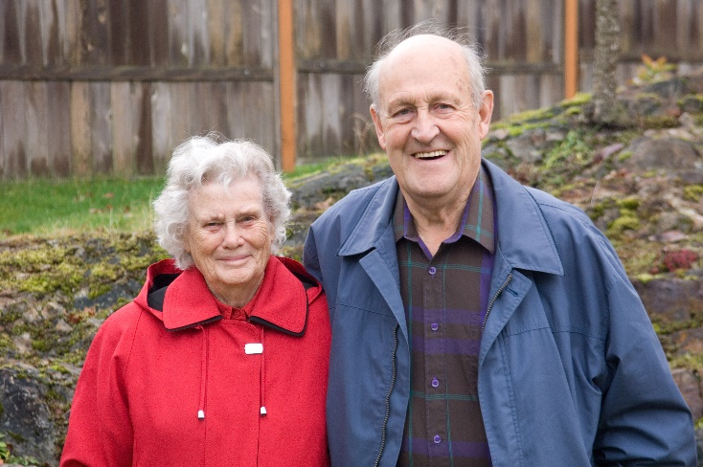

**Grandparents**



**The Extended**

**Family**

Uncles and Aunts

Came for the Dance.

**[](http://www.google.com/url?sa=i&rct=j&q=&esrc=s&source=images&cd=&cad=rja&uact=8&ved=0ahUKEwi-nMznuPDMAhUE8z4KHdX0B1YQjRwIBw&url=http://www.zazzle.com/crazy%2Baunt%2Bcards&psig=AFQjCNHE_7fElwE7A7uk62nDUPDe8_-I8g&ust=1464101376901496)**

[](http://www.google.com/url?sa=i&rct=j&q=&esrc=s&source=images&cd=&cad=rja&uact=8&ved=0ahUKEwjW4_78uPDMAhUBbj4KHQNZA1kQjRwIBw&url=http://quotesgram.com/aunt-and-uncle-quotes/&psig=AFQjCNHE_7fElwE7A7uk62nDUPDe8_-I8g&ust=1464101376901496)

**Rocco would get no peace**

**Playing with a nephew or niece.**

**“Brothers and sisters are well wishers.”** ut……What if ??”

Mother said.

Edit to include brothers and or sisters or none.

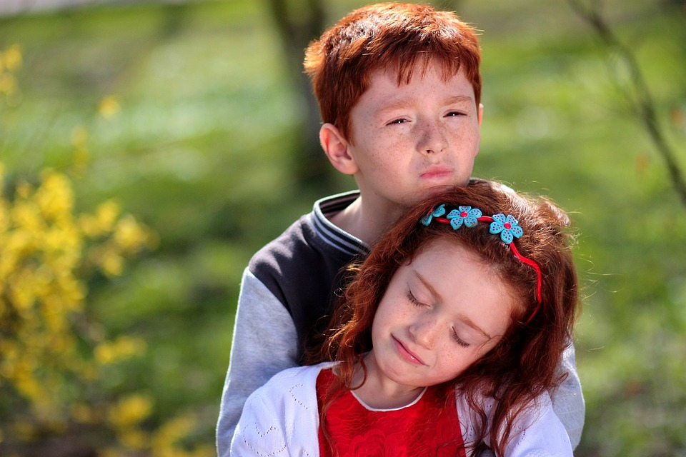

**Rocco Even Met**

**The Family Pet**

[](http://www.google.com/url?sa=i&rct=j&q=&esrc=s&source=images&cd=&cad=rja&uact=8&ved=0ahUKEwim9tOk-LbMAhVpkIMKHWDdAb0QjRwIBw&url=http://animaliaz-life.com/dogs.html&psig=AFQjCNEuqZKFgO5au9SVgVJT6B8tSWiFtQ&ust=1462125553786605)

If no pet skip page and move text below to next page. .

**Everyone said, “Rocco is a keeper” and what a great sleeper.**

**And “me oh my**

**How that boy can cry!”**

[](https://www.google.com/url?sa=i&rct=j&q=&esrc=s&source=images&cd=&cad=rja&uact=8&ved=0ahUKEwjWvpeU1fDMAhUIOFIKHRuFBVsQjRwIBw&url=https://www.pinterest.com/pin/127086020711867844/&psig=AFQjCNHGK5JTwK1hRtJBeFTYoE97XhCVBA&ust=1464108990582352)

**Sometimes no one knew why.**

**Often he was in the mood for food.**

[](http://www.google.com/url?sa=i&rct=j&q=&esrc=s&source=images&cd=&cad=rja&uact=8&ved=0ahUKEwjOwIXT9fDMAhVLUVIKHSfsAVwQjRwIBw&url=http://www.iemoji.com/view/emoji/623/objects/baby-bottle&bvm=bv.122676328,d.amc&psig=AFQjCNHcj0h7zQKX2s0DpUFSJLC2CetPrA&ust=1464117700990197)

**One minute he would chirp**

**The next, burp. Later he would slurp.**

**He wasn’t very neat when it was time to eat.**

**The family understood why sometimes he didn’t smell so good.**

[](http://www.google.com/url?sa=i&rct=j&q=&esrc=s&source=images&cd=&cad=rja&uact=8&ved=0ahUKEwixlNzf9_DMAhVOE1IKHXUwDj8QjRwIBw&url=http://www.itsmyhouse.net/bath-for-child/&psig=AFQjCNGrk-VJQQGHeb2IMLMgQDCCiNXUqw&ust=1464118267483807)

***But after the bath it was hard to beat that smell so sweet.***

**Then Rocco began to coo and talk…although it would be some time before he would walk.**

Sounding like a little bird

was his first word

Pick first word

[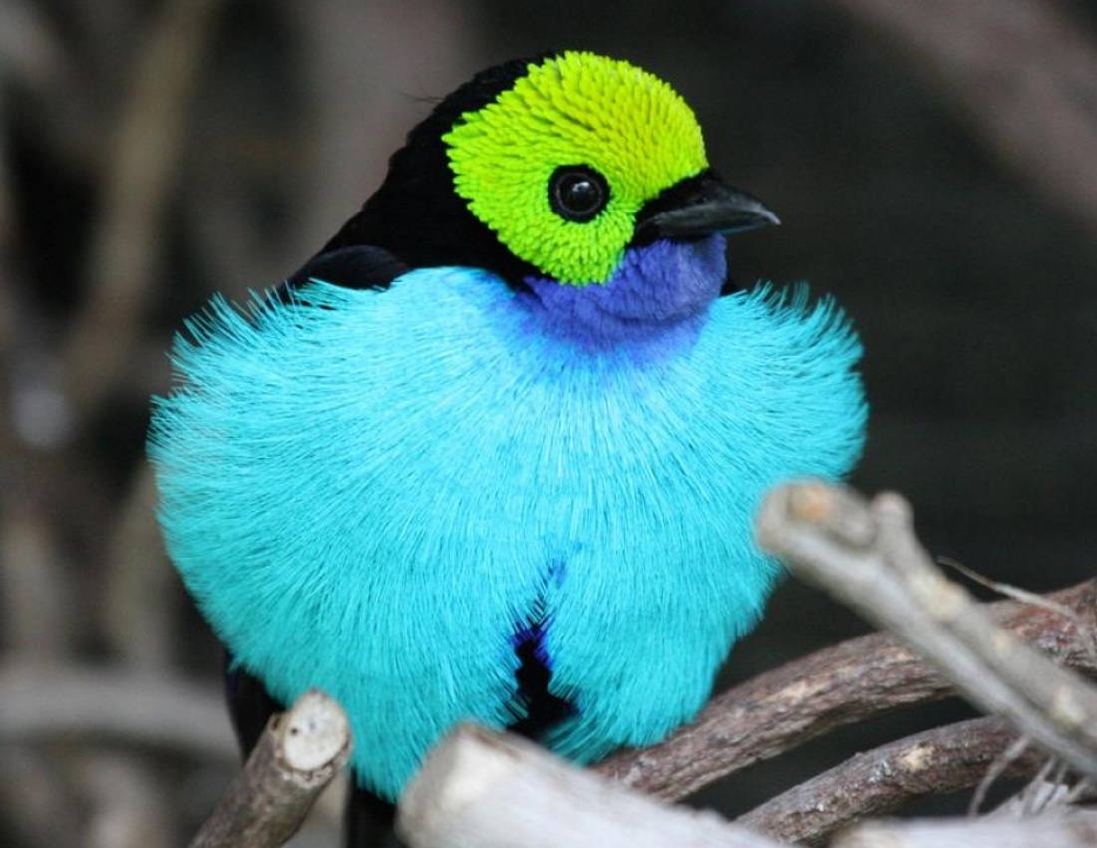](http://www.google.com/url?sa=i&rct=j&q=&esrc=s&source=images&cd=&cad=rja&uact=8&ved=0ahUKEwj0m67HhPHMAhUKVz4KHegSB-UQjRwIBw&url=http%3A%2F%2Fwaitbutwhy.com%2F2014%2F10%2Fdark-secrets-bird-world.html&psig=AFQjCNGFNUMvymuSM4xG3-3ThnSP95Eqzw&ust=1464121714365783)

***“MOM.”***

**Like most boys**

**He could make serious noise.**

**Sometimes he would try to stand, but you know where he’d land.**

**Sometimes the engine would stall when he first started to crawl.**



**It was a hoot**

**to watch him scoot**

**Rocco took a certain joy**

**At the sight of his favorite toy.**

**He hugged her teddy bear with care.**

[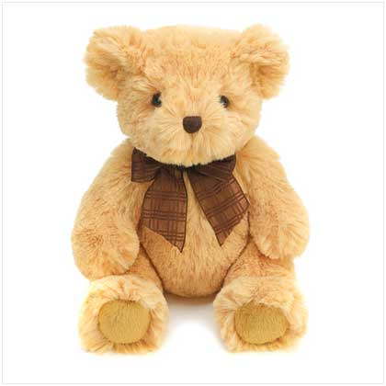](http://www.google.com/url?sa=i&rct=j&q=&esrc=s&source=images&cd=&cad=rja&uact=8&ved=0ahUKEwjvx-yWhvHMAhUKHT4KHfNPCfUQjRwIBw&url=http://tx.english-ch.com/teacher/len/level-b/teddy-bear/&psig=AFQjCNHBJDoqez1Nyhs2n3d7ZC2YVQmIxA&ust=1464122149449269) [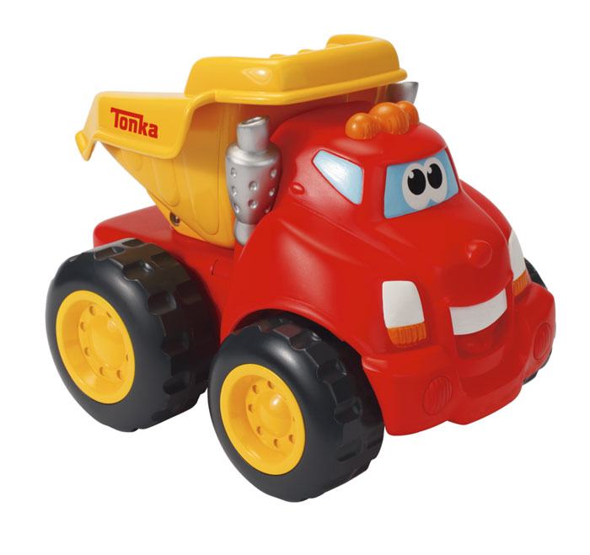](http://www.google.com/url?sa=i&rct=j&q=&esrc=s&source=images&cd=&cad=rja&uact=8&ved=0ahUKEwjuwNDEhvHMAhVKaz4KHQqKDF8QjRwIBw&url=http://www.amazon.com/Playskool-Chuck-My-Talking-Truck/dp/B0028YVCBW&psig=AFQjCNGnHsDZyua0d6X7lWTznKerNf8ioQ&ust=1464122245683774)

**Crawling along the floor looking for more.**

**Crawling gave Rocco a new gear.**

**And sometimes falling, a tear.**

**Not so stable,**

**He ran into the table.**

**He would take a bead and get there with speed.**

**From his head to his toe**

**Rocco did grow.**

**He would beguile all**

**With his bright smile.**

**His mind always going why**

**There’s a twinkle in his eye.**





And soon he had his own car seat. Pretty neat.

With a look he would say, Oh, please stay and play.

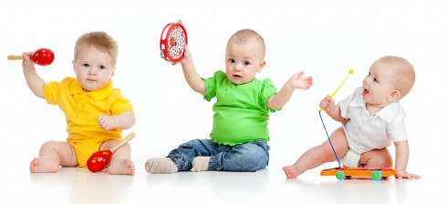

**It was clear at the end of a year**

**Everyone wanted Rocco near.**

**Who knew**

**We could so love you.**

[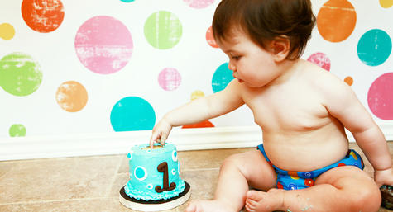](http://www.google.com/url?sa=i&rct=j&q=&esrc=s&source=images&cd=&cad=rja&uact=8&ved=0ahUKEwjmm8mrifHMAhUEOj4KHVwZBAMQjRwIBw&url=http://www.babycenter.com/0_celebrating-your-babys-first-birthday_1493204.bc&bvm=bv.122676328,d.eWE&psig=AFQjCNEN-EPO1dy7mLWHef5b_1ySY1uiFA&ust=1464122968222259)

***To our hears so near***

***It was a great year.***

Add additional photos.