**The Pink Diamonds**



A story from Prohibition to WWII to the present

**By Joseph W. Beach**

**© 2015 Joseph Beach**

[**Xanaducorporate@gmail.com**](mailto:Xanaducorporate@gmail.com)

The Pink Diamonds

Nate Golden had a great deal of money and there was more where it came from. Everyone in America wanted whiskey and he had come to Australia to buy it and then smuggle it into the speak easies in The United States.

He had made a deal with a small distiller who was delighted at the large order and now Nate needed to get his whiskey relabeled and loaded onto the cargo ship bound for LA. Nate had survived bootlegging by being a careful man which included a healthy dose of mistrust. In a discrete warehouse he repackaged the bottled whiskey as a medical laxative. Then he tried to hire a boat but all the boat owners required documentation and use of their own crews. Maybe there was no revenuers watching Australia but Nate was careful. He didn’t want to leave a trail. He bought an old 26 foot open boat from a private party at the main marina. The seller gave Nate temporary papers for the harbor which Nate pasted next to the boats control panel. The old boat was an added expense but by ferrying the whiskey the cargo ship could avoid the Darwin Port. Twenty seven trips later the whiskey was loaded. The captain told Nate he had to dispose of the boat and hire a water taxi to bring him back to the ship. Nate who wanted as little attention as possible took the boat into the rough seas miles outside of Darwin and then beached it.

He sat on the beach contemplating his long walk back to Darwin when an old weathered man with one arm, an Aboriginal, came down the beach, carrying two lobsters. The man sat down on the drift log next to Nate and started scooping out a hole in the sand. “It is time to eat,” the man said. “You collect some firewood.”

When the fire was going the man unwrapped some tin foil and placed the lobsters and some sort of root on the foil. Using only a knife and his fingers to eat, Nate remembered it as the best meal ever. All the man said was, “Enjoy the now. The future will come soon enough.” After they had eaten Nate pulled out his wallet to pay the old man. The old man understood the gesture, waived Nate off, and responded, “A gift.”

“Can you drive it?” Nate asked, pointing to his beached boat.

Sure,” said the old man. “Turn it on and it goes.”

“Drive me to a ship. He pointed out to sea. “And I will give you the boat.” Nate had plenty of money, a boat load of whiskey and didn’t need to sell his

boat. He could afford to be generous.

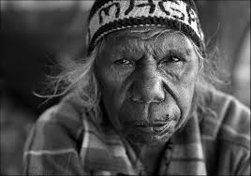“It is a very nice boat,” the old man said. “This month the sea is too rough for our canoes. My people need a boat like this to fish, but I cannot just take the boat. I must pay you.”

Nate replied, “No, no, no. Take the boat. You have nothing I need.”

The old man smiled, and said “Not so.” From his pocket he pulled out three sparkly rocks. “Here. Very rare. Save them until the time your people need great help. Your boat will feed my people and my stones will help yours.”

“Done,” said Nate feeling the glow of his own generosity.”

The whiskey had been successfully smuggled and Nate feeling lucky decided to have a ring made of one of the rocks. The Minneapolis jeweler looked at them and whistled. “I have never seen such pink diamond quality. How did you acquire them?”

Nate hiding most of the truth simply said, “I traded them for a boat.”

The Jeweler replied, “It must have been one beautiful yacht. Cut, these stones will be worth $300,000.”

Nate remembered. The old man has said very rare. It dawned on Nate he wasn’t the generous one, it was the old man.

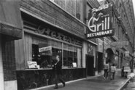One week later he got a call. “You bring those pink diamonds to Peter’s Grill downtown and after I check them you get the kid.” The phone line crackled. “No cops.”

“When?” asked Nate Golden?

“Tomorrow at 3:00.” The phone line went dead.

Police detective Bjorn Bergstrom had heard the instructions on the phone extension. “We will get someone in the kitchen and cover all the doors. He can’t get away and we will get your son out safely. We’ll have a patty wagon right around the corner.”

[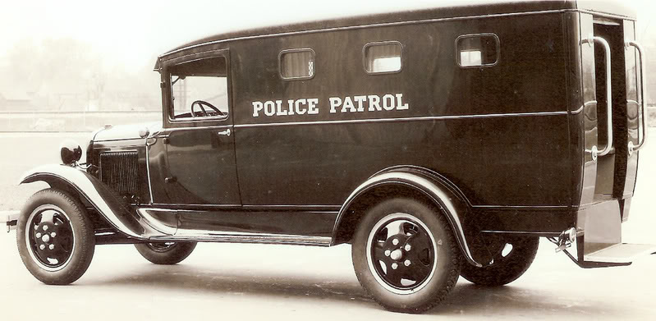](http://www.google.com/url?sa=i&rct=j&q=&esrc=s&source=images&cd=&cad=rja&uact=8&ved=0CAcQjRw&url=http://www.fordbarn.com/forum/showthread.php?t%3D3031%26showall%3D1&ei=scZsVcC3O8PjsAXl8IHIAg&bvm=bv.94455598,d.b2w&psig=AFQjCNGLwbcZiKGTy6DxdsK7oLyXCm5hvA&ust=1433278157530051) “Detective, there are only two things you need to do. Get my son back and keep this quiet. No press, no shootouts, no big announcements. No radios, no publicity or there will be more kidnappings. I know some of these people. They will come after my family. Prohibition is coming to an end and this is their new way to make money.” Nate did not add that any publicity would alert the revenue agents looking to crack down on bootleggers.

Bergstrom knew the St Paul people already expected more kidnappings. The police in Minneapolis were as concerned as Nate Golden about a continued crime wave coming out of St Paul where the criminals were given police protection if they committed their crimes outside the St Paul City limits. They even knew the name for this practice – the O’Connor system. The O’Connor System - named for a previous St Paul police chief. Protected were some of the "Public Enemy" era's best known arch criminals:

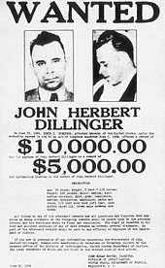John Dillinger, Babyface Nelson, Roger "the Terrible" Touhy, Machine Gun Kelly, Alvin "Creepy" Karpis, and the Barker gang all spent time in St. Paul, robbing, smuggling, looting, extorting and murdering. Even one of the crime kingpins, Leon Gleckman, had been grabbed in 1931. On March 1, 1932, the son of aviator Charles Lindberg Jr. (a Minnesota native) was [kidnapped](http://www.fbi.gov/about-us/history/famous-cases/the-lindbergh-kidnapping). William Hamm Jr. had taken over the Hamm Brewery in 1931 after his father, who had been a close associate of R. T. O’Connor, had passed away. On June 15, 1933, Hamm was walking back to his home, where his mother had lunch waiting for him.  He was approached by a man on the side walk. “Mr. Hamm,” the man said, reaching out his hand to shake.

When Hamm grabbed it, the man, Charles Fitzgerald, forced him to the ground as a car pulled up.  Hamm was thrust into the back seat.  In the car with him were “Doc” Barker and Alvin Karpis. They drove to a hideout in Illinois while other members of the gang negotiated a ransom – $100,000.

On January 17, 1934. Edward Bremer, owner of the [Schmidt Brewery](http://www.fortroadfederation.org/brewery/index.html) in St. Paul was kidnapped with the ransom of $200,000 paid for Bremer several months later. Schmidt had survived prohibition by making soft drinks, root beer and near beer. It also had an exclusive agreements with Dutch Sawyer to brew real beer that was sold throughout St Paul. It was ironic, a ransom paid to bootleggers from profits of an illegal beer manufacturer. The Mpls police suspected similar bootlegging arrangements in their city, especially in the hotels. Nate Golden was widely suspected of importing illegal whiskey and mixing it with a home brew he made somewhere in the Township of Bloomington.

“He is probably not clean, but he is right about more kidnappings," the police chief said to Bergstrom. “The city leaders are already petitioning the Roosevelt administration to do more.” Several months later J. Edgar Hoover unveiled a list of “public enemies.” At the top of this list were Alvin Karpis and Ma Barker. All of the known bootleggers including Nate Golden were also on the list.

At exactly 3:00 the Minneapolis police lead by Detective Bjorn Bergstrom charged through St Peter’s Grill. At 3:03 the cashier said, “There is a call for you Detective.”

“Bring the diamonds to Murray’s Steak House on 6th. You have 10 minutes or the kid bites it. Oh and this time no cops.”

Nate Golden walked alone through the front door of Murray’s Steak House at 3:12, carrying a small velvet bag with the three pink diamonds. The sidewalk in front of the restaurant, the alley and the buildings next door were thick with plain clothes cops. Bergstrom thought, “Just get the boy out.” He didn’t care if the bootlegger kidnappers shot each other, but this time it was different. This time it involved a kid.

Suddenly the kitchen staff came rushing into Murray’s main room trailed by a single man waving a gun and then there was a shriek: “Daddy” and again “daddy” as the twelve year old boy rushed to his father. The kidnapper stepped in front of the boy and grabbed the velvet bag, shaking three stones into his palm. Subsequent reports were not clear, but most of the staff reported that the boy kicked the kidnapper in the shin. Only Nate noticed that the kidnapper dropped one of the stones and Nate covered it with his foot. Cursing, the kidnapper retreated to the kitchen. There was some chaos as the word went up and down the block that the boy was safe. Then the police charged Murray’s front door and on into the kitchen looking for the man with a gun.

The Dykman Hotel completed in 1915 was a first class downtown hotel with nine floors of rooms, a chic restaurant, and a spacious yet somehow cozy street level lobby. Just inside its 6th Street entrance sat a lectern and swivel chair. This was the office and domain of Elijah Powers, the chief and most of the time the only bell hop. Although only 16 Elijah was a Dykman veteran who knew every inch of his hotel as well as a great deal of the seamier side of Minneapolis. Tickets to the fights at the Armory, a girl for the night, discrete of course, or a moving poker game all lead to tips. Elijah knew the bartender could find some fine Australian whiskey or other spirits. His mother, a cook in the hotel had brought him to work when he was 10, and it was as if he had never left. Sometimes he would sleep in a closet used to store blankets in the basement laundry complex to get a jump on the next day’s tips. For him it was survival and life until the next tip. Dressed in his uniform this slightly built black boy would jump up to help a guest and yet was almost invisible. He was like the lobby furniture, comfortably there. From his mother he had learned honesty and politeness.

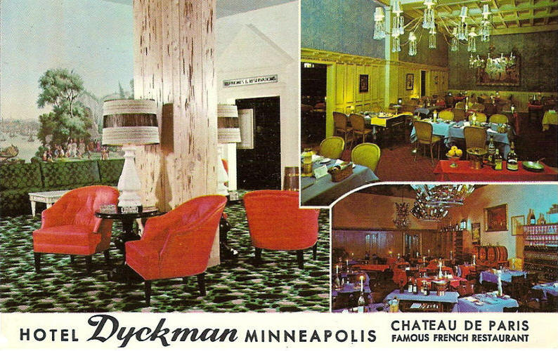At exactly 3:17 Elijah could feel something was up. He could feel it in his fingertips. The air was charged, yet the lobby was quiet. From his office Elijah could see the entire lobby: The four elevators, the main stairwell, the concierge desk against the west wall, and the front door just feet away. Mr. Lundsgaard was at his usual post behind the concierge desk reviewing the day’s bookings. The part of the 6th street sidewalk Elijah could see was quiet.

Suddenly there was a rocking explosive boom. Upstairs an elevator bell went off. Elijah saw it all. Mr. Lundsgaard disappeared behind the protection of the heavy oak concierge counter, then dust came up the stairwell from the basement, and then something even stranger. In the corner at the unused end of the concierge counter behind one of the building’s support pillars a door hidden in the paneling opened a crack. A man slipped out. First he dusted off his coat and then with purposeful long strides headed directly toward Elijah and out the front door. The paneled door with no hardware and no visible hinges closed and again look like a single paneled wall.

Elijah turned and saw the man head down the outside courtyard and down the ground level mall through Dayton’s Department Store toward 7th Street. Out of the corner of his eye Elijah could see Mr. Lundsgaard peer above his counter checking to see if it was safe. Elijah could see uniforms running south across 6th Street from Murray’s. One particularly large pot- bellied cop pushed Elijah away from the door and stood there as a sentry.

[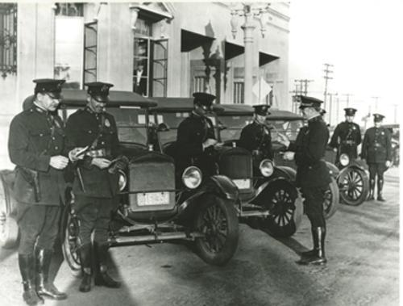](http://www.google.com/url?sa=i&rct=j&q=&esrc=s&source=images&cd=&cad=rja&uact=8&ved=0CAcQjRw&url=http://bhgov.net/citygovernment/aboutbeverlyhills/historyofbeverlyhills/?PSMODE%3Ddefault%26PSSET%3DN&ei=J8ZsVeWQLIbYtQWJtYOwCw&bvm=bv.94455598,d.b2w&psig=AFQjCNGLwbcZiKGTy6DxdsK7oLyXCm5hvA&ust=1433278157530051)Down the mall, a uniform was having an animated conversation with two people in the doorway of the popcorn shop, and a curb side radio was squawking. Uniforms poured into the lobby from the street, sealing the elevators and taking control of the stairs. Boot noises reverberated off the marble floor.

Bergstrom surveyed the concierge area while interviewing Mr. Lundsgaard. Lundsgaard ashamedly admitted that he ducked and then closed his eyes when he heard the explosion. Standing next to Lundsgaard Bergrstrom noticed two chalky footprints next to a pillar. Similar white dust was covered the stairwell to the basement. “Looks like you have some clean-up to do,” Bergstrom commented. Then as an afterthought he asked, “Do you have somewhere you would lock up guest valuables?”

Lundsgaard answered, “Before the crash we did. Behind the desk. We don’t do it anymore.”

For some time there was a great deal of milling. The basement stairs were roped off, and the elevator repair people arrived. Elijah stayed unnoticed in his swivel chair behind his lectern just inside the door.

At 4:00 the hotel owner arrived and was updated by Detective Bergstrom within hearing of where Elijah sat. “There has been a kidnapping across the street. The kidnapper used a tunnel to get to your hotel. He had a get-a-away car at the 7th Street mall entrance. We caught and killed the two men there a little while ago. Sorry about the mess. We will need a couple of days to search your basement for clues, but you should be able to reopen soon. Best keep this incident hush – hush. We think that most likely this was a gang fight. At least that is our official position.”

Elijah could hear from other officers it was an attempted kidnapping and the kidnapper was believed to be a brother of a Dillinger gang member, Homer Van Meter. His residence was listed as the St Paul Hotel. “Dillinger has robbed a number of banks across the country, most notably in Indiana and Ohio. The FBI has a $20,000 reward for his capture,” one of the officers noted.

Elijah daydreamed that he had tackled the man coming out of the strong box room and they had come to him with a bag full of money, a $20,000 tip.

Elijah considered approaching the police with what he had seen and with what he knew about the hidden room and it’s even more hidden trap door, but this was not something a black youth would do. If he were asked he would tell the truth, but his mother had often said, “mind your own business, not that of others. Black is to be seen not heard.”

With some cleaning and The Dykman returned to normal. The Police searching the basement inch by inch went unnoticed. Elijah returned to his helping guests and earning tips. That afternoon Elijah told his mother he was spending the night in his blanket closet.

Elijah had seen a ceiling trap door open once two years ago. A big man was standing on a rickety ladder peering up into a room from the basement hall. The trap door opening was just big enough so the man could have climbed into the strong box room. The man had turned, waved Elijah over and holding his finger to his lips in the quiet-it’s a secret signal pointed to a case of [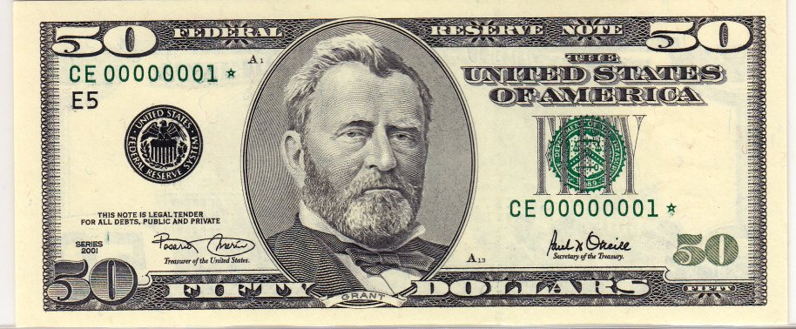](http://www.google.com/url?sa=i&rct=j&q=&esrc=s&source=images&cd=&cad=rja&uact=8&ved=0CAcQjRw&url=http://becuo.com/old-fifty-dollar-bill&ei=SUNvVeO5LcWjsAXwzoGwCA&bvm=bv.94911696,d.b2w&psig=AFQjCNG2in16YyPkY5yyu93foXc7WSeBIA&ust=1433441480412984)moonshine. He then passed a fifty dollar bill to Elijah. It was the only time Elijah could remember he had kept something from his mother. She would have made him do something constructive with the money, god bless her, not spend the entire amount at the candy store.

Now, with bricks, plaster, and wood splinters all over the floor from the police

knocking down the bootleg tunnel it was impossible to tell if the trap door had been opened. The police had left for the day and Elijah was anxious to take a look inside the strong box room. He couldn’t do it from the lobby as day and night someone was responsible for the concierge desk. He might be seen. Elijah moved a table to the spot below the trap door, put a chair on the table and with a flashlight in his mouth pushed open the trap door. The agile 16 year old had no trouble lifting himself into the tight strong box room. The room itself was wide enough for only one person and against one wall there were strong boxes with keys sticking out. The door of one of the boxes was open. Elijah felt inside but it was empty. Elijah then tried to close the door but it would not close. Looking carefully he saw a pink sparkle in the hinge of the door. Elijah pinched the glittering small rock and put it in his pocket. When he was done looking, exhausted, he climbed out, moved the table a few feet, and fell asleep in the blanket closet.

The newspaper had a blurb on the “kidnapping incident” on page 3. It mentioned the gang connections, called the police heroes, and without names stated that the possible kidnap victim was doing fine. There was no mention of a ransom, Dillinger or a chase...

Often at 3:00 after the lunch trade Elijah and his mother would sit together in the kitchen having some lunch. Elijah causally said, “There is a secret room behind the concierge desk.” His mother raised her eyebrow. “It has a hidden door and I saw the kidnapper come out of the room.” The other eyebrow went up. “There is a trap door near my blanket closet and I climbed into the room last night.”

 “Such a story, Elijah,” she commented. “Keep going.”

“No gun or anything. Just a wall of locked boxes.” Then remembering the glittery rock Elijah reached into his pocket, “and this.”

Elijah could hear his mother take a giant breath and then let it go. To his astonishment she grabbed him by his uniform collar, stared into his eyes and said, “Never, ever speak of this again.” She took the stone. “We must never tell anyone you found this. Never tell anyone of that trap door unless they specifically ask. Promise me.” She shook Elijah until he promised.

Her dedication to honesty compelled her to try to return the diamond and try she did. She called the police and asked for the name of the kidnap family. “That case is closed to the public. Anyway the family has moved and can’t be reached.” She got the same answer when she called the newspaper.

Several evenings later Elijah and his mother boarded their bus in front of the hotel along with the lunch cook at Murray’s. The two women sat behind Elijah and he could hear them laugh as they talked about their dream of starting a restaurant. He heard the Murray’s cook say, “The boy kicked the man so hard he dropped one of the diamonds. I saw the father pick it while he hugged his son. You know what happened next. They walked out with the police holding open the door. “The two women laughed, and Elijah’s mother said to her friend, “we must never talk about the pink rock.”

Soon thereafter she purchased a diner in St Paul and made Elijah quit his job to concentrate on his education. Whenever Elijah asked about money his mother would always say, “Elijah we are lucky, but the thing is we must pay it back to keep it. Do something good today.”

The two women made the best meatloaf ever and a unique cheesy pepper dip of enormous popularity. The diner was a great success and within a few years the original mortgage was paid off and the collateral returned. It became known that the restaurant was a safe place and no one was turned away for lack of funds.

[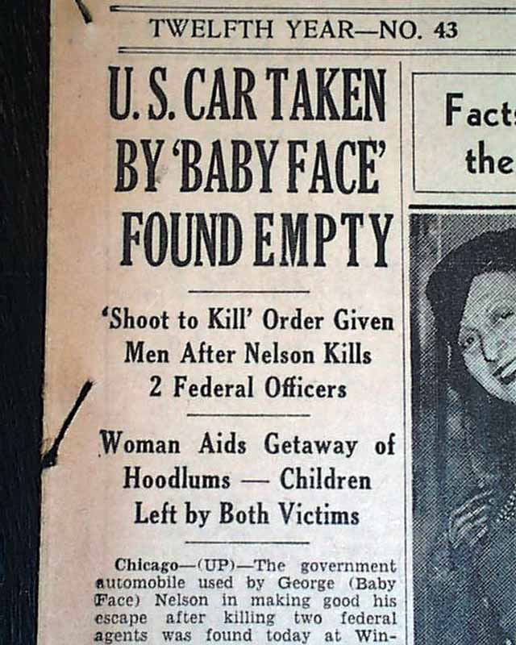](http://www.rarenewspapers.com/view/563360)Maybe out of curiosity or maybe from fear someone would come for the diamond, Elijah followed the news of Dillinger for a few years. The authorities believed that while in St Paul Dillinger had organized a new gang with old collaborators of his like Homer Van Meter along with new hands John Paul Chase and Eddie Green – who were also associated with the Barer-Karpis gang.

Later George “Baby Face” Nelson’s gang helped Dillinger escape from prison. Over these years the FBI with the power of the IRS imprisoned or killed all of the St Paul gang members. There was never any mention of Nate Golden.

Bjorn Bergstrom was known as a detail conscious, almost dogged cop. They indulged him when he asked the medical examiner to check the stomach contents of the kidnapper. The corner gave him an unidentified key that was found in the kidnapper’s stomach. Again, when he spent two days alone combing the bootlegger tunnel his police superiors indulged him. There was something that bothered Bergstrom. A table and chair were just outside the laundry area and there was no reason for them to be in that specific location. The scrap marks could have been made by someone pulling a table from the laundry area next to a closet filled with blankets. On the third day poking the ceiling with a broom handle he found the trap door. Inside the hidden room the key fit the third safety box he tried and inside was a velvet bag with one large pink diamond.

When he offered the stone to the police commissioner as evidence of the kidnapping he was told in no uncertain terms that the department wanted no publicity and that the case was closed. He also tried to find Nate Golden, but the man had disappeared.

Nate Golden knew the government had started using the IRS as the vehicle to imprison bootleggers and even though he was small fish he would be a target. Someone knew about the diamonds so someone betrayed him. Within hours of walking out of Murray’s he had started severing his ties with the old life. He sold his house and goods at a cash discount and in secret the former bootlegger moved his family including his thirteen year old son, Nate III to Green point NY in 1935. This northernmost suburb of [Brooklyn](http://en.wikipedia.org/wiki/Brooklyn) was known as “Little Poland.” With what money he had left he established a mini-bank helping immigrating polish Jews get started. Young Nate III was immersed in Polish Language School and by 1939 sounded like a native pole. He also had more than passable German. Nate III knew about Hitler and had the itch of youth to get involved. 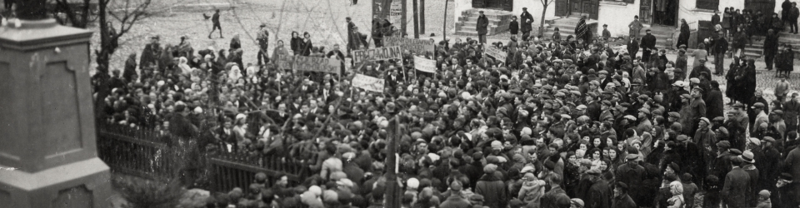 On October 12, 1940, during the holy day of Yom Kippur Nate Golden bowed his head and said, ”Son, today is the end. The Governor of the Warsaw District, signed a decree establishing the Warsaw ghetto. It is just a matter of time before the slaughter begins. I give you my blessing to follow your heart and join the fight. In my other life I thought I was bein generous to an old man. It turned out that he was the generous one and he gave me this. Nate showed his son the diamond. "I had three of them before you were kidnapped. The ransom was the three diamonds which I was happy to pay, but the kidnapper dropped one when you kicked him. This old man told me to ‘save the rocks until the time your people need great help.’ Now seems to be the time. You take it.” The next day Nate III left for Europe and the underground.

In 1940, five years after the kidnapping, Elijah had become a highly trained auto mechanic and then an expert at airplanes at Wold Chamberlain Airport in Minneapolis. The BCATP, part of the [Royal Canadian Air Force](http://en.wikipedia.org/wiki/Royal_Canadian_Air_Force), was gearing up the war effort in England and creating basic training facilities in Canada. The commander of the facility in Winnipeg came to Minneapolis specifically to recruit Elijah bypassing the racial restrictions. Off Elijah went, first to Canada and then to an unidentified airfield in England.

BJ Bergstrom, a cop’s kid, found athletics as his avenue for approval and he excelled. He was captain of his high school football team as an all-state linebacker as well as an accomplished wrestler. The recruiting office designated him officer material and sent him to flight training school. By 1944 he had risen to the rank of captain and was a veteran flying fortress pilot. Captain Bjorn Bergstrom was assigned to the 8th Air force in England in 1944 as part of Operation Titanic. A horrible name for a war changing effort. The United States had finished building a massive airfield in Russia known as Base X. The missions were to fly and bomb across Germany landing in Russia and then after restocking, bomb their way back to England.

Sargent Elijah Powers was assigned to train, plane maintenance personnel at the new Base X. “Imagine me, teaching the white boys,” he wrote his mother. The RAF arranged a ride with Captain Bjornson and the crew of the Hot Mama, as the fortress was known.

In an English pub BJ recruited the navigator, a RAF veteran from the northern coast of Australia nicknamed Oi.

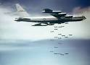Toward the end of the mission over the German-Polish border the Hot Mama was hit by flak, first just behind the cockpit and then damaging the tail section beyond its ability to steer. A last German effort with antiaircraft guns recently moved from the Russian Front had done the damage. The plane started careening toward earth. “We are going down,” BJ announced over the speakers. “Get out.” With no bombs left to blow up the three cleared the plane. The rest of the crew did not make it out. There was just enough cloud cover so that there was no moon light and no one shooting at the floating airmen.

“We’ve got to move,” BJ stated.

“The plane is south of us,” The navigator stated. “West is Germany.”

“North it is,” said BJ. They quickly got out of their harnesses and walked across what had been plowed fields before the German Occupation eventually coming to a gravel drive.

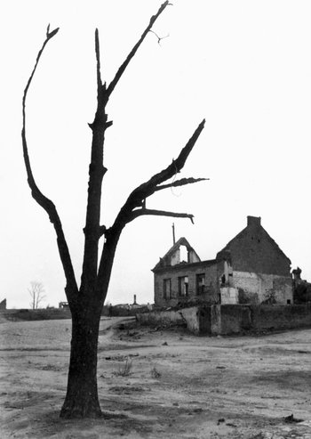 Out of the darkness they made out a stone chimney of a burned out farmhouse and two out buildings, a Dutch style barn and a smaller lean-to. The barn had a strong smell of gasoline so they elected to rest in the lean-to.

Toward morning they heard the rumbling of a heavy vehicle. Looking out through an opening in the wood slats of the lean-to, the Aussie said, “Troop carrier. Got a Swastika on the door.”

“Oh, good. Not a tank,” BJ said pulling out his revolver.

The vehicle pulled up to the barn. Then, a German officer jumped out of the truck cab and started singing at the top of his voice in perfect English, “Oh what a beautiful morning, Oh what a beautiful day. I hope there is someone going my way.” Then in Polish said, “Let’s gas up.” From inside the shed they could see two men in civilian working clothes climb out of the carrier and open the barn door. The uniformed man turned toward the shed and yelled, “If you be German surrender.” If you be Polish we have Nazi’s for you to shoot. If you be Americans we have hamburgers and apple pie. My name is Nate from Brooklyn, NY.”

Elijah said, “Cover me.” And stepped out.

The man then yelled, “Here’s your test. “What’s the name of the Windy City

or The Big Apple?”

Elijah yelled back, “Elijah, Sargent RAF and now United States Air Force.” He paused and then added, “So I guess I’ll take the apple pie.”

The man, the gun holstered at his side, walked up to the door and added, “I thought I could find you before the Germans. Name’s Nate, proud to be an American and a Polish Freedom Fighter.”

With the three men out of the lean-to Nate added, “The Germans have some special camps for you fly-boys. They call them Stalags. They are very interested in your bombing plans, so first they like to have a little chat. They have other places, they call them camps where they simply kill everyone who is not German. We’ll gas up and take you north. With some luck we’ll get you back to the war.”

They traveled north keeping to rural roads, by passing a larger town that looked bombed out. “German’s did it for spite,” Nate commented. “Probably a Jew or two hidden in the town.”

[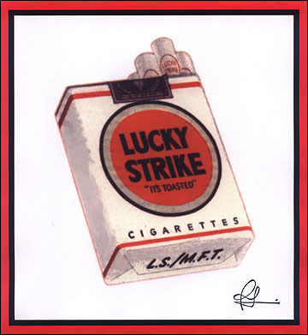](http://www.google.com/url?sa=i&rct=j&q=&esrc=s&source=images&cd=&cad=rja&uact=8&ved=0CAcQjRw&url=http://www.underconsideration.com/brandnew/archives/lucky_strikes_out.php&ei=iEpvVdiRL8TAtQWIyIHIDA&bvm=bv.94911696,d.aWw&psig=AFQjCNEvCLto2d9BcX2pQzgySBI3N8eczw&ust=1433443330346150)Later Nate said, “It’s time for the afternoon spotter planes. We will go undercover until tomorrow. The driver nodded and soon they had the troop carrier camouflaged and hidden in an isolated woods. The two poles pulled a basket from the truck. “Bread and cheese and of course local wine... Sorry no hamburgers,” Nate stated.

“Beautiful,” said Elijah. “Let’s make a feast.” Elijah pulled out several chocolate bars, two packs of Lucky Strikes, and two tins of mystery meat. “As a civilian I was a bell hop and a good bell hop is always prepared.” One of the Poles said in broken English, “family owns hotel on coast if you need job.” They laughed.

BJ described their flight. The Poles were hungry for war news and with every detail of the bombings cheered. Nate, the American, working as a Polish Freedom Fighter, dressed as a Nazi officer, translated every word.

In a lull Nate looked at the navigator and said, “One unimportant question. “Where did your nickname, Oi, come from?”

“Real name is Peter. I was in a bar with my Australian friends when BJ came in recruiting. There aren’t a lot of us left in the RAF. Well you know that. He heard my accent and said, you are an Aussi. Everyone in the bar went Oi, Oi, Oi. He thought everyone in the bar new my name, not that this is just something we say when someone says you’re an Aussie. I guess the nickname stuck.”

Elijah stared at Nate, There was something familiar, but he couldn’t put his finger on it. Something to do with Minnesota and his life those years ago. Some memory his bell hop comment had triggered. “I have seen you before.” Together they established they had lived in Minneapolis in 1935, but there seemed to be no other connection. BJ added he had also grown up in Minneapolis.

The next day they came to a checkpoint just outside what had been a city. All one could see was partial buildings, broken concrete, and Swastikas. “Taking the prisoners to the ship yards in the north. This is important to the war effort,” The freedom fighter said. He then demanded fuel. The small German contingent was anxious to help such a high ranking officer.

At first the few civilians they saw all had their heads down, then one of the Poles in the back of the vehicle briefly waved the polish flag. Very quickly a few slipped food items and others gave them the thumbs up OK sign. When they were free of the city the truck stopped in a wooded area and a group of men approached. “The Germans are retreating,” they said. “We can handle it from here.”

Sitting on the warm ground, Nate drew a dirt map to where they were going. “I am sorry I cannot go with you, but there are other pilots, prisoners in Stalags, we can help to escape. With great sadness he added there is a train coming from Hungary. It has 15 cars full of people, mostly Romi but I sure some Jews and others who do not please Hitler. It is headed to one of the death camps south of us. This train also has anti-tank cannon headed for the French coast. My sources tell me that with a large bribe the train can be acquired and rerouted to the Ukraine. This means safety for its passengers and cannon that will never fire at our troops.”

“Anything to screw up the Nazi’s,” BJ stated.

The Freedom fighter said “Yes. In March a group of airmen tunneled their way out and disguised as Danish foreign workers, with forged documents and non- prison clothing. They took up lots of Nazi resources. Kept the [Gestapo](http://en.wikipedia.org/wiki/Gestapo) 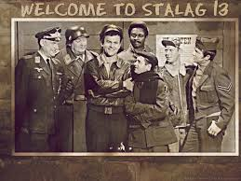looking for months? The Germans even acknowledge these airmen, calling it the great escape.

Suddenly Elijah knew why Nate, the Freedom Fighter, was familiar. “Do you have a picture of your family?” Elijah asked seemingly out of nowhere. There in his wallet was a single photo of a man and woman cut so it had no background. “My parents.” Nate said.

Elijah stared at the photo. “I once met your father in a tunnel under the Dykman Hotel. He gave me a $50.00 tip and told me to keep quiet. You were the one kidnapped.”

“Yes,” said Nate. Right after my father quit bootlegging and went into hiding from that life. We moved to New York in the middle of the night and he changed his first name.” Nate pulled out his diamond and put it on the ground in front of him. “This diamond was part of the ransom. He paid the ransom with three pink diamonds. Before the kidnapper could escape he dropped one of the diamonds, this one. He told me when I left that there is a destiny attached to the diamonds. A destiny for all of them to be used for something to help what he called the people.”

“Amazing.” Elijah shook his head. “I was there. The kidnapper hid a diamond in my hotel and I found it. My mother tried to find your dad.” He paused, pulled out his diamond and held it in his palm. “Before I left she said, keep the diamond for your safety. Then she added, but remember son you did not earn it. You found it.”

BJ said, “Impossible.” His pink diamond twinkled in his hand. My father only told me the police told him to keep it and that someday I would find the right use.”

“Nate, where did your father get the stones?” Oi asked.” I know for a fact pink diamonds only come from northern Australia.”

Nate shrugged, “I know he once imported whiskey from Australia.”

The Aussi added, “I don’t know if this fits, but there is a legend in Northern Australia from the Aboriginals. Waking to the ocean an old man found three of the prized pink rocks, but instead of going into Darwin to sell them to a diamond dealer who cheated the people he walked the beach where he ran into a stranger with a peculiar accent sitting by a boat. Someone from another tribe, a white man. It was a time when the people could not fish because the ocean was too rough for their small boats. The stranger offered his boat to the old man for a lobster. The old man was convinced that this boat was sent by the Gods and it was destiny that he had the three uncut rocks to give to the stranger. He told the stranger, “As surely as the boat will help my people, these rocks will help yours.” According to the legend the stranger looked disappointed, but said nothing.”

BJ fingered his diamond. “Would this help us get out of Poland and back to the war?” He asked.

“Sure,” Nate answered. “Our only plan is to get you to the ocean and maybe Finland, not back to England.” BJ put his stone back on the ground.

BJ asked, “For the record how many people are on that train going to the death camp?”

Before Nate could answer BJ said, “take my diamond and buy a train.” He then added, “for the people.”

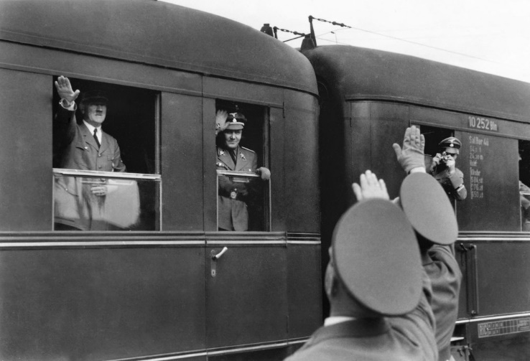 “My mother always said the diamond was there to help. She would be happy to feed a train load of people.” Elijah pushed his diamond toward Nate.

“Time to move,” one of the Poles said.

Nate pocketing the three stones stood up. “It’s time for me to catch a train.” He hugged each of the three and said, “Catch a Baltic codfish for me.”

Many of the Hungarian war records did not survive. There are however some references to a German train that mysteriously reversed its direction and took passengers and guns the wrong way into what in now the Ukraine. There is a personal account of one Klaus Gunther who was a train engineer. Apparently he traded a pink diamond for enough food to feed the train passengers for a week. The best trade ever in Hungarian Gypsy lore is a pink diamond for a train.

BJ and Elijah made their way to Swinoujscie, a town in the northwest corner of Poland where they worked with the Polish Underground sabotaging sites in northern Germany until the end of the war. After the war both returned to Minneapolis.

Oi returned to England first, then to Australia where he flew missions against the Japanese. After the war he became a champion of preserving Australia’s aboriginal heritage.

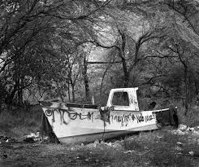 He often visited aboriginal communities and never tired of the old stories, particularly those that involved pink diamonds. On one trip one of the young men took him to a cove where there was an old abandoned boat. Inside on the now stripped control panel was a weathered owner’s certificate. The name was barely visible: N Golden.

In 1990 with the fall of the Berlin Wall and erosion of communism certain documents were released. A Nate Golden III of unknown background had been a major benefactor aiding the 3.5 million Germans who defected from East Germany. His son, Nate IV had pledged two million dollars in rare pink diamonds to help tear down the wall. There are no pictures or other details about the two men, nor this disposition of the diamonds.

The End

Copyright © 2012 Xanadu, Inc. and Joseph Beach

DEDICATION: To imaginative friends and Neighbors