Student name: 陳昱螢Student ID: 0616091 Department: CS

Part A. Questions

1. What is your command to filter the packet with customized header on Wireshark?

Ans: Use “tcp.srcport == 1024 && frame.len >= 80“ to filter the packet.

2. Show the screenshot of filtering the packet with customized header.

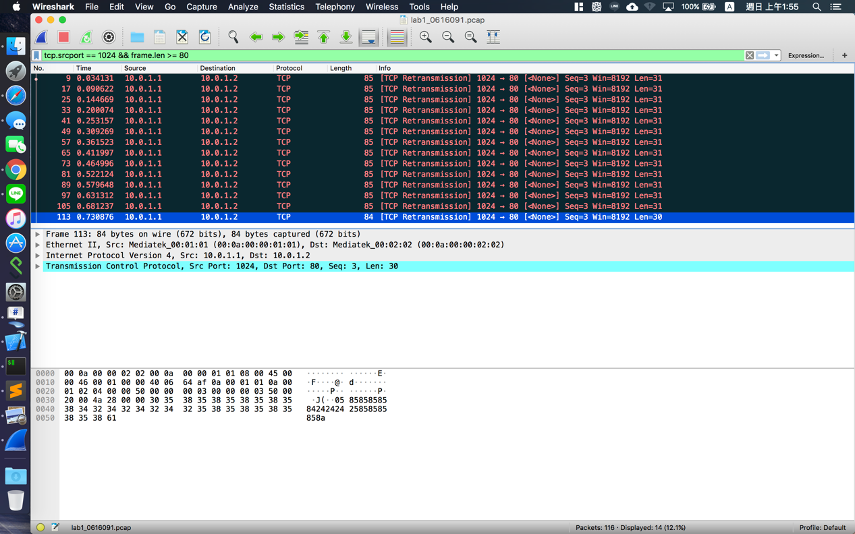

3. What is your command to filter the packet with “secret” payload on Wireshark?

Ans:

4. Show the screenshot of filtering the packet with “secret” payload .

5. Show the result after decoding the “secret” payload.

Ans:

Part B. Description

* Task 1 – Environment setup
* Task 2 – Define protocol via Scapy
* Task 3 – Send packets
* Task 4 – Sniff packets
* Task 5 – Run sender and receiver
* Task 6 – Push your files to remote
* Task 7 – Load PCAP via Wireshark
* Task 8 – Filter the target packets
* Task 9 – Decode the secret key
  1. Input the secret key into ./src/decoder.py
* Execute decoder.py in terminal
* $ python decoder.py 19061601906160
  1. Will have output in ./src/out/lab1_0616091.png
* My result is 