**Technical Details :**

**Technologies** : HTML5, CSS, Bootstrap, Angular Js.

**IDE Used** : Visual studio code

**Features :**

* Intigrated Search feature.
* Integrated ordering.
* Used HTML5 Audio tag for playing music.

**File Structure :**

We have 2 folders

1. App (it contains angular js controller and services codes)
2. Resources (it contains bootstrap files,important javascripts and css)
3. Index.html (all the importent resources are included here)

**Installation :**

* Put “code” folder in server(i used xampp).
* Open URL as per your server.

**Screen Shorts :**

Home :

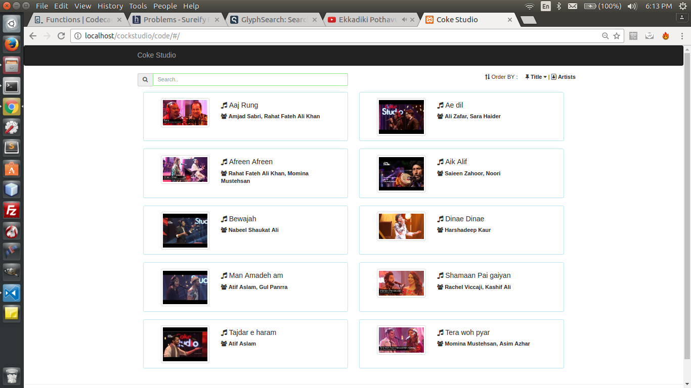

Click on BOX get **Music Player View** :

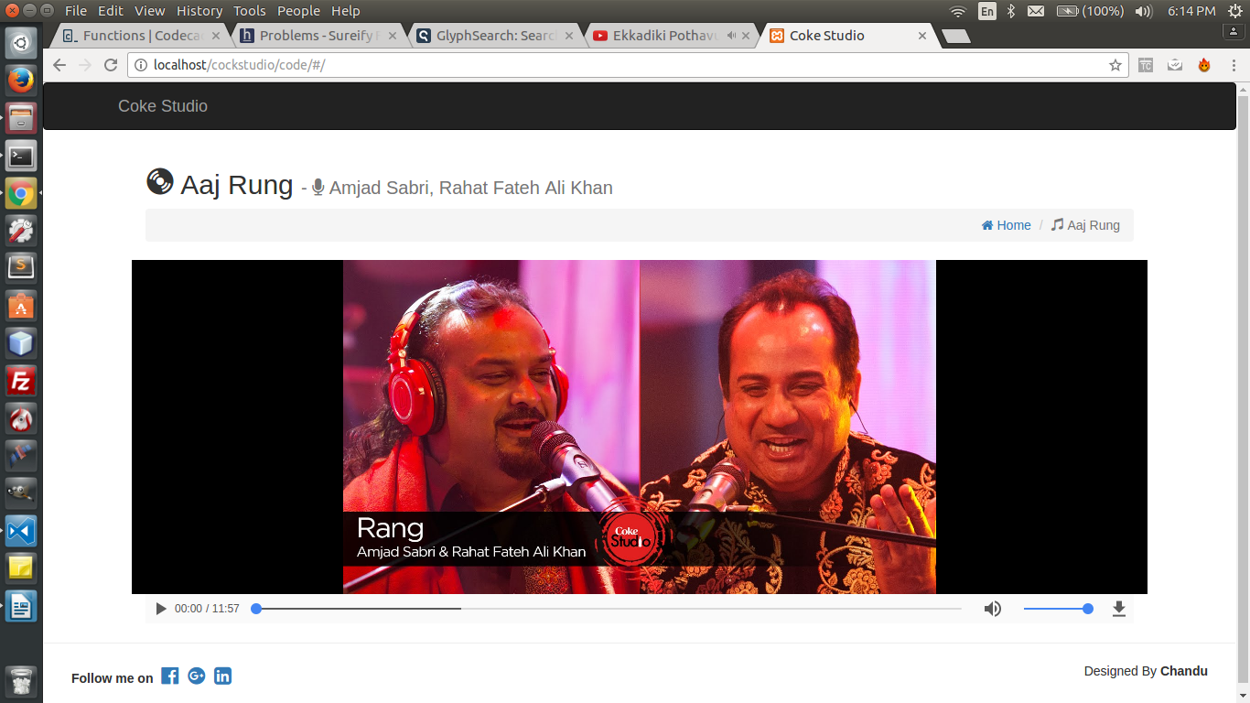

Clck on “home” button to go back..