**Technical Details :**

**Front End Technologies** : Bootstrap, Angular Js.

**Routing** : Basic Angular Routing.

**IDE Used** : Visual studio code

**File Structure :**

We have 3 major folders

1. App (it contains angular js controller and services codes)
2. Views folder contains all view files(.html files)
3. Resources (it contains bootstrap files,important javascripts and css)
4. Index.html (all the importent resources are included here)

**Screen Shorts :**

Home :

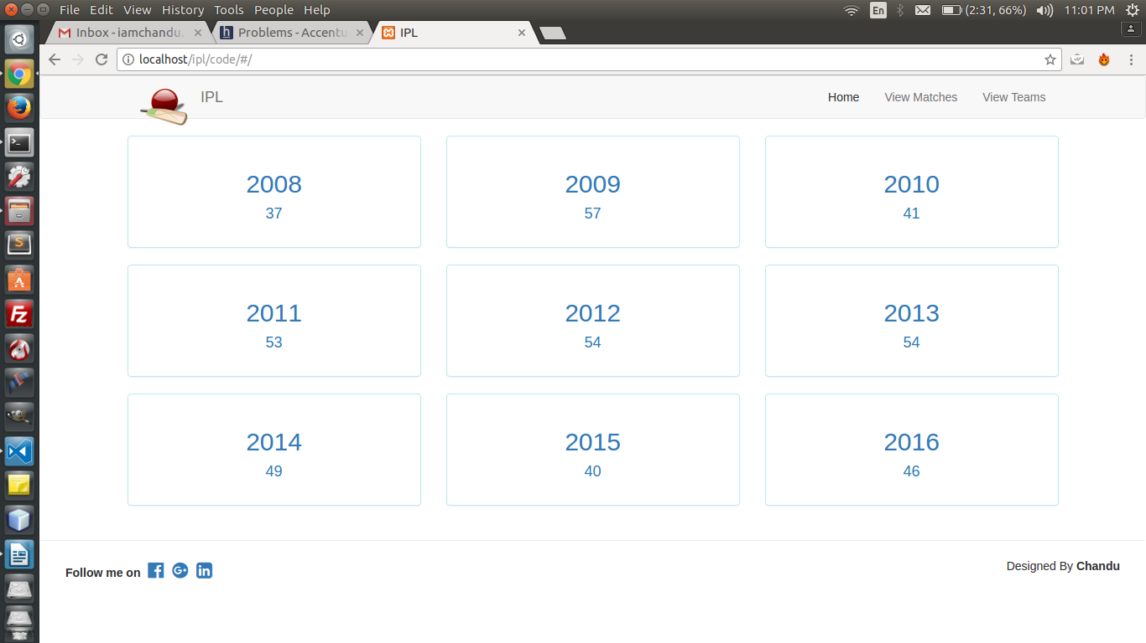

**View Matches :**

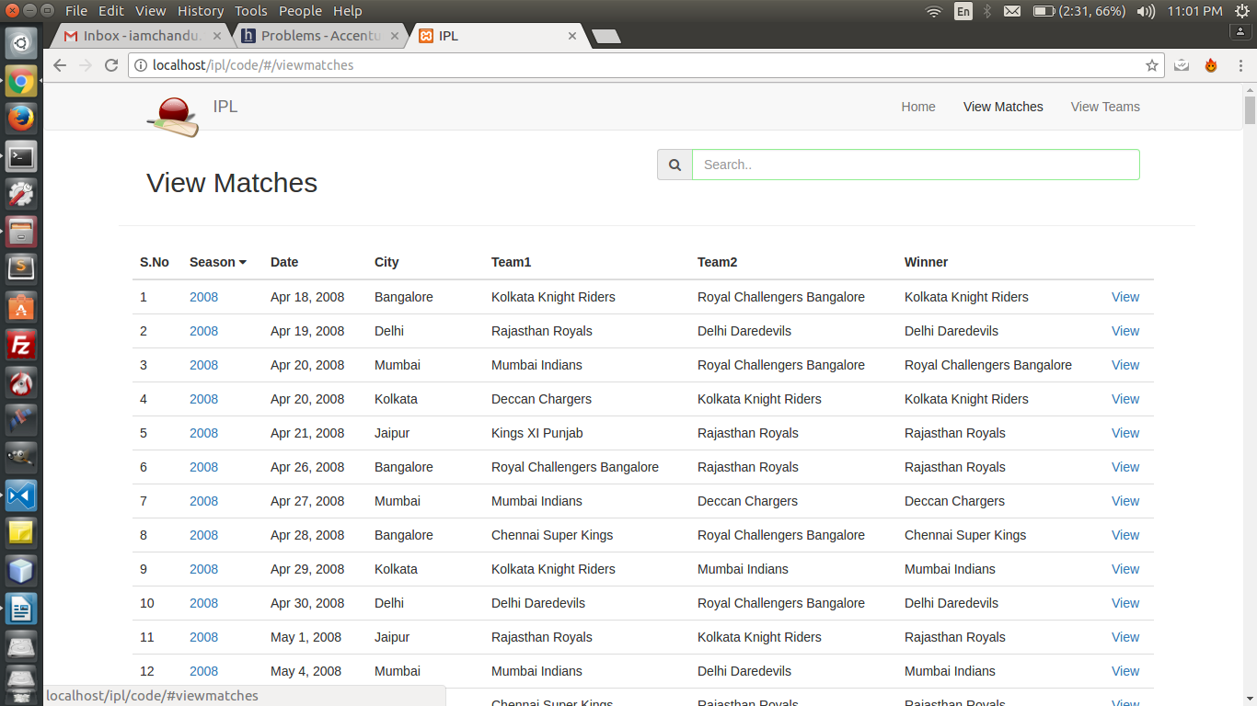

**Matches Detail View with Highligts:**

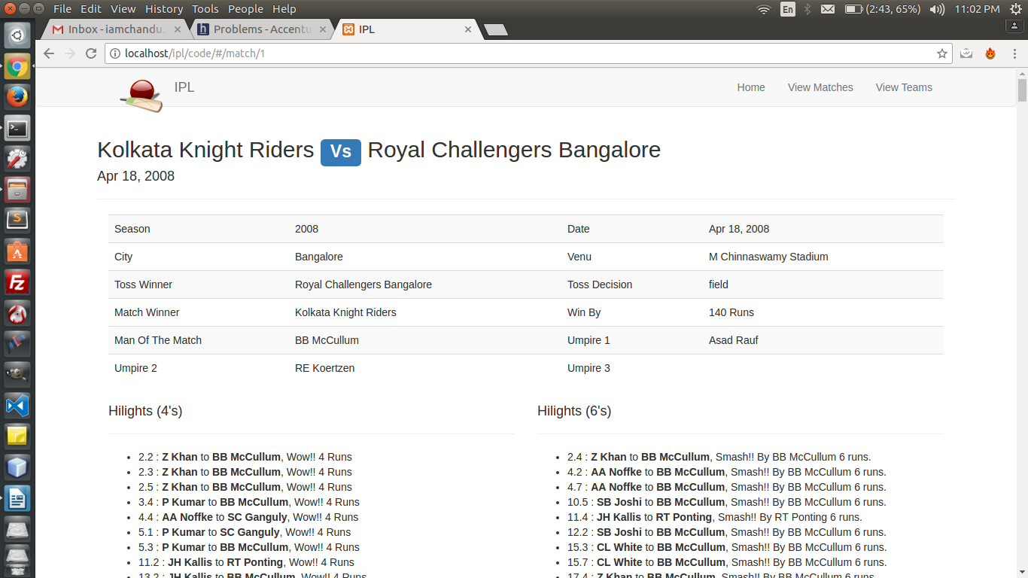

**View Teams :**

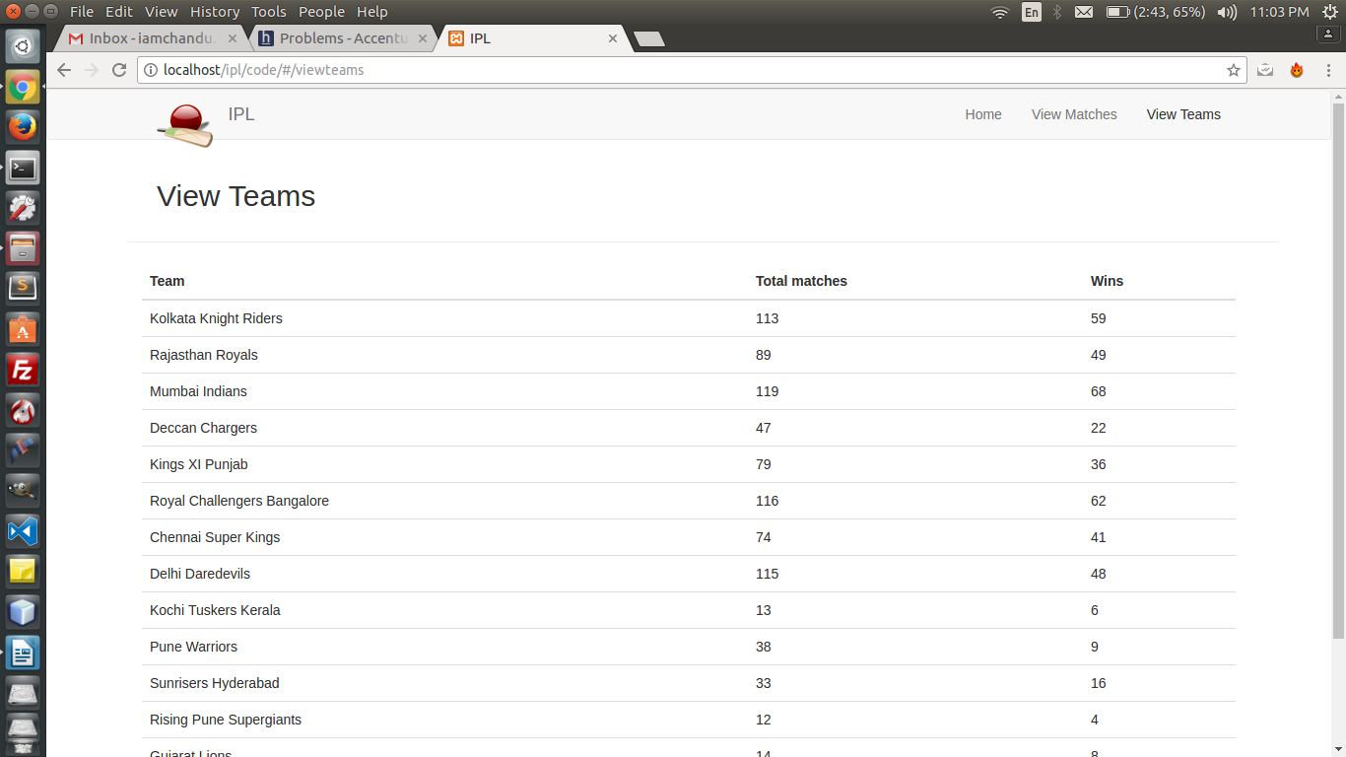

**Season wise Matchs:**

