**Technical Details :**

**Front End Technologies** : HTML, Bootstrap, Angular Js.

**Routing** : Basic Angular Routing.

**IDE Used** : Visual studio code

**Services** : REST Services

**File Structure :**

We have 2 folders

1. App (it contains angular js controller and services codes)
2. Resources (it contains bootstrap files,important javascripts and css)
3. Index.html (all the importent resources are included here)

**Screen Shorts :**

Home :

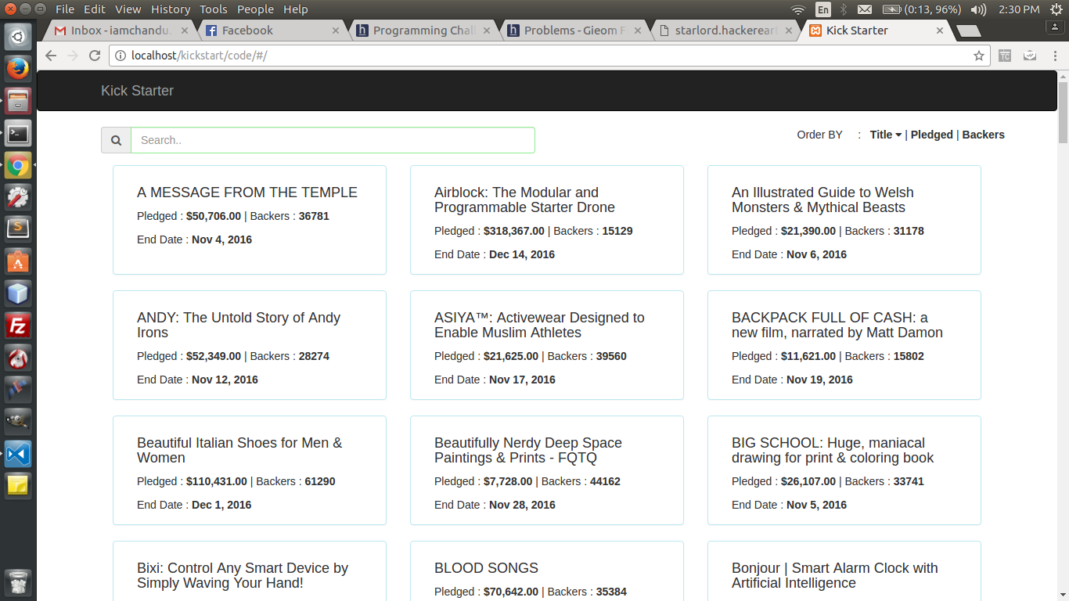

Click on BOX get **Full Details** :

