**react-frontend-challenge:**

**Instructions:**

Install dependencies using npm i

Start Server using npm start

Sample csv file attached here use that file as sample (sample upload.csv)

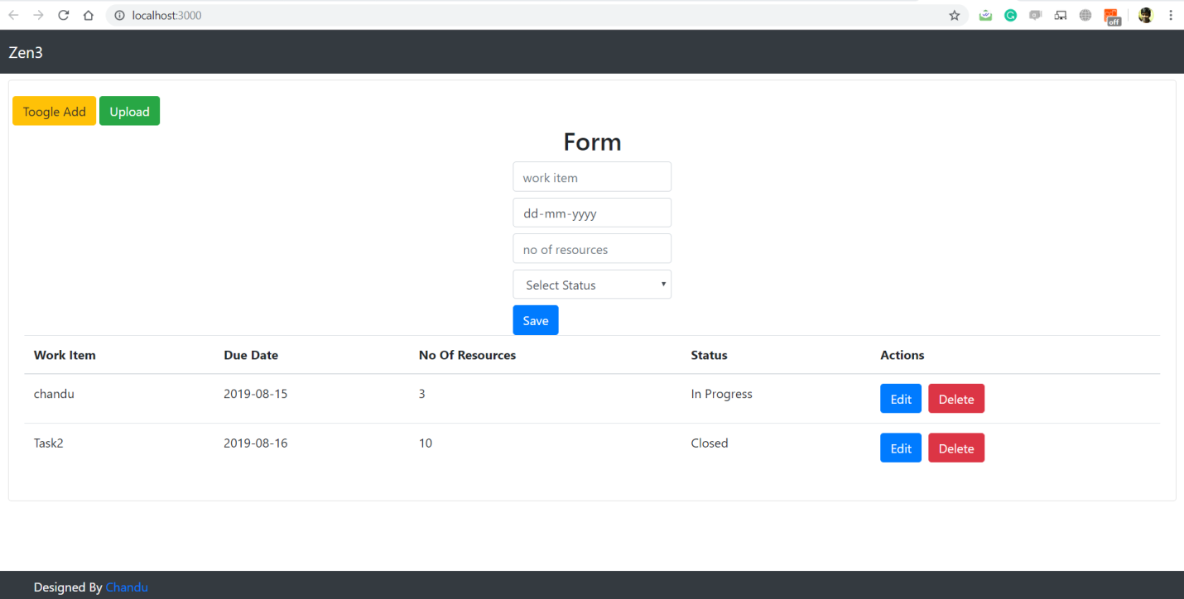

**Node-env:**

**Instructions:**

Install dependencies using npm i

Start Server using npm run dev (for development) / node index.js (for live)

Set your paths for each and every process in (node-env/.env)

**Routes:**

|  |  |  |
| --- | --- | --- |
| **Method** | **Route** | **Remarks** |
| **Get** | **http://localhost:8000/ getEnvironment/:process** | **To get data corresponding process** |
| **Get** | **http://localhost:8000/ setEnvironment/:process/:key/:value** | **Set data to environment file** |
| **Post** | **http://localhost:8000/ addNewProcess**  **Input Parameters:**  **{**  **"path": "c:/progremfiles/a.env",**  **"process": "newpro"**  **}** | **To add new process** |