UniVault

Gemini 3 Pro
399 per month
As an introductory offer 199 per month for the first six months

1 year of Gemini 3 Pro = 3,588 inr

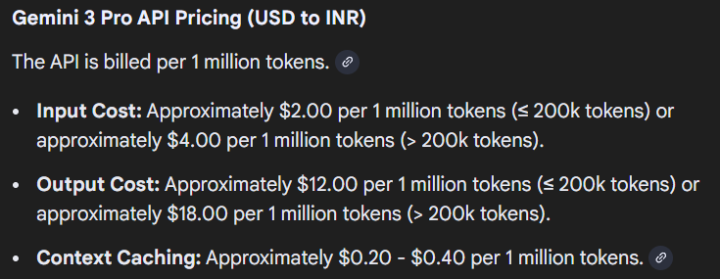

Gemini 3 Pro usage by students:
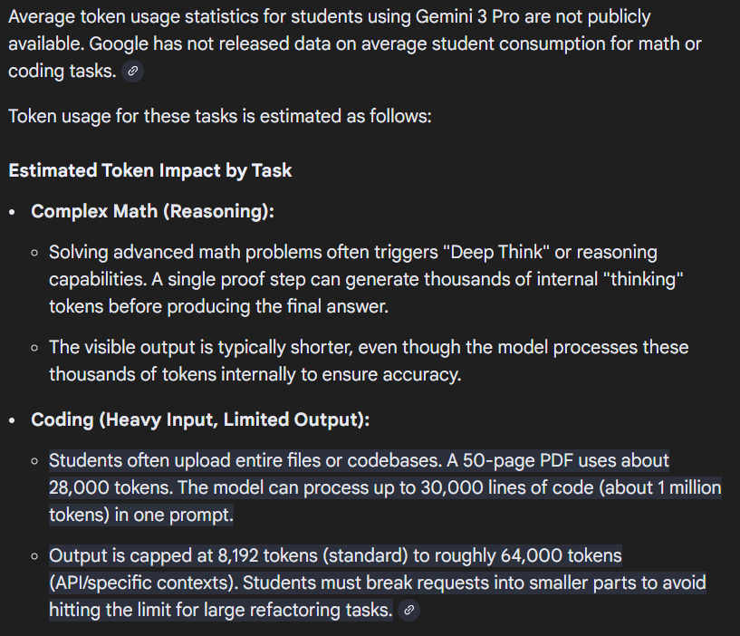

Usage in one month:
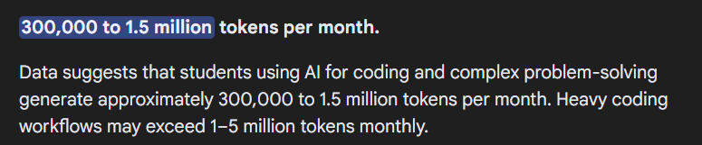
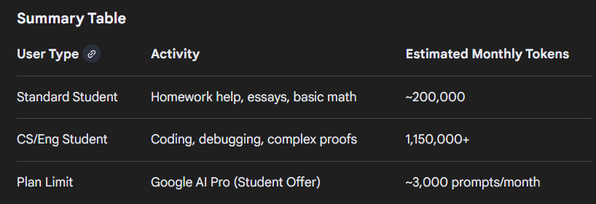
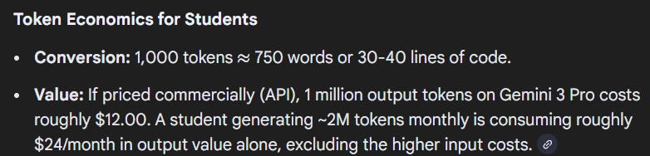
INR 2,160 used by a single student in terms of tokens (api)

Grok api key: 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

