UniVault

Gemini 3 Pro
399 per month
As an introductory offer 199 per month for the first six months

1 year of Gemini 3 Pro = 3,588 inr

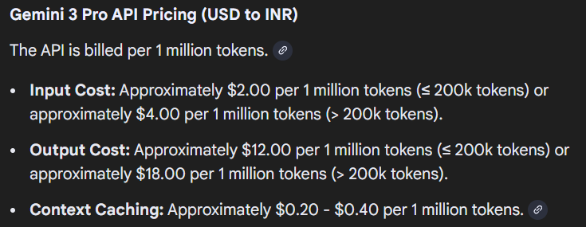

Gemini 3 Pro usage by students:
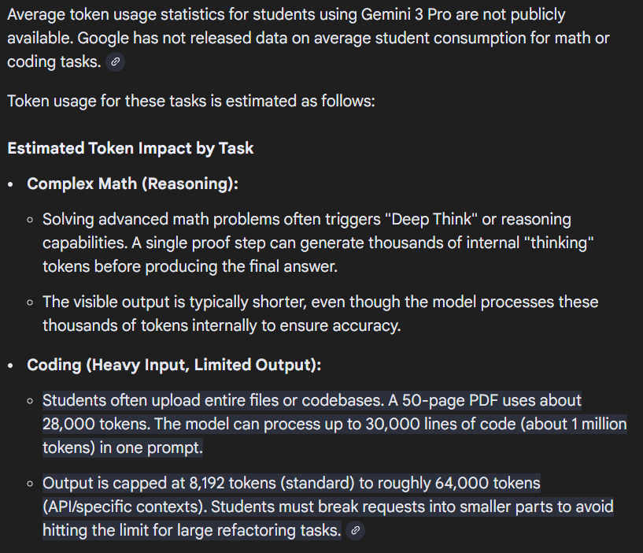

Usage in one month:
