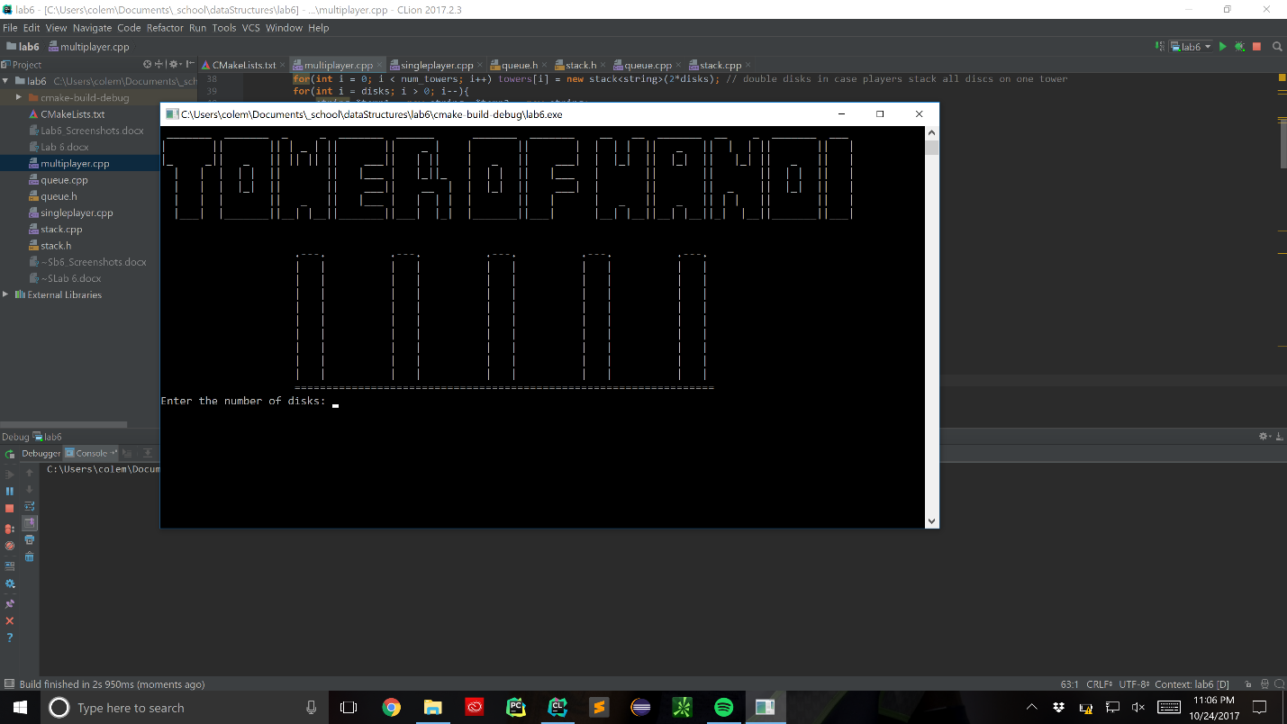**Beginning of Multiplayer Tower of Hanoi**

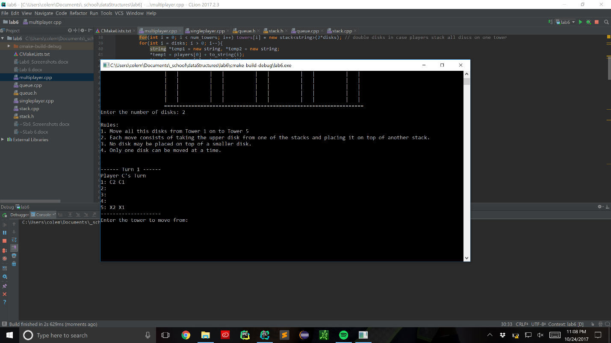**I just did 2 disks for each player to keep it simple. The two players are player ‘C’ (for Coleman the greatest name of all time) and player ‘X’ because x is a cool letter**

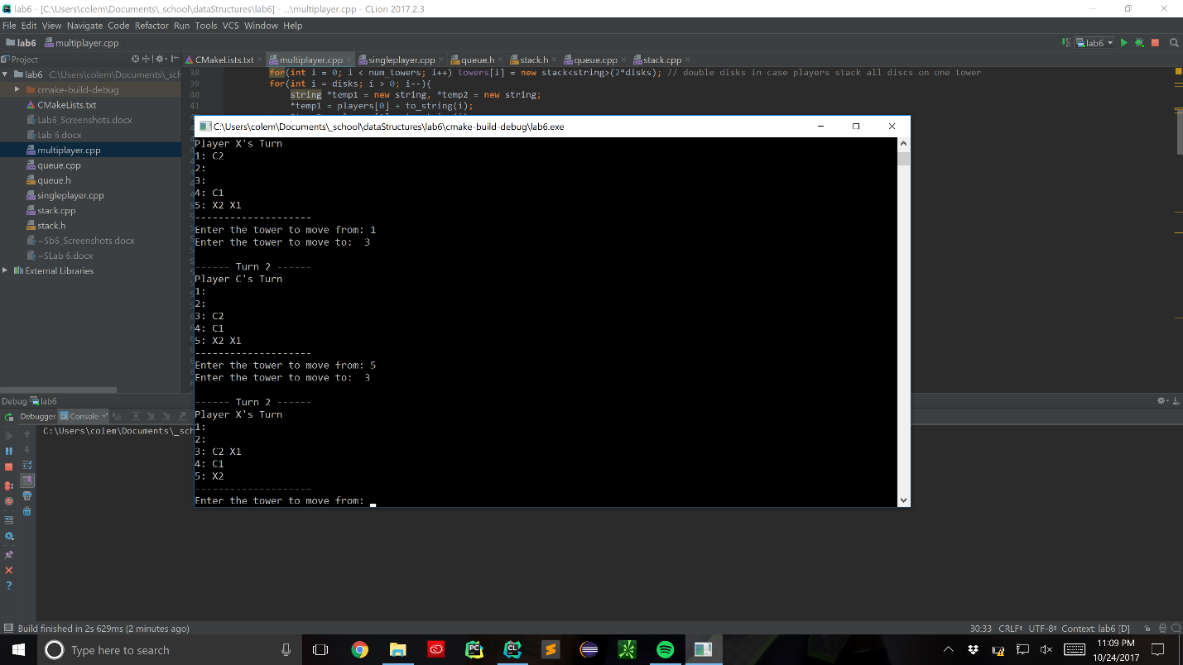**Action shot of the game…**

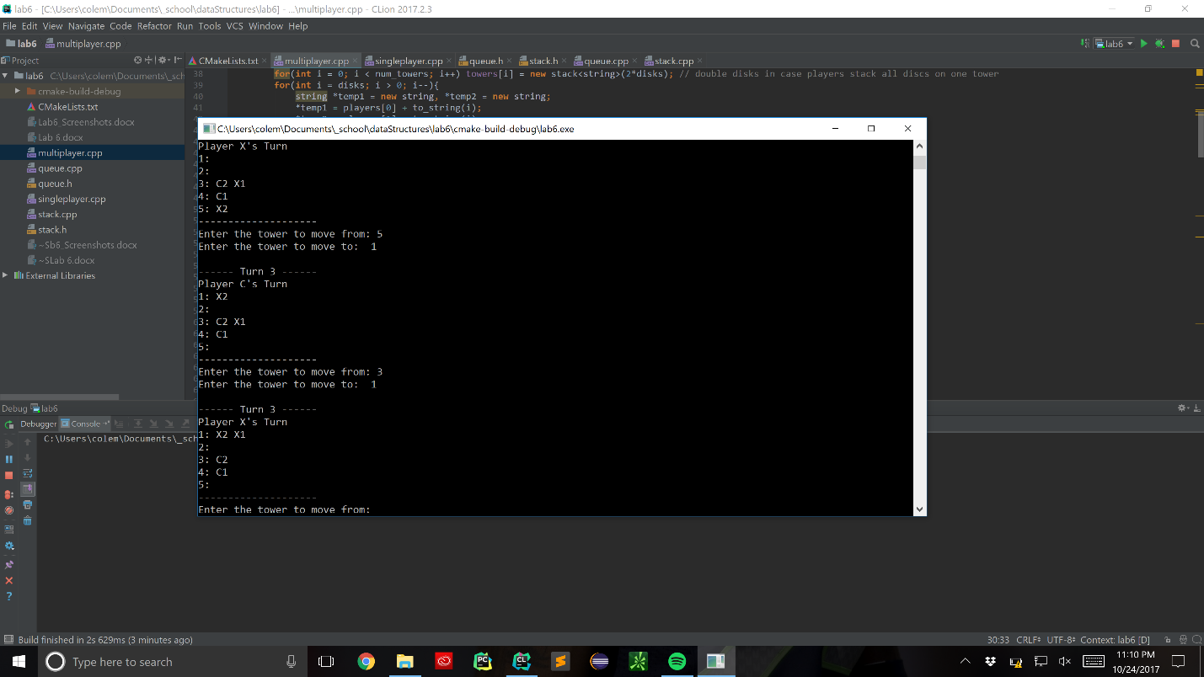**Player ‘X’ has won, but player ‘C’ hasn’t yet, so the game must go on…**

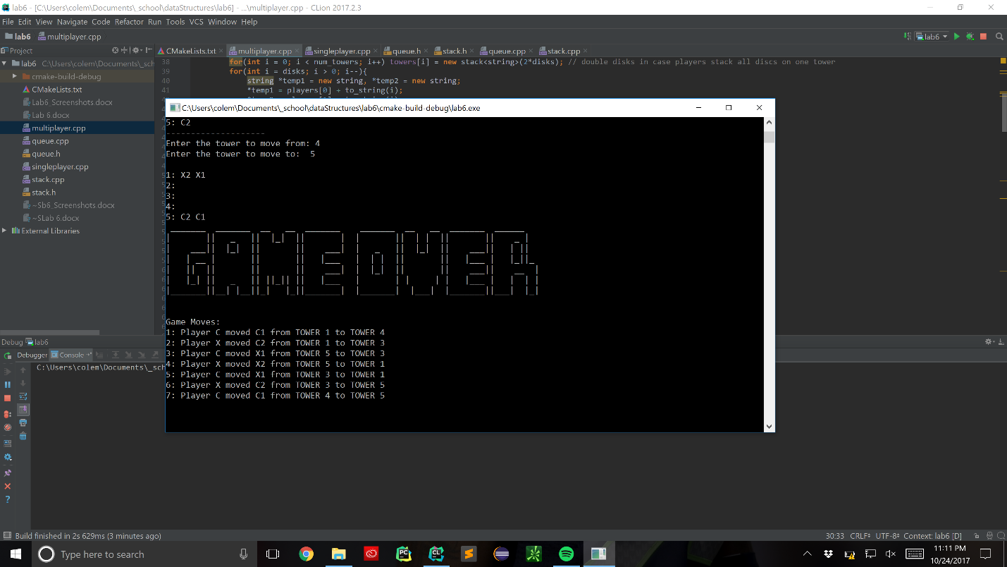**Winner Winner Chicken Dinner!!!**

**Now on to Single Player Game:**

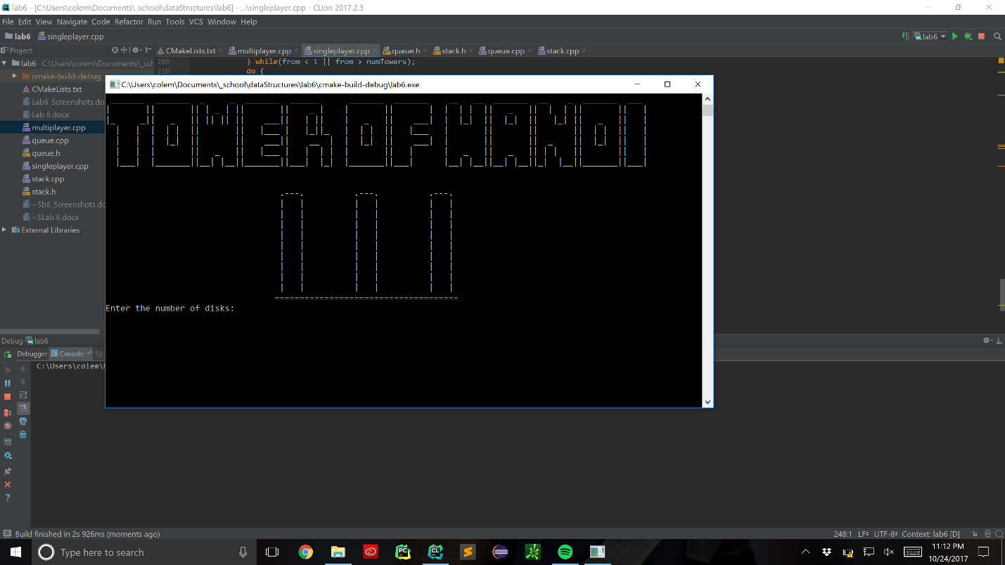**Singleplayer intro screen**

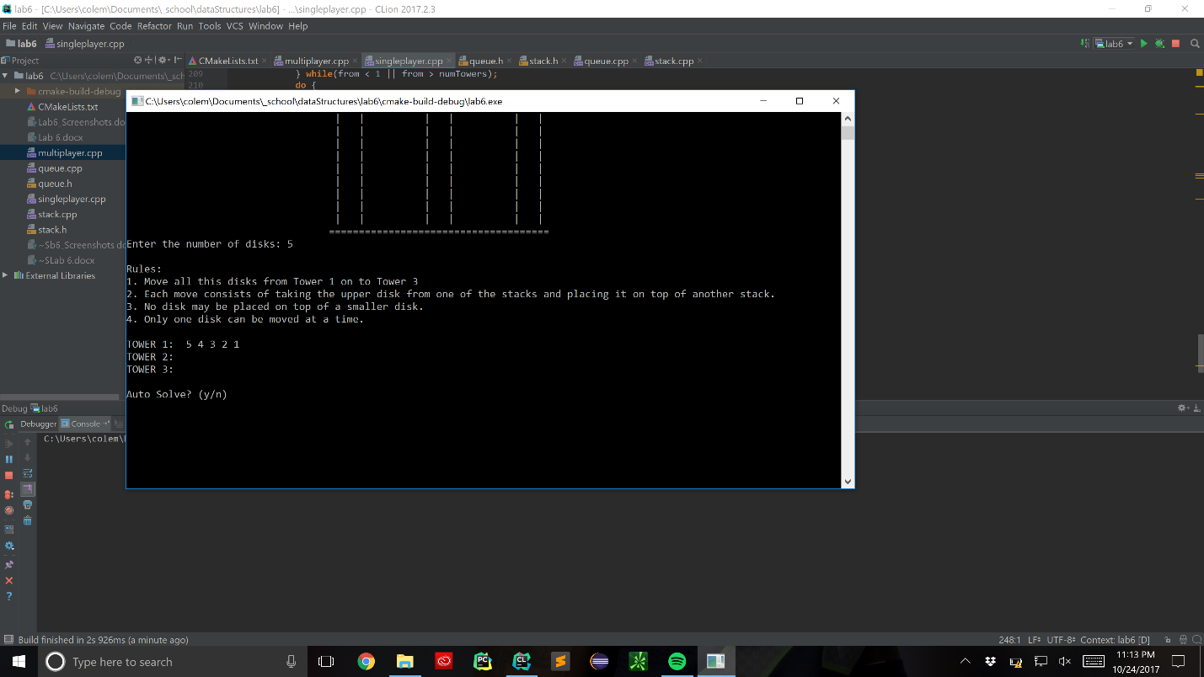**I chose 5 disks because I’ve gotten pretty good at playing this game not gunna lie… I also included an auto solve function for single player out of the sudo code I found on Wikipedia and StackOverflow**

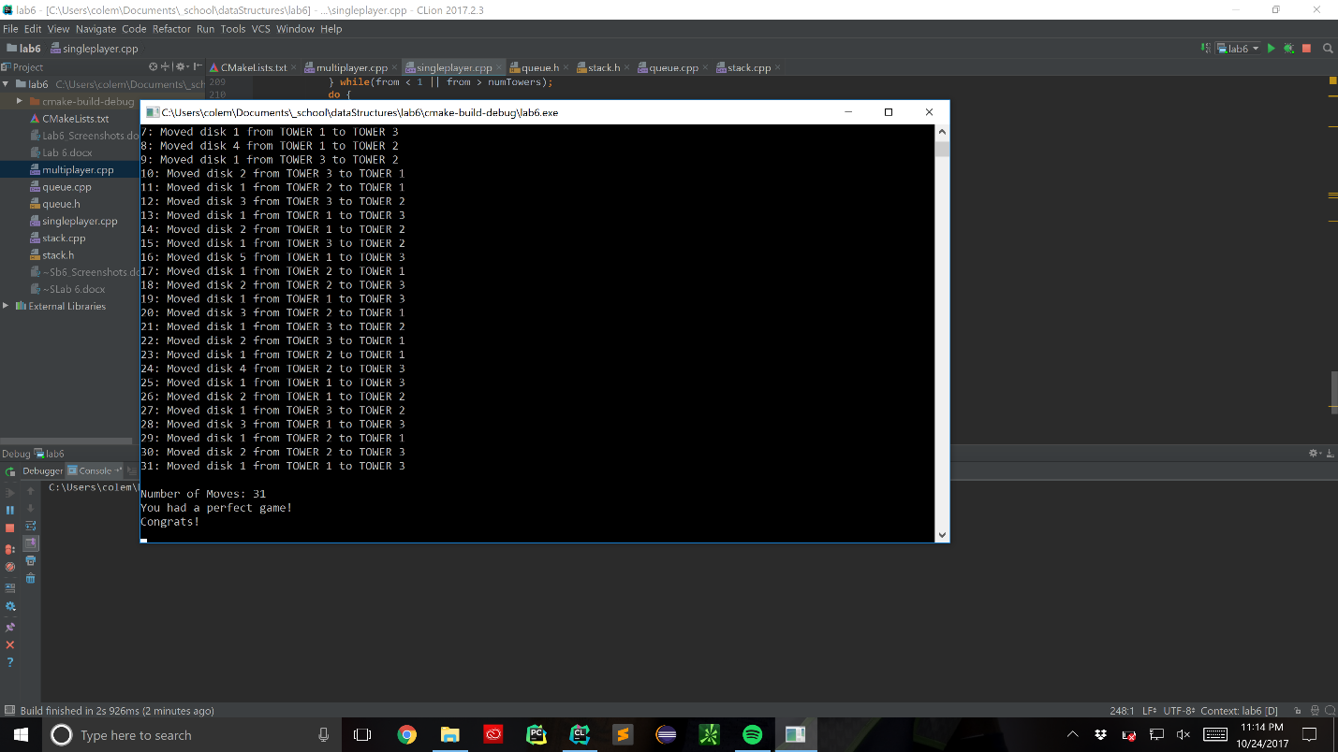**Demonstration of Auto Solve**

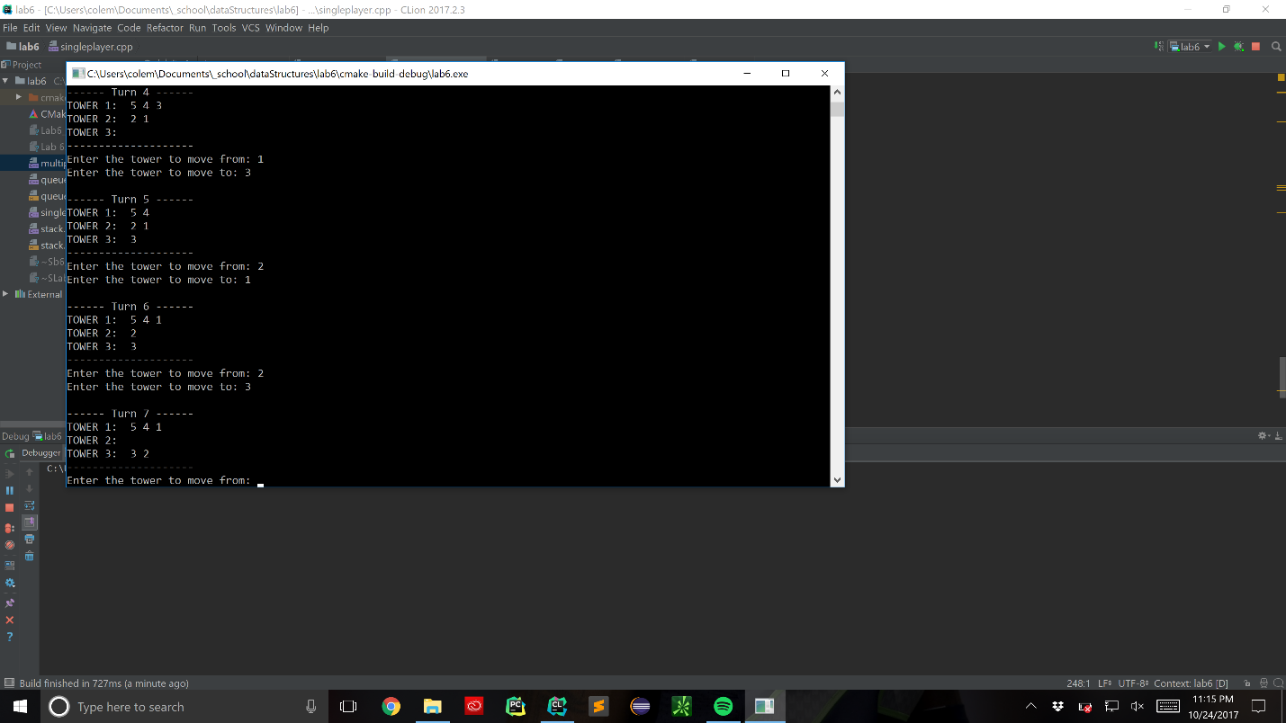**Action shot of some gameplay**

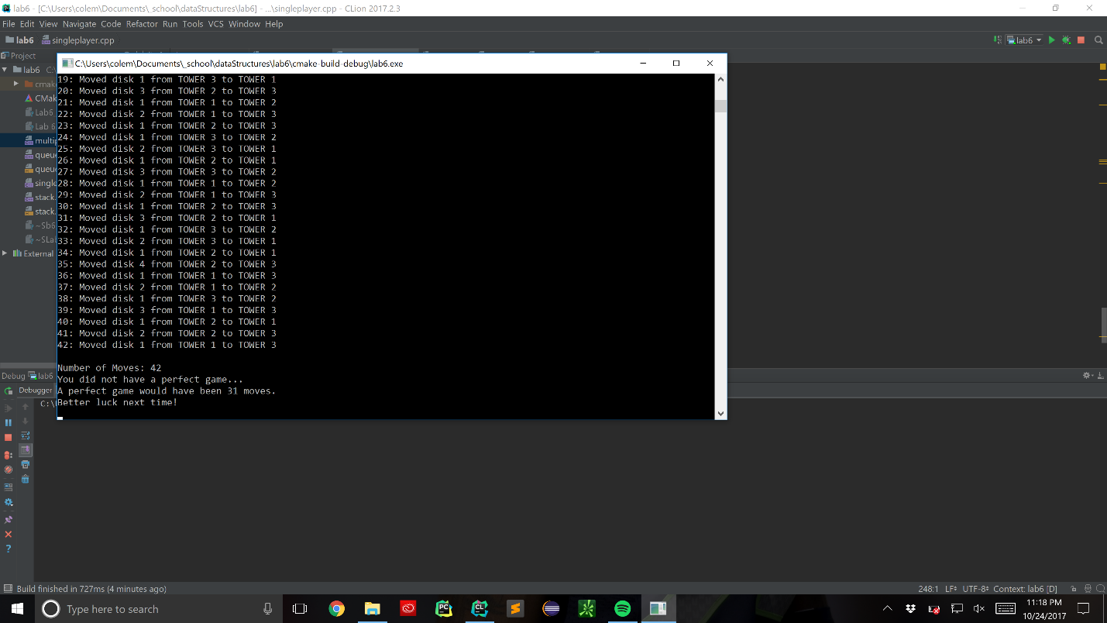**Here’s the end of a manually solved 5 disk game. It also calculates the least amount of moves needed to solve the puzzle and compares how many moves the user made to the ‘Perfect Game’. As you can see I messed up a little so I did not complete the puzzle in the perfect 31 moves.**

**For the multiplayer part of the lab, I found that working collaboratively worked out the best. If both players move each other’s pieces, you are able to finish the puzzle much faster than only moving your own pieces.**